**Normalization results for pairs 14_0.png_14_1.png from subset png\graffiti_picture_outside**

**14_0.png: 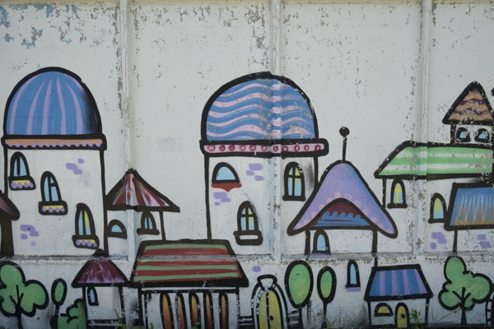14_1.png:** 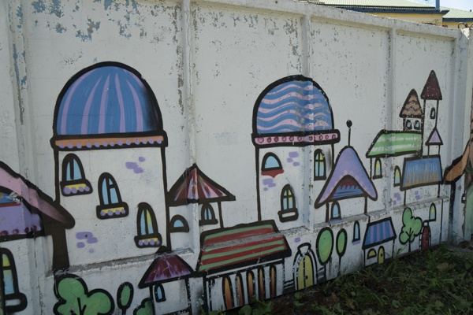

**Table 1 - Found homography parameters and normalization accuracy assessment**

|  |  |  |  |  |  |  |  |  |  |  |  |  |
| --- | --- | --- | --- | --- | --- | --- | --- | --- | --- | --- | --- | --- |
| Original:  img1: 0 img2: 0 | h11 | h12 | h13 | h21 | h22 | h23 | h31 | h32 | h33 | avg ErrIM (pixel) | max ErrIM | Expert rate |
| SIFT | 1,484 | 0,072 | 46,116 | 0,169 | 1,258 | -31,91 | 0,001 | 0 | 1 | 1,212 | 2,923 |  |
| SURF128 | 1,446 | 0,026 | 55,553 | 0,171 | 1,195 | -24,633 | 0,001 | -0 | 1 | 1,53 | 3,897 |  |
| SURF64 | 1,446 | 0,023 | 56,164 | 0,163 | 1,19 | -23,518 | 0,001 | -0 | 1 | 1,508 | 3,965 |  |
| ORB | 1,468 | 0,012 | 55,195 | 0,174 | 1,199 | -26,252 | 0,001 | -0 | 1 | 1,295 | 3,545 |  |
| ORB1000 | 1,526 | 0 | 50,414 | 0,194 | 1,213 | -29,684 | 0,001 | -0 | 1 | 1,193 | 3,359 |  |
| BRISK | 1,48 | 0,025 | 53,466 | 0,18 | 1,216 | -28,796 | 0,001 | 0 | 1 | 1,295 | 3,423 |  |
| KAZE | 1,421 | 0,031 | 56,395 | 0,143 | 1,212 | -24,752 | 0,001 | 0 | 1 | 0,863 | 2,964 |  |
| AKAZE | 1,453 | 0,026 | 53,722 | 0,172 | 1,193 | -24,631 | 0,001 | -0 | 1 | 1,275 | 3,203 |  |
|  |  |  |  |  |  |  |  |  |  |  |  |  |

where h11, h12, h13, h21, h22, h23, h31, h32, h33 - parameters of found homography matrix H* or of original one H;   
avgErrPar - average error of found parameters, the accuracy of found homography matrix parameters with a preliminary minimax normalization of found and original matrices;  
avgErrIM - average error of inlier coordinate matching;  
inliers - correct matches; outliers - false matches;  
maxErrIM – maximum error of inlier coordinate matching;  
avgErrCPM - average error of corner point matching;  
maxErrCPM - maximum error of corner point matching;  
expert rate - experts assessment of normalization accuracy with a 5-point scale: 0 - normalization failed, 1 - insufficient, 2 - satisfactory, 3 - good, 4 – excellent.

**Table 2 - Quantitative evaluation of descriptors, precision and recall estimation (with found overlap)**

|  |  |  |  |  |  |  |  |  |  |  |  |  |  |  |  |  |
| --- | --- | --- | --- | --- | --- | --- | --- | --- | --- | --- | --- | --- | --- | --- | --- | --- |
| Name | NP1 | NP2 | NM | NI | DP1 | DP2 | OP1 | OP2 | NPO1 | NPO2 | NMO | DPO1 | DPO2 | Precision | RecallO1 | Comments |
| SIFT | 1972 | 1881 | 730 | 482 | 0,0082 | 0,0078 | 97,6192 | 73,9363 | 1887 | 1528 | 724 | 0,0081 | 0,0086 | 0,6603 | 0,2554 |  |
| SURF128 | 2300 | 2415 | 562 | 344 | 0,0096 | 0,0101 | 97,845 | 72,4267 | 2272 | 1977 | 562 | 0,0097 | 0,0114 | 0,6121 | 0,1514 |  |
| SURF64 | 2300 | 2415 | 648 | 429 | 0,0096 | 0,0101 | 97,8487 | 72,9454 | 2272 | 2004 | 648 | 0,0097 | 0,0114 | 0,662 | 0,1888 |  |
| ORB | 5801 | 5905 | 1063 | 819 | 0,0242 | 0,0246 | 97,6233 | 73,2562 | 5800 | 5583 | 1063 | 0,0248 | 0,0318 | 0,7705 | 0,1412 |  |
| ORB1000 | 1000 | 1000 | 281 | 188 | 0,0042 | 0,0042 | 97,2467 | 73,8542 | 1000 | 934 | 281 | 0,0043 | 0,0053 | 0,669 | 0,188 |  |
| BRISK | 2451 | 2326 | 551 | 353 | 0,0102 | 0,0097 | 97,5846 | 73,0496 | 2442 | 2143 | 551 | 0,0104 | 0,0122 | 0,6407 | 0,1446 |  |
| KAZE | 1193 | 1036 | 387 | 231 | 0,005 | 0,0043 | 97,8521 | 74,7117 | 1170 | 913 | 387 | 0,005 | 0,0051 | 0,5969 | 0,1974 |  |
| AKAZE | 917 | 850 | 266 | 194 | 0,0038 | 0,0035 | 97,8167 | 72,9267 | 917 | 788 | 266 | 0,0039 | 0,0045 | 0,7293 | 0,2116 |  |

where NP - number of found key points; NP1, NP2 - number of found key points for image1 and image2 respectively;  
NM - number of matches found with NNDR method, NM=NI+NO;  
NI - number of inliers found with RANSAC method;  
NO - number of outliers discarded with RANSAC method;   
DP - density of key points (per cent), DP= NP/(height x width) , height, width - vertical and horizontal image sizes respectively (pixels)  
DP1, DP2 - density of key points points for image1 and image2 respectively;  
OP1, OP2 - overlap percentage for image1 and image2 respectively;  
NPO1, NPO2 - number of found key points on overlap for image1 and image2 respectivelyy;  
NMO - number of matches on overlap found with NNDR method;  
DPO1, DPO2 - density of key points points on overlap for image1 and image2 respectively;   
OA - overlap area (pixels), OA1, OA2 - overlap area for image1 and image2 respectively;  
DPO1= NPO1/OA1; DPO2= NPO2/OA2;  
Precision = NI/ NM - the rate to evaluate the part of inliers to all found matches with NNDR method;  
RecallO1 = NI/ NPO1 - completeness of inlier retrieval relative to the number of all key points on overlap for image1. The rate illustrates usefulness of the found key points for normalization.

**Table 3 - Estimation of time costs**

|  |  |  |  |  |  |  |  |  |  |  |
| --- | --- | --- | --- | --- | --- | --- | --- | --- | --- | --- |
| Name | NP1 | NP2 | DesT1, sec | DesT2, sec | MatchT, sec | InlierT, sec | AvgDesT, ms | AvgMatchT, ms | AvgInlierT, ms | TotalNormT, sec |
| SIFT | 1972 | 1881 | 0,057135 | 0,052121 | 0,029098 | 0,001069 | 0,028341 | 0,03986 | 0,002217 | 0,139423 |
| SURF128 | 2300 | 2415 | 0,059015 | 0,06645 | 0,043657 | 0,001529 | 0,026586 | 0,077681 | 0,004445 | 0,170651 |
| SURF64 | 2300 | 2415 | 0,067315 | 0,068725 | 0,024576 | 0,001293 | 0,028862 | 0,037925 | 0,003013 | 0,161908 |
| ORB | 5801 | 5905 | 0,019138 | 0,016269 | 0,078772 | 0,000923 | 0,003027 | 0,074103 | 0,001126 | 0,115101 |
| ORB1000 | 1000 | 1000 | 0,009758 | 0,009515 | 0,003202 | 0,000871 | 0,009636 | 0,011395 | 0,004635 | 0,023346 |
| BRISK | 2451 | 2326 | 0,040612 | 0,036449 | 0,015524 | 0,001106 | 0,016119 | 0,028174 | 0,003133 | 0,093692 |
| KAZE | 1193 | 1036 | 0,116902 | 0,115795 | 0,010431 | 0,001251 | 0,10488 | 0,026953 | 0,005415 | 0,244379 |
| AKAZE | 917 | 850 | 0,0186 | 0,015119 | 0,003848 | 0,000782 | 0,019035 | 0,014465 | 0,004029 | 0,038349 |

where DesT – descriptor creation time (time for key point detection and descriptor computation), DesT1, DesT2 – creation time of descriptors for image1 and image2 respectively;  
MatchT - retrieval time of matching found with NNDR method for the pair;  
InlierT – inlier retrieval time found with RANSAC method for the pair;  
AvgDesT – average time for one descriptor creation;  
AvgMatchT - average time for one match retrieval with NNDR method;  
AvgInlierT – average time for one inlier retrieval with RANSAC method;  
TotalNormT – total normalization time for the pair.