**Normalization results for pairs 17_0.png_17_1.png from subset png\graffiti_picture_outside**

**17_0.png: 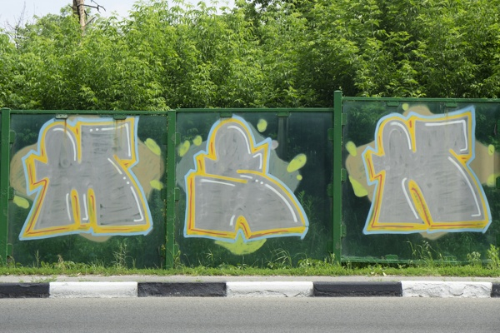17_1.png:** 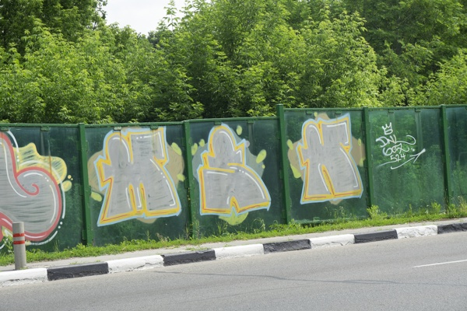

**Table 1 - Found homography parameters and normalization accuracy assessment**

|  |  |  |  |  |  |  |  |  |  |  |  |  |
| --- | --- | --- | --- | --- | --- | --- | --- | --- | --- | --- | --- | --- |
| Original:  img1: 0 img2: 0 | h11 | h12 | h13 | h21 | h22 | h23 | h31 | h32 | h33 | avg ErrIM (pixel) | max ErrIM | Expert rate |
| SIFT | 0,759 | 0,076 | 87,478 | 0,023 | 0,858 | 47,426 | 0 | 0 | 1 | 0,609 | 2,298 |  |
| SURF128 | 0,768 | 0,091 | 85,026 | 0,029 | 0,876 | 44,695 | 0 | 0 | 1 | 1,053 | 2,646 |  |
| SURF64 | 0,735 | 0,047 | 90,887 | 0,023 | 0,8 | 52,297 | 0 | -0 | 1 | 1,112 | 3,693 |  |
| ORB | 0,746 | 0,077 | 87,818 | 0,018 | 0,844 | 49,299 | 0 | 0 | 1 | 1,023 | 3,278 |  |
| ORB1000 | 0,83 | 0,136 | 72,845 | 0,035 | 0,937 | 40,709 | 0 | 0 | 1 | 0,837 | 2,482 |  |
| BRISK | 0,748 | 0,078 | 86,581 | 0,022 | 0,846 | 47,799 | 0 | -0 | 1 | 1,026 | 2,776 |  |
| KAZE | 0,782 | 0,108 | 82,22 | 0,028 | 0,901 | 43,079 | 0 | 0 | 1 | 0,957 | 2,359 |  |
| AKAZE | 0,8 | 0,138 | 76,083 | 0,03 | 0,936 | 38,633 | 0 | 0 | 1 | 0,812 | 1,534 |  |
|  |  |  |  |  |  |  |  |  |  |  |  |  |

where h11, h12, h13, h21, h22, h23, h31, h32, h33 - parameters of found homography matrix H* or of original one H;   
avgErrPar - average error of found parameters, the accuracy of found homography matrix parameters with a preliminary minimax normalization of found and original matrices;  
avgErrIM - average error of inlier coordinate matching;  
inliers - correct matches; outliers - false matches;  
maxErrIM – maximum error of inlier coordinate matching;  
avgErrCPM - average error of corner point matching;  
maxErrCPM - maximum error of corner point matching;  
expert rate - experts assessment of normalization accuracy with a 5-point scale: 0 - normalization failed, 1 - insufficient, 2 - satisfactory, 3 - good, 4 – excellent.

**Table 2 - Quantitative evaluation of descriptors, precision and recall estimation (with found overlap)**

|  |  |  |  |  |  |  |  |  |  |  |  |  |  |  |  |  |
| --- | --- | --- | --- | --- | --- | --- | --- | --- | --- | --- | --- | --- | --- | --- | --- | --- |
| Name | NP1 | NP2 | NM | NI | DP1 | DP2 | OP1 | OP2 | NPO1 | NPO2 | NMO | DPO1 | DPO2 | Precision | RecallO1 | Comments |
| SIFT | 2047 | 2255 | 109 | 69 | 0,0085 | 0,0094 | 100 | 48,6287 | 2047 | 1133 | 109 | 0,0085 | 0,0097 | 0,633 | 0,0337 |  |
| SURF128 | 2292 | 2375 | 119 | 75 | 0,0095 | 0,0099 | 100 | 48,6163 | 2292 | 1310 | 119 | 0,0095 | 0,0112 | 0,6303 | 0,0327 |  |
| SURF64 | 2292 | 2375 | 144 | 71 | 0,0095 | 0,0099 | 100 | 48,2638 | 2292 | 1274 | 144 | 0,0095 | 0,011 | 0,4931 | 0,031 |  |
| ORB | 8951 | 10348 | 197 | 118 | 0,0373 | 0,0431 | 100 | 48,4979 | 8951 | 6610 | 197 | 0,0373 | 0,0568 | 0,599 | 0,0132 |  |
| ORB1000 | 1000 | 1000 | 63 | 43 | 0,0042 | 0,0042 | 100 | 49,3225 | 1000 | 614 | 63 | 0,0042 | 0,0052 | 0,6825 | 0,043 |  |
| BRISK | 3512 | 3935 | 101 | 57 | 0,0146 | 0,0164 | 100 | 48,9429 | 3512 | 2162 | 101 | 0,0146 | 0,0184 | 0,5644 | 0,0162 |  |
| KAZE | 554 | 659 | 52 | 30 | 0,0023 | 0,0027 | 100 | 48,6821 | 554 | 345 | 52 | 0,0023 | 0,003 | 0,5769 | 0,0542 |  |
| AKAZE | 470 | 635 | 30 | 17 | 0,002 | 0,0026 | 100 | 49,5454 | 470 | 408 | 30 | 0,002 | 0,0034 | 0,5667 | 0,0362 |  |

where NP - number of found key points; NP1, NP2 - number of found key points for image1 and image2 respectively;  
NM - number of matches found with NNDR method, NM=NI+NO;  
NI - number of inliers found with RANSAC method;  
NO - number of outliers discarded with RANSAC method;   
DP - density of key points (per cent), DP= NP/(height x width) , height, width - vertical and horizontal image sizes respectively (pixels)  
DP1, DP2 - density of key points points for image1 and image2 respectively;  
OP1, OP2 - overlap percentage for image1 and image2 respectively;  
NPO1, NPO2 - number of found key points on overlap for image1 and image2 respectivelyy;  
NMO - number of matches on overlap found with NNDR method;  
DPO1, DPO2 - density of key points points on overlap for image1 and image2 respectively;   
OA - overlap area (pixels), OA1, OA2 - overlap area for image1 and image2 respectively;  
DPO1= NPO1/OA1; DPO2= NPO2/OA2;  
Precision = NI/ NM - the rate to evaluate the part of inliers to all found matches with NNDR method;  
RecallO1 = NI/ NPO1 - completeness of inlier retrieval relative to the number of all key points on overlap for image1. The rate illustrates usefulness of the found key points for normalization.

**Table 3 - Estimation of time costs**

|  |  |  |  |  |  |  |  |  |  |  |
| --- | --- | --- | --- | --- | --- | --- | --- | --- | --- | --- |
| Name | NP1 | NP2 | DesT1, sec | DesT2, sec | MatchT, sec | InlierT, sec | AvgDesT, ms | AvgMatchT, ms | AvgInlierT, ms | TotalNormT, sec |
| SIFT | 2047 | 2255 | 0,049715 | 0,049734 | 0,035335 | 0,000954 | 0,02317 | 0,324175 | 0,013831 | 0,135738 |
| SURF128 | 2292 | 2375 | 0,056451 | 0,054888 | 0,044634 | 0,000968 | 0,023869 | 0,375076 | 0,012906 | 0,156942 |
| SURF64 | 2292 | 2375 | 0,059538 | 0,054409 | 0,02381 | 0,002313 | 0,024442 | 0,165345 | 0,03258 | 0,140071 |
| ORB | 8951 | 10348 | 0,021272 | 0,022659 | 0,204327 | 0,001157 | 0,002282 | 1,037194 | 0,009803 | 0,249415 |
| ORB1000 | 1000 | 1000 | 0,009985 | 0,009953 | 0,003156 | 0,000741 | 0,009968 | 0,0501 | 0,017233 | 0,023835 |
| BRISK | 3512 | 3935 | 0,053178 | 0,057049 | 0,033972 | 0,001391 | 0,014819 | 0,336355 | 0,024396 | 0,14559 |
| KAZE | 554 | 659 | 0,12739 | 0,114662 | 0,003285 | 0,001267 | 0,20197 | 0,063179 | 0,042245 | 0,246606 |
| AKAZE | 470 | 635 | 0,015943 | 0,012667 | 0,001367 | 0,001353 | 0,026933 | 0,045568 | 0,079611 | 0,03133 |

where DesT – descriptor creation time (time for key point detection and descriptor computation), DesT1, DesT2 – creation time of descriptors for image1 and image2 respectively;  
MatchT - retrieval time of matching found with NNDR method for the pair;  
InlierT – inlier retrieval time found with RANSAC method for the pair;  
AvgDesT – average time for one descriptor creation;  
AvgMatchT - average time for one match retrieval with NNDR method;  
AvgInlierT – average time for one inlier retrieval with RANSAC method;  
TotalNormT – total normalization time for the pair.