**Normalization results for pairs 19_0.png_19_1.png from subset png\graffiti_picture_outside**

**19_0.png: 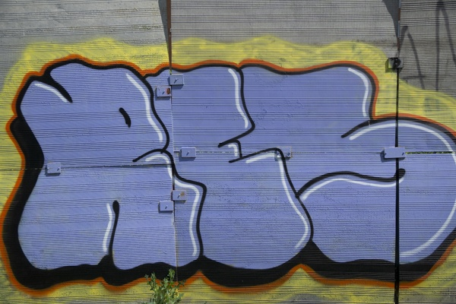19_1.png:** 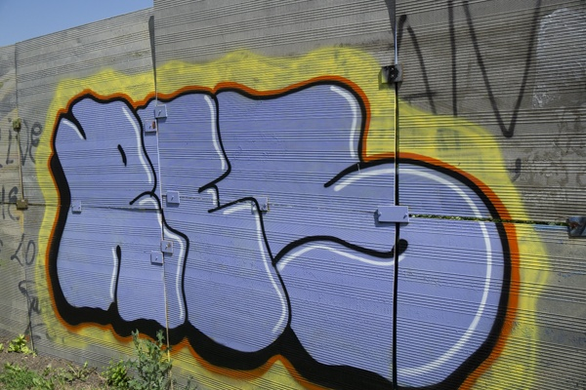

**Table 1 - Found homography parameters and normalization accuracy assessment**

|  |  |  |  |  |  |  |  |  |  |  |  |  |
| --- | --- | --- | --- | --- | --- | --- | --- | --- | --- | --- | --- | --- |
| Original:  img1: 0 img2: 0 | h11 | h12 | h13 | h21 | h22 | h23 | h31 | h32 | h33 | avg ErrIM (pixel) | max ErrIM | Expert rate |
| SIFT | 0,405 | 0,025 | 41,547 | -0,105 | 0,774 | 39,091 | -0,001 | 0 | 1 | 1,022 | 3,789 |  |
| SURF128 | 0,418 | 0,028 | 37,87 | -0,103 | 0,779 | 38,467 | -0,001 | 0 | 1 | 1,238 | 3,69 |  |
| SURF64 | 0,402 | 0,005 | 43,496 | -0,103 | 0,759 | 39,08 | -0,001 | -0 | 1 | 1,3 | 3,645 |  |
| ORB | 0,396 | 0,015 | 43,098 | -0,106 | 0,755 | 40,208 | -0,001 | -0 | 1 | 1,098 | 3,431 |  |
| ORB1000 | 0,404 | 0,033 | 40,445 | -0,107 | 0,779 | 39,129 | -0,001 | 0 | 1 | 1,171 | 3,273 |  |
| BRISK | 0,396 | 0,008 | 44,607 | -0,107 | 0,756 | 40,651 | -0,001 | -0 | 1 | 1,16 | 2,749 |  |
| KAZE | 0,415 | 0,033 | 38,309 | -0,104 | 0,787 | 37,565 | -0,001 | 0 | 1 | 1,172 | 3,893 |  |
| AKAZE | 0,403 | 0,02 | 42,219 | -0,107 | 0,776 | 38,911 | -0,001 | 0 | 1 | 1,022 | 3,192 |  |
|  |  |  |  |  |  |  |  |  |  |  |  |  |

where h11, h12, h13, h21, h22, h23, h31, h32, h33 - parameters of found homography matrix H* or of original one H;   
avgErrPar - average error of found parameters, the accuracy of found homography matrix parameters with a preliminary minimax normalization of found and original matrices;  
avgErrIM - average error of inlier coordinate matching;  
inliers - correct matches; outliers - false matches;  
maxErrIM – maximum error of inlier coordinate matching;  
avgErrCPM - average error of corner point matching;  
maxErrCPM - maximum error of corner point matching;  
expert rate - experts assessment of normalization accuracy with a 5-point scale: 0 - normalization failed, 1 - insufficient, 2 - satisfactory, 3 - good, 4 – excellent.

**Table 2 - Quantitative evaluation of descriptors, precision and recall estimation (with found overlap)**

|  |  |  |  |  |  |  |  |  |  |  |  |  |  |  |  |  |
| --- | --- | --- | --- | --- | --- | --- | --- | --- | --- | --- | --- | --- | --- | --- | --- | --- |
| Name | NP1 | NP2 | NM | NI | DP1 | DP2 | OP1 | OP2 | NPO1 | NPO2 | NMO | DPO1 | DPO2 | Precision | RecallO1 | Comments |
| SIFT | 547 | 784 | 129 | 94 | 0,0023 | 0,0033 | 94,7388 | 71,4942 | 529 | 462 | 129 | 0,0023 | 0,0027 | 0,7287 | 0,1777 |  |
| SURF128 | 2203 | 3749 | 260 | 137 | 0,0092 | 0,0156 | 94,88 | 72,0692 | 2150 | 2721 | 260 | 0,0094 | 0,0157 | 0,5269 | 0,0637 |  |
| SURF64 | 2203 | 3749 | 299 | 161 | 0,0092 | 0,0156 | 94,4146 | 72,0637 | 2147 | 2732 | 299 | 0,0095 | 0,0158 | 0,5385 | 0,075 |  |
| ORB | 3490 | 4559 | 374 | 238 | 0,0145 | 0,019 | 94,1392 | 72,4071 | 3472 | 3848 | 374 | 0,0154 | 0,0221 | 0,6364 | 0,0685 |  |
| ORB1000 | 1000 | 1000 | 168 | 122 | 0,0042 | 0,0042 | 94,8088 | 71,6358 | 1000 | 956 | 168 | 0,0044 | 0,0056 | 0,7262 | 0,122 |  |
| BRISK | 1229 | 1521 | 131 | 95 | 0,0051 | 0,0063 | 94,4829 | 71,8746 | 1223 | 1218 | 131 | 0,0054 | 0,0071 | 0,7252 | 0,0777 |  |
| KAZE | 559 | 609 | 147 | 105 | 0,0023 | 0,0025 | 94,7271 | 72,0375 | 556 | 523 | 147 | 0,0024 | 0,003 | 0,7143 | 0,1888 |  |
| AKAZE | 330 | 390 | 96 | 73 | 0,0014 | 0,0016 | 94,6308 | 72,025 | 330 | 361 | 96 | 0,0015 | 0,0021 | 0,7604 | 0,2212 |  |

where NP - number of found key points; NP1, NP2 - number of found key points for image1 and image2 respectively;  
NM - number of matches found with NNDR method, NM=NI+NO;  
NI - number of inliers found with RANSAC method;  
NO - number of outliers discarded with RANSAC method;   
DP - density of key points (per cent), DP= NP/(height x width) , height, width - vertical and horizontal image sizes respectively (pixels)  
DP1, DP2 - density of key points points for image1 and image2 respectively;  
OP1, OP2 - overlap percentage for image1 and image2 respectively;  
NPO1, NPO2 - number of found key points on overlap for image1 and image2 respectivelyy;  
NMO - number of matches on overlap found with NNDR method;  
DPO1, DPO2 - density of key points points on overlap for image1 and image2 respectively;   
OA - overlap area (pixels), OA1, OA2 - overlap area for image1 and image2 respectively;  
DPO1= NPO1/OA1; DPO2= NPO2/OA2;  
Precision = NI/ NM - the rate to evaluate the part of inliers to all found matches with NNDR method;  
RecallO1 = NI/ NPO1 - completeness of inlier retrieval relative to the number of all key points on overlap for image1. The rate illustrates usefulness of the found key points for normalization.

**Table 3 - Estimation of time costs**

|  |  |  |  |  |  |  |  |  |  |  |
| --- | --- | --- | --- | --- | --- | --- | --- | --- | --- | --- |
| Name | NP1 | NP2 | DesT1, sec | DesT2, sec | MatchT, sec | InlierT, sec | AvgDesT, ms | AvgMatchT, ms | AvgInlierT, ms | TotalNormT, sec |
| SIFT | 547 | 784 | 0,046068 | 0,045581 | 0,004595 | 0,000607 | 0,071179 | 0,03562 | 0,006459 | 0,096852 |
| SURF128 | 2203 | 3749 | 0,061451 | 0,08504 | 0,062314 | 0,001858 | 0,025288 | 0,239668 | 0,013558 | 0,210663 |
| SURF64 | 2203 | 3749 | 0,066561 | 0,080433 | 0,034998 | 0,001877 | 0,025833 | 0,117051 | 0,011656 | 0,183869 |
| ORB | 3490 | 4559 | 0,012029 | 0,013641 | 0,038329 | 0,001045 | 0,003219 | 0,102483 | 0,00439 | 0,065044 |
| ORB1000 | 1000 | 1000 | 0,008416 | 0,00883 | 0,003166 | 0,000606 | 0,008622 | 0,018846 | 0,004966 | 0,021018 |
| BRISK | 1229 | 1521 | 0,01891 | 0,023878 | 0,005593 | 0,001092 | 0,015542 | 0,042697 | 0,011497 | 0,049474 |
| KAZE | 559 | 609 | 0,116052 | 0,111425 | 0,003071 | 0,000683 | 0,195285 | 0,020891 | 0,006501 | 0,231231 |
| AKAZE | 330 | 390 | 0,017768 | 0,018284 | 0,000835 | 0,000516 | 0,050362 | 0,008696 | 0,007065 | 0,037403 |

where DesT – descriptor creation time (time for key point detection and descriptor computation), DesT1, DesT2 – creation time of descriptors for image1 and image2 respectively;  
MatchT - retrieval time of matching found with NNDR method for the pair;  
InlierT – inlier retrieval time found with RANSAC method for the pair;  
AvgDesT – average time for one descriptor creation;  
AvgMatchT - average time for one match retrieval with NNDR method;  
AvgInlierT – average time for one inlier retrieval with RANSAC method;  
TotalNormT – total normalization time for the pair.