**Normalization results for pairs 20_0.png_20_1.png from subset png\graffiti_picture_outside**

**20_0.png: 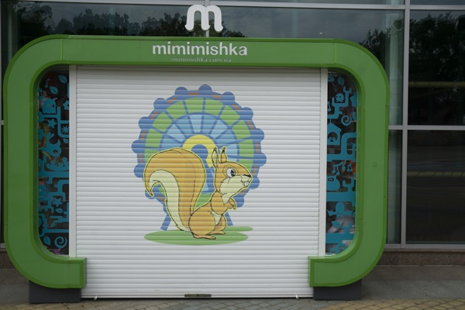20_1.png:** 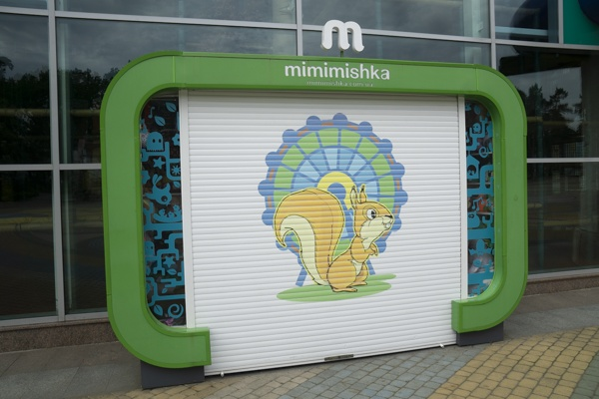

**Table 1 - Found homography parameters and normalization accuracy assessment**

|  |  |  |  |  |  |  |  |  |  |  |  |  |
| --- | --- | --- | --- | --- | --- | --- | --- | --- | --- | --- | --- | --- |
| Original:  img1: 0 img2: 0 | h11 | h12 | h13 | h21 | h22 | h23 | h31 | h32 | h33 | avg ErrIM (pixel) | max ErrIM | Expert rate |
| SIFT | 1,133 | 0,042 | 81,9 | 0,055 | 1,028 | 1,871 | 0 | 0 | 1 | 0,417 | 2,047 |  |
| SURF128 | 1,129 | 0,052 | 81,442 | 0,052 | 1,036 | 1,762 | 0 | 0 | 1 | 0,875 | 3,448 |  |
| SURF64 | 1,129 | 0,061 | 80,519 | 0,053 | 1,041 | 1,089 | 0 | 0 | 1 | 0,911 | 3,731 |  |
| ORB | 1,12 | 0,032 | 83,285 | 0,054 | 1,01 | 3,675 | 0 | -0 | 1 | 0,874 | 3,467 |  |
| ORB1000 | 1,121 | 0,028 | 83,834 | 0,054 | 1,006 | 4,386 | 0 | -0 | 1 | 1,063 | 3,365 |  |
| BRISK | 1,125 | 0,039 | 82,488 | 0,054 | 1,019 | 2,78 | 0 | 0 | 1 | 0,702 | 3,194 |  |
| KAZE | 1,169 | 0,058 | 79,216 | 0,064 | 1,065 | -1,909 | 0,001 | 0 | 1 | 1,015 | 3,835 |  |
| AKAZE | 1,12 | 0,042 | 82,519 | 0,05 | 1,019 | 3,452 | 0 | 0 | 1 | 0,676 | 2,541 |  |
|  |  |  |  |  |  |  |  |  |  |  |  |  |

where h11, h12, h13, h21, h22, h23, h31, h32, h33 - parameters of found homography matrix H* or of original one H;   
avgErrPar - average error of found parameters, the accuracy of found homography matrix parameters with a preliminary minimax normalization of found and original matrices;  
avgErrIM - average error of inlier coordinate matching;  
inliers - correct matches; outliers - false matches;  
maxErrIM – maximum error of inlier coordinate matching;  
avgErrCPM - average error of corner point matching;  
maxErrCPM - maximum error of corner point matching;  
expert rate - experts assessment of normalization accuracy with a 5-point scale: 0 - normalization failed, 1 - insufficient, 2 - satisfactory, 3 - good, 4 – excellent.

**Table 2 - Quantitative evaluation of descriptors, precision and recall estimation (with found overlap)**

|  |  |  |  |  |  |  |  |  |  |  |  |  |  |  |  |  |
| --- | --- | --- | --- | --- | --- | --- | --- | --- | --- | --- | --- | --- | --- | --- | --- | --- |
| Name | NP1 | NP2 | NM | NI | DP1 | DP2 | OP1 | OP2 | NPO1 | NPO2 | NMO | DPO1 | DPO2 | Precision | RecallO1 | Comments |
| SIFT | 1016 | 1127 | 432 | 330 | 0,0042 | 0,0047 | 99,9008 | 75,6779 | 1016 | 1014 | 432 | 0,0042 | 0,0056 | 0,7639 | 0,3248 |  |
| SURF128 | 1525 | 1867 | 294 | 240 | 0,0064 | 0,0078 | 99,9375 | 75,5921 | 1525 | 1630 | 294 | 0,0064 | 0,009 | 0,8163 | 0,1574 |  |
| SURF64 | 1525 | 1867 | 386 | 272 | 0,0064 | 0,0078 | 99,9583 | 75,5079 | 1525 | 1627 | 386 | 0,0064 | 0,009 | 0,7047 | 0,1784 |  |
| ORB | 3858 | 3794 | 1045 | 896 | 0,0161 | 0,0158 | 99,8854 | 75,6183 | 3858 | 3708 | 1045 | 0,0161 | 0,0204 | 0,8574 | 0,2322 |  |
| ORB1000 | 994 | 1000 | 260 | 183 | 0,0041 | 0,0042 | 99,8675 | 75,5317 | 994 | 978 | 260 | 0,0041 | 0,0054 | 0,7038 | 0,1841 |  |
| BRISK | 1138 | 1256 | 330 | 270 | 0,0047 | 0,0052 | 99,9104 | 75,6192 | 1138 | 1224 | 330 | 0,0047 | 0,0067 | 0,8182 | 0,2373 |  |
| KAZE | 335 | 442 | 127 | 86 | 0,0014 | 0,0018 | 99,945 | 75,3254 | 335 | 393 | 127 | 0,0014 | 0,0022 | 0,6772 | 0,2567 |  |
| AKAZE | 279 | 354 | 104 | 86 | 0,0012 | 0,0015 | 99,9304 | 75,7687 | 279 | 336 | 104 | 0,0012 | 0,0018 | 0,8269 | 0,3082 |  |

where NP - number of found key points; NP1, NP2 - number of found key points for image1 and image2 respectively;  
NM - number of matches found with NNDR method, NM=NI+NO;  
NI - number of inliers found with RANSAC method;  
NO - number of outliers discarded with RANSAC method;   
DP - density of key points (per cent), DP= NP/(height x width) , height, width - vertical and horizontal image sizes respectively (pixels)  
DP1, DP2 - density of key points points for image1 and image2 respectively;  
OP1, OP2 - overlap percentage for image1 and image2 respectively;  
NPO1, NPO2 - number of found key points on overlap for image1 and image2 respectivelyy;  
NMO - number of matches on overlap found with NNDR method;  
DPO1, DPO2 - density of key points points on overlap for image1 and image2 respectively;   
OA - overlap area (pixels), OA1, OA2 - overlap area for image1 and image2 respectively;  
DPO1= NPO1/OA1; DPO2= NPO2/OA2;  
Precision = NI/ NM - the rate to evaluate the part of inliers to all found matches with NNDR method;  
RecallO1 = NI/ NPO1 - completeness of inlier retrieval relative to the number of all key points on overlap for image1. The rate illustrates usefulness of the found key points for normalization.

**Table 3 - Estimation of time costs**

|  |  |  |  |  |  |  |  |  |  |  |
| --- | --- | --- | --- | --- | --- | --- | --- | --- | --- | --- |
| Name | NP1 | NP2 | DesT1, sec | DesT2, sec | MatchT, sec | InlierT, sec | AvgDesT, ms | AvgMatchT, ms | AvgInlierT, ms | TotalNormT, sec |
| SIFT | 1016 | 1127 | 0,047157 | 0,046093 | 0,009649 | 0,000665 | 0,043655 | 0,022335 | 0,002014 | 0,103563 |
| SURF128 | 1525 | 1867 | 0,056737 | 0,05587 | 0,023225 | 0,000514 | 0,033564 | 0,078995 | 0,002143 | 0,136346 |
| SURF64 | 1525 | 1867 | 0,054065 | 0,051221 | 0,012657 | 0,000868 | 0,031443 | 0,032789 | 0,003192 | 0,118811 |
| ORB | 3858 | 3794 | 0,012197 | 0,012065 | 0,034767 | 0,000834 | 0,00317 | 0,03327 | 0,000931 | 0,059863 |
| ORB1000 | 994 | 1000 | 0,008553 | 0,008415 | 0,003007 | 0,000936 | 0,00851 | 0,011567 | 0,005112 | 0,020912 |
| BRISK | 1138 | 1256 | 0,017622 | 0,018165 | 0,004688 | 0,000521 | 0,014973 | 0,014206 | 0,00193 | 0,040996 |
| KAZE | 335 | 442 | 0,106691 | 0,108049 | 0,001556 | 0,000735 | 0,281467 | 0,01225 | 0,008549 | 0,217031 |
| AKAZE | 279 | 354 | 0,01795 | 0,018718 | 0,000762 | 0,000465 | 0,058606 | 0,007328 | 0,005409 | 0,037896 |

where DesT – descriptor creation time (time for key point detection and descriptor computation), DesT1, DesT2 – creation time of descriptors for image1 and image2 respectively;  
MatchT - retrieval time of matching found with NNDR method for the pair;  
InlierT – inlier retrieval time found with RANSAC method for the pair;  
AvgDesT – average time for one descriptor creation;  
AvgMatchT - average time for one match retrieval with NNDR method;  
AvgInlierT – average time for one inlier retrieval with RANSAC method;  
TotalNormT – total normalization time for the pair.