**Normalization results for pairs 2_0.png_2_1.png from subset png\graffiti_picture_outside**

**2_0.png: 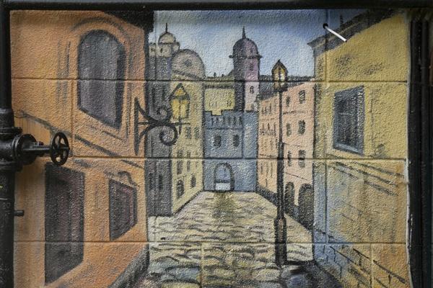2_1.png:** 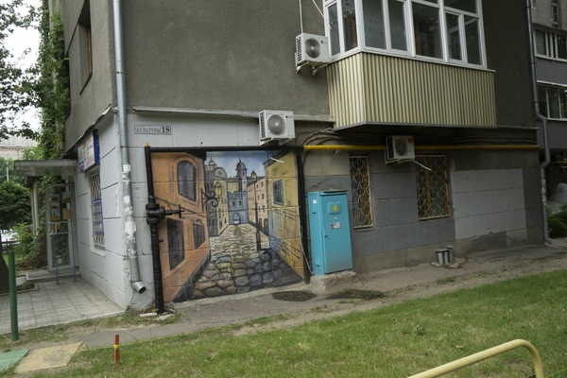

**Table 1 - Found homography parameters and normalization accuracy assessment**

|  |  |  |  |  |  |  |  |  |  |  |  |  |
| --- | --- | --- | --- | --- | --- | --- | --- | --- | --- | --- | --- | --- |
| Original:  img1: 0 img2: 0 | h11 | h12 | h13 | h21 | h22 | h23 | h31 | h32 | h33 | avg ErrIM (pixel) | max ErrIM | Expert rate |
| SIFT | 0,383 | 0,022 | 150,394 | 0,046 | 0,337 | 156,302 | 0 | -0 | 1 | 0,232 | 1,274 |  |
| SURF128 | 0,386 | 0,023 | 149,801 | 0,049 | 0,336 | 156,268 | 0 | -0 | 1 | 0,712 | 1,984 |  |
| SURF64 | 0,381 | 0,026 | 149,844 | 0,044 | 0,339 | 156,22 | 0 | 0 | 1 | 0,784 | 2,692 |  |
| ORB | 0,366 | 0,024 | 151,481 | 0,033 | 0,335 | 157,365 | 0 | 0 | 1 | 0,58 | 1,984 |  |
| ORB1000 | 0,361 | 0,047 | 149,717 | 0,025 | 0,357 | 156,537 | 0 | 0 | 1 | 0,49 | 1,209 |  |
| BRISK | 0,373 | 0,017 | 151,247 | 0,04 | 0,33 | 156,682 | 0 | -0 | 1 | 0,54 | 1,996 |  |
| KAZE | 0,399 | 0,022 | 148,906 | 0,055 | 0,341 | 155,313 | 0 | -0 | 1 | 0,562 | 1,591 |  |
| AKAZE | 0,413 | -0,005 | 148,987 | 0,065 | 0,32 | 155,082 | 0 | -0 | 1 | 0,572 | 2,028 |  |
|  |  |  |  |  |  |  |  |  |  |  |  |  |

where h11, h12, h13, h21, h22, h23, h31, h32, h33 - parameters of found homography matrix H* or of original one H;   
avgErrPar - average error of found parameters, the accuracy of found homography matrix parameters with a preliminary minimax normalization of found and original matrices;  
avgErrIM - average error of inlier coordinate matching;  
inliers - correct matches; outliers - false matches;  
maxErrIM – maximum error of inlier coordinate matching;  
avgErrCPM - average error of corner point matching;  
maxErrCPM - maximum error of corner point matching;  
expert rate - experts assessment of normalization accuracy with a 5-point scale: 0 - normalization failed, 1 - insufficient, 2 - satisfactory, 3 - good, 4 – excellent.

**Table 2 - Quantitative evaluation of descriptors, precision and recall estimation (with found overlap)**

|  |  |  |  |  |  |  |  |  |  |  |  |  |  |  |  |  |
| --- | --- | --- | --- | --- | --- | --- | --- | --- | --- | --- | --- | --- | --- | --- | --- | --- |
| Name | NP1 | NP2 | NM | NI | DP1 | DP2 | OP1 | OP2 | NPO1 | NPO2 | NMO | DPO1 | DPO2 | Precision | RecallO1 | Comments |
| SIFT | 2532 | 1380 | 159 | 139 | 0,0106 | 0,0057 | 100 | 8,795 | 2532 | 295 | 159 | 0,0106 | 0,014 | 0,8742 | 0,0549 |  |
| SURF128 | 3208 | 2439 | 70 | 62 | 0,0134 | 0,0102 | 100 | 8,7508 | 3208 | 352 | 70 | 0,0134 | 0,0168 | 0,8857 | 0,0193 |  |
| SURF64 | 3208 | 2439 | 98 | 83 | 0,0134 | 0,0102 | 100 | 8,7862 | 3208 | 352 | 98 | 0,0134 | 0,0167 | 0,8469 | 0,0259 |  |
| ORB | 14171 | 5151 | 170 | 111 | 0,059 | 0,0215 | 100 | 8,8121 | 14171 | 1481 | 170 | 0,059 | 0,07 | 0,6529 | 0,0078 |  |
| ORB1000 | 1000 | 1000 | 21 | 19 | 0,0042 | 0,0042 | 100 | 8,9025 | 1000 | 314 | 21 | 0,0042 | 0,0147 | 0,9048 | 0,019 |  |
| BRISK | 4740 | 1890 | 107 | 75 | 0,0198 | 0,0079 | 100 | 8,8204 | 4740 | 478 | 107 | 0,0198 | 0,0226 | 0,7009 | 0,0158 |  |
| KAZE | 773 | 567 | 16 | 12 | 0,0032 | 0,0024 | 100 | 8,895 | 773 | 110 | 16 | 0,0032 | 0,0052 | 0,75 | 0,0155 |  |
| AKAZE | 779 | 433 | 16 | 12 | 0,0032 | 0,0018 | 100 | 9,1758 | 779 | 126 | 16 | 0,0032 | 0,0057 | 0,75 | 0,0154 |  |

where NP - number of found key points; NP1, NP2 - number of found key points for image1 and image2 respectively;  
NM - number of matches found with NNDR method, NM=NI+NO;  
NI - number of inliers found with RANSAC method;  
NO - number of outliers discarded with RANSAC method;   
DP - density of key points (per cent), DP= NP/(height x width) , height, width - vertical and horizontal image sizes respectively (pixels)  
DP1, DP2 - density of key points points for image1 and image2 respectively;  
OP1, OP2 - overlap percentage for image1 and image2 respectively;  
NPO1, NPO2 - number of found key points on overlap for image1 and image2 respectivelyy;  
NMO - number of matches on overlap found with NNDR method;  
DPO1, DPO2 - density of key points points on overlap for image1 and image2 respectively;   
OA - overlap area (pixels), OA1, OA2 - overlap area for image1 and image2 respectively;  
DPO1= NPO1/OA1; DPO2= NPO2/OA2;  
Precision = NI/ NM - the rate to evaluate the part of inliers to all found matches with NNDR method;  
RecallO1 = NI/ NPO1 - completeness of inlier retrieval relative to the number of all key points on overlap for image1. The rate illustrates usefulness of the found key points for normalization.

**Table 3 - Estimation of time costs**

|  |  |  |  |  |  |  |  |  |  |  |
| --- | --- | --- | --- | --- | --- | --- | --- | --- | --- | --- |
| Name | NP1 | NP2 | DesT1, sec | DesT2, sec | MatchT, sec | InlierT, sec | AvgDesT, ms | AvgMatchT, ms | AvgInlierT, ms | TotalNormT, sec |
| SIFT | 2532 | 1380 | 0,055338 | 0,047767 | 0,027861 | 0,00037 | 0,028234 | 0,175226 | 0,002659 | 0,131335 |
| SURF128 | 3208 | 2439 | 0,079445 | 0,063148 | 0,064788 | 0,000372 | 0,025327 | 0,925549 | 0,006006 | 0,207755 |
| SURF64 | 3208 | 2439 | 0,079901 | 0,062687 | 0,033609 | 0,000653 | 0,025304 | 0,342949 | 0,007863 | 0,17685 |
| ORB | 14171 | 5151 | 0,028006 | 0,014799 | 0,177959 | 0,000879 | 0,002424 | 1,046815 | 0,007918 | 0,221643 |
| ORB1000 | 1000 | 1000 | 0,010007 | 0,009044 | 0,003087 | 0,000303 | 0,009525 | 0,147017 | 0,015952 | 0,022442 |
| BRISK | 4740 | 1890 | 0,063506 | 0,030254 | 0,023916 | 0,000666 | 0,014702 | 0,223512 | 0,008874 | 0,118341 |
| KAZE | 773 | 567 | 0,111332 | 0,109579 | 0,004154 | 0,000513 | 0,168643 | 0,259626 | 0,04278 | 0,225579 |
| AKAZE | 779 | 433 | 0,01818 | 0,015404 | 0,001784 | 0,000533 | 0,029456 | 0,11153 | 0,044401 | 0,035902 |

where DesT – descriptor creation time (time for key point detection and descriptor computation), DesT1, DesT2 – creation time of descriptors for image1 and image2 respectively;  
MatchT - retrieval time of matching found with NNDR method for the pair;  
InlierT – inlier retrieval time found with RANSAC method for the pair;  
AvgDesT – average time for one descriptor creation;  
AvgMatchT - average time for one match retrieval with NNDR method;  
AvgInlierT – average time for one inlier retrieval with RANSAC method;  
TotalNormT – total normalization time for the pair.