**Normalization results for pairs 3_0.png_3_1.png from subset png\graffiti_picture_outside**

**3_0.png: 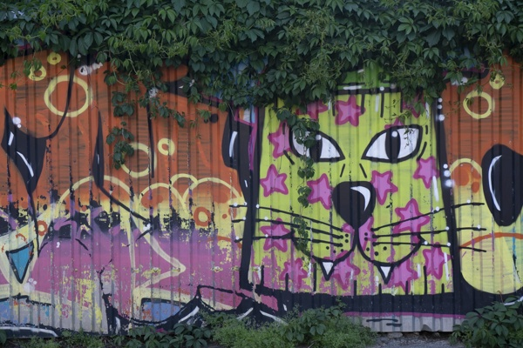3_1.png:** 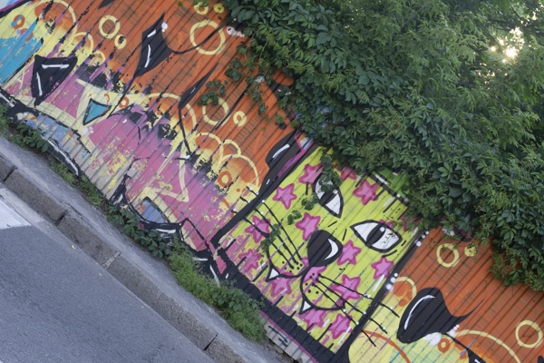

**Table 1 - Found homography parameters and normalization accuracy assessment**

|  |  |  |  |  |  |  |  |  |  |  |  |  |
| --- | --- | --- | --- | --- | --- | --- | --- | --- | --- | --- | --- | --- |
| Original:  img1: 0 img2: 0 | h11 | h12 | h13 | h21 | h22 | h23 | h31 | h32 | h33 | avg ErrIM (pixel) | max ErrIM | Expert rate |
| SIFT | 0,57 | -0,497 | 239,12 | 0,496 | 0,572 | -60,492 | -0 | 0 | 1 | 0,222 | 2,067 |  |
| SURF128 | 0,569 | -0,494 | 238,947 | 0,495 | 0,575 | -60,797 | -0 | 0 | 1 | 0,965 | 3,239 |  |
| SURF64 | 0,566 | -0,494 | 238,825 | 0,493 | 0,572 | -60,335 | -0 | 0 | 1 | 1,018 | 3,191 |  |
| ORB | 0,57 | -0,497 | 238,875 | 0,496 | 0,573 | -60,601 | -0 | 0 | 1 | 0,815 | 3,467 |  |
| ORB1000 | 0,571 | -0,496 | 238,869 | 0,497 | 0,575 | -61,087 | -0 | 0 | 1 | 0,874 | 3,15 |  |
| BRISK | 0,569 | -0,496 | 238,783 | 0,495 | 0,573 | -60,471 | -0 | 0 | 1 | 0,722 | 2,963 |  |
| KAZE | 0,57 | -0,493 | 238,587 | 0,496 | 0,576 | -61,408 | -0 | 0 | 1 | 0,785 | 3,373 |  |
| AKAZE | 0,569 | -0,495 | 238,762 | 0,496 | 0,574 | -60,898 | -0 | 0 | 1 | 0,513 | 2,685 |  |
|  |  |  |  |  |  |  |  |  |  |  |  |  |

where h11, h12, h13, h21, h22, h23, h31, h32, h33 - parameters of found homography matrix H* or of original one H;   
avgErrPar - average error of found parameters, the accuracy of found homography matrix parameters with a preliminary minimax normalization of found and original matrices;  
avgErrIM - average error of inlier coordinate matching;  
inliers - correct matches; outliers - false matches;  
maxErrIM – maximum error of inlier coordinate matching;  
avgErrCPM - average error of corner point matching;  
maxErrCPM - maximum error of corner point matching;  
expert rate - experts assessment of normalization accuracy with a 5-point scale: 0 - normalization failed, 1 - insufficient, 2 - satisfactory, 3 - good, 4 – excellent.

**Table 2 - Quantitative evaluation of descriptors, precision and recall estimation (with found overlap)**

|  |  |  |  |  |  |  |  |  |  |  |  |  |  |  |  |  |
| --- | --- | --- | --- | --- | --- | --- | --- | --- | --- | --- | --- | --- | --- | --- | --- | --- |
| Name | NP1 | NP2 | NM | NI | DP1 | DP2 | OP1 | OP2 | NPO1 | NPO2 | NMO | DPO1 | DPO2 | Precision | RecallO1 | Comments |
| SIFT | 3612 | 3776 | 1741 | 1634 | 0,015 | 0,0157 | 94,1479 | 54,2267 | 3469 | 2692 | 1740 | 0,0154 | 0,0207 | 0,9385 | 0,471 |  |
| SURF128 | 2895 | 2581 | 399 | 340 | 0,0121 | 0,0108 | 94,14 | 54,2429 | 2805 | 1801 | 398 | 0,0124 | 0,0138 | 0,8521 | 0,1212 |  |
| SURF64 | 2895 | 2581 | 535 | 478 | 0,0121 | 0,0108 | 94,1412 | 54,2062 | 2805 | 1797 | 533 | 0,0124 | 0,0138 | 0,8935 | 0,1704 |  |
| ORB | 10642 | 12316 | 2498 | 2344 | 0,0443 | 0,0513 | 94,095 | 54,3079 | 10577 | 10244 | 2498 | 0,0468 | 0,0786 | 0,9384 | 0,2216 |  |
| ORB1000 | 1000 | 1000 | 296 | 258 | 0,0042 | 0,0042 | 94,0958 | 54,3288 | 1000 | 929 | 296 | 0,0044 | 0,0071 | 0,8716 | 0,258 |  |
| BRISK | 3957 | 4437 | 1046 | 1009 | 0,0165 | 0,0185 | 94,1454 | 54,245 | 3908 | 3564 | 1046 | 0,0173 | 0,0274 | 0,9646 | 0,2582 |  |
| KAZE | 1220 | 1123 | 446 | 409 | 0,0051 | 0,0047 | 94,0792 | 54,2746 | 1198 | 892 | 446 | 0,0053 | 0,0068 | 0,917 | 0,3414 |  |
| AKAZE | 1215 | 1082 | 303 | 284 | 0,0051 | 0,0045 | 94,1163 | 54,2808 | 1211 | 931 | 303 | 0,0054 | 0,0071 | 0,9373 | 0,2345 |  |

where NP - number of found key points; NP1, NP2 - number of found key points for image1 and image2 respectively;  
NM - number of matches found with NNDR method, NM=NI+NO;  
NI - number of inliers found with RANSAC method;  
NO - number of outliers discarded with RANSAC method;   
DP - density of key points (per cent), DP= NP/(height x width) , height, width - vertical and horizontal image sizes respectively (pixels)  
DP1, DP2 - density of key points points for image1 and image2 respectively;  
OP1, OP2 - overlap percentage for image1 and image2 respectively;  
NPO1, NPO2 - number of found key points on overlap for image1 and image2 respectivelyy;  
NMO - number of matches on overlap found with NNDR method;  
DPO1, DPO2 - density of key points points on overlap for image1 and image2 respectively;   
OA - overlap area (pixels), OA1, OA2 - overlap area for image1 and image2 respectively;  
DPO1= NPO1/OA1; DPO2= NPO2/OA2;  
Precision = NI/ NM - the rate to evaluate the part of inliers to all found matches with NNDR method;  
RecallO1 = NI/ NPO1 - completeness of inlier retrieval relative to the number of all key points on overlap for image1. The rate illustrates usefulness of the found key points for normalization.

**Table 3 - Estimation of time costs**

|  |  |  |  |  |  |  |  |  |  |  |
| --- | --- | --- | --- | --- | --- | --- | --- | --- | --- | --- |
| Name | NP1 | NP2 | DesT1, sec | DesT2, sec | MatchT, sec | InlierT, sec | AvgDesT, ms | AvgMatchT, ms | AvgInlierT, ms | TotalNormT, sec |
| SIFT | 3612 | 3776 | 0,068381 | 0,061123 | 0,104443 | 0,001009 | 0,017559 | 0,059989 | 0,000617 | 0,234956 |
| SURF128 | 2895 | 2581 | 0,075016 | 0,065409 | 0,056894 | 0,000457 | 0,025627 | 0,14259 | 0,001345 | 0,197775 |
| SURF64 | 2895 | 2581 | 0,074653 | 0,059222 | 0,032074 | 0,000515 | 0,024365 | 0,059951 | 0,001076 | 0,166463 |
| ORB | 10642 | 12316 | 0,023995 | 0,026004 | 0,290634 | 0,001576 | 0,002182 | 0,116346 | 0,000672 | 0,342209 |
| ORB1000 | 1000 | 1000 | 0,010564 | 0,01063 | 0,00339 | 0,000433 | 0,010597 | 0,011453 | 0,001677 | 0,025017 |
| BRISK | 3957 | 4437 | 0,059377 | 0,065501 | 0,043201 | 0,000638 | 0,014883 | 0,041301 | 0,000631 | 0,168716 |
| KAZE | 1220 | 1123 | 0,112144 | 0,094095 | 0,012221 | 0,000436 | 0,087854 | 0,0274 | 0,001064 | 0,218895 |
| AKAZE | 1215 | 1082 | 0,018362 | 0,013541 | 0,004868 | 0,000363 | 0,013813 | 0,016066 | 0,001277 | 0,037134 |

where DesT – descriptor creation time (time for key point detection and descriptor computation), DesT1, DesT2 – creation time of descriptors for image1 and image2 respectively;  
MatchT - retrieval time of matching found with NNDR method for the pair;  
InlierT – inlier retrieval time found with RANSAC method for the pair;  
AvgDesT – average time for one descriptor creation;  
AvgMatchT - average time for one match retrieval with NNDR method;  
AvgInlierT – average time for one inlier retrieval with RANSAC method;  
TotalNormT – total normalization time for the pair.