**Normalization results for pairs 4_0.png_4_1.png from subset png\graffiti_picture_outside**

**4_0.png: 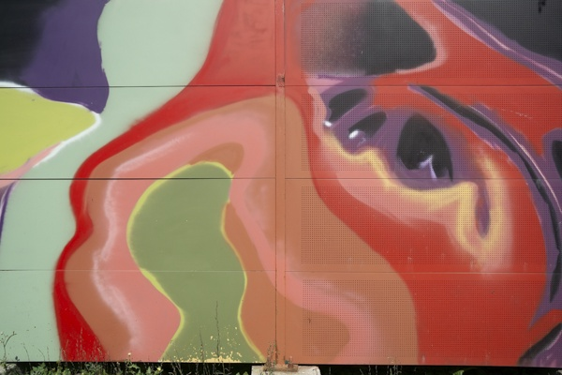4_1.png:** 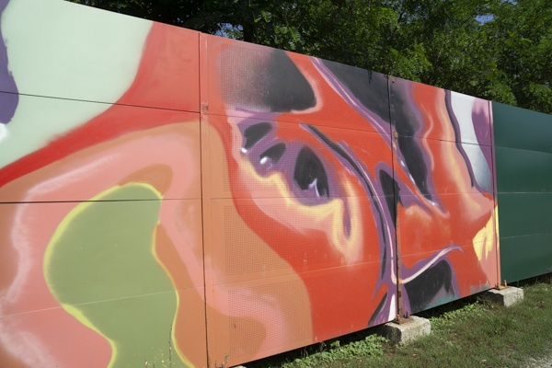

**Table 1 - Found homography parameters and normalization accuracy assessment**

|  |  |  |  |  |  |  |  |  |  |  |  |  |
| --- | --- | --- | --- | --- | --- | --- | --- | --- | --- | --- | --- | --- |
| Original:  img1: 0 img2: 0 | h11 | h12 | h13 | h21 | h22 | h23 | h31 | h32 | h33 | avg ErrIM (pixel) | max ErrIM | Expert rate |
| SIFT | 1,745 | 0,015 | -182,604 | 0,358 | 1,424 | -48,047 | 0,002 | -0 | 1 | 0,691 | 2,832 |  |
| SURF128 | 1,746 | -0 | -180,357 | 0,369 | 1,411 | -50,39 | 0,002 | -0 | 1 | 1,24 | 3,367 |  |
| SURF64 | 1,72 | -0,003 | -176,894 | 0,356 | 1,398 | -47,196 | 0,002 | -0 | 1 | 1,043 | 3,022 |  |
| ORB | 1,794 | 0,013 | -192,504 | 0,379 | 1,436 | -53,144 | 0,002 | -0 | 1 | 0,878 | 2,675 |  |
| ORB1000 | 2,639 | -0,661 | -306,796 | 0,727 | 1,365 | -108,769 | 0,004 | -0,002 | 1 | 0,945 | 3,273 |  |
| BRISK | 1,851 | -0,257 | -187,529 | 0,404 | 1,299 | -49,893 | 0,002 | -0,001 | 1 | 0,666 | 2,171 |  |
| KAZE | 1,68 | -0,066 | -165,504 | 0,358 | 1,308 | -43,009 | 0,002 | -0 | 1 | 0,948 | 2,475 |  |
| AKAZE | 2,214 | -0,13 | -264,541 | 0,519 | 1,594 | -87,944 | 0,003 | -0,001 | 1 | 0,643 | 1,55 |  |
|  |  |  |  |  |  |  |  |  |  |  |  |  |

where h11, h12, h13, h21, h22, h23, h31, h32, h33 - parameters of found homography matrix H* or of original one H;   
avgErrPar - average error of found parameters, the accuracy of found homography matrix parameters with a preliminary minimax normalization of found and original matrices;  
avgErrIM - average error of inlier coordinate matching;  
inliers - correct matches; outliers - false matches;  
maxErrIM – maximum error of inlier coordinate matching;  
avgErrCPM - average error of corner point matching;  
maxErrCPM - maximum error of corner point matching;  
expert rate - experts assessment of normalization accuracy with a 5-point scale: 0 - normalization failed, 1 - insufficient, 2 - satisfactory, 3 - good, 4 – excellent.

**Table 2 - Quantitative evaluation of descriptors, precision and recall estimation (with found overlap)**

|  |  |  |  |  |  |  |  |  |  |  |  |  |  |  |  |  |
| --- | --- | --- | --- | --- | --- | --- | --- | --- | --- | --- | --- | --- | --- | --- | --- | --- |
| Name | NP1 | NP2 | NM | NI | DP1 | DP2 | OP1 | OP2 | NPO1 | NPO2 | NMO | DPO1 | DPO2 | Precision | RecallO1 | Comments |
| SIFT | 245 | 602 | 67 | 46 | 0,001 | 0,0025 | 71,7167 | 62,4542 | 133 | 144 | 61 | 0,0008 | 0,001 | 0,6866 | 0,3459 |  |
| SURF128 | 609 | 1306 | 144 | 106 | 0,0025 | 0,0054 | 71,8458 | 62,4508 | 461 | 566 | 139 | 0,0027 | 0,0038 | 0,7361 | 0,2299 |  |
| SURF64 | 609 | 1306 | 159 | 110 | 0,0025 | 0,0054 | 71,4796 | 62,68 | 462 | 571 | 156 | 0,0027 | 0,0038 | 0,6918 | 0,2381 |  |
| ORB | 581 | 2172 | 110 | 96 | 0,0024 | 0,0091 | 71,4308 | 62,5004 | 511 | 542 | 110 | 0,003 | 0,0036 | 0,8727 | 0,1879 |  |
| ORB1000 | 531 | 970 | 74 | 59 | 0,0022 | 0,004 | 64,0708 | 61,5733 | 413 | 298 | 74 | 0,0027 | 0,002 | 0,7973 | 0,1429 |  |
| BRISK | 134 | 890 | 23 | 17 | 0,0006 | 0,0037 | 66,7867 | 63,2762 | 75 | 260 | 22 | 0,0005 | 0,0017 | 0,7391 | 0,2267 |  |
| KAZE | 145 | 341 | 25 | 22 | 0,0006 | 0,0014 | 71,7467 | 62,5808 | 85 | 122 | 25 | 0,0005 | 0,0008 | 0,88 | 0,2588 |  |
| AKAZE | 70 | 205 | 17 | 15 | 0,0003 | 0,0009 | 67,6504 | 62,7146 | 41 | 62 | 17 | 0,0003 | 0,0004 | 0,8824 | 0,3659 |  |

where NP - number of found key points; NP1, NP2 - number of found key points for image1 and image2 respectively;  
NM - number of matches found with NNDR method, NM=NI+NO;  
NI - number of inliers found with RANSAC method;  
NO - number of outliers discarded with RANSAC method;   
DP - density of key points (per cent), DP= NP/(height x width) , height, width - vertical and horizontal image sizes respectively (pixels)  
DP1, DP2 - density of key points points for image1 and image2 respectively;  
OP1, OP2 - overlap percentage for image1 and image2 respectively;  
NPO1, NPO2 - number of found key points on overlap for image1 and image2 respectivelyy;  
NMO - number of matches on overlap found with NNDR method;  
DPO1, DPO2 - density of key points points on overlap for image1 and image2 respectively;   
OA - overlap area (pixels), OA1, OA2 - overlap area for image1 and image2 respectively;  
DPO1= NPO1/OA1; DPO2= NPO2/OA2;  
Precision = NI/ NM - the rate to evaluate the part of inliers to all found matches with NNDR method;  
RecallO1 = NI/ NPO1 - completeness of inlier retrieval relative to the number of all key points on overlap for image1. The rate illustrates usefulness of the found key points for normalization.

**Table 3 - Estimation of time costs**

|  |  |  |  |  |  |  |  |  |  |  |
| --- | --- | --- | --- | --- | --- | --- | --- | --- | --- | --- |
| Name | NP1 | NP2 | DesT1, sec | DesT2, sec | MatchT, sec | InlierT, sec | AvgDesT, ms | AvgMatchT, ms | AvgInlierT, ms | TotalNormT, sec |
| SIFT | 245 | 602 | 0,038964 | 0,04249 | 0,002003 | 0,000785 | 0,114809 | 0,029894 | 0,017059 | 0,084242 |
| SURF128 | 609 | 1306 | 0,041217 | 0,04619 | 0,00627 | 0,000869 | 0,051523 | 0,043543 | 0,008201 | 0,094547 |
| SURF64 | 609 | 1306 | 0,039412 | 0,045583 | 0,003712 | 0,00077 | 0,049809 | 0,023345 | 0,006997 | 0,089477 |
| ORB | 581 | 2172 | 0,007203 | 0,009768 | 0,003428 | 0,000364 | 0,008447 | 0,031166 | 0,003786 | 0,020763 |
| ORB1000 | 531 | 970 | 0,006975 | 0,00809 | 0,001798 | 0,000463 | 0,010737 | 0,024299 | 0,007839 | 0,017326 |
| BRISK | 134 | 890 | 0,005239 | 0,014796 | 0,000503 | 0,000546 | 0,027862 | 0,021889 | 0,032125 | 0,021085 |
| KAZE | 145 | 341 | 0,100206 | 0,089258 | 0,000615 | 0,000386 | 0,476414 | 0,024616 | 0,017563 | 0,190466 |
| AKAZE | 70 | 205 | 0,010793 | 0,017391 | 0,000198 | 0,000393 | 0,119508 | 0,011665 | 0,026191 | 0,028775 |

where DesT – descriptor creation time (time for key point detection and descriptor computation), DesT1, DesT2 – creation time of descriptors for image1 and image2 respectively;  
MatchT - retrieval time of matching found with NNDR method for the pair;  
InlierT – inlier retrieval time found with RANSAC method for the pair;  
AvgDesT – average time for one descriptor creation;  
AvgMatchT - average time for one match retrieval with NNDR method;  
AvgInlierT – average time for one inlier retrieval with RANSAC method;  
TotalNormT – total normalization time for the pair.