**Normalization results for pairs 5_0.png_5_1.png from subset png\graffiti_picture_outside**

**5_0.png: 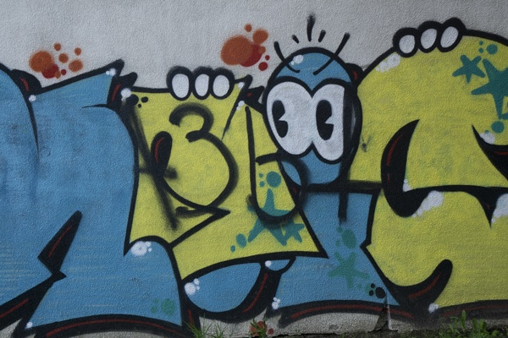5_1.png:** 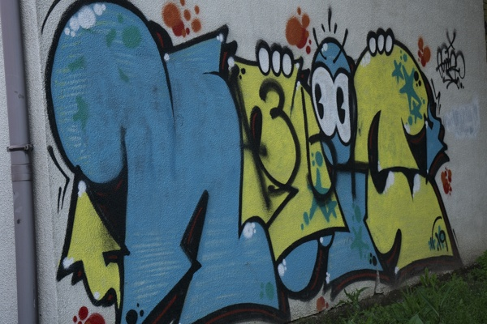

**Table 1 - Found homography parameters and normalization accuracy assessment**

|  |  |  |  |  |  |  |  |  |  |  |  |  |
| --- | --- | --- | --- | --- | --- | --- | --- | --- | --- | --- | --- | --- |
| Original:  img1: 0 img2: 0 | h11 | h12 | h13 | h21 | h22 | h23 | h31 | h32 | h33 | avg ErrIM (pixel) | max ErrIM | Expert rate |
| SIFT | 0,982 | 0,052 | 166,782 | 0,187 | 1,249 | -79,522 | 0,001 | -0 | 1 | 1,068 | 2,426 |  |
| SURF128 | 0,949 | 0,074 | 166,909 | 0,172 | 1,264 | -79,872 | 0,001 | 0 | 1 | 1,377 | 3,579 |  |
| SURF64 | 0,973 | 0,071 | 166,102 | 0,187 | 1,269 | -81,115 | 0,001 | 0 | 1 | 1,273 | 2,768 |  |
| ORB | 1,002 | 0,046 | 167,784 | 0,208 | 1,25 | -80,957 | 0,001 | -0 | 1 | 1,245 | 2,542 |  |
| ORB1000 | 0,985 | 0,078 | 166,152 | 0,192 | 1,278 | -82,282 | 0,001 | 0 | 1 | 1,135 | 3,125 |  |
| BRISK | 0,99 | 0,046 | 167,554 | 0,197 | 1,247 | -79,825 | 0,001 | -0 | 1 | 0,957 | 2,072 |  |
| KAZE | 0,989 | 0,063 | 166,544 | 0,194 | 1,272 | -82,229 | 0,001 | -0 | 1 | 1,086 | 1,765 |  |
| AKAZE | 1,076 | 0,091 | 157,442 | 0,244 | 1,353 | -103,975 | 0,001 | 0 | 1 | 1,232 | 2,327 |  |
|  |  |  |  |  |  |  |  |  |  |  |  |  |

where h11, h12, h13, h21, h22, h23, h31, h32, h33 - parameters of found homography matrix H* or of original one H;   
avgErrPar - average error of found parameters, the accuracy of found homography matrix parameters with a preliminary minimax normalization of found and original matrices;  
avgErrIM - average error of inlier coordinate matching;  
inliers - correct matches; outliers - false matches;  
maxErrIM – maximum error of inlier coordinate matching;  
avgErrCPM - average error of corner point matching;  
maxErrCPM - maximum error of corner point matching;  
expert rate - experts assessment of normalization accuracy with a 5-point scale: 0 - normalization failed, 1 - insufficient, 2 - satisfactory, 3 - good, 4 – excellent.

**Table 2 - Quantitative evaluation of descriptors, precision and recall estimation (with found overlap)**

|  |  |  |  |  |  |  |  |  |  |  |  |  |  |  |  |  |
| --- | --- | --- | --- | --- | --- | --- | --- | --- | --- | --- | --- | --- | --- | --- | --- | --- |
| Name | NP1 | NP2 | NM | NI | DP1 | DP2 | OP1 | OP2 | NPO1 | NPO2 | NMO | DPO1 | DPO2 | Precision | RecallO1 | Comments |
| SIFT | 1149 | 1185 | 105 | 55 | 0,0048 | 0,0049 | 93,5471 | 54 | 1135 | 752 | 103 | 0,0051 | 0,0058 | 0,5238 | 0,0485 |  |
| SURF128 | 1760 | 2164 | 92 | 35 | 0,0073 | 0,009 | 93,2137 | 54,1129 | 1752 | 1199 | 90 | 0,0078 | 0,0092 | 0,3804 | 0,02 |  |
| SURF64 | 1760 | 2164 | 92 | 39 | 0,0073 | 0,009 | 93,5438 | 54,1013 | 1750 | 1197 | 90 | 0,0078 | 0,0092 | 0,4239 | 0,0223 |  |
| ORB | 3098 | 3224 | 76 | 34 | 0,0129 | 0,0134 | 94,1008 | 53,6292 | 3096 | 2167 | 76 | 0,0137 | 0,0168 | 0,4474 | 0,011 |  |
| ORB1000 | 1000 | 1000 | 38 | 18 | 0,0042 | 0,0042 | 93,6979 | 53,5362 | 1000 | 840 | 38 | 0,0044 | 0,0065 | 0,4737 | 0,018 |  |
| BRISK | 1054 | 1255 | 49 | 33 | 0,0044 | 0,0052 | 93,8088 | 53,7525 | 1054 | 852 | 49 | 0,0047 | 0,0066 | 0,6735 | 0,0313 |  |
| KAZE | 899 | 889 | 39 | 24 | 0,0037 | 0,0037 | 93,5154 | 53,105 | 896 | 616 | 39 | 0,004 | 0,0048 | 0,6154 | 0,0268 |  |
| AKAZE | 680 | 628 | 19 | 10 | 0,0028 | 0,0026 | 92,2358 | 53,4012 | 676 | 463 | 19 | 0,0031 | 0,0036 | 0,5263 | 0,0148 |  |

where NP - number of found key points; NP1, NP2 - number of found key points for image1 and image2 respectively;  
NM - number of matches found with NNDR method, NM=NI+NO;  
NI - number of inliers found with RANSAC method;  
NO - number of outliers discarded with RANSAC method;   
DP - density of key points (per cent), DP= NP/(height x width) , height, width - vertical and horizontal image sizes respectively (pixels)  
DP1, DP2 - density of key points points for image1 and image2 respectively;  
OP1, OP2 - overlap percentage for image1 and image2 respectively;  
NPO1, NPO2 - number of found key points on overlap for image1 and image2 respectivelyy;  
NMO - number of matches on overlap found with NNDR method;  
DPO1, DPO2 - density of key points points on overlap for image1 and image2 respectively;   
OA - overlap area (pixels), OA1, OA2 - overlap area for image1 and image2 respectively;  
DPO1= NPO1/OA1; DPO2= NPO2/OA2;  
Precision = NI/ NM - the rate to evaluate the part of inliers to all found matches with NNDR method;  
RecallO1 = NI/ NPO1 - completeness of inlier retrieval relative to the number of all key points on overlap for image1. The rate illustrates usefulness of the found key points for normalization.

**Table 3 - Estimation of time costs**

|  |  |  |  |  |  |  |  |  |  |  |
| --- | --- | --- | --- | --- | --- | --- | --- | --- | --- | --- |
| Name | NP1 | NP2 | DesT1, sec | DesT2, sec | MatchT, sec | InlierT, sec | AvgDesT, ms | AvgMatchT, ms | AvgInlierT, ms | TotalNormT, sec |
| SIFT | 1149 | 1185 | 0,048417 | 0,047995 | 0,011444 | 0,00184 | 0,041319 | 0,108992 | 0,033456 | 0,109696 |
| SURF128 | 1760 | 2164 | 0,057895 | 0,069571 | 0,030979 | 0,006314 | 0,032521 | 0,336729 | 0,180389 | 0,164758 |
| SURF64 | 1760 | 2164 | 0,055003 | 0,067004 | 0,017008 | 0,004074 | 0,031107 | 0,184869 | 0,104456 | 0,143089 |
| ORB | 3098 | 3224 | 0,011964 | 0,011843 | 0,027204 | 0,003365 | 0,003767 | 0,357941 | 0,098966 | 0,054375 |
| ORB1000 | 1000 | 1000 | 0,00891 | 0,008858 | 0,003123 | 0,002681 | 0,008883 | 0,08218 | 0,148935 | 0,023571 |
| BRISK | 1054 | 1255 | 0,018343 | 0,021607 | 0,004037 | 0,000757 | 0,017309 | 0,082379 | 0,022952 | 0,044744 |
| KAZE | 899 | 889 | 0,113549 | 0,110158 | 0,006629 | 0,001 | 0,125108 | 0,169984 | 0,041685 | 0,231336 |
| AKAZE | 680 | 628 | 0,01731 | 0,015952 | 0,001815 | 0,001789 | 0,025427 | 0,095519 | 0,178858 | 0,036865 |

where DesT – descriptor creation time (time for key point detection and descriptor computation), DesT1, DesT2 – creation time of descriptors for image1 and image2 respectively;  
MatchT - retrieval time of matching found with NNDR method for the pair;  
InlierT – inlier retrieval time found with RANSAC method for the pair;  
AvgDesT – average time for one descriptor creation;  
AvgMatchT - average time for one match retrieval with NNDR method;  
AvgInlierT – average time for one inlier retrieval with RANSAC method;  
TotalNormT – total normalization time for the pair.