**Normalization results for pairs 8_0.png_8_1.png from subset png\graffiti_picture_outside**

**8_0.png: 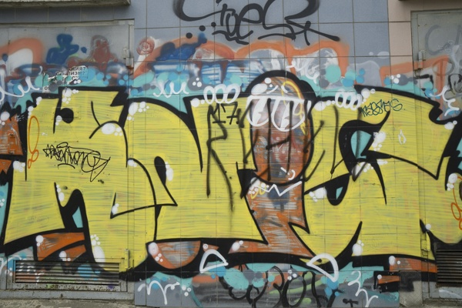8_1.png:** 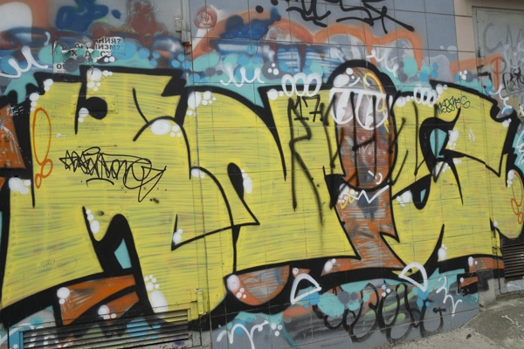

**Table 1 - Found homography parameters and normalization accuracy assessment**

|  |  |  |  |  |  |  |  |  |  |  |  |  |
| --- | --- | --- | --- | --- | --- | --- | --- | --- | --- | --- | --- | --- |
| Original:  img1: 0 img2: 0 | h11 | h12 | h13 | h21 | h22 | h23 | h31 | h32 | h33 | avg ErrIM (pixel) | max ErrIM | Expert rate |
| SIFT | 1,689 | 0,098 | -39,529 | 0,162 | 1,426 | -92,023 | 0,001 | 0 | 1 | 0,679 | 3,069 |  |
| SURF128 | 1,688 | 0,086 | -38,164 | 0,163 | 1,414 | -90,663 | 0,001 | 0 | 1 | 1,019 | 5,3 |  |
| SURF64 | 1,695 | 0,091 | -39,725 | 0,162 | 1,425 | -91,683 | 0,001 | 0 | 1 | 1,012 | 3,944 |  |
| ORB | 1,71 | 0,103 | -42,209 | 0,167 | 1,437 | -93,276 | 0,001 | 0 | 1 | 1,04 | 3,431 |  |
| ORB1000 | 1,733 | 0,117 | -46,527 | 0,17 | 1,46 | -96,028 | 0,001 | 0 | 1 | 1,067 | 3,588 |  |
| BRISK | 1,703 | 0,104 | -41,627 | 0,166 | 1,436 | -93,248 | 0,001 | 0 | 1 | 0,884 | 3,699 |  |
| KAZE | 1,696 | 0,098 | -40,097 | 0,164 | 1,428 | -92,127 | 0,001 | 0 | 1 | 0,891 | 3,203 |  |
| AKAZE | 1,699 | 0,098 | -40,267 | 0,165 | 1,429 | -92,459 | 0,001 | 0 | 1 | 0,769 | 3,2 |  |
|  |  |  |  |  |  |  |  |  |  |  |  |  |

where h11, h12, h13, h21, h22, h23, h31, h32, h33 - parameters of found homography matrix H* or of original one H;   
avgErrPar - average error of found parameters, the accuracy of found homography matrix parameters with a preliminary minimax normalization of found and original matrices;  
avgErrIM - average error of inlier coordinate matching;  
inliers - correct matches; outliers - false matches;  
maxErrIM – maximum error of inlier coordinate matching;  
avgErrCPM - average error of corner point matching;  
maxErrCPM - maximum error of corner point matching;  
expert rate - experts assessment of normalization accuracy with a 5-point scale: 0 - normalization failed, 1 - insufficient, 2 - satisfactory, 3 - good, 4 – excellent.

**Table 2 - Quantitative evaluation of descriptors, precision and recall estimation (with found overlap)**

|  |  |  |  |  |  |  |  |  |  |  |  |  |  |  |  |  |
| --- | --- | --- | --- | --- | --- | --- | --- | --- | --- | --- | --- | --- | --- | --- | --- | --- |
| Name | NP1 | NP2 | NM | NI | DP1 | DP2 | OP1 | OP2 | NPO1 | NPO2 | NMO | DPO1 | DPO2 | Precision | RecallO1 | Comments |
| SIFT | 2289 | 2202 | 1193 | 1077 | 0,0095 | 0,0092 | 88,3975 | 95,5108 | 2105 | 2140 | 1190 | 0,0099 | 0,0093 | 0,9028 | 0,5116 |  |
| SURF128 | 2726 | 2783 | 885 | 660 | 0,0114 | 0,0116 | 88,4246 | 95,4783 | 2613 | 2743 | 885 | 0,0123 | 0,012 | 0,7458 | 0,2526 |  |
| SURF64 | 2726 | 2783 | 1021 | 731 | 0,0114 | 0,0116 | 88,2046 | 95,5346 | 2609 | 2743 | 1021 | 0,0123 | 0,012 | 0,716 | 0,2802 |  |
| ORB | 6924 | 6794 | 2289 | 2090 | 0,0289 | 0,0283 | 88,3812 | 95,2383 | 6904 | 6777 | 2289 | 0,0325 | 0,0296 | 0,9131 | 0,3027 |  |
| ORB1000 | 1000 | 1000 | 463 | 400 | 0,0042 | 0,0042 | 88,1654 | 95,0675 | 999 | 1000 | 463 | 0,0047 | 0,0044 | 0,8639 | 0,4004 |  |
| BRISK | 2662 | 2613 | 918 | 817 | 0,0111 | 0,0109 | 88,3779 | 95,34 | 2618 | 2598 | 918 | 0,0123 | 0,0114 | 0,89 | 0,3121 |  |
| KAZE | 1289 | 1267 | 674 | 614 | 0,0054 | 0,0053 | 88,4138 | 95,3883 | 1249 | 1253 | 674 | 0,0059 | 0,0055 | 0,911 | 0,4916 |  |
| AKAZE | 1038 | 1034 | 439 | 424 | 0,0043 | 0,0043 | 88,4204 | 95,3342 | 1035 | 1033 | 439 | 0,0049 | 0,0045 | 0,9658 | 0,4097 |  |

where NP - number of found key points; NP1, NP2 - number of found key points for image1 and image2 respectively;  
NM - number of matches found with NNDR method, NM=NI+NO;  
NI - number of inliers found with RANSAC method;  
NO - number of outliers discarded with RANSAC method;   
DP - density of key points (per cent), DP= NP/(height x width) , height, width - vertical and horizontal image sizes respectively (pixels)  
DP1, DP2 - density of key points points for image1 and image2 respectively;  
OP1, OP2 - overlap percentage for image1 and image2 respectively;  
NPO1, NPO2 - number of found key points on overlap for image1 and image2 respectivelyy;  
NMO - number of matches on overlap found with NNDR method;  
DPO1, DPO2 - density of key points points on overlap for image1 and image2 respectively;   
OA - overlap area (pixels), OA1, OA2 - overlap area for image1 and image2 respectively;  
DPO1= NPO1/OA1; DPO2= NPO2/OA2;  
Precision = NI/ NM - the rate to evaluate the part of inliers to all found matches with NNDR method;  
RecallO1 = NI/ NPO1 - completeness of inlier retrieval relative to the number of all key points on overlap for image1. The rate illustrates usefulness of the found key points for normalization.

**Table 3 - Estimation of time costs**

|  |  |  |  |  |  |  |  |  |  |  |
| --- | --- | --- | --- | --- | --- | --- | --- | --- | --- | --- |
| Name | NP1 | NP2 | DesT1, sec | DesT2, sec | MatchT, sec | InlierT, sec | AvgDesT, ms | AvgMatchT, ms | AvgInlierT, ms | TotalNormT, sec |
| SIFT | 2289 | 2202 | 0,054478 | 0,053289 | 0,038773 | 0,000874 | 0,023999 | 0,0325 | 0,000811 | 0,147414 |
| SURF128 | 2726 | 2783 | 0,070357 | 0,07042 | 0,058298 | 0,000848 | 0,025556 | 0,065873 | 0,001285 | 0,199924 |
| SURF64 | 2726 | 2783 | 0,065191 | 0,070742 | 0,032668 | 0,000994 | 0,024666 | 0,031996 | 0,001359 | 0,169594 |
| ORB | 6924 | 6794 | 0,018035 | 0,0178 | 0,105981 | 0,001673 | 0,002611 | 0,046299 | 0,0008 | 0,143488 |
| ORB1000 | 1000 | 1000 | 0,010155 | 0,009921 | 0,003236 | 0,000571 | 0,010037 | 0,006988 | 0,001428 | 0,023883 |
| BRISK | 2662 | 2613 | 0,042624 | 0,041475 | 0,018293 | 0,000892 | 0,015941 | 0,019926 | 0,001091 | 0,103283 |
| KAZE | 1289 | 1267 | 0,112486 | 0,095586 | 0,013167 | 0,000572 | 0,081353 | 0,019535 | 0,000931 | 0,22181 |
| AKAZE | 1038 | 1034 | 0,013503 | 0,013217 | 0,004158 | 0,00045 | 0,012895 | 0,009471 | 0,001061 | 0,031328 |

where DesT – descriptor creation time (time for key point detection and descriptor computation), DesT1, DesT2 – creation time of descriptors for image1 and image2 respectively;  
MatchT - retrieval time of matching found with NNDR method for the pair;  
InlierT – inlier retrieval time found with RANSAC method for the pair;  
AvgDesT – average time for one descriptor creation;  
AvgMatchT - average time for one match retrieval with NNDR method;  
AvgInlierT – average time for one inlier retrieval with RANSAC method;  
TotalNormT – total normalization time for the pair.