**Normalization results for pairs 9_0.png_9_1.png from subset png\graffiti_picture_outside**

**9_0.png: 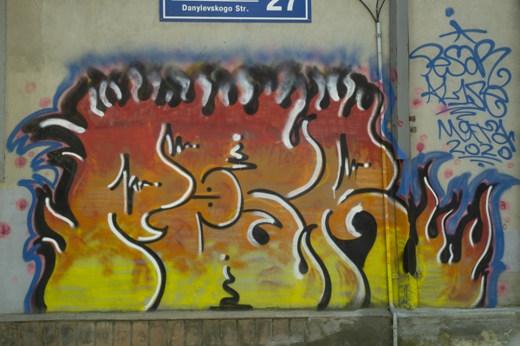9_1.png:** 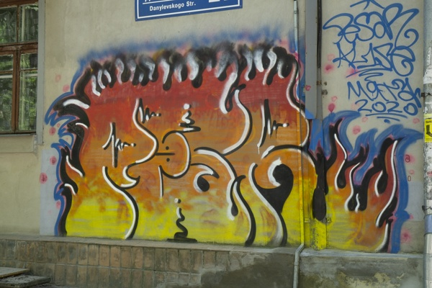

**Table 1 - Found homography parameters and normalization accuracy assessment**

|  |  |  |  |  |  |  |  |  |  |  |  |  |
| --- | --- | --- | --- | --- | --- | --- | --- | --- | --- | --- | --- | --- |
| Original:  img1: 0 img2: 0 | h11 | h12 | h13 | h21 | h22 | h23 | h31 | h32 | h33 | avg ErrIM (pixel) | max ErrIM | Expert rate |
| SIFT | 0,625 | 0,003 | 56,98 | -0,108 | 0,843 | 25,818 | -0 | 0 | 1 | 0,334 | 2,948 |  |
| SURF128 | 0,627 | 0,008 | 55,683 | -0,108 | 0,846 | 25,807 | -0 | 0 | 1 | 0,821 | 3,168 |  |
| SURF64 | 0,628 | 0,007 | 55,872 | -0,107 | 0,848 | 25,005 | -0 | 0 | 1 | 0,839 | 3,686 |  |
| ORB | 0,626 | 0,004 | 56,718 | -0,108 | 0,844 | 25,654 | -0 | 0 | 1 | 0,903 | 3,531 |  |
| ORB1000 | 0,627 | 0,007 | 56,22 | -0,108 | 0,846 | 25,429 | -0 | 0 | 1 | 0,856 | 3,123 |  |
| BRISK | 0,625 | 0,004 | 56,736 | -0,108 | 0,844 | 25,7 | -0 | 0 | 1 | 0,786 | 3,28 |  |
| KAZE | 0,626 | 0,004 | 56,601 | -0,107 | 0,843 | 25,695 | -0 | 0 | 1 | 0,628 | 3,143 |  |
| AKAZE | 0,627 | 0,004 | 56,373 | -0,107 | 0,844 | 25,573 | -0 | 0 | 1 | 0,498 | 2,596 |  |
|  |  |  |  |  |  |  |  |  |  |  |  |  |

where h11, h12, h13, h21, h22, h23, h31, h32, h33 - parameters of found homography matrix H* or of original one H;   
avgErrPar - average error of found parameters, the accuracy of found homography matrix parameters with a preliminary minimax normalization of found and original matrices;  
avgErrIM - average error of inlier coordinate matching;  
inliers - correct matches; outliers - false matches;  
maxErrIM – maximum error of inlier coordinate matching;  
avgErrCPM - average error of corner point matching;  
maxErrCPM - maximum error of corner point matching;  
expert rate - experts assessment of normalization accuracy with a 5-point scale: 0 - normalization failed, 1 - insufficient, 2 - satisfactory, 3 - good, 4 – excellent.

**Table 2 - Quantitative evaluation of descriptors, precision and recall estimation (with found overlap)**

|  |  |  |  |  |  |  |  |  |  |  |  |  |  |  |  |  |
| --- | --- | --- | --- | --- | --- | --- | --- | --- | --- | --- | --- | --- | --- | --- | --- | --- |
| Name | NP1 | NP2 | NM | NI | DP1 | DP2 | OP1 | OP2 | NPO1 | NPO2 | NMO | DPO1 | DPO2 | Precision | RecallO1 | Comments |
| SIFT | 1375 | 1576 | 812 | 745 | 0,0057 | 0,0066 | 96,6038 | 83,9275 | 1346 | 1401 | 812 | 0,0058 | 0,007 | 0,9175 | 0,5535 |  |
| SURF128 | 2385 | 2453 | 970 | 780 | 0,0099 | 0,0102 | 96,5704 | 83,8904 | 2362 | 2305 | 970 | 0,0102 | 0,0114 | 0,8041 | 0,3302 |  |
| SURF64 | 2385 | 2453 | 1045 | 860 | 0,0099 | 0,0102 | 96,5329 | 84,0154 | 2362 | 2306 | 1044 | 0,0102 | 0,0114 | 0,823 | 0,3641 |  |
| ORB | 4580 | 5016 | 1664 | 1538 | 0,0191 | 0,0209 | 96,5888 | 83,9479 | 4577 | 4902 | 1664 | 0,0197 | 0,0243 | 0,9243 | 0,336 |  |
| ORB1000 | 1000 | 1000 | 415 | 370 | 0,0042 | 0,0042 | 96,5629 | 83,8688 | 1000 | 999 | 415 | 0,0043 | 0,005 | 0,8916 | 0,37 |  |
| BRISK | 1623 | 1730 | 610 | 582 | 0,0068 | 0,0072 | 96,5842 | 83,9729 | 1616 | 1677 | 610 | 0,007 | 0,0083 | 0,9541 | 0,3601 |  |
| KAZE | 866 | 856 | 501 | 470 | 0,0036 | 0,0036 | 96,5971 | 83,9717 | 855 | 830 | 501 | 0,0037 | 0,0041 | 0,9381 | 0,5497 |  |
| AKAZE | 735 | 760 | 365 | 351 | 0,0031 | 0,0032 | 96,6046 | 83,9933 | 733 | 750 | 365 | 0,0032 | 0,0037 | 0,9616 | 0,4789 |  |

where NP - number of found key points; NP1, NP2 - number of found key points for image1 and image2 respectively;  
NM - number of matches found with NNDR method, NM=NI+NO;  
NI - number of inliers found with RANSAC method;  
NO - number of outliers discarded with RANSAC method;   
DP - density of key points (per cent), DP= NP/(height x width) , height, width - vertical and horizontal image sizes respectively (pixels)  
DP1, DP2 - density of key points points for image1 and image2 respectively;  
OP1, OP2 - overlap percentage for image1 and image2 respectively;  
NPO1, NPO2 - number of found key points on overlap for image1 and image2 respectivelyy;  
NMO - number of matches on overlap found with NNDR method;  
DPO1, DPO2 - density of key points points on overlap for image1 and image2 respectively;   
OA - overlap area (pixels), OA1, OA2 - overlap area for image1 and image2 respectively;  
DPO1= NPO1/OA1; DPO2= NPO2/OA2;  
Precision = NI/ NM - the rate to evaluate the part of inliers to all found matches with NNDR method;  
RecallO1 = NI/ NPO1 - completeness of inlier retrieval relative to the number of all key points on overlap for image1. The rate illustrates usefulness of the found key points for normalization.

**Table 3 - Estimation of time costs**

|  |  |  |  |  |  |  |  |  |  |  |
| --- | --- | --- | --- | --- | --- | --- | --- | --- | --- | --- |
| Name | NP1 | NP2 | DesT1, sec | DesT2, sec | MatchT, sec | InlierT, sec | AvgDesT, ms | AvgMatchT, ms | AvgInlierT, ms | TotalNormT, sec |
| SIFT | 1375 | 1576 | 0,051691 | 0,050017 | 0,018468 | 0,00064 | 0,034664 | 0,022743 | 0,000859 | 0,120815 |
| SURF128 | 2385 | 2453 | 0,070765 | 0,065294 | 0,044982 | 0,000772 | 0,028143 | 0,046372 | 0,00099 | 0,181813 |
| SURF64 | 2385 | 2453 | 0,063761 | 0,069958 | 0,025143 | 0,000785 | 0,027626 | 0,02406 | 0,000913 | 0,159648 |
| ORB | 4580 | 5016 | 0,014207 | 0,014766 | 0,055579 | 0,001114 | 0,003022 | 0,0334 | 0,000724 | 0,085667 |
| ORB1000 | 1000 | 1000 | 0,009135 | 0,009216 | 0,003171 | 0,000434 | 0,009175 | 0,00764 | 0,001172 | 0,021956 |
| BRISK | 1623 | 1730 | 0,029859 | 0,028473 | 0,007943 | 0,00053 | 0,017427 | 0,013021 | 0,000911 | 0,066805 |
| KAZE | 866 | 856 | 0,108249 | 0,090244 | 0,008021 | 0,000454 | 0,115212 | 0,016009 | 0,000965 | 0,206969 |
| AKAZE | 735 | 760 | 0,013038 | 0,012539 | 0,002178 | 0,000442 | 0,017118 | 0,005968 | 0,00126 | 0,028198 |

where DesT – descriptor creation time (time for key point detection and descriptor computation), DesT1, DesT2 – creation time of descriptors for image1 and image2 respectively;  
MatchT - retrieval time of matching found with NNDR method for the pair;  
InlierT – inlier retrieval time found with RANSAC method for the pair;  
AvgDesT – average time for one descriptor creation;  
AvgMatchT - average time for one match retrieval with NNDR method;  
AvgInlierT – average time for one inlier retrieval with RANSAC method;  
TotalNormT – total normalization time for the pair.