**Normalization results for pairs 10_0.png_10_1.png from subset png\picture_inside**

**10_0.png: 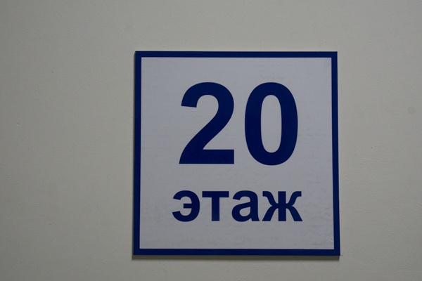10_1.png:** 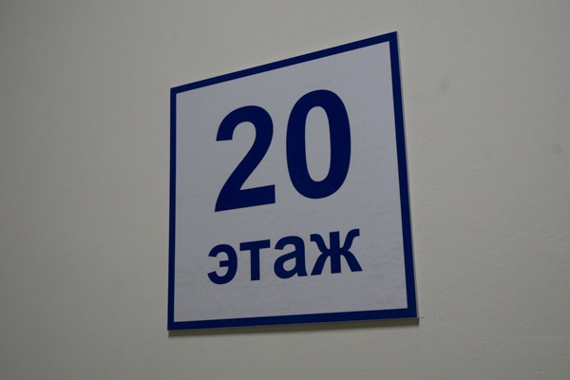

**Table 1 - Found homography parameters and normalization accuracy assessment**

|  |  |  |  |  |  |  |  |  |  |  |  |  |  |  |  |
| --- | --- | --- | --- | --- | --- | --- | --- | --- | --- | --- | --- | --- | --- | --- | --- |
| Original:  img1: 0 img2: 0 | h11 | h12 | h13 | h21 | h22 | h23 | h31 | h32 | h33 | avg ErrPar (param) | avg ErrIM (pixel) | max ErrIM | avg ErrCPM (corner) | max ErrCPM | Expert rate |
| SIFT | 0,524 | -0,027 | 60,956 | -0,218 | 0,728 | 71,789 | -0,001 | -0 | 1 | 0 | 0,729 | 2,444 | ~ | ~ |  |
| SURF128 | 0,551 | 0,007 | 50,082 | -0,217 | 0,756 | 70,155 | -0,001 | -0 | 1 | 0 | 0,992 | 3,017 | ~ | ~ |  |
| SURF64 | 0,649 | -0,03 | 38,679 | -0,163 | 0,776 | 56,423 | -0 | -0 | 1 | 0 | 1,271 | 3,896 | ~ | ~ |  |
| ORB | 0,537 | -0,036 | 59,79 | -0,211 | 0,732 | 69,082 | -0 | -0 | 1 | 0 | 1,01 | 3,317 | ~ | ~ |  |
| ORB1000 | 0,537 | -0,036 | 59,79 | -0,211 | 0,732 | 69,082 | -0 | -0 | 1 | 0 | 1,01 | 3,317 | ~ | ~ |  |
| BRISK | 0,527 | -0,048 | 61,551 | -0,201 | 0,695 | 71,62 | -0 | -0 | 1 | 0 | 0,908 | 3,134 | ~ | ~ |  |
| KAZE | 0,563 | -0,093 | 63,135 | -0,171 | 0,663 | 70,896 | -0 | -0 | 1 | 0 | 0,664 | 2,263 | ~ | ~ |  |
| AKAZE | 0,54 | -0,009 | 55,18 | -0,212 | 0,75 | 67,848 | -0,001 | -0 | 1 | 0 | 0,69 | 2,019 | ~ | ~ |  |
| Original matrix |  |  |  |  |  |  |  |  |  |  |  |  |  |  |  |

where h11, h12, h13, h21, h22, h23, h31, h32, h33 - parameters of found homography matrix H* or of original one H;   
avgErrPar - average error of found parameters, the accuracy of found homography matrix parameters with a preliminary minimax normalization of found and original matrices;  
avgErrIM - average error of inlier coordinate matching;  
inliers - correct matches; outliers - false matches;  
maxErrIM – maximum error of inlier coordinate matching;  
avgErrCPM - average error of corner point matching;  
maxErrCPM - maximum error of corner point matching;  
expert rate - experts assessment of normalization accuracy with a 5-point scale: 0 - normalization failed, 1 - insufficient, 2 - satisfactory, 3 - good, 4 – excellent.

**Table 2 - Quantitative evaluation of descriptors, precision and recall estimation (with found overlap)**

|  |  |  |  |  |  |  |  |  |  |  |  |  |  |  |  |  |
| --- | --- | --- | --- | --- | --- | --- | --- | --- | --- | --- | --- | --- | --- | --- | --- | --- |
| Name | NP1 | NP2 | NM | NI | DP1 | DP2 | OP1 | OP2 | NPO1 | NPO2 | NMO | DPO1 | DPO2 | Precision | RecallO1 | Comments |
| SIFT | 144 | 119 | 90 | 67 | 0,0006 | 0,0005 | 95,4871 | 77,6196 | 144 | 119 | 90 | 0,0006 | 0,0006 | 0,7444 | 0,4653 |  |
| SURF128 | 543 | 747 | 166 | 72 | 0,0023 | 0,0031 | 95,5246 | 77,4971 | 543 | 747 | 166 | 0,0024 | 0,004 | 0,4337 | 0,1326 |  |
| SURF64 | 543 | 747 | 178 | 87 | 0,0023 | 0,0031 | 97,2263 | 78,1429 | 543 | 747 | 178 | 0,0023 | 0,004 | 0,4888 | 0,1602 |  |
| ORB | 750 | 782 | 244 | 187 | 0,0031 | 0,0033 | 95,595 | 77,9458 | 750 | 782 | 244 | 0,0033 | 0,0042 | 0,7664 | 0,2493 |  |
| ORB1000 | 750 | 780 | 244 | 187 | 0,0031 | 0,0032 | 95,595 | 77,9458 | 750 | 780 | 244 | 0,0033 | 0,0042 | 0,7664 | 0,2493 |  |
| BRISK | 284 | 282 | 117 | 87 | 0,0012 | 0,0012 | 96,4996 | 77,1346 | 284 | 282 | 117 | 0,0012 | 0,0015 | 0,7436 | 0,3063 |  |
| KAZE | 195 | 226 | 78 | 54 | 0,0008 | 0,0009 | 98,2142 | 75,8933 | 195 | 226 | 78 | 0,0008 | 0,0012 | 0,6923 | 0,2769 |  |
| AKAZE | 184 | 167 | 71 | 55 | 0,0008 | 0,0007 | 95,4233 | 77,49 | 184 | 167 | 71 | 0,0008 | 0,0009 | 0,7746 | 0,2989 |  |

where NP - number of found key points; NP1, NP2 - number of found key points for image1 and image2 respectively;  
NM - number of matches found with NNDR method, NM=NI+NO;  
NI - number of inliers found with RANSAC method;  
NO - number of outliers discarded with RANSAC method;   
DP - density of key points (per cent), DP= NP/(height x width) , height, width - vertical and horizontal image sizes respectively (pixels)  
DP1, DP2 - density of key points points for image1 and image2 respectively;  
OP1, OP2 - overlap percentage for image1 and image2 respectively;  
NPO1, NPO2 - number of found key points on overlap for image1 and image2 respectivelyy;  
NMO - number of matches on overlap found with NNDR method;  
DPO1, DPO2 - density of key points points on overlap for image1 and image2 respectively;   
OA - overlap area (pixels), OA1, OA2 - overlap area for image1 and image2 respectively;  
DPO1= NPO1/OA1; DPO2= NPO2/OA2;  
Precision = NI/ NM - the rate to evaluate the part of inliers to all found matches with NNDR method;  
RecallO1 = NI/ NPO1 - completeness of inlier retrieval relative to the number of all key points on overlap for image1. The rate illustrates usefulness of the found key points for normalization.

**Table 3 - Estimation of time costs**

|  |  |  |  |  |  |  |  |  |  |  |
| --- | --- | --- | --- | --- | --- | --- | --- | --- | --- | --- |
| Name | NP1 | NP2 | DesT1, sec | DesT2, sec | MatchT, sec | InlierT, sec | AvgDesT, ms | AvgMatchT, ms | AvgInlierT, ms | TotalNormT, sec |
| SIFT | 144 | 119 | 0,057179 | 0,114862 | 0,003429 | 0,00455 | 0,681151 | 0,0381 | 0,06791 | 0,18002 |
| SURF128 | 543 | 747 | 0,2085 | 0,05631 | 0,048793 | 0,003895 | 0,229679 | 0,293935 | 0,054101 | 0,317499 |
| SURF64 | 543 | 747 | 0,069741 | 0,060268 | 0,002512 | 0,003462 | 0,104557 | 0,014111 | 0,039794 | 0,135983 |
| ORB | 750 | 782 | 0,007539 | 0,007391 | 0,002681 | 0,000571 | 0,009751 | 0,010987 | 0,003051 | 0,018181 |
| ORB1000 | 750 | 780 | 0,00832 | 0,007295 | 0,003464 | 0,000617 | 0,010222 | 0,014196 | 0,003298 | 0,019695 |
| BRISK | 284 | 282 | 0,006464 | 0,005798 | 0,000712 | 0,000593 | 0,02166 | 0,006088 | 0,00681 | 0,013567 |
| KAZE | 195 | 226 | 0,36094 | 0,197896 | 0,001236 | 0,00114 | 1,36331 | 0,015841 | 0,021112 | 0,561212 |
| AKAZE | 184 | 167 | 0,029019 | 0,026526 | 0,000473 | 0,000513 | 0,158277 | 0,006663 | 0,009321 | 0,056532 |

where DesT – descriptor creation time (time for key point detection and descriptor computation), DesT1, DesT2 – creation time of descriptors for image1 and image2 respectively;  
MatchT - retrieval time of matching found with NNDR method for the pair;  
InlierT – inlier retrieval time found with RANSAC method for the pair;  
AvgDesT – average time for one descriptor creation;  
AvgMatchT - average time for one match retrieval with NNDR method;  
AvgInlierT – average time for one inlier retrieval with RANSAC method;  
TotalNormT – total normalization time for the pair.