**Normalization results for pairs 13_0.png_13_1.png from subset png\picture_inside**

**13_0.png: 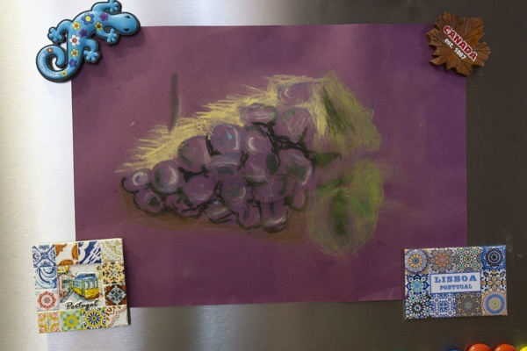13_1.png:** 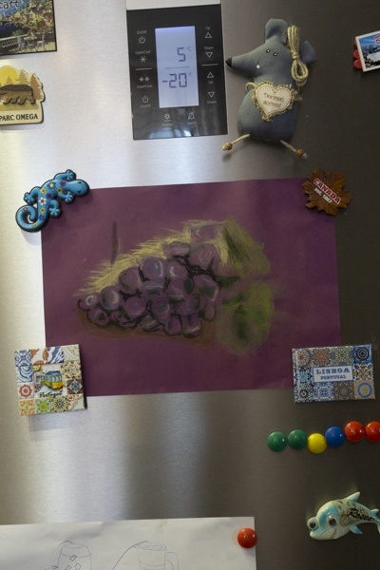

**Table 1 - Found homography parameters and normalization accuracy assessment**

|  |  |  |  |  |  |  |  |  |  |  |  |  |  |  |  |
| --- | --- | --- | --- | --- | --- | --- | --- | --- | --- | --- | --- | --- | --- | --- | --- |
| Original:  img1: 0 img2: 0 | h11 | h12 | h13 | h21 | h22 | h23 | h31 | h32 | h33 | avg ErrPar (param) | avg ErrIM (pixel) | max ErrIM | avg ErrCPM (corner) | max ErrCPM | Expert rate |
| SIFT | 0,641 | 0,006 | -10,505 | -0,048 | 0,636 | 183,882 | -0 | -0 | 1 | 0 | 0,353 | 1,902 | ~ | ~ |  |
| SURF128 | 0,641 | 0,007 | -10,549 | -0,053 | 0,644 | 183,94 | -0 | -0 | 1 | 0 | 0,674 | 3,051 | ~ | ~ |  |
| SURF64 | 0,64 | 0,008 | -10,472 | -0,052 | 0,642 | 183,948 | -0 | -0 | 1 | 0 | 0,738 | 3,091 | ~ | ~ |  |
| ORB | 0,64 | 0,006 | -10,277 | -0,048 | 0,635 | 183,911 | -0 | -0 | 1 | 0 | 0,809 | 2,792 | ~ | ~ |  |
| ORB1000 | 0,648 | 0,005 | -10,939 | -0,044 | 0,635 | 184,248 | -0 | -0 | 1 | 0 | 0,907 | 3,053 | ~ | ~ |  |
| BRISK | 0,639 | 0,005 | -10,416 | -0,049 | 0,633 | 184,128 | -0 | -0 | 1 | 0 | 0,639 | 2,347 | ~ | ~ |  |
| KAZE | 0,639 | 0,007 | -10,453 | -0,054 | 0,642 | 184,216 | -0 | -0 | 1 | 0 | 0,656 | 2,366 | ~ | ~ |  |
| AKAZE | 0,64 | 0,01 | -10,882 | -0,063 | 0,66 | 184,067 | -0 | -0 | 1 | 0 | 0,715 | 2,554 | ~ | ~ |  |
| Original matrix |  |  |  |  |  |  |  |  |  |  |  |  |  |  |  |

where h11, h12, h13, h21, h22, h23, h31, h32, h33 - parameters of found homography matrix H* or of original one H;   
avgErrPar - average error of found parameters, the accuracy of found homography matrix parameters with a preliminary minimax normalization of found and original matrices;  
avgErrIM - average error of inlier coordinate matching;  
inliers - correct matches; outliers - false matches;  
maxErrIM – maximum error of inlier coordinate matching;  
avgErrCPM - average error of corner point matching;  
maxErrCPM - maximum error of corner point matching;  
expert rate - experts assessment of normalization accuracy with a 5-point scale: 0 - normalization failed, 1 - insufficient, 2 - satisfactory, 3 - good, 4 – excellent.

**Table 2 - Quantitative evaluation of descriptors, precision and recall estimation (with found overlap)**

|  |  |  |  |  |  |  |  |  |  |  |  |  |  |  |  |  |
| --- | --- | --- | --- | --- | --- | --- | --- | --- | --- | --- | --- | --- | --- | --- | --- | --- |
| Name | NP1 | NP2 | NM | NI | DP1 | DP2 | OP1 | OP2 | NPO1 | NPO2 | NMO | DPO1 | DPO2 | Precision | RecallO1 | Comments |
| SIFT | 885 | 747 | 225 | 212 | 0,0037 | 0,0031 | 95,8192 | 46,2017 | 885 | 388 | 225 | 0,0038 | 0,0035 | 0,9422 | 0,2395 |  |
| SURF128 | 1034 | 1107 | 269 | 244 | 0,0043 | 0,0046 | 95,665 | 46,2483 | 1034 | 616 | 269 | 0,0045 | 0,0055 | 0,9071 | 0,236 |  |
| SURF64 | 1034 | 1107 | 306 | 270 | 0,0043 | 0,0046 | 95,7704 | 46,2679 | 1034 | 616 | 306 | 0,0045 | 0,0055 | 0,8824 | 0,2611 |  |
| ORB | 3665 | 2657 | 576 | 561 | 0,0153 | 0,0111 | 95,9113 | 46,1958 | 3665 | 1559 | 576 | 0,0159 | 0,0141 | 0,974 | 0,1531 |  |
| ORB1000 | 963 | 942 | 170 | 143 | 0,004 | 0,0039 | 95,9767 | 45,9071 | 963 | 601 | 170 | 0,0042 | 0,0055 | 0,8412 | 0,1485 |  |
| BRISK | 1597 | 1187 | 206 | 200 | 0,0067 | 0,0049 | 95,8596 | 46,2104 | 1597 | 686 | 206 | 0,0069 | 0,0062 | 0,9709 | 0,1252 |  |
| KAZE | 414 | 384 | 72 | 61 | 0,0017 | 0,0016 | 95,6387 | 46,2529 | 414 | 195 | 72 | 0,0018 | 0,0018 | 0,8472 | 0,1473 |  |
| AKAZE | 352 | 280 | 51 | 39 | 0,0015 | 0,0012 | 95,2279 | 46,4342 | 352 | 154 | 51 | 0,0015 | 0,0014 | 0,7647 | 0,1108 |  |

where NP - number of found key points; NP1, NP2 - number of found key points for image1 and image2 respectively;  
NM - number of matches found with NNDR method, NM=NI+NO;  
NI - number of inliers found with RANSAC method;  
NO - number of outliers discarded with RANSAC method;   
DP - density of key points (per cent), DP= NP/(height x width) , height, width - vertical and horizontal image sizes respectively (pixels)  
DP1, DP2 - density of key points points for image1 and image2 respectively;  
OP1, OP2 - overlap percentage for image1 and image2 respectively;  
NPO1, NPO2 - number of found key points on overlap for image1 and image2 respectivelyy;  
NMO - number of matches on overlap found with NNDR method;  
DPO1, DPO2 - density of key points points on overlap for image1 and image2 respectively;   
OA - overlap area (pixels), OA1, OA2 - overlap area for image1 and image2 respectively;  
DPO1= NPO1/OA1; DPO2= NPO2/OA2;  
Precision = NI/ NM - the rate to evaluate the part of inliers to all found matches with NNDR method;  
RecallO1 = NI/ NPO1 - completeness of inlier retrieval relative to the number of all key points on overlap for image1. The rate illustrates usefulness of the found key points for normalization.

**Table 3 - Estimation of time costs**

|  |  |  |  |  |  |  |  |  |  |  |
| --- | --- | --- | --- | --- | --- | --- | --- | --- | --- | --- |
| Name | NP1 | NP2 | DesT1, sec | DesT2, sec | MatchT, sec | InlierT, sec | AvgDesT, ms | AvgMatchT, ms | AvgInlierT, ms | TotalNormT, sec |
| SIFT | 885 | 747 | 0,080521 | 0,067269 | 0,006253 | 0,000407 | 0,090518 | 0,027792 | 0,001919 | 0,15445 |
| SURF128 | 1034 | 1107 | 0,068052 | 0,088007 | 0,011299 | 0,000467 | 0,072657 | 0,042003 | 0,001912 | 0,167824 |
| SURF64 | 1034 | 1107 | 0,067094 | 0,060342 | 0,007522 | 0,000441 | 0,059698 | 0,024582 | 0,001634 | 0,1354 |
| ORB | 3665 | 2657 | 0,012245 | 0,011563 | 0,045085 | 0,000715 | 0,003845 | 0,078273 | 0,001274 | 0,069608 |
| ORB1000 | 963 | 942 | 0,009452 | 0,010037 | 0,008803 | 0,000428 | 0,010234 | 0,051782 | 0,002995 | 0,02872 |
| BRISK | 1597 | 1187 | 0,026179 | 0,021892 | 0,010333 | 0,00037 | 0,017417 | 0,050159 | 0,001848 | 0,058774 |
| KAZE | 414 | 384 | 0,280447 | 0,159035 | 0,004518 | 0,000527 | 0,54578 | 0,062753 | 0,008639 | 0,444527 |
| AKAZE | 352 | 280 | 0,02055 | 0,021966 | 0,001012 | 0,000504 | 0,068414 | 0,019837 | 0,012935 | 0,044032 |

where DesT – descriptor creation time (time for key point detection and descriptor computation), DesT1, DesT2 – creation time of descriptors for image1 and image2 respectively;  
MatchT - retrieval time of matching found with NNDR method for the pair;  
InlierT – inlier retrieval time found with RANSAC method for the pair;  
AvgDesT – average time for one descriptor creation;  
AvgMatchT - average time for one match retrieval with NNDR method;  
AvgInlierT – average time for one inlier retrieval with RANSAC method;  
TotalNormT – total normalization time for the pair.