**Normalization results for pairs 15_0.png_15_1.png from subset png\picture_inside**

**15_0.png: 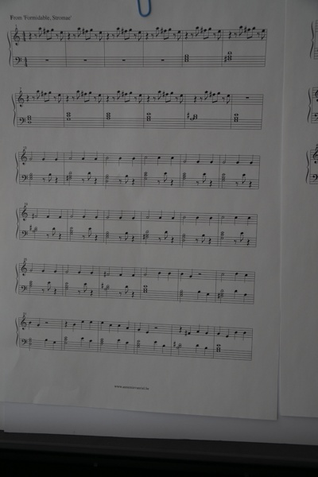15_1.png:** 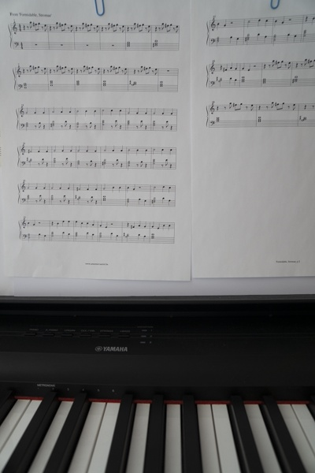

**Table 1 - Found homography parameters and normalization accuracy assessment**

|  |  |  |  |  |  |  |  |  |  |  |  |  |  |  |  |
| --- | --- | --- | --- | --- | --- | --- | --- | --- | --- | --- | --- | --- | --- | --- | --- |
| Original:  img1: 0 img2: 0 | h11 | h12 | h13 | h21 | h22 | h23 | h31 | h32 | h33 | avg ErrPar (param) | avg ErrIM (pixel) | max ErrIM | avg ErrCPM (corner) | max ErrCPM | Expert rate |
| SIFT | 0,7 | 0,02 | 3,069 | 0,013 | 0,707 | 2,739 | 0 | 0 | 1 | 0 | 0,38 | 0,798 | ~ | ~ |  |
| SURF128 | 0,698 | 0,018 | 3,34 | 0,014 | 0,705 | 2,5 | 0 | 0 | 1 | 0 | 0,628 | 2,247 | ~ | ~ |  |
| SURF64 | 0,697 | 0,017 | 3,411 | 0,012 | 0,698 | 3,616 | 0 | 0 | 1 | 0 | 0,731 | 2,278 | ~ | ~ |  |
| ORB | 0,69 | 0,015 | 4,277 | 0,009 | 0,694 | 4,585 | 0 | 0 | 1 | 0 | 0,748 | 1,94 | ~ | ~ |  |
| ORB1000 | 0,687 | 0,013 | 4,481 | 0,006 | 0,687 | 5,618 | 0 | 0 | 1 | 0 | 0,809 | 2,708 | ~ | ~ |  |
| BRISK | 0,703 | 0,018 | 3,073 | 0,015 | 0,706 | 2,866 | 0 | 0 | 1 | 0 | 0,421 | 1,083 | ~ | ~ |  |
| KAZE | 0,692 | 0,015 | 4,205 | 0,012 | 0,695 | 4,186 | 0 | 0 | 1 | 0 | 0,162 | 0,39 | ~ | ~ |  |
| AKAZE | -1,122 | -0,721 | 266,901 | -0,259 | -0,142 | 54,396 | -0,005 | -0,003 | 1 | 0 | 0 | 0 | ~ | ~ |  |
| Original matrix |  |  |  |  |  |  |  |  |  |  |  |  |  |  |  |

where h11, h12, h13, h21, h22, h23, h31, h32, h33 - parameters of found homography matrix H* or of original one H;   
avgErrPar - average error of found parameters, the accuracy of found homography matrix parameters with a preliminary minimax normalization of found and original matrices;  
avgErrIM - average error of inlier coordinate matching;  
inliers - correct matches; outliers - false matches;  
maxErrIM – maximum error of inlier coordinate matching;  
avgErrCPM - average error of corner point matching;  
maxErrCPM - maximum error of corner point matching;  
expert rate - experts assessment of normalization accuracy with a 5-point scale: 0 - normalization failed, 1 - insufficient, 2 - satisfactory, 3 - good, 4 – excellent.

**Table 2 - Quantitative evaluation of descriptors, precision and recall estimation (with found overlap)**

|  |  |  |  |  |  |  |  |  |  |  |  |  |  |  |  |  |
| --- | --- | --- | --- | --- | --- | --- | --- | --- | --- | --- | --- | --- | --- | --- | --- | --- |
| Name | NP1 | NP2 | NM | NI | DP1 | DP2 | OP1 | OP2 | NPO1 | NPO2 | NMO | DPO1 | DPO2 | Precision | RecallO1 | Comments |
| SIFT | 322 | 194 | 51 | 28 | 0,0013 | 0,0008 | 100 | 44,09 | 322 | 88 | 51 | 0,0013 | 0,0008 | 0,549 | 0,087 |  |
| SURF128 | 1116 | 989 | 109 | 69 | 0,0046 | 0,0041 | 100 | 44,1842 | 1116 | 658 | 109 | 0,0046 | 0,0062 | 0,633 | 0,0618 |  |
| SURF64 | 1116 | 989 | 197 | 122 | 0,0046 | 0,0041 | 100 | 44,3879 | 1116 | 658 | 197 | 0,0046 | 0,0062 | 0,6193 | 0,1093 |  |
| ORB | 1932 | 2012 | 256 | 167 | 0,008 | 0,0084 | 100 | 44,3904 | 1932 | 1500 | 256 | 0,008 | 0,0141 | 0,6523 | 0,0864 |  |
| ORB1000 | 931 | 904 | 143 | 84 | 0,0039 | 0,0038 | 100 | 44,6475 | 931 | 639 | 143 | 0,0039 | 0,006 | 0,5874 | 0,0902 |  |
| BRISK | 751 | 868 | 71 | 34 | 0,0031 | 0,0036 | 100 | 43,8654 | 751 | 612 | 71 | 0,0031 | 0,0058 | 0,4789 | 0,0453 |  |
| KAZE | 70 | 111 | 11 | 7 | 0,0003 | 0,0005 | 100 | 44,1504 | 70 | 43 | 11 | 0,0003 | 0,0004 | 0,6364 | 0,1 |  |
| AKAZE | 140 | 87 | 9 | 4 | 0,0006 | 0,0004 | 95,5354 | 96,7158 | 130 | 82 | 9 | 0,0006 | 0,0004 | 0,4444 | 0,0308 |  |

where NP - number of found key points; NP1, NP2 - number of found key points for image1 and image2 respectively;  
NM - number of matches found with NNDR method, NM=NI+NO;  
NI - number of inliers found with RANSAC method;  
NO - number of outliers discarded with RANSAC method;   
DP - density of key points (per cent), DP= NP/(height x width) , height, width - vertical and horizontal image sizes respectively (pixels)  
DP1, DP2 - density of key points points for image1 and image2 respectively;  
OP1, OP2 - overlap percentage for image1 and image2 respectively;  
NPO1, NPO2 - number of found key points on overlap for image1 and image2 respectivelyy;  
NMO - number of matches on overlap found with NNDR method;  
DPO1, DPO2 - density of key points points on overlap for image1 and image2 respectively;   
OA - overlap area (pixels), OA1, OA2 - overlap area for image1 and image2 respectively;  
DPO1= NPO1/OA1; DPO2= NPO2/OA2;  
Precision = NI/ NM - the rate to evaluate the part of inliers to all found matches with NNDR method;  
RecallO1 = NI/ NPO1 - completeness of inlier retrieval relative to the number of all key points on overlap for image1. The rate illustrates usefulness of the found key points for normalization.

**Table 3 - Estimation of time costs**

|  |  |  |  |  |  |  |  |  |  |  |
| --- | --- | --- | --- | --- | --- | --- | --- | --- | --- | --- |
| Name | NP1 | NP2 | DesT1, sec | DesT2, sec | MatchT, sec | InlierT, sec | AvgDesT, ms | AvgMatchT, ms | AvgInlierT, ms | TotalNormT, sec |
| SIFT | 322 | 194 | 0,055075 | 0,050474 | 0,000857 | 0,001543 | 0,215607 | 0,016812 | 0,0551 | 0,107949 |
| SURF128 | 1116 | 989 | 0,045841 | 0,136793 | 0,009367 | 0,000979 | 0,089695 | 0,085934 | 0,014182 | 0,192979 |
| SURF64 | 1116 | 989 | 0,04666 | 0,044519 | 0,007783 | 0,001368 | 0,043411 | 0,039506 | 0,011216 | 0,10033 |
| ORB | 1932 | 2012 | 0,009647 | 0,009464 | 0,015001 | 0,00094 | 0,004848 | 0,058596 | 0,005628 | 0,035052 |
| ORB1000 | 931 | 904 | 0,007982 | 0,00798 | 0,004033 | 0,00126 | 0,0087 | 0,028201 | 0,014998 | 0,021254 |
| BRISK | 751 | 868 | 0,012225 | 0,013354 | 0,002554 | 0,002875 | 0,01583 | 0,035969 | 0,08457 | 0,031007 |
| KAZE | 70 | 111 | 0,297015 | 0,541775 | 0,000527 | 0,0009 | 4,561959 | 0,04791 | 0,128536 | 0,840216 |
| AKAZE | 140 | 87 | 0,028357 | 0,020675 | 0,000335 | 0,003372 | 0,220094 | 0,037167 | 0,843008 | 0,052738 |

where DesT – descriptor creation time (time for key point detection and descriptor computation), DesT1, DesT2 – creation time of descriptors for image1 and image2 respectively;  
MatchT - retrieval time of matching found with NNDR method for the pair;  
InlierT – inlier retrieval time found with RANSAC method for the pair;  
AvgDesT – average time for one descriptor creation;  
AvgMatchT - average time for one match retrieval with NNDR method;  
AvgInlierT – average time for one inlier retrieval with RANSAC method;  
TotalNormT – total normalization time for the pair.