**Normalization results for pairs 16_0.png_16_1.png from subset png\picture_inside**

**16_0.png: 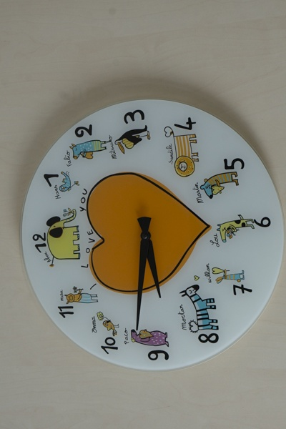16_1.png:** 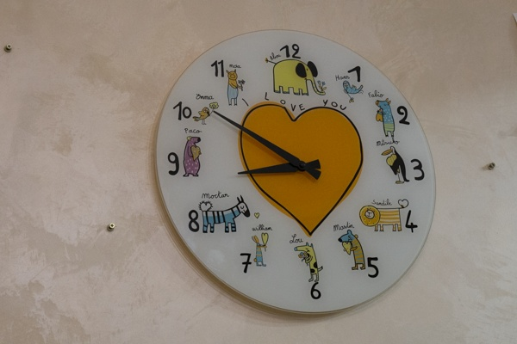

**Table 1 - Found homography parameters and normalization accuracy assessment**

|  |  |  |  |  |  |  |  |  |  |  |  |  |  |  |  |
| --- | --- | --- | --- | --- | --- | --- | --- | --- | --- | --- | --- | --- | --- | --- | --- |
| Original:  img1: 0 img2: 0 | h11 | h12 | h13 | h21 | h22 | h23 | h31 | h32 | h33 | avg ErrPar (param) | avg ErrIM (pixel) | max ErrIM | avg ErrCPM (corner) | max ErrCPM | Expert rate |
| SIFT | 0,04 | -0,874 | 611,447 | 0,86 | -0,141 | 55,628 | 0 | -0 | 1 | 0 | 0,311 | 2,123 | ~ | ~ |  |
| SURF128 | 0,037 | -0,874 | 609,349 | 0,848 | -0,143 | 57,254 | 0 | -0 | 1 | 0 | 0,934 | 3,87 | ~ | ~ |  |
| SURF64 | 0,04 | -0,874 | 610,691 | 0,858 | -0,141 | 55,94 | 0 | -0 | 1 | 0 | 0,998 | 3,375 | ~ | ~ |  |
| ORB | 0,039 | -0,873 | 610,996 | 0,861 | -0,14 | 55,491 | 0 | -0 | 1 | 0 | 0,981 | 3,623 | ~ | ~ |  |
| ORB1000 | 0,054 | -0,886 | 621,595 | 0,904 | -0,129 | 47,929 | 0 | -0 | 1 | 0 | 0,998 | 3,542 | ~ | ~ |  |
| BRISK | 0,042 | -0,874 | 610,698 | 0,861 | -0,141 | 55,592 | 0 | -0 | 1 | 0 | 0,66 | 3,316 | ~ | ~ |  |
| KAZE | 0,035 | -0,871 | 609,376 | 0,853 | -0,141 | 56,104 | 0 | -0 | 1 | 0 | 0,632 | 2,77 | ~ | ~ |  |
| AKAZE | 0,044 | -0,875 | 611,646 | 0,867 | -0,141 | 54,952 | 0 | -0 | 1 | 0 | 0,604 | 2,603 | ~ | ~ |  |
| Original matrix |  |  |  |  |  |  |  |  |  |  |  |  |  |  |  |

where h11, h12, h13, h21, h22, h23, h31, h32, h33 - parameters of found homography matrix H* or of original one H;   
avgErrPar - average error of found parameters, the accuracy of found homography matrix parameters with a preliminary minimax normalization of found and original matrices;  
avgErrIM - average error of inlier coordinate matching;  
inliers - correct matches; outliers - false matches;  
maxErrIM – maximum error of inlier coordinate matching;  
avgErrCPM - average error of corner point matching;  
maxErrCPM - maximum error of corner point matching;  
expert rate - experts assessment of normalization accuracy with a 5-point scale: 0 - normalization failed, 1 - insufficient, 2 - satisfactory, 3 - good, 4 – excellent.

**Table 2 - Quantitative evaluation of descriptors, precision and recall estimation (with found overlap)**

|  |  |  |  |  |  |  |  |  |  |  |  |  |  |  |  |  |
| --- | --- | --- | --- | --- | --- | --- | --- | --- | --- | --- | --- | --- | --- | --- | --- | --- |
| Name | NP1 | NP2 | NM | NI | DP1 | DP2 | OP1 | OP2 | NPO1 | NPO2 | NMO | DPO1 | DPO2 | Precision | RecallO1 | Comments |
| SIFT | 537 | 439 | 267 | 249 | 0,0022 | 0,0018 | 96,1312 | 71,845 | 537 | 435 | 267 | 0,0023 | 0,0025 | 0,9326 | 0,4637 |  |
| SURF128 | 1076 | 923 | 262 | 169 | 0,0045 | 0,0038 | 96,2512 | 71,8304 | 1076 | 901 | 262 | 0,0047 | 0,0052 | 0,645 | 0,1571 |  |
| SURF64 | 1076 | 923 | 289 | 251 | 0,0045 | 0,0038 | 96,3129 | 71,8404 | 1076 | 901 | 289 | 0,0047 | 0,0052 | 0,8685 | 0,2333 |  |
| ORB | 3777 | 3059 | 867 | 812 | 0,0157 | 0,0127 | 96,1617 | 71,8992 | 3777 | 3059 | 867 | 0,0164 | 0,0177 | 0,9366 | 0,215 |  |
| ORB1000 | 1000 | 1000 | 215 | 150 | 0,0042 | 0,0042 | 94,76 | 72,3088 | 1000 | 1000 | 215 | 0,0044 | 0,0058 | 0,6977 | 0,15 |  |
| BRISK | 1504 | 1152 | 427 | 408 | 0,0063 | 0,0048 | 96,2929 | 71,9083 | 1504 | 1152 | 427 | 0,0065 | 0,0067 | 0,9555 | 0,2713 |  |
| KAZE | 541 | 355 | 122 | 103 | 0,0023 | 0,0015 | 96,3804 | 71,9738 | 541 | 354 | 122 | 0,0023 | 0,002 | 0,8443 | 0,1904 |  |
| AKAZE | 442 | 306 | 95 | 72 | 0,0018 | 0,0013 | 96,2404 | 71,8738 | 442 | 306 | 95 | 0,0019 | 0,0018 | 0,7579 | 0,1629 |  |

where NP - number of found key points; NP1, NP2 - number of found key points for image1 and image2 respectively;  
NM - number of matches found with NNDR method, NM=NI+NO;  
NI - number of inliers found with RANSAC method;  
NO - number of outliers discarded with RANSAC method;   
DP - density of key points (per cent), DP= NP/(height x width) , height, width - vertical and horizontal image sizes respectively (pixels)  
DP1, DP2 - density of key points points for image1 and image2 respectively;  
OP1, OP2 - overlap percentage for image1 and image2 respectively;  
NPO1, NPO2 - number of found key points on overlap for image1 and image2 respectivelyy;  
NMO - number of matches on overlap found with NNDR method;  
DPO1, DPO2 - density of key points points on overlap for image1 and image2 respectively;   
OA - overlap area (pixels), OA1, OA2 - overlap area for image1 and image2 respectively;  
DPO1= NPO1/OA1; DPO2= NPO2/OA2;  
Precision = NI/ NM - the rate to evaluate the part of inliers to all found matches with NNDR method;  
RecallO1 = NI/ NPO1 - completeness of inlier retrieval relative to the number of all key points on overlap for image1. The rate illustrates usefulness of the found key points for normalization.

**Table 3 - Estimation of time costs**

|  |  |  |  |  |  |  |  |  |  |  |
| --- | --- | --- | --- | --- | --- | --- | --- | --- | --- | --- |
| Name | NP1 | NP2 | DesT1, sec | DesT2, sec | MatchT, sec | InlierT, sec | AvgDesT, ms | AvgMatchT, ms | AvgInlierT, ms | TotalNormT, sec |
| SIFT | 537 | 439 | 0,042714 | 0,04394 | 0,002924 | 0,000407 | 0,089816 | 0,010949 | 0,001635 | 0,089985 |
| SURF128 | 1076 | 923 | 0,061531 | 0,05474 | 0,010952 | 0,000994 | 0,058245 | 0,0418 | 0,005883 | 0,128217 |
| SURF64 | 1076 | 923 | 0,053271 | 0,056829 | 0,010632 | 0,000659 | 0,055538 | 0,036787 | 0,002624 | 0,121389 |
| ORB | 3777 | 3059 | 0,01366 | 0,01254 | 0,035666 | 0,000753 | 0,003857 | 0,041137 | 0,000927 | 0,062619 |
| ORB1000 | 1000 | 1000 | 0,009384 | 0,008274 | 0,004342 | 0,000718 | 0,008828 | 0,020195 | 0,004785 | 0,022718 |
| BRISK | 1504 | 1152 | 0,021591 | 0,016958 | 0,006368 | 0,000681 | 0,014537 | 0,014913 | 0,001669 | 0,045599 |
| KAZE | 541 | 355 | 0,13962 | 0,132382 | 0,002452 | 0,000377 | 0,315492 | 0,020096 | 0,003658 | 0,274831 |
| AKAZE | 442 | 306 | 0,018845 | 0,015234 | 0,000949 | 0,000567 | 0,046209 | 0,009988 | 0,007869 | 0,035594 |

where DesT – descriptor creation time (time for key point detection and descriptor computation), DesT1, DesT2 – creation time of descriptors for image1 and image2 respectively;  
MatchT - retrieval time of matching found with NNDR method for the pair;  
InlierT – inlier retrieval time found with RANSAC method for the pair;  
AvgDesT – average time for one descriptor creation;  
AvgMatchT - average time for one match retrieval with NNDR method;  
AvgInlierT – average time for one inlier retrieval with RANSAC method;  
TotalNormT – total normalization time for the pair.