**Normalization results for pairs 5_0.png_5_1.png from subset png\picture_inside**

**5_0.png: 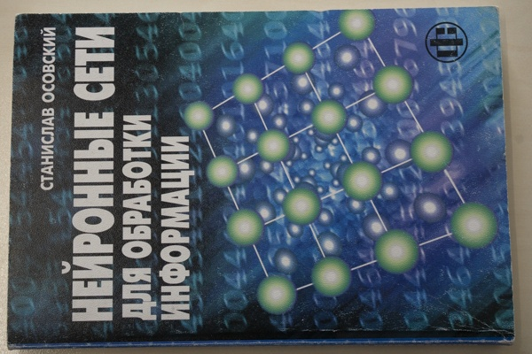5_1.png:** 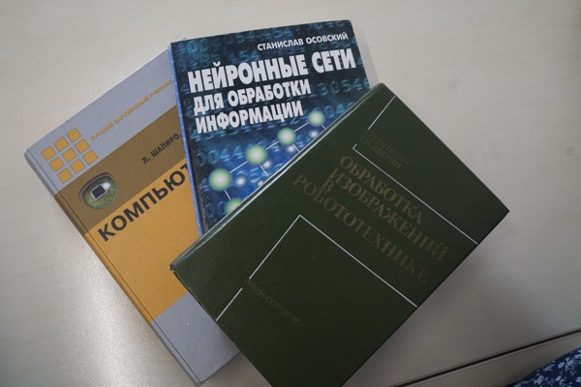

**Table 1 - Found homography parameters and normalization accuracy assessment**

|  |  |  |  |  |  |  |  |  |  |  |  |  |  |  |  |
| --- | --- | --- | --- | --- | --- | --- | --- | --- | --- | --- | --- | --- | --- | --- | --- |
| Original:  img1: 0 img2: 0 | h11 | h12 | h13 | h21 | h22 | h23 | h31 | h32 | h33 | avg ErrPar (param) | avg ErrIM (pixel) | max ErrIM | avg ErrCPM (corner) | max ErrCPM | Expert rate |
| SIFT | 0,012 | -0,5 | 366,982 | 0,423 | 0,078 | 9,21 | -0 | -0 | 1 | 0 | 0,379 | 2,54 | ~ | ~ |  |
| SURF128 | 0,005 | -0,498 | 366,735 | 0,417 | 0,078 | 9,708 | -0 | -0 | 1 | 0 | 0,739 | 2,949 | ~ | ~ |  |
| SURF64 | 0,012 | -0,502 | 367,025 | 0,424 | 0,076 | 9,272 | -0 | -0 | 1 | 0 | 0,77 | 2,938 | ~ | ~ |  |
| ORB | 0,004 | -0,497 | 366,562 | 0,421 | 0,077 | 9,592 | -0 | -0 | 1 | 0 | 0,754 | 2,736 | ~ | ~ |  |
| ORB1000 | -0,001 | -0,493 | 366,578 | 0,418 | 0,079 | 9,625 | -0 | -0 | 1 | 0 | 0,741 | 2,001 | ~ | ~ |  |
| BRISK | 0,014 | -0,503 | 366,925 | 0,423 | 0,077 | 9,195 | -0 | -0 | 1 | 0 | 0,598 | 2,178 | ~ | ~ |  |
| KAZE | 0,012 | -0,503 | 366,294 | 0,424 | 0,071 | 10,366 | -0 | -0 | 1 | 0 | 0,887 | 2,24 | ~ | ~ |  |
| AKAZE | 0,017 | -0,501 | 367,328 | 0,431 | 0,078 | 8,097 | -0 | -0 | 1 | 0 | 0,516 | 3,209 | ~ | ~ |  |
| Original matrix |  |  |  |  |  |  |  |  |  |  |  |  |  |  |  |

where h11, h12, h13, h21, h22, h23, h31, h32, h33 - parameters of found homography matrix H* or of original one H;   
avgErrPar - average error of found parameters, the accuracy of found homography matrix parameters with a preliminary minimax normalization of found and original matrices;  
avgErrIM - average error of inlier coordinate matching;  
inliers - correct matches; outliers - false matches;  
maxErrIM – maximum error of inlier coordinate matching;  
avgErrCPM - average error of corner point matching;  
maxErrCPM - maximum error of corner point matching;  
expert rate - experts assessment of normalization accuracy with a 5-point scale: 0 - normalization failed, 1 - insufficient, 2 - satisfactory, 3 - good, 4 – excellent.

**Table 2 - Quantitative evaluation of descriptors, precision and recall estimation (with found overlap)**

|  |  |  |  |  |  |  |  |  |  |  |  |  |  |  |  |  |
| --- | --- | --- | --- | --- | --- | --- | --- | --- | --- | --- | --- | --- | --- | --- | --- | --- |
| Name | NP1 | NP2 | NM | NI | DP1 | DP2 | OP1 | OP2 | NPO1 | NPO2 | NMO | DPO1 | DPO2 | Precision | RecallO1 | Comments |
| SIFT | 1913 | 693 | 362 | 261 | 0,008 | 0,0029 | 100 | 29,5404 | 1913 | 542 | 362 | 0,008 | 0,0076 | 0,721 | 0,1364 |  |
| SURF128 | 2274 | 1012 | 134 | 106 | 0,0095 | 0,0042 | 100 | 30,0383 | 2274 | 690 | 134 | 0,0095 | 0,0096 | 0,791 | 0,0466 |  |
| SURF64 | 2274 | 1012 | 194 | 150 | 0,0095 | 0,0042 | 100 | 29,5171 | 2274 | 689 | 194 | 0,0095 | 0,0097 | 0,7732 | 0,066 |  |
| ORB | 6678 | 3482 | 444 | 374 | 0,0278 | 0,0145 | 100 | 30,0654 | 6678 | 2869 | 444 | 0,0278 | 0,0398 | 0,8423 | 0,056 |  |
| ORB1000 | 1000 | 974 | 149 | 135 | 0,0042 | 0,0041 | 100 | 30,6071 | 1000 | 947 | 149 | 0,0042 | 0,0129 | 0,906 | 0,135 |  |
| BRISK | 2135 | 1305 | 229 | 206 | 0,0089 | 0,0054 | 100 | 29,3796 | 2135 | 1061 | 229 | 0,0089 | 0,015 | 0,8996 | 0,0965 |  |
| KAZE | 982 | 521 | 57 | 42 | 0,0041 | 0,0022 | 100 | 29,4421 | 982 | 430 | 57 | 0,0041 | 0,0061 | 0,7368 | 0,0428 |  |
| AKAZE | 932 | 424 | 100 | 78 | 0,0039 | 0,0018 | 100 | 29,0888 | 932 | 354 | 100 | 0,0039 | 0,0051 | 0,78 | 0,0837 |  |

where NP - number of found key points; NP1, NP2 - number of found key points for image1 and image2 respectively;  
NM - number of matches found with NNDR method, NM=NI+NO;  
NI - number of inliers found with RANSAC method;  
NO - number of outliers discarded with RANSAC method;   
DP - density of key points (per cent), DP= NP/(height x width) , height, width - vertical and horizontal image sizes respectively (pixels)  
DP1, DP2 - density of key points points for image1 and image2 respectively;  
OP1, OP2 - overlap percentage for image1 and image2 respectively;  
NPO1, NPO2 - number of found key points on overlap for image1 and image2 respectivelyy;  
NMO - number of matches on overlap found with NNDR method;  
DPO1, DPO2 - density of key points points on overlap for image1 and image2 respectively;   
OA - overlap area (pixels), OA1, OA2 - overlap area for image1 and image2 respectively;  
DPO1= NPO1/OA1; DPO2= NPO2/OA2;  
Precision = NI/ NM - the rate to evaluate the part of inliers to all found matches with NNDR method;  
RecallO1 = NI/ NPO1 - completeness of inlier retrieval relative to the number of all key points on overlap for image1. The rate illustrates usefulness of the found key points for normalization.

**Table 3 - Estimation of time costs**

|  |  |  |  |  |  |  |  |  |  |  |
| --- | --- | --- | --- | --- | --- | --- | --- | --- | --- | --- |
| Name | NP1 | NP2 | DesT1, sec | DesT2, sec | MatchT, sec | InlierT, sec | AvgDesT, ms | AvgMatchT, ms | AvgInlierT, ms | TotalNormT, sec |
| SIFT | 1913 | 693 | 0,054482 | 0,054317 | 0,013929 | 0,000736 | 0,053429 | 0,038478 | 0,00282 | 0,123464 |
| SURF128 | 2274 | 1012 | 0,096613 | 0,057841 | 0,024574 | 0,000474 | 0,04982 | 0,18339 | 0,004472 | 0,179502 |
| SURF64 | 2274 | 1012 | 0,078187 | 0,046045 | 0,012995 | 0,000535 | 0,03994 | 0,066984 | 0,003568 | 0,137762 |
| ORB | 6678 | 3482 | 0,017947 | 0,011922 | 0,075583 | 0,000567 | 0,003055 | 0,170231 | 0,001516 | 0,10602 |
| ORB1000 | 1000 | 974 | 0,009692 | 0,008415 | 0,003869 | 0,000351 | 0,009165 | 0,025964 | 0,002599 | 0,022326 |
| BRISK | 2135 | 1305 | 0,033275 | 0,018973 | 0,008606 | 0,000384 | 0,015061 | 0,03758 | 0,001865 | 0,061238 |
| KAZE | 982 | 521 | 0,11902 | 0,112798 | 0,004826 | 0,000833 | 0,168851 | 0,084674 | 0,019829 | 0,237477 |
| AKAZE | 932 | 424 | 0,020974 | 0,017915 | 0,002694 | 0,000468 | 0,032378 | 0,026944 | 0,006003 | 0,042052 |

where DesT – descriptor creation time (time for key point detection and descriptor computation), DesT1, DesT2 – creation time of descriptors for image1 and image2 respectively;  
MatchT - retrieval time of matching found with NNDR method for the pair;  
InlierT – inlier retrieval time found with RANSAC method for the pair;  
AvgDesT – average time for one descriptor creation;  
AvgMatchT - average time for one match retrieval with NNDR method;  
AvgInlierT – average time for one inlier retrieval with RANSAC method;  
TotalNormT – total normalization time for the pair.