**Normalization results for pairs 6_0.png_6_1.png from subset png\picture_inside**

**6_0.png: 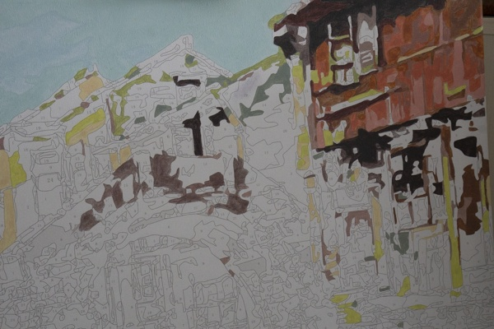6_1.png:** 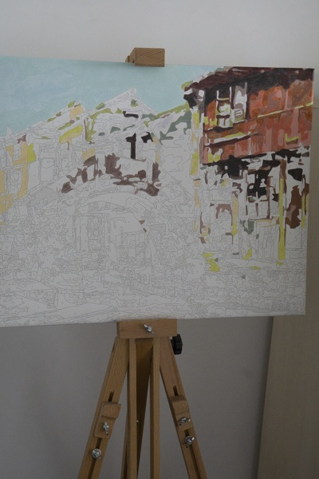

**Table 1 - Found homography parameters and normalization accuracy assessment**

|  |  |  |  |  |  |  |  |  |  |  |  |  |  |  |  |
| --- | --- | --- | --- | --- | --- | --- | --- | --- | --- | --- | --- | --- | --- | --- | --- |
| Original:  img1: 0 img2: 0 | h11 | h12 | h13 | h21 | h22 | h23 | h31 | h32 | h33 | avg ErrPar (param) | avg ErrIM (pixel) | max ErrIM | avg ErrCPM (corner) | max ErrCPM | Expert rate |
| SIFT | 0,546 | -0,064 | 40,381 | 0,044 | 0,571 | 72,069 | -0 | -0 | 1 | 0 | 0,176 | 1,666 | ~ | ~ |  |
| SURF128 | 0,544 | -0,065 | 40,633 | 0,043 | 0,569 | 72,455 | -0 | -0 | 1 | 0 | 0,754 | 3,571 | ~ | ~ |  |
| SURF64 | 0,548 | -0,066 | 40,24 | 0,045 | 0,57 | 71,957 | -0 | -0 | 1 | 0 | 0,754 | 3,303 | ~ | ~ |  |
| ORB | 0,548 | -0,067 | 40,418 | 0,046 | 0,567 | 72,514 | -0 | -0 | 1 | 0 | 0,797 | 2,718 | ~ | ~ |  |
| ORB1000 | 0,548 | -0,071 | 40,363 | 0,046 | 0,564 | 72,26 | -0 | -0 | 1 | 0 | 0,823 | 2,506 | ~ | ~ |  |
| BRISK | 0,545 | -0,064 | 40,179 | 0,044 | 0,571 | 71,967 | -0 | -0 | 1 | 0 | 0,612 | 2,705 | ~ | ~ |  |
| KAZE | 0,549 | -0,062 | 39,318 | 0,046 | 0,573 | 71,607 | -0 | -0 | 1 | 0 | 0,627 | 3,154 | ~ | ~ |  |
| AKAZE | 0,546 | -0,064 | 40,246 | 0,044 | 0,569 | 72,33 | -0 | -0 | 1 | 0 | 0,518 | 2,412 | ~ | ~ |  |
| Original matrix |  |  |  |  |  |  |  |  |  |  |  |  |  |  |  |

where h11, h12, h13, h21, h22, h23, h31, h32, h33 - parameters of found homography matrix H* or of original one H;   
avgErrPar - average error of found parameters, the accuracy of found homography matrix parameters with a preliminary minimax normalization of found and original matrices;  
avgErrIM - average error of inlier coordinate matching;  
inliers - correct matches; outliers - false matches;  
maxErrIM – maximum error of inlier coordinate matching;  
avgErrCPM - average error of corner point matching;  
maxErrCPM - maximum error of corner point matching;  
expert rate - experts assessment of normalization accuracy with a 5-point scale: 0 - normalization failed, 1 - insufficient, 2 - satisfactory, 3 - good, 4 – excellent.

**Table 2 - Quantitative evaluation of descriptors, precision and recall estimation (with found overlap)**

|  |  |  |  |  |  |  |  |  |  |  |  |  |  |  |  |  |
| --- | --- | --- | --- | --- | --- | --- | --- | --- | --- | --- | --- | --- | --- | --- | --- | --- |
| Name | NP1 | NP2 | NM | NI | DP1 | DP2 | OP1 | OP2 | NPO1 | NPO2 | NMO | DPO1 | DPO2 | Precision | RecallO1 | Comments |
| SIFT | 1082 | 699 | 450 | 432 | 0,0045 | 0,0029 | 99,9488 | 37,4108 | 1082 | 616 | 450 | 0,0045 | 0,0069 | 0,96 | 0,3993 |  |
| SURF128 | 1436 | 913 | 337 | 316 | 0,006 | 0,0038 | 99,9425 | 37,4475 | 1436 | 652 | 337 | 0,006 | 0,0073 | 0,9377 | 0,2201 |  |
| SURF64 | 1436 | 913 | 365 | 332 | 0,006 | 0,0038 | 99,9517 | 37,475 | 1436 | 652 | 365 | 0,006 | 0,0072 | 0,9096 | 0,2312 |  |
| ORB | 3825 | 2675 | 870 | 767 | 0,0159 | 0,0111 | 99,9608 | 37,4233 | 3825 | 2355 | 870 | 0,0159 | 0,0262 | 0,8816 | 0,2005 |  |
| ORB1000 | 1000 | 992 | 315 | 267 | 0,0042 | 0,0041 | 99,9775 | 37,7642 | 1000 | 943 | 315 | 0,0042 | 0,0104 | 0,8476 | 0,267 |  |
| BRISK | 1305 | 1044 | 354 | 350 | 0,0054 | 0,0043 | 99,9417 | 37,435 | 1305 | 940 | 354 | 0,0054 | 0,0105 | 0,9887 | 0,2682 |  |
| KAZE | 580 | 390 | 159 | 145 | 0,0024 | 0,0016 | 99,9517 | 37,4233 | 580 | 345 | 159 | 0,0024 | 0,0038 | 0,9119 | 0,25 |  |
| AKAZE | 433 | 307 | 122 | 118 | 0,0018 | 0,0013 | 99,9396 | 37,3454 | 433 | 280 | 122 | 0,0018 | 0,0031 | 0,9672 | 0,2725 |  |

where NP - number of found key points; NP1, NP2 - number of found key points for image1 and image2 respectively;  
NM - number of matches found with NNDR method, NM=NI+NO;  
NI - number of inliers found with RANSAC method;  
NO - number of outliers discarded with RANSAC method;   
DP - density of key points (per cent), DP= NP/(height x width) , height, width - vertical and horizontal image sizes respectively (pixels)  
DP1, DP2 - density of key points points for image1 and image2 respectively;  
OP1, OP2 - overlap percentage for image1 and image2 respectively;  
NPO1, NPO2 - number of found key points on overlap for image1 and image2 respectivelyy;  
NMO - number of matches on overlap found with NNDR method;  
DPO1, DPO2 - density of key points points on overlap for image1 and image2 respectively;   
OA - overlap area (pixels), OA1, OA2 - overlap area for image1 and image2 respectively;  
DPO1= NPO1/OA1; DPO2= NPO2/OA2;  
Precision = NI/ NM - the rate to evaluate the part of inliers to all found matches with NNDR method;  
RecallO1 = NI/ NPO1 - completeness of inlier retrieval relative to the number of all key points on overlap for image1. The rate illustrates usefulness of the found key points for normalization.

**Table 3 - Estimation of time costs**

|  |  |  |  |  |  |  |  |  |  |  |
| --- | --- | --- | --- | --- | --- | --- | --- | --- | --- | --- |
| Name | NP1 | NP2 | DesT1, sec | DesT2, sec | MatchT, sec | InlierT, sec | AvgDesT, ms | AvgMatchT, ms | AvgInlierT, ms | TotalNormT, sec |
| SIFT | 1082 | 699 | 0,051883 | 0,046458 | 0,008229 | 0,000468 | 0,057207 | 0,018286 | 0,001083 | 0,107038 |
| SURF128 | 1436 | 913 | 0,056279 | 0,04601 | 0,01776 | 0,000429 | 0,044792 | 0,0527 | 0,001358 | 0,120478 |
| SURF64 | 1436 | 913 | 0,054724 | 0,046385 | 0,006548 | 0,000465 | 0,044456 | 0,01794 | 0,0014 | 0,108122 |
| ORB | 3825 | 2675 | 0,012752 | 0,010702 | 0,029623 | 0,000801 | 0,003666 | 0,034048 | 0,001044 | 0,053877 |
| ORB1000 | 1000 | 992 | 0,008879 | 0,008308 | 0,003684 | 0,017403 | 0,008626 | 0,011695 | 0,065179 | 0,038274 |
| BRISK | 1305 | 1044 | 0,020377 | 0,01566 | 0,004322 | 0,000451 | 0,015307 | 0,012208 | 0,001287 | 0,04081 |
| KAZE | 580 | 390 | 0,113745 | 0,113943 | 0,002515 | 0,000452 | 0,244136 | 0,015819 | 0,003116 | 0,230655 |
| AKAZE | 433 | 307 | 0,018894 | 0,017393 | 0,000972 | 0,000377 | 0,050144 | 0,007968 | 0,003193 | 0,037636 |

where DesT – descriptor creation time (time for key point detection and descriptor computation), DesT1, DesT2 – creation time of descriptors for image1 and image2 respectively;  
MatchT - retrieval time of matching found with NNDR method for the pair;  
InlierT – inlier retrieval time found with RANSAC method for the pair;  
AvgDesT – average time for one descriptor creation;  
AvgMatchT - average time for one match retrieval with NNDR method;  
AvgInlierT – average time for one inlier retrieval with RANSAC method;  
TotalNormT – total normalization time for the pair.