**Normalization results for pairs 11_0.png_11_1.png from subset png\texture_artificial**

**11_0.png: 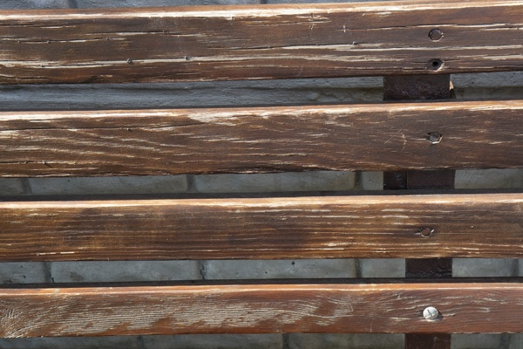11_1.png:** 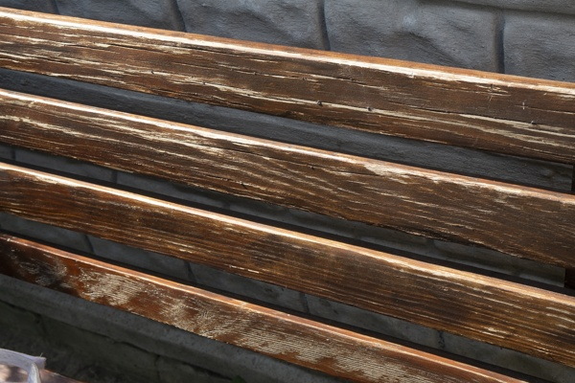

**Table 1 - Found homography parameters and normalization accuracy assessment**

|  |  |  |  |  |  |  |  |  |  |  |  |  |
| --- | --- | --- | --- | --- | --- | --- | --- | --- | --- | --- | --- | --- |
| Original:  img1: 0 img2: 0 | h11 | h12 | h13 | h21 | h22 | h23 | h31 | h32 | h33 | avg ErrIM (pixel) | max ErrIM | Expert rate |
| SIFT | 0,607 | -0,065 | 228,659 | 0,094 | 0,824 | 29,619 | -0 | 0 | 1 | 0,651 | 3,472 |  |
| SURF128 | 0,599 | -0,076 | 230,068 | 0,093 | 0,815 | 30,192 | -0 | -0 | 1 | 1,023 | 2,459 |  |
| SURF64 | 0,6 | -0,065 | 229,911 | 0,094 | 0,824 | 29,614 | -0 | 0 | 1 | 1,046 | 3,084 |  |
| ORB | 0,597 | -0,07 | 230,043 | 0,089 | 0,817 | 30,985 | -0 | -0 | 1 | 0,959 | 3,162 |  |
| ORB1000 | 0,606 | -0,073 | 230,043 | 0,093 | 0,821 | 30,314 | -0 | 0 | 1 | 0,94 | 2,771 |  |
| BRISK | 0,599 | -0,086 | 230,415 | 0,091 | 0,807 | 31,226 | -0 | -0 | 1 | 0,746 | 2,717 |  |
| KAZE | 0,601 | -0,062 | 228,846 | 0,092 | 0,824 | 29,594 | -0 | 0 | 1 | 0,922 | 2,147 |  |
| AKAZE | 0,589 | -0,072 | 231,106 | 0,087 | 0,814 | 31,757 | -0 | -0 | 1 | 0,652 | 1,543 |  |
|  |  |  |  |  |  |  |  |  |  |  |  |  |

where h11, h12, h13, h21, h22, h23, h31, h32, h33 - parameters of found homography matrix H* or of original one H;   
avgErrPar - average error of found parameters, the accuracy of found homography matrix parameters with a preliminary minimax normalization of found and original matrices;  
avgErrIM - average error of inlier coordinate matching;  
inliers - correct matches; outliers - false matches;  
maxErrIM – maximum error of inlier coordinate matching;  
avgErrCPM - average error of corner point matching;  
maxErrCPM - maximum error of corner point matching;  
expert rate - experts assessment of normalization accuracy with a 5-point scale: 0 - normalization failed, 1 - insufficient, 2 - satisfactory, 3 - good, 4 – excellent.

**Table 2 - Quantitative evaluation of descriptors, precision and recall estimation (with found overlap)**

|  |  |  |  |  |  |  |  |  |  |  |  |  |  |  |  |  |
| --- | --- | --- | --- | --- | --- | --- | --- | --- | --- | --- | --- | --- | --- | --- | --- | --- |
| Name | NP1 | NP2 | NM | NI | DP1 | DP2 | OP1 | OP2 | NPO1 | NPO2 | NMO | DPO1 | DPO2 | Precision | RecallO1 | Comments |
| SIFT | 955 | 862 | 172 | 152 | 0,004 | 0,0036 | 71,8787 | 54,2617 | 726 | 485 | 169 | 0,0042 | 0,0037 | 0,8837 | 0,2094 |  |
| SURF128 | 2907 | 3528 | 93 | 53 | 0,0121 | 0,0147 | 71,84 | 54,2092 | 2321 | 2152 | 85 | 0,0135 | 0,0165 | 0,5699 | 0,0228 |  |
| SURF64 | 2907 | 3528 | 129 | 92 | 0,0121 | 0,0147 | 71,9275 | 54,0917 | 2324 | 2151 | 125 | 0,0135 | 0,0166 | 0,7132 | 0,0396 |  |
| ORB | 3714 | 5066 | 388 | 302 | 0,0155 | 0,0211 | 71,8846 | 54,0813 | 2816 | 2971 | 376 | 0,0163 | 0,0229 | 0,7784 | 0,1072 |  |
| ORB1000 | 919 | 951 | 94 | 74 | 0,0038 | 0,004 | 72,0442 | 54,2217 | 636 | 504 | 88 | 0,0037 | 0,0039 | 0,7872 | 0,1164 |  |
| BRISK | 1275 | 1790 | 168 | 131 | 0,0053 | 0,0075 | 71,7079 | 54,3108 | 924 | 1011 | 164 | 0,0054 | 0,0078 | 0,7798 | 0,1418 |  |
| KAZE | 290 | 595 | 43 | 37 | 0,0012 | 0,0025 | 71,8496 | 54,1592 | 220 | 330 | 42 | 0,0013 | 0,0025 | 0,8605 | 0,1682 |  |
| AKAZE | 221 | 393 | 28 | 25 | 0,0009 | 0,0016 | 71,8762 | 53,9075 | 173 | 224 | 27 | 0,001 | 0,0017 | 0,8929 | 0,1445 |  |

where NP - number of found key points; NP1, NP2 - number of found key points for image1 and image2 respectively;  
NM - number of matches found with NNDR method, NM=NI+NO;  
NI - number of inliers found with RANSAC method;  
NO - number of outliers discarded with RANSAC method;   
DP - density of key points (per cent), DP= NP/(height x width) , height, width - vertical and horizontal image sizes respectively (pixels)  
DP1, DP2 - density of key points points for image1 and image2 respectively;  
OP1, OP2 - overlap percentage for image1 and image2 respectively;  
NPO1, NPO2 - number of found key points on overlap for image1 and image2 respectivelyy;  
NMO - number of matches on overlap found with NNDR method;  
DPO1, DPO2 - density of key points points on overlap for image1 and image2 respectively;   
OA - overlap area (pixels), OA1, OA2 - overlap area for image1 and image2 respectively;  
DPO1= NPO1/OA1; DPO2= NPO2/OA2;  
Precision = NI/ NM - the rate to evaluate the part of inliers to all found matches with NNDR method;  
RecallO1 = NI/ NPO1 - completeness of inlier retrieval relative to the number of all key points on overlap for image1. The rate illustrates usefulness of the found key points for normalization.

**Table 3 - Estimation of time costs**

|  |  |  |  |  |  |  |  |  |  |  |
| --- | --- | --- | --- | --- | --- | --- | --- | --- | --- | --- |
| Name | NP1 | NP2 | DesT1, sec | DesT2, sec | MatchT, sec | InlierT, sec | AvgDesT, ms | AvgMatchT, ms | AvgInlierT, ms | TotalNormT, sec |
| SIFT | 955 | 862 | 0,045511 | 0,044293 | 0,008271 | 0,000489 | 0,049519 | 0,048084 | 0,003215 | 0,098563 |
| SURF128 | 2907 | 3528 | 0,07378 | 0,096275 | 0,078667 | 0,001371 | 0,026334 | 0,845886 | 0,025876 | 0,250094 |
| SURF64 | 2907 | 3528 | 0,079721 | 0,100437 | 0,043065 | 0,000648 | 0,027945 | 0,333837 | 0,007038 | 0,223871 |
| ORB | 3714 | 5066 | 0,0121 | 0,014319 | 0,046552 | 0,000628 | 0,003042 | 0,119979 | 0,00208 | 0,0736 |
| ORB1000 | 919 | 951 | 0,008388 | 0,009137 | 0,003007 | 0,000639 | 0,009366 | 0,031994 | 0,008634 | 0,021171 |
| BRISK | 1275 | 1790 | 0,01854 | 0,024986 | 0,006989 | 0,000495 | 0,014249 | 0,041602 | 0,003778 | 0,05101 |
| KAZE | 290 | 595 | 0,108549 | 0,114125 | 0,001874 | 0,000392 | 0,283056 | 0,043571 | 0,01059 | 0,224939 |
| AKAZE | 221 | 393 | 0,018216 | 0,017429 | 0,000678 | 0,000428 | 0,063386 | 0,024222 | 0,017107 | 0,036751 |

where DesT – descriptor creation time (time for key point detection and descriptor computation), DesT1, DesT2 – creation time of descriptors for image1 and image2 respectively;  
MatchT - retrieval time of matching found with NNDR method for the pair;  
InlierT – inlier retrieval time found with RANSAC method for the pair;  
AvgDesT – average time for one descriptor creation;  
AvgMatchT - average time for one match retrieval with NNDR method;  
AvgInlierT – average time for one inlier retrieval with RANSAC method;  
TotalNormT – total normalization time for the pair.