**Normalization results for pairs 12_0.png_12_1.png from subset png\texture_artificial**

**12_0.png: 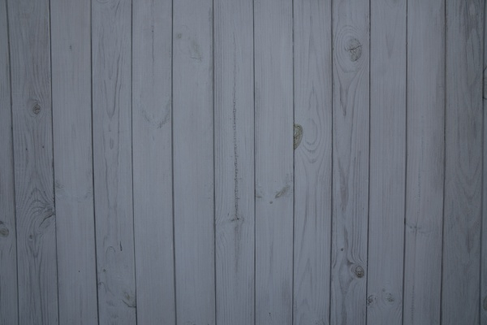12_1.png:** 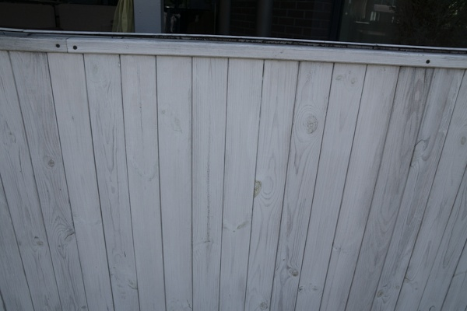

**Table 1 - Found homography parameters and normalization accuracy assessment**

|  |  |  |  |  |  |  |  |  |  |  |  |  |
| --- | --- | --- | --- | --- | --- | --- | --- | --- | --- | --- | --- | --- |
| Original:  img1: 0 img2: 0 | h11 | h12 | h13 | h21 | h22 | h23 | h31 | h32 | h33 | avg ErrIM (pixel) | max ErrIM | Expert rate |
| SIFT | -0,255 | -0,395 | 246,521 | -0,325 | -0,504 | 314,891 | -0,001 | -0,002 | 1 | 26,355 | 105,421 |  |
| SURF128 | 0,897 | 0,166 | 9,699 | 0,019 | 0,958 | 100,012 | -0 | 0,001 | 1 | 1,074 | 2,3 |  |
| SURF64 | 0,889 | 0,16 | 11,393 | 0,015 | 0,952 | 100,436 | -0 | 0,001 | 1 | 1,016 | 2,308 |  |
| ORB | 0,907 | 0,222 | 0,743 | 0,011 | 1,008 | 98,044 | -0 | 0,001 | 1 | 1,092 | 1,753 |  |
| ORB1000 | 0,907 | 0,222 | 0,743 | 0,011 | 1,008 | 98,044 | -0 | 0,001 | 1 | 1,092 | 1,753 |  |
| BRISK | 0 | 0 | 0 | 0 | 0 | 0 | 0 | 0 | 0 | -1 | ~ |  |
| KAZE | 0 | 0 | 0 | 0 | 0 | 0 | 0 | 0 | 0 | 0 | ~ |  |
| AKAZE | 0 | 0 | 0 | 0 | 0 | 0 | 0 | 0 | 0 | 0 | ~ |  |
|  |  |  |  |  |  |  |  |  |  |  |  |  |

where h11, h12, h13, h21, h22, h23, h31, h32, h33 - parameters of found homography matrix H* or of original one H;   
avgErrPar - average error of found parameters, the accuracy of found homography matrix parameters with a preliminary minimax normalization of found and original matrices;  
avgErrIM - average error of inlier coordinate matching;  
inliers - correct matches; outliers - false matches;  
maxErrIM – maximum error of inlier coordinate matching;  
avgErrCPM - average error of corner point matching;  
maxErrCPM - maximum error of corner point matching;  
expert rate - experts assessment of normalization accuracy with a 5-point scale: 0 - normalization failed, 1 - insufficient, 2 - satisfactory, 3 - good, 4 – excellent.

**Table 2 - Quantitative evaluation of descriptors, precision and recall estimation (with found overlap)**

|  |  |  |  |  |  |  |  |  |  |  |  |  |  |  |  |  |
| --- | --- | --- | --- | --- | --- | --- | --- | --- | --- | --- | --- | --- | --- | --- | --- | --- |
| Name | NP1 | NP2 | NM | NI | DP1 | DP2 | OP1 | OP2 | NPO1 | NPO2 | NMO | DPO1 | DPO2 | Precision | RecallO1 | Comments |
| SIFT | 28 | 126 | 4 | 4 | 0,0001 | 0,0005 | 100 | 0,0083 | 0 | 0 | 0 | 0 | 0 | 1 | ∞ |  |
| SURF128 | 74 | 637 | 16 | 12 | 0,0003 | 0,0027 | 100 | 56,8488 | 74 | 89 | 16 | 0,0003 | 0,0007 | 0,75 | 0,1622 |  |
| SURF64 | 74 | 637 | 26 | 17 | 0,0003 | 0,0027 | 100 | 56,9583 | 74 | 90 | 26 | 0,0003 | 0,0007 | 0,6538 | 0,2297 |  |
| ORB | 93 | 323 | 11 | 9 | 0,0004 | 0,0013 | 100 | 57,4542 | 93 | 110 | 11 | 0,0004 | 0,0008 | 0,8182 | 0,0968 |  |
| ORB1000 | 93 | 323 | 11 | 9 | 0,0004 | 0,0013 | 100 | 57,4542 | 93 | 110 | 11 | 0,0004 | 0,0008 | 0,8182 | 0,0968 |  |
| BRISK | 16 | 71 | 3 | 0 | 0,0001 | 0,0003 | 0 | 0 | 0 | 0 | 0 | � | � | 0 | � |  |
| KAZE | 1 | 65 | 0 | 0 | 0 | 0,0003 | 0 | 0 | 0 | 0 | 0 | � | � | � | � |  |
| AKAZE | 1 | 32 | 0 | 0 | 0 | 0,0001 | 0 | 0 | 0 | 0 | 0 | � | � | � | � |  |

where NP - number of found key points; NP1, NP2 - number of found key points for image1 and image2 respectively;  
NM - number of matches found with NNDR method, NM=NI+NO;  
NI - number of inliers found with RANSAC method;  
NO - number of outliers discarded with RANSAC method;   
DP - density of key points (per cent), DP= NP/(height x width) , height, width - vertical and horizontal image sizes respectively (pixels)  
DP1, DP2 - density of key points points for image1 and image2 respectively;  
OP1, OP2 - overlap percentage for image1 and image2 respectively;  
NPO1, NPO2 - number of found key points on overlap for image1 and image2 respectivelyy;  
NMO - number of matches on overlap found with NNDR method;  
DPO1, DPO2 - density of key points points on overlap for image1 and image2 respectively;   
OA - overlap area (pixels), OA1, OA2 - overlap area for image1 and image2 respectively;  
DPO1= NPO1/OA1; DPO2= NPO2/OA2;  
Precision = NI/ NM - the rate to evaluate the part of inliers to all found matches with NNDR method;  
RecallO1 = NI/ NPO1 - completeness of inlier retrieval relative to the number of all key points on overlap for image1. The rate illustrates usefulness of the found key points for normalization.

**Table 3 - Estimation of time costs**

|  |  |  |  |  |  |  |  |  |  |  |
| --- | --- | --- | --- | --- | --- | --- | --- | --- | --- | --- |
| Name | NP1 | NP2 | DesT1, sec | DesT2, sec | MatchT, sec | InlierT, sec | AvgDesT, ms | AvgMatchT, ms | AvgInlierT, ms | TotalNormT, sec |
| SIFT | 28 | 126 | 0,039609 | 0,039662 | 0,00017 | 0,000065 | 0,864696 | 0,042581 | 0,016298 | 0,079506 |
| SURF128 | 74 | 637 | 0,022947 | 0,039147 | 0,000645 | 0,000739 | 0,185773 | 0,04032 | 0,061553 | 0,063477 |
| SURF64 | 74 | 637 | 0,022425 | 0,035761 | 0,000398 | 0,000799 | 0,179589 | 0,01532 | 0,047003 | 0,059383 |
| ORB | 93 | 323 | 0,006086 | 0,006474 | 0,000299 | 0,000383 | 0,042741 | 0,027213 | 0,042515 | 0,013242 |
| ORB1000 | 93 | 323 | 0,005882 | 0,006386 | 0,000297 | 0,000401 | 0,041506 | 0,027027 | 0,044563 | 0,012966 |
| BRISK | 16 | 71 | 0,002059 | 0,002873 | 0,00011 | 0 | 0,084586 | 0,036636 | 0 | 0,005043 |
| KAZE | 1 | 65 | 0,112965 | 0,167164 | 0 | 0 | 57,768192 | 0 | 0 | 0,280129 |
| AKAZE | 1 | 32 | 0,016777 | 0,015173 | 0 | 0 | 8,62551 | 0 | 0 | 0,031949 |

where DesT – descriptor creation time (time for key point detection and descriptor computation), DesT1, DesT2 – creation time of descriptors for image1 and image2 respectively;  
MatchT - retrieval time of matching found with NNDR method for the pair;  
InlierT – inlier retrieval time found with RANSAC method for the pair;  
AvgDesT – average time for one descriptor creation;  
AvgMatchT - average time for one match retrieval with NNDR method;  
AvgInlierT – average time for one inlier retrieval with RANSAC method;  
TotalNormT – total normalization time for the pair.