**Normalization results for pairs 14_0.png_14_1.png from subset png\texture_artificial**

**14_0.png: 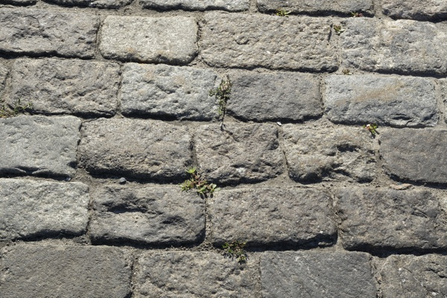14_1.png:** 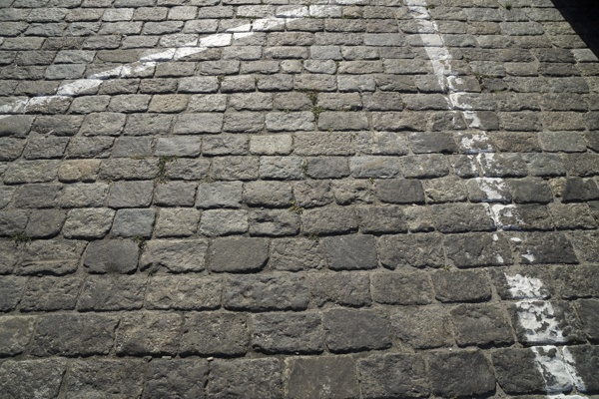

**Table 1 - Found homography parameters and normalization accuracy assessment**

|  |  |  |  |  |  |  |  |  |  |  |  |  |
| --- | --- | --- | --- | --- | --- | --- | --- | --- | --- | --- | --- | --- |
| Original:  img1: 0 img2: 0 | h11 | h12 | h13 | h21 | h22 | h23 | h31 | h32 | h33 | avg ErrIM (pixel) | max ErrIM | Expert rate |
| SIFT | 0,327 | 0,014 | 205,078 | -0,017 | 0,328 | 131,452 | -0 | -0 | 1 | 0,312 | 1,189 |  |
| SURF128 | 0,328 | 0,021 | 204,035 | -0,016 | 0,334 | 130,705 | -0 | 0 | 1 | 0,703 | 3,997 |  |
| SURF64 | 0,325 | 0,007 | 205,255 | -0,018 | 0,323 | 131,556 | -0 | -0 | 1 | 0,723 | 2,519 |  |
| ORB | 0,33 | 0,021 | 204,166 | -0,017 | 0,335 | 130,828 | -0 | 0 | 1 | 0,666 | 2,41 |  |
| ORB1000 | 0,156 | -0,179 | 221,969 | -0,087 | 0,128 | 146,966 | -0 | -0,001 | 1 | 0,44 | 1,451 |  |
| BRISK | 0,329 | 0,023 | 204,098 | -0,018 | 0,337 | 130,818 | -0 | 0 | 1 | 0,583 | 1,854 |  |
| KAZE | 0,309 | 0,015 | 205,46 | -0,027 | 0,324 | 132,29 | -0 | -0 | 1 | 0,891 | 2,444 |  |
| AKAZE | 0,328 | 0,021 | 204,499 | -0,017 | 0,337 | 130,326 | -0 | 0 | 1 | 0,509 | 1,951 |  |
|  |  |  |  |  |  |  |  |  |  |  |  |  |

where h11, h12, h13, h21, h22, h23, h31, h32, h33 - parameters of found homography matrix H* or of original one H;   
avgErrPar - average error of found parameters, the accuracy of found homography matrix parameters with a preliminary minimax normalization of found and original matrices;  
avgErrIM - average error of inlier coordinate matching;  
inliers - correct matches; outliers - false matches;  
maxErrIM – maximum error of inlier coordinate matching;  
avgErrCPM - average error of corner point matching;  
maxErrCPM - maximum error of corner point matching;  
expert rate - experts assessment of normalization accuracy with a 5-point scale: 0 - normalization failed, 1 - insufficient, 2 - satisfactory, 3 - good, 4 – excellent.

**Table 2 - Quantitative evaluation of descriptors, precision and recall estimation (with found overlap)**

|  |  |  |  |  |  |  |  |  |  |  |  |  |  |  |  |  |
| --- | --- | --- | --- | --- | --- | --- | --- | --- | --- | --- | --- | --- | --- | --- | --- | --- |
| Name | NP1 | NP2 | NM | NI | DP1 | DP2 | OP1 | OP2 | NPO1 | NPO2 | NMO | DPO1 | DPO2 | Precision | RecallO1 | Comments |
| SIFT | 3191 | 3420 | 215 | 208 | 0,0133 | 0,0143 | 100 | 10,9358 | 3191 | 349 | 215 | 0,0133 | 0,0133 | 0,9674 | 0,0652 |  |
| SURF128 | 3395 | 3543 | 140 | 130 | 0,0141 | 0,0148 | 100 | 10,9829 | 3395 | 507 | 140 | 0,0141 | 0,0192 | 0,9286 | 0,0383 |  |
| SURF64 | 3395 | 3543 | 203 | 165 | 0,0141 | 0,0148 | 100 | 10,9767 | 3395 | 507 | 203 | 0,0141 | 0,0192 | 0,8128 | 0,0486 |  |
| ORB | 21587 | 16741 | 370 | 293 | 0,0899 | 0,0698 | 100 | 11,0808 | 21587 | 2733 | 370 | 0,0899 | 0,1028 | 0,7919 | 0,0136 |  |
| ORB1000 | 1000 | 1000 | 20 | 7 | 0,0042 | 0,0042 | 100 | 12,9892 | 1000 | 95 | 20 | 0,0042 | 0,003 | 0,35 | 0,007 |  |
| BRISK | 8401 | 6106 | 188 | 160 | 0,035 | 0,0254 | 100 | 11,0367 | 8401 | 830 | 188 | 0,035 | 0,0313 | 0,8511 | 0,019 |  |
| KAZE | 1299 | 1061 | 35 | 27 | 0,0054 | 0,0044 | 100 | 11,045 | 1299 | 117 | 35 | 0,0054 | 0,0044 | 0,7714 | 0,0208 |  |
| AKAZE | 1281 | 1098 | 31 | 25 | 0,0053 | 0,0046 | 100 | 11,0225 | 1281 | 159 | 31 | 0,0053 | 0,006 | 0,8065 | 0,0195 |  |

where NP - number of found key points; NP1, NP2 - number of found key points for image1 and image2 respectively;  
NM - number of matches found with NNDR method, NM=NI+NO;  
NI - number of inliers found with RANSAC method;  
NO - number of outliers discarded with RANSAC method;   
DP - density of key points (per cent), DP= NP/(height x width) , height, width - vertical and horizontal image sizes respectively (pixels)  
DP1, DP2 - density of key points points for image1 and image2 respectively;  
OP1, OP2 - overlap percentage for image1 and image2 respectively;  
NPO1, NPO2 - number of found key points on overlap for image1 and image2 respectivelyy;  
NMO - number of matches on overlap found with NNDR method;  
DPO1, DPO2 - density of key points points on overlap for image1 and image2 respectively;   
OA - overlap area (pixels), OA1, OA2 - overlap area for image1 and image2 respectively;  
DPO1= NPO1/OA1; DPO2= NPO2/OA2;  
Precision = NI/ NM - the rate to evaluate the part of inliers to all found matches with NNDR method;  
RecallO1 = NI/ NPO1 - completeness of inlier retrieval relative to the number of all key points on overlap for image1. The rate illustrates usefulness of the found key points for normalization.

**Table 3 - Estimation of time costs**

|  |  |  |  |  |  |  |  |  |  |  |
| --- | --- | --- | --- | --- | --- | --- | --- | --- | --- | --- |
| Name | NP1 | NP2 | DesT1, sec | DesT2, sec | MatchT, sec | InlierT, sec | AvgDesT, ms | AvgMatchT, ms | AvgInlierT, ms | TotalNormT, sec |
| SIFT | 3191 | 3420 | 0,059133 | 0,057375 | 0,08539 | 0,000327 | 0,017653 | 0,397162 | 0,001573 | 0,202225 |
| SURF128 | 3395 | 3543 | 0,087072 | 0,086538 | 0,092038 | 0,000297 | 0,025036 | 0,657415 | 0,002286 | 0,265945 |
| SURF64 | 3395 | 3543 | 0,080192 | 0,084992 | 0,058544 | 0,000447 | 0,023804 | 0,288396 | 0,002712 | 0,224176 |
| ORB | 21587 | 16741 | 0,040305 | 0,032878 | 0,829713 | 0,000659 | 0,001915 | 2,242466 | 0,00225 | 0,903555 |
| ORB1000 | 1000 | 1000 | 0,011835 | 0,010954 | 0,003893 | 0,009008 | 0,011394 | 0,194662 | 1,286924 | 0,035691 |
| BRISK | 8401 | 6106 | 0,12413 | 0,089035 | 0,124384 | 0,00039 | 0,014678 | 0,661616 | 0,002436 | 0,337939 |
| KAZE | 1299 | 1061 | 0,126179 | 0,185047 | 0,0115 | 0,000468 | 0,135771 | 0,328557 | 0,017319 | 0,323193 |
| AKAZE | 1281 | 1098 | 0,018765 | 0,014874 | 0,005464 | 0,00064 | 0,014097 | 0,176249 | 0,025613 | 0,039743 |

where DesT – descriptor creation time (time for key point detection and descriptor computation), DesT1, DesT2 – creation time of descriptors for image1 and image2 respectively;  
MatchT - retrieval time of matching found with NNDR method for the pair;  
InlierT – inlier retrieval time found with RANSAC method for the pair;  
AvgDesT – average time for one descriptor creation;  
AvgMatchT - average time for one match retrieval with NNDR method;  
AvgInlierT – average time for one inlier retrieval with RANSAC method;  
TotalNormT – total normalization time for the pair.