**Normalization results for pairs 15_0.png_15_1.png from subset png\texture_artificial**

**15_0.png: 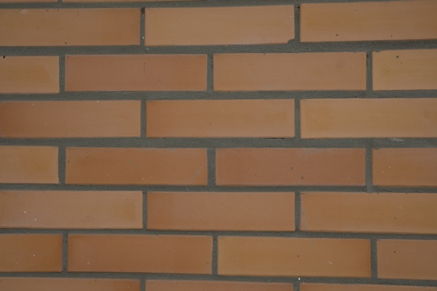15_1.png:** 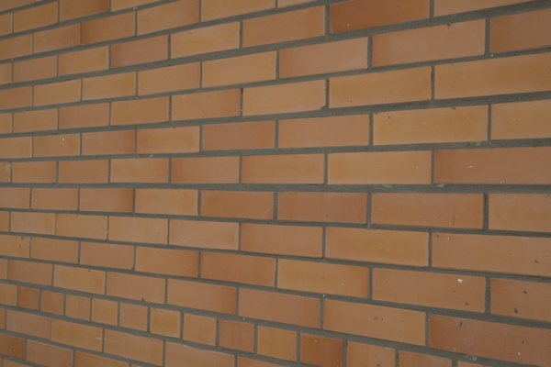

**Table 1 - Found homography parameters and normalization accuracy assessment**

|  |  |  |  |  |  |  |  |  |  |  |  |  |
| --- | --- | --- | --- | --- | --- | --- | --- | --- | --- | --- | --- | --- |
| Original:  img1: 0 img2: 0 | h11 | h12 | h13 | h21 | h22 | h23 | h31 | h32 | h33 | avg ErrIM (pixel) | max ErrIM | Expert rate |
| SIFT | 0,294 | -0,009 | 188,828 | -0,065 | 0,546 | 97,459 | -0 | 0 | 1 | 0,369 | 0,688 |  |
| SURF128 | 0,311 | -0,005 | 186,379 | -0,056 | 0,558 | 94,235 | -0 | 0 | 1 | 0,974 | 2,225 |  |
| SURF64 | 0,301 | -0,011 | 187,985 | -0,061 | 0,547 | 96,219 | -0 | 0 | 1 | 1,067 | 3,392 |  |
| ORB | 0,212 | -2,35 | 534,074 | 0,085 | -0,932 | 211,567 | 0 | -0,004 | 1 | 63,687 | 237,212 |  |
| ORB1000 | 0,212 | -2,35 | 534,074 | 0,085 | -0,932 | 211,567 | 0 | -0,004 | 1 | 63,687 | 237,212 |  |
| BRISK | -0,609 | -0,537 | 483,528 | -0,234 | 0,004 | 160,338 | -0,001 | -0,001 | 1 | 0,097 | 0,13 |  |
| KAZE | 0 | 0 | 0 | 0 | 0 | 0 | 0 | 0 | 0 | -1 | ~ |  |
| AKAZE | -0,19 | -2,061 | 354,716 | -0,064 | -0,694 | 119,412 | -0,001 | -0,006 | 1 | 15,379 | 44,014 |  |
|  |  |  |  |  |  |  |  |  |  |  |  |  |

where h11, h12, h13, h21, h22, h23, h31, h32, h33 - parameters of found homography matrix H* or of original one H;   
avgErrPar - average error of found parameters, the accuracy of found homography matrix parameters with a preliminary minimax normalization of found and original matrices;  
avgErrIM - average error of inlier coordinate matching;  
inliers - correct matches; outliers - false matches;  
maxErrIM – maximum error of inlier coordinate matching;  
avgErrCPM - average error of corner point matching;  
maxErrCPM - maximum error of corner point matching;  
expert rate - experts assessment of normalization accuracy with a 5-point scale: 0 - normalization failed, 1 - insufficient, 2 - satisfactory, 3 - good, 4 – excellent.

**Table 2 - Quantitative evaluation of descriptors, precision and recall estimation (with found overlap)**

|  |  |  |  |  |  |  |  |  |  |  |  |  |  |  |  |  |
| --- | --- | --- | --- | --- | --- | --- | --- | --- | --- | --- | --- | --- | --- | --- | --- | --- |
| Name | NP1 | NP2 | NM | NI | DP1 | DP2 | OP1 | OP2 | NPO1 | NPO2 | NMO | DPO1 | DPO2 | Precision | RecallO1 | Comments |
| SIFT | 74 | 170 | 17 | 10 | 0,0003 | 0,0007 | 100 | 26,8758 | 74 | 51 | 17 | 0,0003 | 0,0008 | 0,5882 | 0,1351 |  |
| SURF128 | 526 | 1078 | 44 | 17 | 0,0022 | 0,0045 | 100 | 27,0679 | 526 | 341 | 44 | 0,0022 | 0,0052 | 0,3864 | 0,0323 |  |
| SURF64 | 526 | 1078 | 73 | 28 | 0,0022 | 0,0045 | 100 | 27,1629 | 526 | 338 | 73 | 0,0022 | 0,0052 | 0,3836 | 0,0532 |  |
| ORB | 244 | 516 | 24 | 8 | 0,001 | 0,0022 | 99,7771 | 76,2271 | 242 | 380 | 23 | 0,001 | 0,0021 | 0,3333 | 0,0331 |  |
| ORB1000 | 244 | 516 | 24 | 8 | 0,001 | 0,0022 | 99,7771 | 76,2271 | 242 | 380 | 23 | 0,001 | 0,0021 | 0,3333 | 0,0331 |  |
| BRISK | 67 | 95 | 10 | 6 | 0,0003 | 0,0004 | 79,8762 | 33,5562 | 59 | 40 | 9 | 0,0003 | 0,0005 | 0,6 | 0,1017 |  |
| KAZE | 46 | 4 | 7 | 0 | 0,0002 | 0 | 0 | 0 | 0 | 0 | 0 | � | � | 0 | � |  |
| AKAZE | 24 | 8 | 4 | 4 | 0,0001 | 0 | 100 | 14,3358 | 22 | 2 | 2 | 0,0001 | 0,0001 | 1 | 0,1818 |  |

where NP - number of found key points; NP1, NP2 - number of found key points for image1 and image2 respectively;  
NM - number of matches found with NNDR method, NM=NI+NO;  
NI - number of inliers found with RANSAC method;  
NO - number of outliers discarded with RANSAC method;   
DP - density of key points (per cent), DP= NP/(height x width) , height, width - vertical and horizontal image sizes respectively (pixels)  
DP1, DP2 - density of key points points for image1 and image2 respectively;  
OP1, OP2 - overlap percentage for image1 and image2 respectively;  
NPO1, NPO2 - number of found key points on overlap for image1 and image2 respectivelyy;  
NMO - number of matches on overlap found with NNDR method;  
DPO1, DPO2 - density of key points points on overlap for image1 and image2 respectively;   
OA - overlap area (pixels), OA1, OA2 - overlap area for image1 and image2 respectively;  
DPO1= NPO1/OA1; DPO2= NPO2/OA2;  
Precision = NI/ NM - the rate to evaluate the part of inliers to all found matches with NNDR method;  
RecallO1 = NI/ NPO1 - completeness of inlier retrieval relative to the number of all key points on overlap for image1. The rate illustrates usefulness of the found key points for normalization.

**Table 3 - Estimation of time costs**

|  |  |  |  |  |  |  |  |  |  |  |
| --- | --- | --- | --- | --- | --- | --- | --- | --- | --- | --- |
| Name | NP1 | NP2 | DesT1, sec | DesT2, sec | MatchT, sec | InlierT, sec | AvgDesT, ms | AvgMatchT, ms | AvgInlierT, ms | TotalNormT, sec |
| SIFT | 74 | 170 | 0,038838 | 0,037098 | 0,000264 | 0,001186 | 0,371531 | 0,0155 | 0,118579 | 0,077385 |
| SURF128 | 526 | 1078 | 0,030996 | 0,044706 | 0,006032 | 0,00615 | 0,050199 | 0,137099 | 0,361773 | 0,087884 |
| SURF64 | 526 | 1078 | 0,03196 | 0,042811 | 0,003018 | 0,006228 | 0,050237 | 0,041348 | 0,222415 | 0,084018 |
| ORB | 244 | 516 | 0,006333 | 0,006748 | 0,000625 | 0,01073 | 0,019516 | 0,02604 | 1,341227 | 0,024436 |
| ORB1000 | 244 | 516 | 0,006222 | 0,00666 | 0,000627 | 0,010691 | 0,019203 | 0,02614 | 1,33632 | 0,0242 |
| BRISK | 67 | 95 | 0,003137 | 0,002877 | 0,000182 | 0,001103 | 0,038551 | 0,018158 | 0,183751 | 0,007298 |
| KAZE | 46 | 4 | 0,125772 | 0,105891 | 0,000136 | 0,001116 | 14,603438 | 0,019358 | 0 | 0,232914 |
| AKAZE | 24 | 8 | 0,015597 | 0,011384 | 0,000108 | 0,000049 | 1,036472 | 0,02688 | 0,012202 | 0,027138 |

where DesT – descriptor creation time (time for key point detection and descriptor computation), DesT1, DesT2 – creation time of descriptors for image1 and image2 respectively;  
MatchT - retrieval time of matching found with NNDR method for the pair;  
InlierT – inlier retrieval time found with RANSAC method for the pair;  
AvgDesT – average time for one descriptor creation;  
AvgMatchT - average time for one match retrieval with NNDR method;  
AvgInlierT – average time for one inlier retrieval with RANSAC method;  
TotalNormT – total normalization time for the pair.