**Normalization results for pairs 16_0.png_16_1.png from subset png\texture_artificial**

**16_0.png: 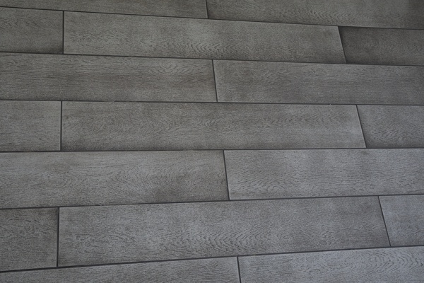16_1.png:** 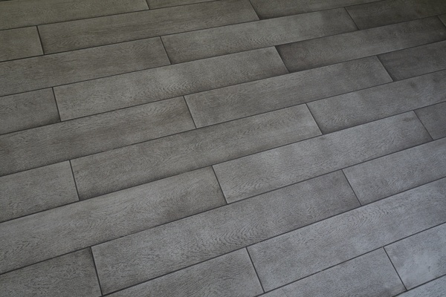

**Table 1 - Found homography parameters and normalization accuracy assessment**

|  |  |  |  |  |  |  |  |  |  |  |  |  |
| --- | --- | --- | --- | --- | --- | --- | --- | --- | --- | --- | --- | --- |
| Original:  img1: 0 img2: 0 | h11 | h12 | h13 | h21 | h22 | h23 | h31 | h32 | h33 | avg ErrIM (pixel) | max ErrIM | Expert rate |
| SIFT | 0,804 | 0,206 | -5,198 | -0,181 | 0,772 | 122,3 | 0 | -0 | 1 | 0,426 | 1,54 |  |
| SURF128 | 0,806 | 0,216 | -6,783 | -0,184 | 0,782 | 122,284 | 0 | 0 | 1 | 1,112 | 3,266 |  |
| SURF64 | 0,809 | 0,214 | -7,105 | -0,182 | 0,778 | 122,387 | 0 | 0 | 1 | 1,102 | 3,118 |  |
| ORB | 0,802 | 0,2 | -4,543 | -0,18 | 0,766 | 122,262 | 0 | -0 | 1 | 0,723 | 1,964 |  |
| ORB1000 | 0,807 | 0,206 | -5,848 | -0,18 | 0,775 | 121,714 | 0 | -0 | 1 | 0,709 | 3,055 |  |
| BRISK | 0,8 | 0,204 | -4,893 | -0,182 | 0,763 | 123,201 | 0 | -0 | 1 | 0,342 | 0,726 |  |
| KAZE | 0,805 | 0,212 | -5,378 | -0,177 | 0,796 | 119,932 | 0 | 0 | 1 | 0,475 | 0,822 |  |
| AKAZE | 0,824 | 0,202 | -6,759 | -0,178 | 0,768 | 121,928 | 0 | -0 | 1 | 0,272 | 0,675 |  |
|  |  |  |  |  |  |  |  |  |  |  |  |  |

where h11, h12, h13, h21, h22, h23, h31, h32, h33 - parameters of found homography matrix H* or of original one H;   
avgErrPar - average error of found parameters, the accuracy of found homography matrix parameters with a preliminary minimax normalization of found and original matrices;  
avgErrIM - average error of inlier coordinate matching;  
inliers - correct matches; outliers - false matches;  
maxErrIM – maximum error of inlier coordinate matching;  
avgErrCPM - average error of corner point matching;  
maxErrCPM - maximum error of corner point matching;  
expert rate - experts assessment of normalization accuracy with a 5-point scale: 0 - normalization failed, 1 - insufficient, 2 - satisfactory, 3 - good, 4 – excellent.

**Table 2 - Quantitative evaluation of descriptors, precision and recall estimation (with found overlap)**

|  |  |  |  |  |  |  |  |  |  |  |  |  |  |  |  |  |
| --- | --- | --- | --- | --- | --- | --- | --- | --- | --- | --- | --- | --- | --- | --- | --- | --- |
| Name | NP1 | NP2 | NM | NI | DP1 | DP2 | OP1 | OP2 | NPO1 | NPO2 | NMO | DPO1 | DPO2 | Precision | RecallO1 | Comments |
| SIFT | 182 | 76 | 41 | 34 | 0,0008 | 0,0003 | 98,6054 | 60,595 | 176 | 54 | 41 | 0,0007 | 0,0004 | 0,8293 | 0,1932 |  |
| SURF128 | 1175 | 1153 | 122 | 94 | 0,0049 | 0,0048 | 98,7325 | 60,6996 | 1160 | 868 | 122 | 0,0049 | 0,006 | 0,7705 | 0,081 |  |
| SURF64 | 1175 | 1153 | 226 | 166 | 0,0049 | 0,0048 | 98,6708 | 60,5642 | 1159 | 866 | 226 | 0,0049 | 0,006 | 0,7345 | 0,1432 |  |
| ORB | 700 | 416 | 93 | 86 | 0,0029 | 0,0017 | 98,4967 | 60,8125 | 700 | 337 | 93 | 0,003 | 0,0023 | 0,9247 | 0,1229 |  |
| ORB1000 | 396 | 374 | 87 | 79 | 0,0016 | 0,0016 | 98,4975 | 60,8888 | 396 | 313 | 87 | 0,0017 | 0,0021 | 0,908 | 0,1995 |  |
| BRISK | 79 | 83 | 18 | 12 | 0,0003 | 0,0003 | 98,5763 | 60,6812 | 79 | 46 | 18 | 0,0003 | 0,0003 | 0,6667 | 0,1519 |  |
| KAZE | 15 | 17 | 8 | 7 | 0,0001 | 0,0001 | 98,7483 | 60,1862 | 15 | 14 | 8 | 0,0001 | 0,0001 | 0,875 | 0,4667 |  |
| AKAZE | 13 | 9 | 5 | 5 | 0,0001 | 0 | 98,3833 | 60,7446 | 13 | 9 | 5 | 0,0001 | 0,0001 | 1 | 0,3846 |  |

where NP - number of found key points; NP1, NP2 - number of found key points for image1 and image2 respectively;  
NM - number of matches found with NNDR method, NM=NI+NO;  
NI - number of inliers found with RANSAC method;  
NO - number of outliers discarded with RANSAC method;   
DP - density of key points (per cent), DP= NP/(height x width) , height, width - vertical and horizontal image sizes respectively (pixels)  
DP1, DP2 - density of key points points for image1 and image2 respectively;  
OP1, OP2 - overlap percentage for image1 and image2 respectively;  
NPO1, NPO2 - number of found key points on overlap for image1 and image2 respectivelyy;  
NMO - number of matches on overlap found with NNDR method;  
DPO1, DPO2 - density of key points points on overlap for image1 and image2 respectively;   
OA - overlap area (pixels), OA1, OA2 - overlap area for image1 and image2 respectively;  
DPO1= NPO1/OA1; DPO2= NPO2/OA2;  
Precision = NI/ NM - the rate to evaluate the part of inliers to all found matches with NNDR method;  
RecallO1 = NI/ NPO1 - completeness of inlier retrieval relative to the number of all key points on overlap for image1. The rate illustrates usefulness of the found key points for normalization.

**Table 3 - Estimation of time costs**

|  |  |  |  |  |  |  |  |  |  |  |
| --- | --- | --- | --- | --- | --- | --- | --- | --- | --- | --- |
| Name | NP1 | NP2 | DesT1, sec | DesT2, sec | MatchT, sec | InlierT, sec | AvgDesT, ms | AvgMatchT, ms | AvgInlierT, ms | TotalNormT, sec |
| SIFT | 182 | 76 | 0,038458 | 0,035822 | 0,000377 | 0,000353 | 0,341325 | 0,009199 | 0,01038 | 0,07501 |
| SURF128 | 1175 | 1153 | 0,036494 | 0,040942 | 0,011183 | 0,000817 | 0,033283 | 0,091667 | 0,008696 | 0,089437 |
| SURF64 | 1175 | 1153 | 0,03591 | 0,039762 | 0,006659 | 0,000823 | 0,032523 | 0,029466 | 0,004957 | 0,083154 |
| ORB | 700 | 416 | 0,007172 | 0,006787 | 0,001394 | 0,000321 | 0,01328 | 0,014985 | 0,00373 | 0,015674 |
| ORB1000 | 396 | 374 | 0,006686 | 0,006616 | 0,000793 | 0,000309 | 0,017286 | 0,009113 | 0,003905 | 0,014404 |
| BRISK | 79 | 83 | 0,00301 | 0,003098 | 0,000201 | 0,000728 | 0,037713 | 0,011188 | 0,0607 | 0,007038 |
| KAZE | 15 | 17 | 0,173732 | 0,107278 | 0,000097 | 0,000308 | 8,946299 | 0,01216 | 0,043983 | 0,281415 |
| AKAZE | 13 | 9 | 0,01516 | 0,010997 | 0,000091 | 0,000183 | 1,194024 | 0,018295 | 0,036591 | 0,026431 |

where DesT – descriptor creation time (time for key point detection and descriptor computation), DesT1, DesT2 – creation time of descriptors for image1 and image2 respectively;  
MatchT - retrieval time of matching found with NNDR method for the pair;  
InlierT – inlier retrieval time found with RANSAC method for the pair;  
AvgDesT – average time for one descriptor creation;  
AvgMatchT - average time for one match retrieval with NNDR method;  
AvgInlierT – average time for one inlier retrieval with RANSAC method;  
TotalNormT – total normalization time for the pair.