**Normalization results for pairs 17_0.png_17_1.png from subset png\texture_artificial**

**17_0.png: 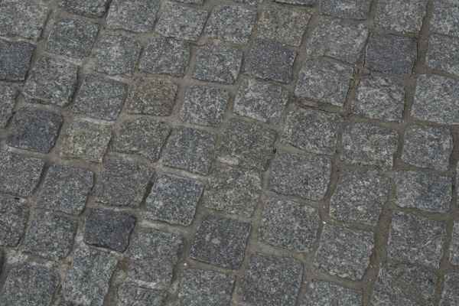17_1.png:** 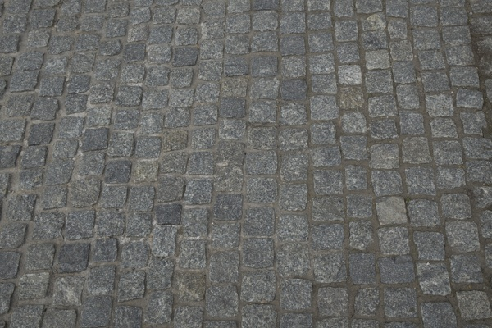

**Table 1 - Found homography parameters and normalization accuracy assessment**

|  |  |  |  |  |  |  |  |  |  |  |  |  |
| --- | --- | --- | --- | --- | --- | --- | --- | --- | --- | --- | --- | --- |
| Original:  img1: 0 img2: 0 | h11 | h12 | h13 | h21 | h22 | h23 | h31 | h32 | h33 | avg ErrIM (pixel) | max ErrIM | Expert rate |
| SIFT | 0,491 | 0,114 | 102,644 | -0,11 | 0,488 | 132,14 | 0 | 0 | 1 | 0,287 | 1,683 |  |
| SURF128 | 0,497 | 0,116 | 101,811 | -0,109 | 0,491 | 131,876 | 0 | 0 | 1 | 0,687 | 2,699 |  |
| SURF64 | 0,495 | 0,113 | 102,222 | -0,109 | 0,488 | 131,806 | 0 | 0 | 1 | 0,8 | 2,766 |  |
| ORB | 0,495 | 0,113 | 102,438 | -0,11 | 0,489 | 131,767 | 0 | 0 | 1 | 0,645 | 2,328 |  |
| ORB1000 | 0,509 | 0,126 | 99,953 | -0,108 | 0,503 | 131,56 | 0 | 0 | 1 | 0,724 | 2,069 |  |
| BRISK | 0,491 | 0,112 | 102,634 | -0,111 | 0,487 | 132,036 | 0 | 0 | 1 | 0,438 | 1,759 |  |
| KAZE | 0 | 0 | 0 | 0 | 0 | 0 | 0 | 0 | 0 | -1 | ~ |  |
| AKAZE | 0 | 0 | 0 | 0 | 0 | 0 | 0 | 0 | 0 | -1 | ~ |  |
|  |  |  |  |  |  |  |  |  |  |  |  |  |

where h11, h12, h13, h21, h22, h23, h31, h32, h33 - parameters of found homography matrix H* or of original one H;   
avgErrPar - average error of found parameters, the accuracy of found homography matrix parameters with a preliminary minimax normalization of found and original matrices;  
avgErrIM - average error of inlier coordinate matching;  
inliers - correct matches; outliers - false matches;  
maxErrIM – maximum error of inlier coordinate matching;  
avgErrCPM - average error of corner point matching;  
maxErrCPM - maximum error of corner point matching;  
expert rate - experts assessment of normalization accuracy with a 5-point scale: 0 - normalization failed, 1 - insufficient, 2 - satisfactory, 3 - good, 4 – excellent.

**Table 2 - Quantitative evaluation of descriptors, precision and recall estimation (with found overlap)**

|  |  |  |  |  |  |  |  |  |  |  |  |  |  |  |  |  |
| --- | --- | --- | --- | --- | --- | --- | --- | --- | --- | --- | --- | --- | --- | --- | --- | --- |
| Name | NP1 | NP2 | NM | NI | DP1 | DP2 | OP1 | OP2 | NPO1 | NPO2 | NMO | DPO1 | DPO2 | Precision | RecallO1 | Comments |
| SIFT | 2590 | 1499 | 215 | 212 | 0,0108 | 0,0062 | 100 | 24,6446 | 2590 | 377 | 215 | 0,0108 | 0,0064 | 0,986 | 0,0819 |  |
| SURF128 | 2783 | 2602 | 107 | 93 | 0,0116 | 0,0108 | 100 | 24,6325 | 2783 | 785 | 107 | 0,0116 | 0,0133 | 0,8692 | 0,0334 |  |
| SURF64 | 2783 | 2602 | 186 | 176 | 0,0116 | 0,0108 | 100 | 24,6613 | 2783 | 787 | 186 | 0,0116 | 0,0133 | 0,9462 | 0,0632 |  |
| ORB | 11340 | 7595 | 389 | 365 | 0,0473 | 0,0316 | 100 | 24,8154 | 11340 | 2824 | 389 | 0,0473 | 0,0474 | 0,9383 | 0,0322 |  |
| ORB1000 | 943 | 909 | 83 | 70 | 0,0039 | 0,0038 | 100 | 24,7146 | 943 | 363 | 83 | 0,0039 | 0,0061 | 0,8434 | 0,0742 |  |
| BRISK | 3231 | 1697 | 106 | 96 | 0,0135 | 0,0071 | 100 | 24,7492 | 3231 | 555 | 106 | 0,0135 | 0,0093 | 0,9057 | 0,0297 |  |
| KAZE | 105 | 47 | 2 | 0 | 0,0004 | 0,0002 | 0 | 0 | 0 | 0 | 0 | � | � | 0 | � |  |
| AKAZE | 135 | 58 | 5 | 0 | 0,0006 | 0,0002 | 0 | 0 | 0 | 0 | 0 | � | � | 0 | � |  |

where NP - number of found key points; NP1, NP2 - number of found key points for image1 and image2 respectively;  
NM - number of matches found with NNDR method, NM=NI+NO;  
NI - number of inliers found with RANSAC method;  
NO - number of outliers discarded with RANSAC method;   
DP - density of key points (per cent), DP= NP/(height x width) , height, width - vertical and horizontal image sizes respectively (pixels)  
DP1, DP2 - density of key points points for image1 and image2 respectively;  
OP1, OP2 - overlap percentage for image1 and image2 respectively;  
NPO1, NPO2 - number of found key points on overlap for image1 and image2 respectivelyy;  
NMO - number of matches on overlap found with NNDR method;  
DPO1, DPO2 - density of key points points on overlap for image1 and image2 respectively;   
OA - overlap area (pixels), OA1, OA2 - overlap area for image1 and image2 respectively;  
DPO1= NPO1/OA1; DPO2= NPO2/OA2;  
Precision = NI/ NM - the rate to evaluate the part of inliers to all found matches with NNDR method;  
RecallO1 = NI/ NPO1 - completeness of inlier retrieval relative to the number of all key points on overlap for image1. The rate illustrates usefulness of the found key points for normalization.

**Table 3 - Estimation of time costs**

|  |  |  |  |  |  |  |  |  |  |  |
| --- | --- | --- | --- | --- | --- | --- | --- | --- | --- | --- |
| Name | NP1 | NP2 | DesT1, sec | DesT2, sec | MatchT, sec | InlierT, sec | AvgDesT, ms | AvgMatchT, ms | AvgInlierT, ms | TotalNormT, sec |
| SIFT | 2590 | 1499 | 0,055238 | 0,046431 | 0,030995 | 0,000269 | 0,02615 | 0,144163 | 0,001267 | 0,132932 |
| SURF128 | 2783 | 2602 | 0,060469 | 0,058967 | 0,057364 | 0,000424 | 0,022194 | 0,53611 | 0,004554 | 0,177223 |
| SURF64 | 2783 | 2602 | 0,060976 | 0,061719 | 0,031065 | 0,000304 | 0,022814 | 0,167014 | 0,001729 | 0,154065 |
| ORB | 11340 | 7595 | 0,026178 | 0,018436 | 0,198311 | 0,00049 | 0,002367 | 0,509795 | 0,001342 | 0,243414 |
| ORB1000 | 943 | 909 | 0,010238 | 0,009092 | 0,003607 | 0,000478 | 0,010429 | 0,04346 | 0,006821 | 0,023415 |
| BRISK | 3231 | 1697 | 0,046557 | 0,023647 | 0,015433 | 0,000331 | 0,014171 | 0,145594 | 0,003452 | 0,085969 |
| KAZE | 105 | 47 | 0,106299 | 0,104562 | 0,00024 | 0 | 1,618551 | 0,119979 | 0 | 0,211101 |
| AKAZE | 135 | 58 | 0,017418 | 0,015853 | 0,000229 | 0,001501 | 0,201177 | 0,045806 | 0 | 0,035001 |

where DesT – descriptor creation time (time for key point detection and descriptor computation), DesT1, DesT2 – creation time of descriptors for image1 and image2 respectively;  
MatchT - retrieval time of matching found with NNDR method for the pair;  
InlierT – inlier retrieval time found with RANSAC method for the pair;  
AvgDesT – average time for one descriptor creation;  
AvgMatchT - average time for one match retrieval with NNDR method;  
AvgInlierT – average time for one inlier retrieval with RANSAC method;  
TotalNormT – total normalization time for the pair.