**Normalization results for pairs 18_0.png_18_1.png from subset png\texture_artificial**

**18_0.png: 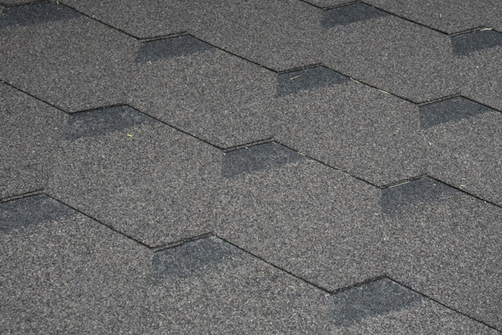18_1.png:** 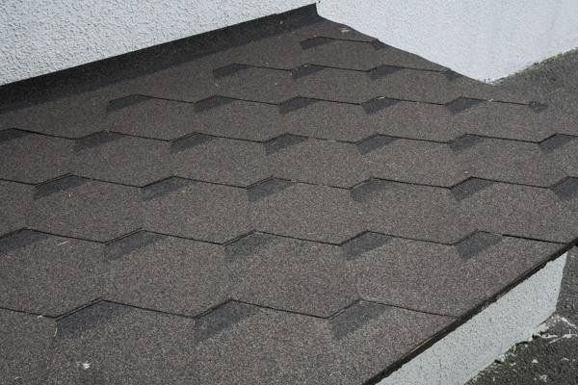

**Table 1 - Found homography parameters and normalization accuracy assessment**

|  |  |  |  |  |  |  |  |  |  |  |  |  |
| --- | --- | --- | --- | --- | --- | --- | --- | --- | --- | --- | --- | --- |
| Original:  img1: 0 img2: 0 | h11 | h12 | h13 | h21 | h22 | h23 | h31 | h32 | h33 | avg ErrIM (pixel) | max ErrIM | Expert rate |
| SIFT | 0,573 | 0,236 | 70,512 | -0,092 | 0,489 | 141,051 | 0 | 0 | 1 | 0,258 | 0,528 |  |
| SURF128 | 0,655 | 0,223 | 56,908 | -0,07 | 0,498 | 139,03 | 0 | 0 | 1 | 0,89 | 2,413 |  |
| SURF64 | 0,562 | 0,216 | 74,59 | -0,094 | 0,476 | 141,696 | 0 | 0 | 1 | 0,892 | 2,153 |  |
| ORB | 0,586 | 0,237 | 69,115 | -0,089 | 0,491 | 141,102 | 0 | 0 | 1 | 0,646 | 1,897 |  |
| ORB1000 | 0,608 | 0,279 | 62,081 | -0,09 | 0,53 | 139,592 | 0 | 0 | 1 | 0,675 | 1,402 |  |
| BRISK | 0,577 | 0,221 | 71,565 | -0,088 | 0,48 | 140,697 | 0 | 0 | 1 | 0,458 | 1,052 |  |
| KAZE | 0 | 0 | 0 | 0 | 0 | 0 | 0 | 0 | 0 | -1 | ~ |  |
| AKAZE | 0 | 0 | 0 | 0 | 0 | 0 | 0 | 0 | 0 | -1 | ~ |  |
|  |  |  |  |  |  |  |  |  |  |  |  |  |

where h11, h12, h13, h21, h22, h23, h31, h32, h33 - parameters of found homography matrix H* or of original one H;   
avgErrPar - average error of found parameters, the accuracy of found homography matrix parameters with a preliminary minimax normalization of found and original matrices;  
avgErrIM - average error of inlier coordinate matching;  
inliers - correct matches; outliers - false matches;  
maxErrIM – maximum error of inlier coordinate matching;  
avgErrCPM - average error of corner point matching;  
maxErrCPM - maximum error of corner point matching;  
expert rate - experts assessment of normalization accuracy with a 5-point scale: 0 - normalization failed, 1 - insufficient, 2 - satisfactory, 3 - good, 4 – excellent.

**Table 2 - Quantitative evaluation of descriptors, precision and recall estimation (with found overlap)**

|  |  |  |  |  |  |  |  |  |  |  |  |  |  |  |  |  |
| --- | --- | --- | --- | --- | --- | --- | --- | --- | --- | --- | --- | --- | --- | --- | --- | --- |
| Name | NP1 | NP2 | NM | NI | DP1 | DP2 | OP1 | OP2 | NPO1 | NPO2 | NMO | DPO1 | DPO2 | Precision | RecallO1 | Comments |
| SIFT | 1123 | 452 | 20 | 17 | 0,0047 | 0,0019 | 100 | 24,8946 | 1123 | 55 | 20 | 0,0047 | 0,0009 | 0,85 | 0,0151 |  |
| SURF128 | 2570 | 1470 | 14 | 7 | 0,0107 | 0,0061 | 100 | 26,4037 | 2570 | 420 | 14 | 0,0107 | 0,0066 | 0,5 | 0,0027 |  |
| SURF64 | 2570 | 1470 | 45 | 25 | 0,0107 | 0,0061 | 100 | 24,7625 | 2570 | 398 | 45 | 0,0107 | 0,0067 | 0,5556 | 0,0097 |  |
| ORB | 12070 | 3268 | 65 | 44 | 0,0503 | 0,0136 | 100 | 25,0075 | 12070 | 958 | 65 | 0,0503 | 0,016 | 0,6769 | 0,0036 |  |
| ORB1000 | 816 | 628 | 17 | 13 | 0,0034 | 0,0026 | 100 | 25,3017 | 816 | 134 | 17 | 0,0034 | 0,0022 | 0,7647 | 0,0159 |  |
| BRISK | 3329 | 740 | 21 | 16 | 0,0139 | 0,0031 | 100 | 24,95 | 3329 | 138 | 21 | 0,0139 | 0,0023 | 0,7619 | 0,0048 |  |
| KAZE | 18 | 141 | 1 | 0 | 0,0001 | 0,0006 | 0 | 0 | 0 | 0 | 0 | � | � | 0 | � |  |
| AKAZE | 31 | 43 | 0 | 0 | 0,0001 | 0,0002 | 0 | 0 | 0 | 0 | 0 | � | � | � | � |  |

where NP - number of found key points; NP1, NP2 - number of found key points for image1 and image2 respectively;  
NM - number of matches found with NNDR method, NM=NI+NO;  
NI - number of inliers found with RANSAC method;  
NO - number of outliers discarded with RANSAC method;   
DP - density of key points (per cent), DP= NP/(height x width) , height, width - vertical and horizontal image sizes respectively (pixels)  
DP1, DP2 - density of key points points for image1 and image2 respectively;  
OP1, OP2 - overlap percentage for image1 and image2 respectively;  
NPO1, NPO2 - number of found key points on overlap for image1 and image2 respectivelyy;  
NMO - number of matches on overlap found with NNDR method;  
DPO1, DPO2 - density of key points points on overlap for image1 and image2 respectively;   
OA - overlap area (pixels), OA1, OA2 - overlap area for image1 and image2 respectively;  
DPO1= NPO1/OA1; DPO2= NPO2/OA2;  
Precision = NI/ NM - the rate to evaluate the part of inliers to all found matches with NNDR method;  
RecallO1 = NI/ NPO1 - completeness of inlier retrieval relative to the number of all key points on overlap for image1. The rate illustrates usefulness of the found key points for normalization.

**Table 3 - Estimation of time costs**

|  |  |  |  |  |  |  |  |  |  |  |
| --- | --- | --- | --- | --- | --- | --- | --- | --- | --- | --- |
| Name | NP1 | NP2 | DesT1, sec | DesT2, sec | MatchT, sec | InlierT, sec | AvgDesT, ms | AvgMatchT, ms | AvgInlierT, ms | TotalNormT, sec |
| SIFT | 1123 | 452 | 0,047386 | 0,041753 | 0,004896 | 0,000349 | 0,067284 | 0,244821 | 0,0205 | 0,094383 |
| SURF128 | 2570 | 1470 | 0,056061 | 0,046937 | 0,030895 | 0,002237 | 0,026871 | 2,206817 | 0,319585 | 0,13613 |
| SURF64 | 2570 | 1470 | 0,060114 | 0,038585 | 0,018236 | 0,001479 | 0,024819 | 0,405253 | 0,059159 | 0,118415 |
| ORB | 12070 | 3268 | 0,024767 | 0,011334 | 0,096227 | 0,000694 | 0,002759 | 1,480415 | 0,015763 | 0,133022 |
| ORB1000 | 816 | 628 | 0,009572 | 0,007662 | 0,002005 | 0,000501 | 0,011965 | 0,11792 | 0,03857 | 0,01974 |
| BRISK | 3329 | 740 | 0,04544 | 0,012099 | 0,008697 | 0,000493 | 0,014999 | 0,414151 | 0,030826 | 0,066729 |
| KAZE | 18 | 141 | 0,104896 | 0,106304 | 0,000139 | 0 | 3,290737 | 0,138923 | 0 | 0,211339 |
| AKAZE | 31 | 43 | 0,017915 | 0,015941 | 0,000144 | 0 | 0,474309 | 0 | 0 | 0,034 |

where DesT – descriptor creation time (time for key point detection and descriptor computation), DesT1, DesT2 – creation time of descriptors for image1 and image2 respectively;  
MatchT - retrieval time of matching found with NNDR method for the pair;  
InlierT – inlier retrieval time found with RANSAC method for the pair;  
AvgDesT – average time for one descriptor creation;  
AvgMatchT - average time for one match retrieval with NNDR method;  
AvgInlierT – average time for one inlier retrieval with RANSAC method;  
TotalNormT – total normalization time for the pair.