**Normalization results for pairs 19_0.png_19_1.png from subset png\texture_artificial**

**19_0.png: 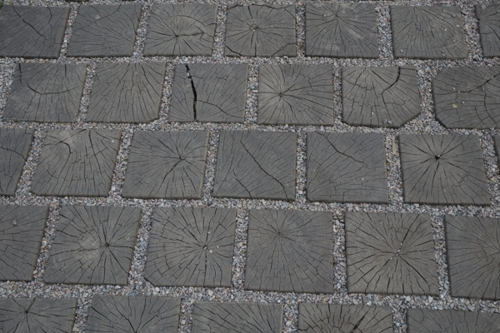19_1.png:** 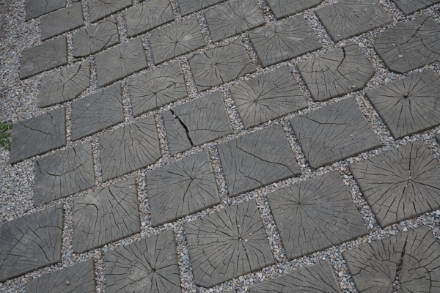

**Table 1 - Found homography parameters and normalization accuracy assessment**

|  |  |  |  |  |  |  |  |  |  |  |  |  |
| --- | --- | --- | --- | --- | --- | --- | --- | --- | --- | --- | --- | --- |
| Original:  img1: 0 img2: 0 | h11 | h12 | h13 | h21 | h22 | h23 | h31 | h32 | h33 | avg ErrIM (pixel) | max ErrIM | Expert rate |
| SIFT | 0,892 | 0,212 | 10,679 | -0,337 | 0,702 | 167,429 | 0 | -0 | 1 | 0,421 | 2,315 |  |
| SURF128 | 0,884 | 0,218 | 11,288 | -0,339 | 0,702 | 167,296 | -0 | -0 | 1 | 1,01 | 2,29 |  |
| SURF64 | 0,892 | 0,213 | 10,421 | -0,339 | 0,703 | 167,192 | 0 | -0 | 1 | 1,103 | 3,718 |  |
| ORB | 0,894 | 0,216 | 10,186 | -0,337 | 0,705 | 167,267 | 0 | -0 | 1 | 0,811 | 3,311 |  |
| ORB1000 | 0,891 | 0,216 | 10,512 | -0,339 | 0,706 | 167,343 | 0 | -0 | 1 | 0,946 | 2,739 |  |
| BRISK | 0,893 | 0,214 | 10,452 | -0,337 | 0,703 | 167,288 | 0 | -0 | 1 | 0,629 | 2,394 |  |
| KAZE | 0,893 | 0,211 | 10,597 | -0,337 | 0,702 | 167,498 | 0 | -0 | 1 | 0,553 | 2,783 |  |
| AKAZE | 0,893 | 0,213 | 10,548 | -0,336 | 0,702 | 167,273 | 0 | -0 | 1 | 0,423 | 1,167 |  |
|  |  |  |  |  |  |  |  |  |  |  |  |  |

where h11, h12, h13, h21, h22, h23, h31, h32, h33 - parameters of found homography matrix H* or of original one H;   
avgErrPar - average error of found parameters, the accuracy of found homography matrix parameters with a preliminary minimax normalization of found and original matrices;  
avgErrIM - average error of inlier coordinate matching;  
inliers - correct matches; outliers - false matches;  
maxErrIM – maximum error of inlier coordinate matching;  
avgErrCPM - average error of corner point matching;  
maxErrCPM - maximum error of corner point matching;  
expert rate - experts assessment of normalization accuracy with a 5-point scale: 0 - normalization failed, 1 - insufficient, 2 - satisfactory, 3 - good, 4 – excellent.

**Table 2 - Quantitative evaluation of descriptors, precision and recall estimation (with found overlap)**

|  |  |  |  |  |  |  |  |  |  |  |  |  |  |  |  |  |
| --- | --- | --- | --- | --- | --- | --- | --- | --- | --- | --- | --- | --- | --- | --- | --- | --- |
| Name | NP1 | NP2 | NM | NI | DP1 | DP2 | OP1 | OP2 | NPO1 | NPO2 | NMO | DPO1 | DPO2 | Precision | RecallO1 | Comments |
| SIFT | 1264 | 1529 | 514 | 513 | 0,0053 | 0,0064 | 84,0925 | 76,9979 | 1040 | 1101 | 514 | 0,0052 | 0,006 | 0,9981 | 0,4933 |  |
| SURF128 | 2176 | 2661 | 108 | 88 | 0,0091 | 0,0111 | 84,1246 | 76,9479 | 1933 | 2131 | 106 | 0,0096 | 0,0115 | 0,8148 | 0,0455 |  |
| SURF64 | 2176 | 2661 | 218 | 170 | 0,0091 | 0,0111 | 83,9562 | 77,1654 | 1928 | 2134 | 218 | 0,0096 | 0,0115 | 0,7798 | 0,0882 |  |
| ORB | 9281 | 9898 | 1755 | 1517 | 0,0387 | 0,0412 | 84,1046 | 77,0442 | 8502 | 8815 | 1751 | 0,0421 | 0,0477 | 0,8644 | 0,1784 |  |
| ORB1000 | 936 | 972 | 195 | 166 | 0,0039 | 0,004 | 83,9667 | 77,0975 | 867 | 910 | 195 | 0,0043 | 0,0049 | 0,8513 | 0,1915 |  |
| BRISK | 3605 | 3977 | 756 | 739 | 0,015 | 0,0166 | 84,0771 | 77,0404 | 3153 | 3336 | 753 | 0,0156 | 0,018 | 0,9775 | 0,2344 |  |
| KAZE | 179 | 262 | 92 | 90 | 0,0007 | 0,0011 | 84,0329 | 77,0392 | 152 | 213 | 92 | 0,0008 | 0,0012 | 0,9783 | 0,5921 |  |
| AKAZE | 291 | 314 | 123 | 122 | 0,0012 | 0,0013 | 84,0933 | 77,0192 | 258 | 268 | 123 | 0,0013 | 0,0014 | 0,9919 | 0,4729 |  |

where NP - number of found key points; NP1, NP2 - number of found key points for image1 and image2 respectively;  
NM - number of matches found with NNDR method, NM=NI+NO;  
NI - number of inliers found with RANSAC method;  
NO - number of outliers discarded with RANSAC method;   
DP - density of key points (per cent), DP= NP/(height x width) , height, width - vertical and horizontal image sizes respectively (pixels)  
DP1, DP2 - density of key points points for image1 and image2 respectively;  
OP1, OP2 - overlap percentage for image1 and image2 respectively;  
NPO1, NPO2 - number of found key points on overlap for image1 and image2 respectivelyy;  
NMO - number of matches on overlap found with NNDR method;  
DPO1, DPO2 - density of key points points on overlap for image1 and image2 respectively;   
OA - overlap area (pixels), OA1, OA2 - overlap area for image1 and image2 respectively;  
DPO1= NPO1/OA1; DPO2= NPO2/OA2;  
Precision = NI/ NM - the rate to evaluate the part of inliers to all found matches with NNDR method;  
RecallO1 = NI/ NPO1 - completeness of inlier retrieval relative to the number of all key points on overlap for image1. The rate illustrates usefulness of the found key points for normalization.

**Table 3 - Estimation of time costs**

|  |  |  |  |  |  |  |  |  |  |  |
| --- | --- | --- | --- | --- | --- | --- | --- | --- | --- | --- |
| Name | NP1 | NP2 | DesT1, sec | DesT2, sec | MatchT, sec | InlierT, sec | AvgDesT, ms | AvgMatchT, ms | AvgInlierT, ms | TotalNormT, sec |
| SIFT | 1264 | 1529 | 0,051479 | 0,052819 | 0,018806 | 0,000486 | 0,037635 | 0,036588 | 0,000946 | 0,12359 |
| SURF128 | 2176 | 2661 | 0,05075 | 0,056308 | 0,04419 | 0,00042 | 0,022241 | 0,40917 | 0,004774 | 0,151669 |
| SURF64 | 2176 | 2661 | 0,055392 | 0,060103 | 0,025116 | 0,000504 | 0,02402 | 0,115209 | 0,002965 | 0,141115 |
| ORB | 9281 | 9898 | 0,021072 | 0,022069 | 0,210638 | 0,001214 | 0,002249 | 0,120021 | 0,0008 | 0,254993 |
| ORB1000 | 936 | 972 | 0,009385 | 0,009562 | 0,002904 | 0,000455 | 0,009931 | 0,014892 | 0,00274 | 0,022306 |
| BRISK | 3605 | 3977 | 0,050338 | 0,057978 | 0,036618 | 0,000607 | 0,01427 | 0,048435 | 0,00082 | 0,14554 |
| KAZE | 179 | 262 | 0,110678 | 0,107306 | 0,000612 | 0,000284 | 0,513938 | 0,006656 | 0,003159 | 0,218881 |
| AKAZE | 291 | 314 | 0,018576 | 0,017054 | 0,000836 | 0,000291 | 0,059072 | 0,006793 | 0,002389 | 0,036756 |

where DesT – descriptor creation time (time for key point detection and descriptor computation), DesT1, DesT2 – creation time of descriptors for image1 and image2 respectively;  
MatchT - retrieval time of matching found with NNDR method for the pair;  
InlierT – inlier retrieval time found with RANSAC method for the pair;  
AvgDesT – average time for one descriptor creation;  
AvgMatchT - average time for one match retrieval with NNDR method;  
AvgInlierT – average time for one inlier retrieval with RANSAC method;  
TotalNormT – total normalization time for the pair.