**Normalization results for pairs 1_0.png_1_1.png from subset png\texture_artificial**

**1_0.png: 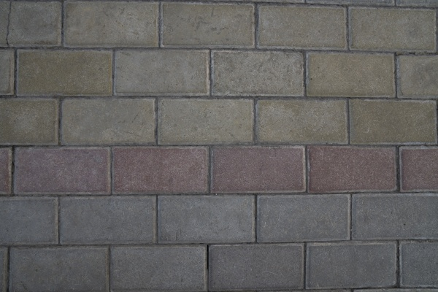1_1.png:** 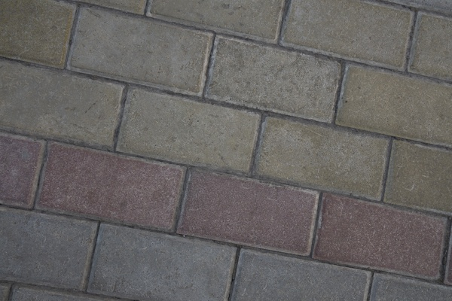

**Table 1 - Found homography parameters and normalization accuracy assessment**

|  |  |  |  |  |  |  |  |  |  |  |  |  |
| --- | --- | --- | --- | --- | --- | --- | --- | --- | --- | --- | --- | --- |
| Original:  img1: 0 img2: 0 | h11 | h12 | h13 | h21 | h22 | h23 | h31 | h32 | h33 | avg ErrIM (pixel) | max ErrIM | Expert rate |
| SIFT | 1,374 | -0,282 | -89,396 | 0,271 | 1,345 | -125,03 | 0 | -0 | 1 | 1,048 | 3,418 |  |
| SURF128 | 1,356 | -0,278 | -85,928 | 0,27 | 1,332 | -123,34 | 0 | -0 | 1 | 1,126 | 2,557 |  |
| SURF64 | 1,401 | -0,291 | -91,958 | 0,286 | 1,356 | -128,924 | 0 | -0 | 1 | 1,148 | 3,013 |  |
| ORB | 1,345 | -0,282 | -82,944 | 0,26 | 1,324 | -119,129 | 0 | -0 | 1 | 1,011 | 2,997 |  |
| ORB1000 | 1,349 | -0,279 | -83,801 | 0,265 | 1,331 | -121,529 | 0 | -0 | 1 | 1,043 | 2,83 |  |
| BRISK | 1,35 | -0,261 | -86,436 | 0,267 | 1,347 | -124,119 | 0 | -0 | 1 | 0,859 | 1,482 |  |
| KAZE | 1,248 | -0,274 | -62,484 | 0,227 | 1,262 | -104,191 | -0 | -0 | 1 | 0,422 | 0,799 |  |
| AKAZE | 1,342 | -0,335 | -76,985 | 0,282 | 1,24 | -115,284 | 0 | -0 | 1 | 0,256 | 0,486 |  |
|  |  |  |  |  |  |  |  |  |  |  |  |  |

where h11, h12, h13, h21, h22, h23, h31, h32, h33 - parameters of found homography matrix H* or of original one H;   
avgErrPar - average error of found parameters, the accuracy of found homography matrix parameters with a preliminary minimax normalization of found and original matrices;  
avgErrIM - average error of inlier coordinate matching;  
inliers - correct matches; outliers - false matches;  
maxErrIM – maximum error of inlier coordinate matching;  
avgErrCPM - average error of corner point matching;  
maxErrCPM - maximum error of corner point matching;  
expert rate - experts assessment of normalization accuracy with a 5-point scale: 0 - normalization failed, 1 - insufficient, 2 - satisfactory, 3 - good, 4 – excellent.

**Table 2 - Quantitative evaluation of descriptors, precision and recall estimation (with found overlap)**

|  |  |  |  |  |  |  |  |  |  |  |  |  |  |  |  |  |
| --- | --- | --- | --- | --- | --- | --- | --- | --- | --- | --- | --- | --- | --- | --- | --- | --- |
| Name | NP1 | NP2 | NM | NI | DP1 | DP2 | OP1 | OP2 | NPO1 | NPO2 | NMO | DPO1 | DPO2 | Precision | RecallO1 | Comments |
| SIFT | 812 | 586 | 280 | 265 | 0,0034 | 0,0024 | 52,6083 | 99,8425 | 423 | 586 | 276 | 0,0034 | 0,0024 | 0,9464 | 0,6265 |  |
| SURF128 | 731 | 921 | 82 | 63 | 0,003 | 0,0038 | 52,9696 | 99,8104 | 523 | 921 | 78 | 0,0041 | 0,0038 | 0,7683 | 0,1205 |  |
| SURF64 | 731 | 921 | 128 | 93 | 0,003 | 0,0038 | 53,0108 | 99,735 | 520 | 921 | 121 | 0,0041 | 0,0038 | 0,7266 | 0,1788 |  |
| ORB | 692 | 1008 | 137 | 108 | 0,0029 | 0,0042 | 53,2479 | 99,8308 | 496 | 1008 | 130 | 0,0039 | 0,0042 | 0,7883 | 0,2177 |  |
| ORB1000 | 517 | 551 | 117 | 92 | 0,0022 | 0,0023 | 53,315 | 99,8212 | 372 | 551 | 110 | 0,0029 | 0,0023 | 0,7863 | 0,2473 |  |
| BRISK | 99 | 126 | 19 | 18 | 0,0004 | 0,0005 | 53,1238 | 99,8829 | 66 | 126 | 19 | 0,0005 | 0,0005 | 0,9474 | 0,2727 |  |
| KAZE | 18 | 27 | 6 | 5 | 0,0001 | 0,0001 | 54,7225 | 99,8529 | 8 | 27 | 5 | 0,0001 | 0,0001 | 0,8333 | 0,625 |  |
| AKAZE | 15 | 18 | 6 | 5 | 0,0001 | 0,0001 | 53,9196 | 99,1221 | 11 | 18 | 5 | 0,0001 | 0,0001 | 0,8333 | 0,4545 |  |

where NP - number of found key points; NP1, NP2 - number of found key points for image1 and image2 respectively;  
NM - number of matches found with NNDR method, NM=NI+NO;  
NI - number of inliers found with RANSAC method;  
NO - number of outliers discarded with RANSAC method;   
DP - density of key points (per cent), DP= NP/(height x width) , height, width - vertical and horizontal image sizes respectively (pixels)  
DP1, DP2 - density of key points points for image1 and image2 respectively;  
OP1, OP2 - overlap percentage for image1 and image2 respectively;  
NPO1, NPO2 - number of found key points on overlap for image1 and image2 respectivelyy;  
NMO - number of matches on overlap found with NNDR method;  
DPO1, DPO2 - density of key points points on overlap for image1 and image2 respectively;   
OA - overlap area (pixels), OA1, OA2 - overlap area for image1 and image2 respectively;  
DPO1= NPO1/OA1; DPO2= NPO2/OA2;  
Precision = NI/ NM - the rate to evaluate the part of inliers to all found matches with NNDR method;  
RecallO1 = NI/ NPO1 - completeness of inlier retrieval relative to the number of all key points on overlap for image1. The rate illustrates usefulness of the found key points for normalization.

**Table 3 - Estimation of time costs**

|  |  |  |  |  |  |  |  |  |  |  |
| --- | --- | --- | --- | --- | --- | --- | --- | --- | --- | --- |
| Name | NP1 | NP2 | DesT1, sec | DesT2, sec | MatchT, sec | InlierT, sec | AvgDesT, ms | AvgMatchT, ms | AvgInlierT, ms | TotalNormT, sec |
| SIFT | 812 | 586 | 0,046963 | 0,043406 | 0,004383 | 0,000395 | 0,065953 | 0,015653 | 0,001488 | 0,095146 |
| SURF128 | 731 | 921 | 0,038522 | 0,036087 | 0,005739 | 0,00066 | 0,045939 | 0,06999 | 0,010478 | 0,081008 |
| SURF64 | 731 | 921 | 0,036337 | 0,03631 | 0,003464 | 0,000602 | 0,044566 | 0,027058 | 0,006474 | 0,076712 |
| ORB | 692 | 1008 | 0,007154 | 0,007606 | 0,002491 | 0,000493 | 0,008941 | 0,018182 | 0,004563 | 0,017744 |
| ORB1000 | 517 | 551 | 0,006772 | 0,006908 | 0,001238 | 0,00047 | 0,012817 | 0,010581 | 0,005105 | 0,015387 |
| BRISK | 99 | 126 | 0,004029 | 0,0038 | 0,000234 | 0,000497 | 0,035428 | 0,012305 | 0,027629 | 0,00856 |
| KAZE | 18 | 27 | 0,104515 | 0,107433 | 0,000093 | 0,000346 | 4,892694 | 0,015473 | 0,06929 | 0,212387 |
| AKAZE | 15 | 18 | 0,017375 | 0,016301 | 0,000121 | 0,000339 | 1,031979 | 0,020195 | 0,067857 | 0,034137 |

where DesT – descriptor creation time (time for key point detection and descriptor computation), DesT1, DesT2 – creation time of descriptors for image1 and image2 respectively;  
MatchT - retrieval time of matching found with NNDR method for the pair;  
InlierT – inlier retrieval time found with RANSAC method for the pair;  
AvgDesT – average time for one descriptor creation;  
AvgMatchT - average time for one match retrieval with NNDR method;  
AvgInlierT – average time for one inlier retrieval with RANSAC method;  
TotalNormT – total normalization time for the pair.