**Normalization results for pairs 20_0.png_20_1.png from subset png\texture_artificial**

**20_0.png: 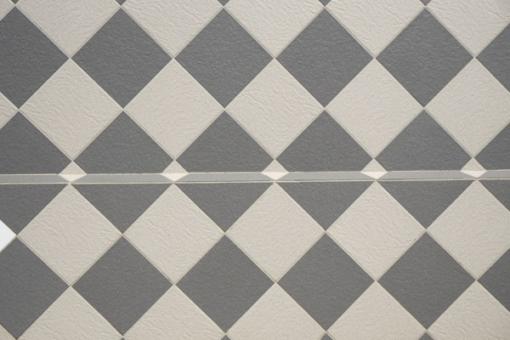20_1.png:** 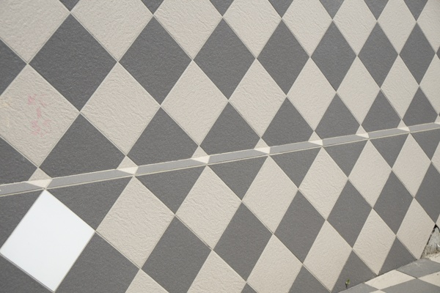

**Table 1 - Found homography parameters and normalization accuracy assessment**

|  |  |  |  |  |  |  |  |  |  |  |  |  |
| --- | --- | --- | --- | --- | --- | --- | --- | --- | --- | --- | --- | --- |
| Original:  img1: 0 img2: 0 | h11 | h12 | h13 | h21 | h22 | h23 | h31 | h32 | h33 | avg ErrIM (pixel) | max ErrIM | Expert rate |
| SIFT | 1,108 | 0,186 | 70,377 | 0,045 | 1,189 | 5,303 | 0,001 | 0 | 1 | 0,909 | 2,398 |  |
| SURF128 | 0,158 | -0,771 | 122,742 | 0,408 | -1,986 | 315,991 | 0,001 | -0,006 | 1 | 3,018 | 61,207 |  |
| SURF64 | -0,016 | -0,161 | 54,549 | -0,024 | -0,247 | 83,921 | -0 | -0,003 | 1 | 5,888 | 70,472 |  |
| ORB | 1,131 | 0,181 | 63,278 | 0,011 | 1,229 | 6,467 | 0,001 | 0 | 1 | 1,219 | 2,281 |  |
| ORB1000 | 1,131 | 0,181 | 63,278 | 0,011 | 1,229 | 6,467 | 0,001 | 0 | 1 | 1,219 | 2,281 |  |
| BRISK | -0,092 | -0,653 | 160,895 | -0,13 | -0,93 | 229,072 | -0,001 | -0,004 | 1 | 0,906 | 1,971 |  |
| KAZE | -0,097 | -0,089 | 36,88 | -0,201 | -0,199 | 79,266 | -0,003 | -0,002 | 1 | 0,554 | 1,551 |  |
| AKAZE | 0,361 | -1,064 | 97,803 | 0,413 | -1,314 | 135,625 | 0,002 | -0,008 | 1 | 20,85 | 53,143 |  |
|  |  |  |  |  |  |  |  |  |  |  |  |  |

where h11, h12, h13, h21, h22, h23, h31, h32, h33 - parameters of found homography matrix H* or of original one H;   
avgErrPar - average error of found parameters, the accuracy of found homography matrix parameters with a preliminary minimax normalization of found and original matrices;  
avgErrIM - average error of inlier coordinate matching;  
inliers - correct matches; outliers - false matches;  
maxErrIM – maximum error of inlier coordinate matching;  
avgErrCPM - average error of corner point matching;  
maxErrCPM - maximum error of corner point matching;  
expert rate - experts assessment of normalization accuracy with a 5-point scale: 0 - normalization failed, 1 - insufficient, 2 - satisfactory, 3 - good, 4 – excellent.

**Table 2 - Quantitative evaluation of descriptors, precision and recall estimation (with found overlap)**

|  |  |  |  |  |  |  |  |  |  |  |  |  |  |  |  |  |
| --- | --- | --- | --- | --- | --- | --- | --- | --- | --- | --- | --- | --- | --- | --- | --- | --- |
| Name | NP1 | NP2 | NM | NI | DP1 | DP2 | OP1 | OP2 | NPO1 | NPO2 | NMO | DPO1 | DPO2 | Precision | RecallO1 | Comments |
| SIFT | 643 | 889 | 86 | 15 | 0,0027 | 0,0037 | 98,2188 | 63,2767 | 638 | 581 | 86 | 0,0027 | 0,0038 | 0,1744 | 0,0235 |  |
| SURF128 | 1017 | 1353 | 129 | 40 | 0,0042 | 0,0056 | 99,6962 | 96,5288 | 1013 | 1312 | 128 | 0,0042 | 0,0057 | 0,3101 | 0,0395 |  |
| SURF64 | 1017 | 1353 | 135 | 27 | 0,0042 | 0,0056 | 99,3896 | 27,3029 | 1015 | 447 | 135 | 0,0043 | 0,0068 | 0,2 | 0,0266 |  |
| ORB | 587 | 903 | 55 | 11 | 0,0024 | 0,0038 | 98,9471 | 67,4121 | 587 | 786 | 55 | 0,0025 | 0,0049 | 0,2 | 0,0187 |  |
| ORB1000 | 587 | 899 | 55 | 11 | 0,0024 | 0,0037 | 98,9471 | 67,4121 | 587 | 783 | 55 | 0,0025 | 0,0048 | 0,2 | 0,0187 |  |
| BRISK | 290 | 438 | 37 | 9 | 0,0012 | 0,0018 | 99,985 | 87,6154 | 289 | 402 | 37 | 0,0012 | 0,0019 | 0,2432 | 0,0311 |  |
| KAZE | 214 | 385 | 38 | 12 | 0,0009 | 0,0016 | 98,7825 | 97,7021 | 214 | 380 | 38 | 0,0009 | 0,0016 | 0,3158 | 0,0561 |  |
| AKAZE | 185 | 281 | 37 | 7 | 0,0008 | 0,0012 | 94,7762 | 96,4196 | 173 | 273 | 35 | 0,0008 | 0,0012 | 0,1892 | 0,0405 |  |

where NP - number of found key points; NP1, NP2 - number of found key points for image1 and image2 respectively;  
NM - number of matches found with NNDR method, NM=NI+NO;  
NI - number of inliers found with RANSAC method;  
NO - number of outliers discarded with RANSAC method;   
DP - density of key points (per cent), DP= NP/(height x width) , height, width - vertical and horizontal image sizes respectively (pixels)  
DP1, DP2 - density of key points points for image1 and image2 respectively;  
OP1, OP2 - overlap percentage for image1 and image2 respectively;  
NPO1, NPO2 - number of found key points on overlap for image1 and image2 respectivelyy;  
NMO - number of matches on overlap found with NNDR method;  
DPO1, DPO2 - density of key points points on overlap for image1 and image2 respectively;   
OA - overlap area (pixels), OA1, OA2 - overlap area for image1 and image2 respectively;  
DPO1= NPO1/OA1; DPO2= NPO2/OA2;  
Precision = NI/ NM - the rate to evaluate the part of inliers to all found matches with NNDR method;  
RecallO1 = NI/ NPO1 - completeness of inlier retrieval relative to the number of all key points on overlap for image1. The rate illustrates usefulness of the found key points for normalization.

**Table 3 - Estimation of time costs**

|  |  |  |  |  |  |  |  |  |  |  |
| --- | --- | --- | --- | --- | --- | --- | --- | --- | --- | --- |
| Name | NP1 | NP2 | DesT1, sec | DesT2, sec | MatchT, sec | InlierT, sec | AvgDesT, ms | AvgMatchT, ms | AvgInlierT, ms | TotalNormT, sec |
| SIFT | 643 | 889 | 0,045193 | 0,047881 | 0,004973 | 0,050783 | 0,06207 | 0,05782 | 3,385503 | 0,148828 |
| SURF128 | 1017 | 1353 | 0,052447 | 0,049791 | 0,011328 | 0,014909 | 0,044184 | 0,087815 | 0,372727 | 0,128474 |
| SURF64 | 1017 | 1353 | 0,051091 | 0,055214 | 0,00625 | 0,050684 | 0,045522 | 0,046299 | 1,877181 | 0,16324 |
| ORB | 587 | 903 | 0,007269 | 0,008614 | 0,001882 | 0,049789 | 0,01096 | 0,03422 | 4,526266 | 0,067554 |
| ORB1000 | 587 | 899 | 0,007192 | 0,007919 | 0,001868 | 0,049297 | 0,010529 | 0,033971 | 4,481583 | 0,066277 |
| BRISK | 290 | 438 | 0,006532 | 0,008892 | 0,000668 | 0,037374 | 0,021412 | 0,018053 | 4,152699 | 0,053466 |
| KAZE | 214 | 385 | 0,108004 | 0,176114 | 0,000915 | 0,013891 | 0,481064 | 0,024072 | 1,157575 | 0,298923 |
| AKAZE | 185 | 281 | 0,017978 | 0,017028 | 0,000433 | 0,049949 | 0,078886 | 0,011716 | 7,135623 | 0,085388 |

where DesT – descriptor creation time (time for key point detection and descriptor computation), DesT1, DesT2 – creation time of descriptors for image1 and image2 respectively;  
MatchT - retrieval time of matching found with NNDR method for the pair;  
InlierT – inlier retrieval time found with RANSAC method for the pair;  
AvgDesT – average time for one descriptor creation;  
AvgMatchT - average time for one match retrieval with NNDR method;  
AvgInlierT – average time for one inlier retrieval with RANSAC method;  
TotalNormT – total normalization time for the pair.