**Normalization results for pairs 2_0.png_2_1.png from subset png\texture_artificial**

**2_0.png: 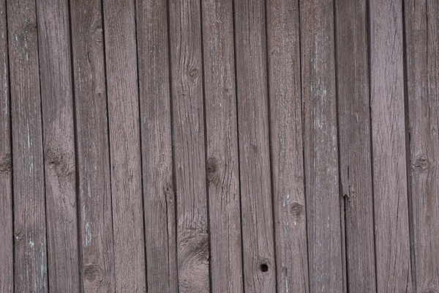2_1.png:** 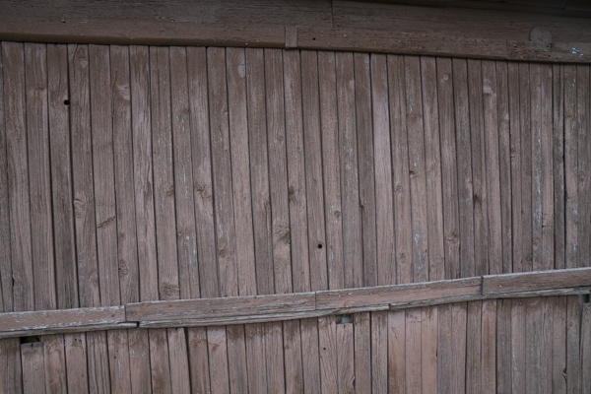

**Table 1 - Found homography parameters and normalization accuracy assessment**

|  |  |  |  |  |  |  |  |  |  |  |  |  |
| --- | --- | --- | --- | --- | --- | --- | --- | --- | --- | --- | --- | --- |
| Original:  img1: 0 img2: 0 | h11 | h12 | h13 | h21 | h22 | h23 | h31 | h32 | h33 | avg ErrIM (pixel) | max ErrIM | Expert rate |
| SIFT | 0,502 | 0,003 | 168,305 | 0,037 | 0,441 | 95,119 | 0 | -0 | 1 | 0,391 | 1,232 |  |
| SURF128 | 0,504 | 0,006 | 167,994 | 0,038 | 0,443 | 95,169 | 0 | 0 | 1 | 0,772 | 2,901 |  |
| SURF64 | 0,508 | 0,009 | 167,418 | 0,04 | 0,448 | 94,596 | 0 | 0 | 1 | 0,804 | 2,94 |  |
| ORB | 0,518 | 0,006 | 167,188 | 0,043 | 0,449 | 94,283 | 0 | 0 | 1 | 0,575 | 1,103 |  |
| ORB1000 | 0,019 | -0,199 | 46,766 | 0,209 | -1,551 | 336,986 | 0,001 | -0,005 | 1 | 0,55 | 1,159 |  |
| BRISK | 0,224 | -4,269 | 222,966 | 0,24 | -4,587 | 239,537 | 0,001 | -0,019 | 1 | 46,062 | 174,174 |  |
| KAZE | 0 | 0 | 0 | 0 | 0 | 0 | 0 | 0 | 0 | -1 | ~ |  |
| AKAZE | 0 | 0 | 0 | 0 | 0 | 0 | 0 | 0 | 0 | -1 | ~ |  |
|  |  |  |  |  |  |  |  |  |  |  |  |  |

where h11, h12, h13, h21, h22, h23, h31, h32, h33 - parameters of found homography matrix H* or of original one H;   
avgErrPar - average error of found parameters, the accuracy of found homography matrix parameters with a preliminary minimax normalization of found and original matrices;  
avgErrIM - average error of inlier coordinate matching;  
inliers - correct matches; outliers - false matches;  
maxErrIM – maximum error of inlier coordinate matching;  
avgErrCPM - average error of corner point matching;  
maxErrCPM - maximum error of corner point matching;  
expert rate - experts assessment of normalization accuracy with a 5-point scale: 0 - normalization failed, 1 - insufficient, 2 - satisfactory, 3 - good, 4 – excellent.

**Table 2 - Quantitative evaluation of descriptors, precision and recall estimation (with found overlap)**

|  |  |  |  |  |  |  |  |  |  |  |  |  |  |  |  |  |
| --- | --- | --- | --- | --- | --- | --- | --- | --- | --- | --- | --- | --- | --- | --- | --- | --- |
| Name | NP1 | NP2 | NM | NI | DP1 | DP2 | OP1 | OP2 | NPO1 | NPO2 | NMO | DPO1 | DPO2 | Precision | RecallO1 | Comments |
| SIFT | 981 | 833 | 96 | 75 | 0,0041 | 0,0035 | 100 | 17,1046 | 981 | 127 | 96 | 0,0041 | 0,0031 | 0,7812 | 0,0765 |  |
| SURF128 | 2968 | 2210 | 113 | 79 | 0,0124 | 0,0092 | 100 | 17,0404 | 2968 | 483 | 113 | 0,0124 | 0,0118 | 0,6991 | 0,0266 |  |
| SURF64 | 2968 | 2210 | 172 | 115 | 0,0124 | 0,0092 | 100 | 17,0896 | 2968 | 484 | 172 | 0,0124 | 0,0118 | 0,6686 | 0,0387 |  |
| ORB | 2477 | 1784 | 42 | 20 | 0,0103 | 0,0074 | 100 | 17,1462 | 2477 | 269 | 42 | 0,0103 | 0,0065 | 0,4762 | 0,0081 |  |
| ORB1000 | 718 | 804 | 11 | 6 | 0,003 | 0,0034 | 98,1792 | 94,0542 | 687 | 773 | 11 | 0,0029 | 0,0034 | 0,5455 | 0,0087 |  |
| BRISK | 445 | 383 | 4 | 4 | 0,0019 | 0,0016 | 98,2771 | 90,6038 | 437 | 352 | 2 | 0,0019 | 0,0016 | 1 | 0,0092 |  |
| KAZE | 49 | 82 | 2 | 0 | 0,0002 | 0,0003 | 0 | 0 | 0 | 0 | 0 | � | � | 0 | � |  |
| AKAZE | 39 | 77 | 2 | 0 | 0,0002 | 0,0003 | 0 | 0 | 0 | 0 | 0 | � | � | 0 | � |  |

where NP - number of found key points; NP1, NP2 - number of found key points for image1 and image2 respectively;  
NM - number of matches found with NNDR method, NM=NI+NO;  
NI - number of inliers found with RANSAC method;  
NO - number of outliers discarded with RANSAC method;   
DP - density of key points (per cent), DP= NP/(height x width) , height, width - vertical and horizontal image sizes respectively (pixels)  
DP1, DP2 - density of key points points for image1 and image2 respectively;  
OP1, OP2 - overlap percentage for image1 and image2 respectively;  
NPO1, NPO2 - number of found key points on overlap for image1 and image2 respectivelyy;  
NMO - number of matches on overlap found with NNDR method;  
DPO1, DPO2 - density of key points points on overlap for image1 and image2 respectively;   
OA - overlap area (pixels), OA1, OA2 - overlap area for image1 and image2 respectively;  
DPO1= NPO1/OA1; DPO2= NPO2/OA2;  
Precision = NI/ NM - the rate to evaluate the part of inliers to all found matches with NNDR method;  
RecallO1 = NI/ NPO1 - completeness of inlier retrieval relative to the number of all key points on overlap for image1. The rate illustrates usefulness of the found key points for normalization.

**Table 3 - Estimation of time costs**

|  |  |  |  |  |  |  |  |  |  |  |
| --- | --- | --- | --- | --- | --- | --- | --- | --- | --- | --- |
| Name | NP1 | NP2 | DesT1, sec | DesT2, sec | MatchT, sec | InlierT, sec | AvgDesT, ms | AvgMatchT, ms | AvgInlierT, ms | TotalNormT, sec |
| SIFT | 981 | 833 | 0,047392 | 0,044948 | 0,007135 | 0,000504 | 0,051134 | 0,074325 | 0,006717 | 0,099979 |
| SURF128 | 2968 | 2210 | 0,068321 | 0,058633 | 0,051357 | 0,000677 | 0,024774 | 0,454483 | 0,008567 | 0,178987 |
| SURF64 | 2968 | 2210 | 0,07081 | 0,05739 | 0,028936 | 0,000834 | 0,024912 | 0,168233 | 0,007254 | 0,157971 |
| ORB | 2477 | 1784 | 0,013572 | 0,009208 | 0,012119 | 0,002643 | 0,00532 | 0,288548 | 0,132147 | 0,037543 |
| ORB1000 | 718 | 804 | 0,007744 | 0,007588 | 0,00252 | 0,001479 | 0,010111 | 0,229065 | 0,246499 | 0,019331 |
| BRISK | 445 | 383 | 0,008762 | 0,007176 | 0,000969 | 0,000047 | 0,019212 | 0,242176 | 0,011861 | 0,016954 |
| KAZE | 49 | 82 | 0,10093 | 0,090452 | 0,000181 | 0 | 1,581438 | 0,090283 | 0 | 0,191563 |
| AKAZE | 39 | 77 | 0,015394 | 0,010541 | 0,000138 | 0 | 0,265806 | 0,068949 | 0 | 0,026073 |

where DesT – descriptor creation time (time for key point detection and descriptor computation), DesT1, DesT2 – creation time of descriptors for image1 and image2 respectively;  
MatchT - retrieval time of matching found with NNDR method for the pair;  
InlierT – inlier retrieval time found with RANSAC method for the pair;  
AvgDesT – average time for one descriptor creation;  
AvgMatchT - average time for one match retrieval with NNDR method;  
AvgInlierT – average time for one inlier retrieval with RANSAC method;  
TotalNormT – total normalization time for the pair.