**Normalization results for pairs 3_0.png_3_1.png from subset png\texture_artificial**

**3_0.png: 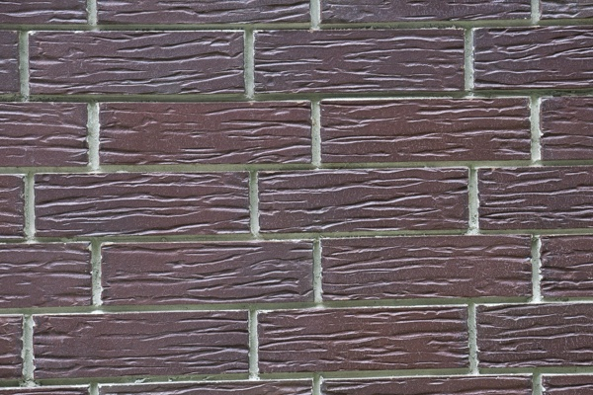3_1.png:** 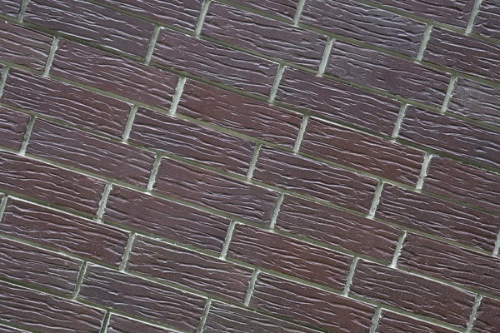

**Table 1 - Found homography parameters and normalization accuracy assessment**

|  |  |  |  |  |  |  |  |  |  |  |  |  |
| --- | --- | --- | --- | --- | --- | --- | --- | --- | --- | --- | --- | --- |
| Original:  img1: 0 img2: 0 | h11 | h12 | h13 | h21 | h22 | h23 | h31 | h32 | h33 | avg ErrIM (pixel) | max ErrIM | Expert rate |
| SIFT | 0,647 | -0,21 | 180,555 | 0,209 | 0,656 | 4,635 | -0 | 0 | 1 | 0,246 | 1,019 |  |
| SURF128 | 0,648 | -0,212 | 180,586 | 0,21 | 0,66 | 3,776 | -0 | 0 | 1 | 0,96 | 2,73 |  |
| SURF64 | 0,647 | -0,212 | 180,418 | 0,209 | 0,654 | 4,583 | -0 | 0 | 1 | 1,01 | 3,121 |  |
| ORB | 0,647 | -0,211 | 180,333 | 0,209 | 0,655 | 4,754 | -0 | 0 | 1 | 0,807 | 3,425 |  |
| ORB1000 | 0,65 | -0,211 | 180,164 | 0,211 | 0,658 | 4,181 | -0 | 0 | 1 | 0,797 | 2,235 |  |
| BRISK | 0,648 | -0,211 | 180,185 | 0,21 | 0,657 | 4,274 | -0 | 0 | 1 | 0,661 | 2,766 |  |
| KAZE | 0,646 | -0,21 | 180,402 | 0,208 | 0,657 | 4,668 | -0 | 0 | 1 | 0,632 | 2,69 |  |
| AKAZE | 0,651 | -0,213 | 180,218 | 0,211 | 0,657 | 4,178 | -0 | 0 | 1 | 0,323 | 1,676 |  |
|  |  |  |  |  |  |  |  |  |  |  |  |  |

where h11, h12, h13, h21, h22, h23, h31, h32, h33 - parameters of found homography matrix H* or of original one H;   
avgErrPar - average error of found parameters, the accuracy of found homography matrix parameters with a preliminary minimax normalization of found and original matrices;  
avgErrIM - average error of inlier coordinate matching;  
inliers - correct matches; outliers - false matches;  
maxErrIM – maximum error of inlier coordinate matching;  
avgErrCPM - average error of corner point matching;  
maxErrCPM - maximum error of corner point matching;  
expert rate - experts assessment of normalization accuracy with a 5-point scale: 0 - normalization failed, 1 - insufficient, 2 - satisfactory, 3 - good, 4 – excellent.

**Table 2 - Quantitative evaluation of descriptors, precision and recall estimation (with found overlap)**

|  |  |  |  |  |  |  |  |  |  |  |  |  |  |  |  |  |
| --- | --- | --- | --- | --- | --- | --- | --- | --- | --- | --- | --- | --- | --- | --- | --- | --- |
| Name | NP1 | NP2 | NM | NI | DP1 | DP2 | OP1 | OP2 | NPO1 | NPO2 | NMO | DPO1 | DPO2 | Precision | RecallO1 | Comments |
| SIFT | 1617 | 1312 | 410 | 390 | 0,0067 | 0,0055 | 100 | 47,8454 | 1617 | 730 | 410 | 0,0067 | 0,0064 | 0,9512 | 0,2412 |  |
| SURF128 | 4331 | 4458 | 89 | 70 | 0,018 | 0,0186 | 100 | 48,1304 | 4331 | 2414 | 89 | 0,018 | 0,0209 | 0,7865 | 0,0162 |  |
| SURF64 | 4331 | 4458 | 182 | 130 | 0,018 | 0,0186 | 100 | 47,9046 | 4331 | 2405 | 182 | 0,018 | 0,0209 | 0,7143 | 0,03 |  |
| ORB | 9044 | 11100 | 1412 | 1260 | 0,0377 | 0,0462 | 100 | 47,9779 | 9044 | 7487 | 1412 | 0,0377 | 0,065 | 0,8924 | 0,1393 |  |
| ORB1000 | 977 | 979 | 193 | 175 | 0,0041 | 0,0041 | 100 | 48,0171 | 977 | 802 | 193 | 0,0041 | 0,007 | 0,9067 | 0,1791 |  |
| BRISK | 3591 | 4302 | 387 | 356 | 0,015 | 0,0179 | 100 | 48,0096 | 3591 | 2644 | 387 | 0,015 | 0,0229 | 0,9199 | 0,0991 |  |
| KAZE | 404 | 319 | 89 | 86 | 0,0017 | 0,0013 | 100 | 47,92 | 404 | 214 | 89 | 0,0017 | 0,0019 | 0,9663 | 0,2129 |  |
| AKAZE | 402 | 309 | 90 | 76 | 0,0017 | 0,0013 | 100 | 47,9667 | 402 | 229 | 90 | 0,0017 | 0,002 | 0,8444 | 0,1891 |  |

where NP - number of found key points; NP1, NP2 - number of found key points for image1 and image2 respectively;  
NM - number of matches found with NNDR method, NM=NI+NO;  
NI - number of inliers found with RANSAC method;  
NO - number of outliers discarded with RANSAC method;   
DP - density of key points (per cent), DP= NP/(height x width) , height, width - vertical and horizontal image sizes respectively (pixels)  
DP1, DP2 - density of key points points for image1 and image2 respectively;  
OP1, OP2 - overlap percentage for image1 and image2 respectively;  
NPO1, NPO2 - number of found key points on overlap for image1 and image2 respectivelyy;  
NMO - number of matches on overlap found with NNDR method;  
DPO1, DPO2 - density of key points points on overlap for image1 and image2 respectively;   
OA - overlap area (pixels), OA1, OA2 - overlap area for image1 and image2 respectively;  
DPO1= NPO1/OA1; DPO2= NPO2/OA2;  
Precision = NI/ NM - the rate to evaluate the part of inliers to all found matches with NNDR method;  
RecallO1 = NI/ NPO1 - completeness of inlier retrieval relative to the number of all key points on overlap for image1. The rate illustrates usefulness of the found key points for normalization.

**Table 3 - Estimation of time costs**

|  |  |  |  |  |  |  |  |  |  |  |
| --- | --- | --- | --- | --- | --- | --- | --- | --- | --- | --- |
| Name | NP1 | NP2 | DesT1, sec | DesT2, sec | MatchT, sec | InlierT, sec | AvgDesT, ms | AvgMatchT, ms | AvgInlierT, ms | TotalNormT, sec |
| SIFT | 1617 | 1312 | 0,05646 | 0,053363 | 0,018578 | 0,000375 | 0,037794 | 0,045311 | 0,000962 | 0,128776 |
| SURF128 | 4331 | 4458 | 0,099097 | 0,088932 | 0,146018 | 0,000457 | 0,021414 | 1,640655 | 0,006524 | 0,334505 |
| SURF64 | 4331 | 4458 | 0,096573 | 0,086163 | 0,082099 | 0,00065 | 0,020812 | 0,45109 | 0,004996 | 0,265484 |
| ORB | 9044 | 11100 | 0,02067 | 0,023756 | 0,226637 | 0,000952 | 0,002212 | 0,160507 | 0,000755 | 0,272015 |
| ORB1000 | 977 | 979 | 0,009688 | 0,009946 | 0,003133 | 0,000377 | 0,010037 | 0,016231 | 0,002155 | 0,023144 |
| BRISK | 3591 | 4302 | 0,053065 | 0,06411 | 0,039703 | 0,000466 | 0,014839 | 0,10259 | 0,001309 | 0,157344 |
| KAZE | 404 | 319 | 0,108136 | 0,107809 | 0,001451 | 0,000379 | 0,302811 | 0,016307 | 0,004409 | 0,217776 |
| AKAZE | 402 | 309 | 0,017697 | 0,016834 | 0,000941 | 0,000397 | 0,049251 | 0,010459 | 0,005218 | 0,03587 |

where DesT – descriptor creation time (time for key point detection and descriptor computation), DesT1, DesT2 – creation time of descriptors for image1 and image2 respectively;  
MatchT - retrieval time of matching found with NNDR method for the pair;  
InlierT – inlier retrieval time found with RANSAC method for the pair;  
AvgDesT – average time for one descriptor creation;  
AvgMatchT - average time for one match retrieval with NNDR method;  
AvgInlierT – average time for one inlier retrieval with RANSAC method;  
TotalNormT – total normalization time for the pair.