**Normalization results for pairs 4_0.png_4_1.png from subset png\texture_artificial**

**4_0.png: 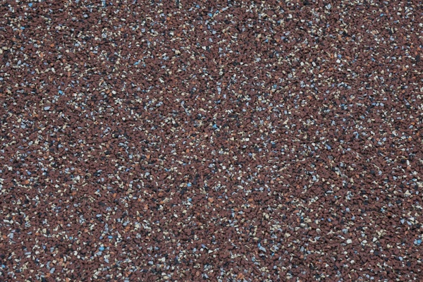4_1.png:** 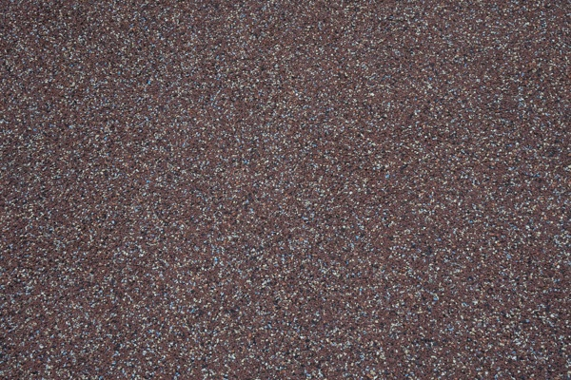

**Table 1 - Found homography parameters and normalization accuracy assessment**

|  |  |  |  |  |  |  |  |  |  |  |  |  |
| --- | --- | --- | --- | --- | --- | --- | --- | --- | --- | --- | --- | --- |
| Original:  img1: 0 img2: 0 | h11 | h12 | h13 | h21 | h22 | h23 | h31 | h32 | h33 | avg ErrIM (pixel) | max ErrIM | Expert rate |
| SIFT | 0,443 | 0,226 | 89,839 | -0,18 | 0,443 | 150,736 | 0 | 0 | 1 | 0,269 | 0,898 |  |
| SURF128 | 0 | 0 | 0 | 0 | 0 | 0 | 0 | 0 | 0 | -1 | ~ |  |
| SURF64 | 0,437 | 0,222 | 89,725 | -0,185 | 0,433 | 151,228 | 0 | 0 | 1 | 0,502 | 0,916 |  |
| ORB | 0,445 | 0,224 | 89,721 | -0,181 | 0,441 | 150,612 | 0 | 0 | 1 | 0,614 | 2,376 |  |
| ORB1000 | 0,442 | 0,22 | 91,022 | -0,179 | 0,437 | 150,388 | 0 | 0 | 1 | 0,536 | 1,195 |  |
| BRISK | 0,445 | 0,226 | 89,174 | -0,18 | 0,442 | 150,418 | 0 | 0 | 1 | 0,478 | 2,284 |  |
| KAZE | 0,437 | 0,225 | 90,353 | -0,183 | 0,442 | 150,866 | 0 | 0 | 1 | 0 | 0 |  |
| AKAZE | 0,432 | 0,228 | 90,098 | -0,187 | 0,444 | 150,686 | 0 | 0 | 1 | 0,481 | 1,05 |  |
|  |  |  |  |  |  |  |  |  |  |  |  |  |

where h11, h12, h13, h21, h22, h23, h31, h32, h33 - parameters of found homography matrix H* or of original one H;   
avgErrPar - average error of found parameters, the accuracy of found homography matrix parameters with a preliminary minimax normalization of found and original matrices;  
avgErrIM - average error of inlier coordinate matching;  
inliers - correct matches; outliers - false matches;  
maxErrIM – maximum error of inlier coordinate matching;  
avgErrCPM - average error of corner point matching;  
maxErrCPM - maximum error of corner point matching;  
expert rate - experts assessment of normalization accuracy with a 5-point scale: 0 - normalization failed, 1 - insufficient, 2 - satisfactory, 3 - good, 4 – excellent.

**Table 2 - Quantitative evaluation of descriptors, precision and recall estimation (with found overlap)**

|  |  |  |  |  |  |  |  |  |  |  |  |  |  |  |  |  |
| --- | --- | --- | --- | --- | --- | --- | --- | --- | --- | --- | --- | --- | --- | --- | --- | --- |
| Name | NP1 | NP2 | NM | NI | DP1 | DP2 | OP1 | OP2 | NPO1 | NPO2 | NMO | DPO1 | DPO2 | Precision | RecallO1 | Comments |
| SIFT | 5345 | 2412 | 242 | 238 | 0,0223 | 0,01 | 100 | 21,3562 | 5345 | 511 | 242 | 0,0223 | 0,01 | 0,9835 | 0,0445 |  |
| SURF128 | 3968 | 4105 | 3 | 0 | 0,0165 | 0,0171 | 0 | 0 | 0 | 0 | 0 | � | � | 0 | � |  |
| SURF64 | 3968 | 4105 | 17 | 11 | 0,0165 | 0,0171 | 100 | 21,6033 | 3968 | 1007 | 17 | 0,0165 | 0,0194 | 0,6471 | 0,0028 |  |
| ORB | 26243 | 24002 | 734 | 711 | 0,1093 | 0,1 | 100 | 21,4642 | 26243 | 7486 | 734 | 0,1093 | 0,1453 | 0,9687 | 0,0271 |  |
| ORB1000 | 1000 | 942 | 24 | 24 | 0,0042 | 0,0039 | 100 | 21,3521 | 1000 | 276 | 24 | 0,0042 | 0,0054 | 1 | 0,024 |  |
| BRISK | 11693 | 10932 | 229 | 218 | 0,0487 | 0,0456 | 100 | 21,4525 | 11693 | 2881 | 229 | 0,0487 | 0,056 | 0,952 | 0,0186 |  |
| KAZE | 1529 | 177 | 4 | 4 | 0,0064 | 0,0007 | 100 | 21,3575 | 1529 | 35 | 4 | 0,0064 | 0,0007 | 1 | 0,0026 |  |
| AKAZE | 1986 | 437 | 14 | 9 | 0,0083 | 0,0018 | 100 | 21,6288 | 1986 | 123 | 14 | 0,0083 | 0,0024 | 0,6429 | 0,0045 |  |

where NP - number of found key points; NP1, NP2 - number of found key points for image1 and image2 respectively;  
NM - number of matches found with NNDR method, NM=NI+NO;  
NI - number of inliers found with RANSAC method;  
NO - number of outliers discarded with RANSAC method;   
DP - density of key points (per cent), DP= NP/(height x width) , height, width - vertical and horizontal image sizes respectively (pixels)  
DP1, DP2 - density of key points points for image1 and image2 respectively;  
OP1, OP2 - overlap percentage for image1 and image2 respectively;  
NPO1, NPO2 - number of found key points on overlap for image1 and image2 respectivelyy;  
NMO - number of matches on overlap found with NNDR method;  
DPO1, DPO2 - density of key points points on overlap for image1 and image2 respectively;   
OA - overlap area (pixels), OA1, OA2 - overlap area for image1 and image2 respectively;  
DPO1= NPO1/OA1; DPO2= NPO2/OA2;  
Precision = NI/ NM - the rate to evaluate the part of inliers to all found matches with NNDR method;  
RecallO1 = NI/ NPO1 - completeness of inlier retrieval relative to the number of all key points on overlap for image1. The rate illustrates usefulness of the found key points for normalization.

**Table 3 - Estimation of time costs**

|  |  |  |  |  |  |  |  |  |  |  |
| --- | --- | --- | --- | --- | --- | --- | --- | --- | --- | --- |
| Name | NP1 | NP2 | DesT1, sec | DesT2, sec | MatchT, sec | InlierT, sec | AvgDesT, ms | AvgMatchT, ms | AvgInlierT, ms | TotalNormT, sec |
| SIFT | 5345 | 2412 | 0,066382 | 0,050801 | 0,102922 | 0,000338 | 0,01674 | 0,425298 | 0,001419 | 0,220443 |
| SURF128 | 3968 | 4105 | 0,091503 | 0,076407 | 0,135037 | 0 | 0,020836 | 45,012317 | 0 | 0,302947 |
| SURF64 | 3968 | 4105 | 0,082397 | 0,073195 | 0,074226 | 0,000828 | 0,019297 | 4,366216 | 0,07531 | 0,230646 |
| ORB | 26243 | 24002 | 0,049454 | 0,043928 | 1,388635 | 0,000592 | 0,001857 | 1,891873 | 0,000832 | 1,48261 |
| ORB1000 | 1000 | 942 | 0,013924 | 0,011626 | 0,003068 | 0,000229 | 0,013132 | 0,127829 | 0,009543 | 0,028847 |
| BRISK | 11693 | 10932 | 0,189258 | 0,16818 | 0,303901 | 0,000339 | 0,015784 | 1,327078 | 0,001556 | 0,661679 |
| KAZE | 1529 | 177 | 0,115752 | 0,091778 | 0,003408 | 0,000053 | 0,297112 | 0,851968 | 0,013141 | 0,21099 |
| AKAZE | 1986 | 437 | 0,020498 | 0,018013 | 0,0044 | 0,002415 | 0,02577 | 0,31427 | 0,268325 | 0,045326 |

where DesT – descriptor creation time (time for key point detection and descriptor computation), DesT1, DesT2 – creation time of descriptors for image1 and image2 respectively;  
MatchT - retrieval time of matching found with NNDR method for the pair;  
InlierT – inlier retrieval time found with RANSAC method for the pair;  
AvgDesT – average time for one descriptor creation;  
AvgMatchT - average time for one match retrieval with NNDR method;  
AvgInlierT – average time for one inlier retrieval with RANSAC method;  
TotalNormT – total normalization time for the pair.