**Normalization results for pairs 5_0.png_5_1.png from subset png\texture_artificial**

**5_0.png: 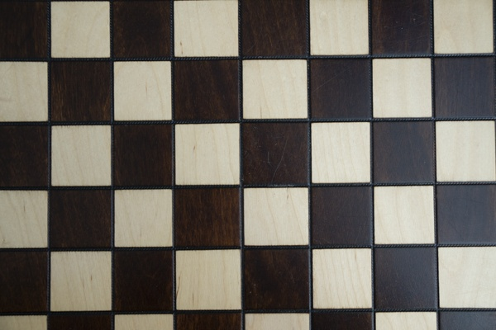5_1.png:** 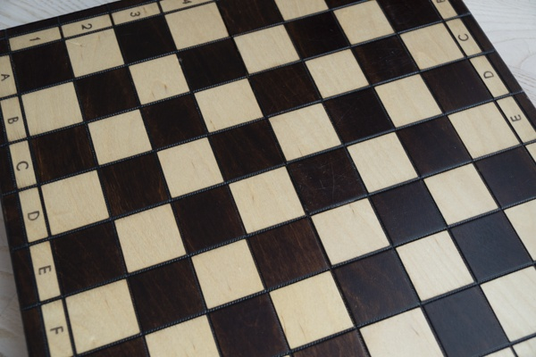

**Table 1 - Found homography parameters and normalization accuracy assessment**

|  |  |  |  |  |  |  |  |  |  |  |  |  |
| --- | --- | --- | --- | --- | --- | --- | --- | --- | --- | --- | --- | --- |
| Original:  img1: 0 img2: 0 | h11 | h12 | h13 | h21 | h22 | h23 | h31 | h32 | h33 | avg ErrIM (pixel) | max ErrIM | Expert rate |
| SIFT | -3,41 | 18,415 | -235,933 | -4,602 | 16,837 | 353,117 | -0,011 | 0,043 | 1 | 0,861 | 1,46 |  |
| SURF128 | -2,99 | 2,104 | 479,983 | -2,144 | 1,509 | 344,307 | -0,006 | 0,004 | 1 | 55,853 | 417,761 |  |
| SURF64 | -0,027 | -1,25 | 480,295 | -0,02 | -0,897 | 344,57 | -0 | -0,003 | 1 | 0,348 | 1,168 |  |
| ORB | -4,733 | -0,49 | 614,745 | -2,366 | 1,054 | -112,907 | -0,01 | -0,002 | 1 | 0,384 | 1,011 |  |
| ORB1000 | 0,954 | -1,871 | 268,683 | 0,866 | -0,713 | -38,634 | 0,002 | -0,005 | 1 | 0,557 | 0,962 |  |
| BRISK | 0,149 | -1,83 | 467,929 | 0,112 | -1,298 | 329,123 | 0 | -0,004 | 1 | 44,691 | 131,448 |  |
| KAZE | -0,241 | 0,026 | 252,431 | -0,545 | -0,258 | 396,68 | -0,001 | 0 | 1 | 0 | 0 |  |
| AKAZE | 0,062 | -1,144 | 325,424 | 0,013 | -0,582 | 173,739 | 0 | -0,003 | 1 | 0,317 | 0,778 |  |
|  |  |  |  |  |  |  |  |  |  |  |  |  |

where h11, h12, h13, h21, h22, h23, h31, h32, h33 - parameters of found homography matrix H* or of original one H;   
avgErrPar - average error of found parameters, the accuracy of found homography matrix parameters with a preliminary minimax normalization of found and original matrices;  
avgErrIM - average error of inlier coordinate matching;  
inliers - correct matches; outliers - false matches;  
maxErrIM – maximum error of inlier coordinate matching;  
avgErrCPM - average error of corner point matching;  
maxErrCPM - maximum error of corner point matching;  
expert rate - experts assessment of normalization accuracy with a 5-point scale: 0 - normalization failed, 1 - insufficient, 2 - satisfactory, 3 - good, 4 – excellent.

**Table 2 - Quantitative evaluation of descriptors, precision and recall estimation (with found overlap)**

|  |  |  |  |  |  |  |  |  |  |  |  |  |  |  |  |  |
| --- | --- | --- | --- | --- | --- | --- | --- | --- | --- | --- | --- | --- | --- | --- | --- | --- |
| Name | NP1 | NP2 | NM | NI | DP1 | DP2 | OP1 | OP2 | NPO1 | NPO2 | NMO | DPO1 | DPO2 | Precision | RecallO1 | Comments |
| SIFT | 499 | 513 | 41 | 10 | 0,0021 | 0,0021 | 81,185 | 93,8933 | 458 | 495 | 37 | 0,0024 | 0,0022 | 0,2439 | 0,0218 |  |
| SURF128 | 1574 | 1496 | 102 | 14 | 0,0066 | 0,0062 | 3,5392 | 58,4229 | 1574 | 918 | 102 | 0,1853 | 0,0065 | 0,1373 | 0,0089 |  |
| SURF64 | 1574 | 1496 | 53 | 14 | 0,0066 | 0,0062 | 99,77 | 49,6317 | 1569 | 769 | 53 | 0,0066 | 0,0065 | 0,2642 | 0,0089 |  |
| ORB | 572 | 1061 | 23 | 7 | 0,0024 | 0,0044 | 73,4621 | 62,1079 | 474 | 618 | 20 | 0,0027 | 0,0041 | 0,3043 | 0,0148 |  |
| ORB1000 | 572 | 871 | 28 | 8 | 0,0024 | 0,0036 | 60,9579 | 93,8925 | 359 | 801 | 23 | 0,0025 | 0,0036 | 0,2857 | 0,0223 |  |
| BRISK | 239 | 531 | 25 | 6 | 0,001 | 0,0022 | 97,6104 | 97,2675 | 238 | 525 | 24 | 0,001 | 0,0022 | 0,24 | 0,0252 |  |
| KAZE | 142 | 619 | 15 | 4 | 0,0006 | 0,0026 | 59,1829 | 47,5175 | 142 | 255 | 15 | 0,001 | 0,0022 | 0,2667 | 0,0282 |  |
| AKAZE | 191 | 408 | 19 | 5 | 0,0008 | 0,0017 | 97,84 | 94,6804 | 182 | 378 | 18 | 0,0008 | 0,0017 | 0,2632 | 0,0275 |  |

where NP - number of found key points; NP1, NP2 - number of found key points for image1 and image2 respectively;  
NM - number of matches found with NNDR method, NM=NI+NO;  
NI - number of inliers found with RANSAC method;  
NO - number of outliers discarded with RANSAC method;   
DP - density of key points (per cent), DP= NP/(height x width) , height, width - vertical and horizontal image sizes respectively (pixels)  
DP1, DP2 - density of key points points for image1 and image2 respectively;  
OP1, OP2 - overlap percentage for image1 and image2 respectively;  
NPO1, NPO2 - number of found key points on overlap for image1 and image2 respectivelyy;  
NMO - number of matches on overlap found with NNDR method;  
DPO1, DPO2 - density of key points points on overlap for image1 and image2 respectively;   
OA - overlap area (pixels), OA1, OA2 - overlap area for image1 and image2 respectively;  
DPO1= NPO1/OA1; DPO2= NPO2/OA2;  
Precision = NI/ NM - the rate to evaluate the part of inliers to all found matches with NNDR method;  
RecallO1 = NI/ NPO1 - completeness of inlier retrieval relative to the number of all key points on overlap for image1. The rate illustrates usefulness of the found key points for normalization.

**Table 3 - Estimation of time costs**

|  |  |  |  |  |  |  |  |  |  |  |
| --- | --- | --- | --- | --- | --- | --- | --- | --- | --- | --- |
| Name | NP1 | NP2 | DesT1, sec | DesT2, sec | MatchT, sec | InlierT, sec | AvgDesT, ms | AvgMatchT, ms | AvgInlierT, ms | TotalNormT, sec |
| SIFT | 499 | 513 | 0,04249 | 0,044367 | 0,002465 | 0,037335 | 0,085816 | 0,060132 | 3,733504 | 0,126657 |
| SURF128 | 1574 | 1496 | 0,046322 | 0,052753 | 0,018931 | 0,049946 | 0,032345 | 0,185598 | 3,567567 | 0,167952 |
| SURF64 | 1574 | 1496 | 0,042869 | 0,051727 | 0,010991 | 0,027133 | 0,030905 | 0,207382 | 1,938042 | 0,13272 |
| ORB | 572 | 1061 | 0,007073 | 0,008539 | 0,002027 | 0,015371 | 0,010206 | 0,088123 | 2,195895 | 0,033011 |
| ORB1000 | 572 | 871 | 0,006994 | 0,008163 | 0,001716 | 0,019951 | 0,010798 | 0,061293 | 2,493909 | 0,036824 |
| BRISK | 239 | 531 | 0,005564 | 0,011053 | 0,000683 | 0,039332 | 0,022048 | 0,02732 | 6,555364 | 0,056633 |
| KAZE | 142 | 619 | 0,104608 | 0,108279 | 0,00101 | 0,029327 | 0,455799 | 0,067356 | 7,33167 | 0,243224 |
| AKAZE | 191 | 408 | 0,012734 | 0,013094 | 0,000657 | 0,027582 | 0,049381 | 0,0346 | 5,516493 | 0,054068 |

where DesT – descriptor creation time (time for key point detection and descriptor computation), DesT1, DesT2 – creation time of descriptors for image1 and image2 respectively;  
MatchT - retrieval time of matching found with NNDR method for the pair;  
InlierT – inlier retrieval time found with RANSAC method for the pair;  
AvgDesT – average time for one descriptor creation;  
AvgMatchT - average time for one match retrieval with NNDR method;  
AvgInlierT – average time for one inlier retrieval with RANSAC method;  
TotalNormT – total normalization time for the pair.