**Normalization results for pairs 6_0.png_6_1.png from subset png\texture_artificial**

**6_0.png: 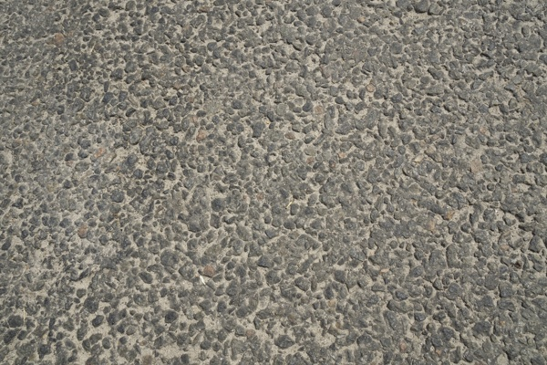6_1.png:** 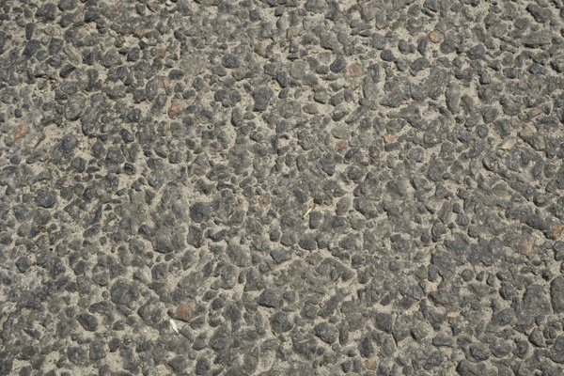

**Table 1 - Found homography parameters and normalization accuracy assessment**

|  |  |  |  |  |  |  |  |  |  |  |  |  |
| --- | --- | --- | --- | --- | --- | --- | --- | --- | --- | --- | --- | --- |
| Original:  img1: 0 img2: 0 | h11 | h12 | h13 | h21 | h22 | h23 | h31 | h32 | h33 | avg ErrIM (pixel) | max ErrIM | Expert rate |
| SIFT | 1,481 | -0,02 | -137,729 | 0,009 | 1,472 | -106,446 | -0 | 0 | 1 | 0,639 | 2,906 |  |
| SURF128 | 1,471 | -0,021 | -135,654 | 0,007 | 1,466 | -105,109 | -0 | 0 | 1 | 0,871 | 2,929 |  |
| SURF64 | 1,463 | -0,019 | -134,655 | 0,005 | 1,462 | -104,283 | -0 | 0 | 1 | 0,878 | 3,028 |  |
| ORB | 1,461 | -0,019 | -134,113 | 0,006 | 1,457 | -103,784 | -0 | 0 | 1 | 1,046 | 3,452 |  |
| ORB1000 | 1,457 | -0,028 | -132,259 | 0,005 | 1,442 | -101,317 | -0 | -0 | 1 | 1,073 | 2,646 |  |
| BRISK | 1,452 | -0,016 | -133,087 | 0,003 | 1,454 | -102,924 | -0 | 0 | 1 | 0,933 | 3,511 |  |
| KAZE | 1,462 | -0,018 | -134,877 | 0,004 | 1,462 | -104,117 | -0 | 0 | 1 | 0,776 | 4,07 |  |
| AKAZE | 1,466 | -0,019 | -134,956 | 0,005 | 1,464 | -104,323 | -0 | 0 | 1 | 0,631 | 3,271 |  |
|  |  |  |  |  |  |  |  |  |  |  |  |  |

where h11, h12, h13, h21, h22, h23, h31, h32, h33 - parameters of found homography matrix H* or of original one H;   
avgErrPar - average error of found parameters, the accuracy of found homography matrix parameters with a preliminary minimax normalization of found and original matrices;  
avgErrIM - average error of inlier coordinate matching;  
inliers - correct matches; outliers - false matches;  
maxErrIM – maximum error of inlier coordinate matching;  
avgErrCPM - average error of corner point matching;  
maxErrCPM - maximum error of corner point matching;  
expert rate - experts assessment of normalization accuracy with a 5-point scale: 0 - normalization failed, 1 - insufficient, 2 - satisfactory, 3 - good, 4 – excellent.

**Table 2 - Quantitative evaluation of descriptors, precision and recall estimation (with found overlap)**

|  |  |  |  |  |  |  |  |  |  |  |  |  |  |  |  |  |
| --- | --- | --- | --- | --- | --- | --- | --- | --- | --- | --- | --- | --- | --- | --- | --- | --- |
| Name | NP1 | NP2 | NM | NI | DP1 | DP2 | OP1 | OP2 | NPO1 | NPO2 | NMO | DPO1 | DPO2 | Precision | RecallO1 | Comments |
| SIFT | 5581 | 5026 | 1663 | 1528 | 0,0233 | 0,0209 | 45,9675 | 100 | 2672 | 5026 | 1659 | 0,0242 | 0,0209 | 0,9188 | 0,5719 |  |
| SURF128 | 3194 | 3080 | 374 | 365 | 0,0133 | 0,0128 | 45,9971 | 100 | 1687 | 3080 | 374 | 0,0153 | 0,0128 | 0,9759 | 0,2164 |  |
| SURF64 | 3194 | 3080 | 508 | 477 | 0,0133 | 0,0128 | 45,9921 | 100 | 1686 | 3080 | 505 | 0,0153 | 0,0128 | 0,939 | 0,2829 |  |
| ORB | 24037 | 22754 | 3611 | 3261 | 0,1002 | 0,0948 | 46,2421 | 100 | 16284 | 22754 | 3604 | 0,1467 | 0,0948 | 0,9031 | 0,2003 |  |
| ORB1000 | 1000 | 1000 | 186 | 147 | 0,0042 | 0,0042 | 46,35 | 100 | 790 | 1000 | 185 | 0,0071 | 0,0042 | 0,7903 | 0,1861 |  |
| BRISK | 9679 | 8907 | 1040 | 897 | 0,0403 | 0,0371 | 46,1833 | 100 | 5578 | 8907 | 1038 | 0,0503 | 0,0371 | 0,8625 | 0,1608 |  |
| KAZE | 1318 | 1621 | 306 | 288 | 0,0055 | 0,0068 | 45,9804 | 100 | 686 | 1621 | 302 | 0,0062 | 0,0068 | 0,9412 | 0,4198 |  |
| AKAZE | 1695 | 1641 | 321 | 316 | 0,0071 | 0,0068 | 46,0787 | 100 | 1049 | 1641 | 321 | 0,0095 | 0,0068 | 0,9844 | 0,3012 |  |

where NP - number of found key points; NP1, NP2 - number of found key points for image1 and image2 respectively;  
NM - number of matches found with NNDR method, NM=NI+NO;  
NI - number of inliers found with RANSAC method;  
NO - number of outliers discarded with RANSAC method;   
DP - density of key points (per cent), DP= NP/(height x width) , height, width - vertical and horizontal image sizes respectively (pixels)  
DP1, DP2 - density of key points points for image1 and image2 respectively;  
OP1, OP2 - overlap percentage for image1 and image2 respectively;  
NPO1, NPO2 - number of found key points on overlap for image1 and image2 respectivelyy;  
NMO - number of matches on overlap found with NNDR method;  
DPO1, DPO2 - density of key points points on overlap for image1 and image2 respectively;   
OA - overlap area (pixels), OA1, OA2 - overlap area for image1 and image2 respectively;  
DPO1= NPO1/OA1; DPO2= NPO2/OA2;  
Precision = NI/ NM - the rate to evaluate the part of inliers to all found matches with NNDR method;  
RecallO1 = NI/ NPO1 - completeness of inlier retrieval relative to the number of all key points on overlap for image1. The rate illustrates usefulness of the found key points for normalization.

**Table 3 - Estimation of time costs**

|  |  |  |  |  |  |  |  |  |  |  |
| --- | --- | --- | --- | --- | --- | --- | --- | --- | --- | --- |
| Name | NP1 | NP2 | DesT1, sec | DesT2, sec | MatchT, sec | InlierT, sec | AvgDesT, ms | AvgMatchT, ms | AvgInlierT, ms | TotalNormT, sec |
| SIFT | 5581 | 5026 | 0,07232 | 0,070611 | 0,214281 | 0,001038 | 0,013503 | 0,128852 | 0,000679 | 0,358251 |
| SURF128 | 3194 | 3080 | 0,074869 | 0,073431 | 0,082014 | 0,000388 | 0,02364 | 0,219289 | 0,001064 | 0,230703 |
| SURF64 | 3194 | 3080 | 0,066915 | 0,073534 | 0,041749 | 0,000585 | 0,022412 | 0,082182 | 0,001226 | 0,182783 |
| ORB | 24037 | 22754 | 0,045258 | 0,043296 | 1,242532 | 0,00302 | 0,001892 | 0,344096 | 0,000926 | 1,334106 |
| ORB1000 | 1000 | 1000 | 0,012934 | 0,012834 | 0,003199 | 0,000499 | 0,012884 | 0,017196 | 0,003394 | 0,029467 |
| BRISK | 9679 | 8907 | 0,149774 | 0,138269 | 0,206942 | 0,000769 | 0,015498 | 0,198982 | 0,000857 | 0,495754 |
| KAZE | 1318 | 1621 | 0,113053 | 0,104774 | 0,017186 | 0,000377 | 0,075205 | 0,056163 | 0,001308 | 0,23539 |
| AKAZE | 1695 | 1641 | 0,02119 | 0,016265 | 0,011096 | 0,000353 | 0,011206 | 0,034567 | 0,001116 | 0,048904 |

where DesT – descriptor creation time (time for key point detection and descriptor computation), DesT1, DesT2 – creation time of descriptors for image1 and image2 respectively;  
MatchT - retrieval time of matching found with NNDR method for the pair;  
InlierT – inlier retrieval time found with RANSAC method for the pair;  
AvgDesT – average time for one descriptor creation;  
AvgMatchT - average time for one match retrieval with NNDR method;  
AvgInlierT – average time for one inlier retrieval with RANSAC method;  
TotalNormT – total normalization time for the pair.