**Normalization results for pairs 8_0.png_8_1.png from subset png\texture_artificial**

**8_0.png: 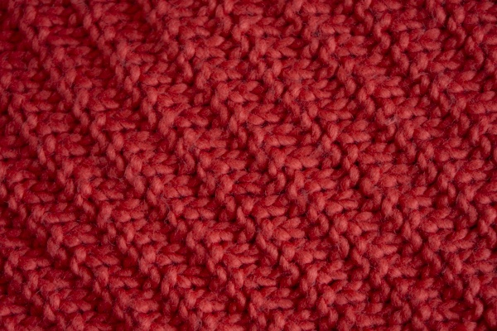8_1.png:** 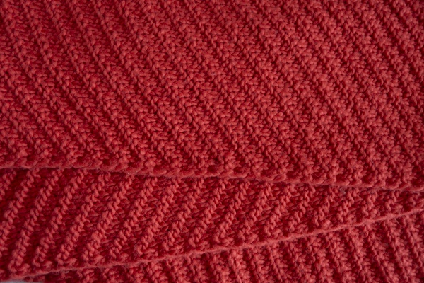

**Table 1 - Found homography parameters and normalization accuracy assessment**

|  |  |  |  |  |  |  |  |  |  |  |  |  |
| --- | --- | --- | --- | --- | --- | --- | --- | --- | --- | --- | --- | --- |
| Original:  img1: 0 img2: 0 | h11 | h12 | h13 | h21 | h22 | h23 | h31 | h32 | h33 | avg ErrIM (pixel) | max ErrIM | Expert rate |
| SIFT | 0,477 | -0,062 | 97,799 | 0,069 | 0,444 | 12,602 | 0 | -0 | 1 | 0,366 | 1,797 |  |
| SURF128 | 0,471 | -0,063 | 97,95 | 0,066 | 0,441 | 13,124 | 0 | -0 | 1 | 0,475 | 1,153 |  |
| SURF64 | 0,478 | -0,059 | 97,025 | 0,069 | 0,448 | 12,119 | 0 | -0 | 1 | 0,64 | 1,449 |  |
| ORB | 0,478 | -0,063 | 97,555 | 0,069 | 0,445 | 12,314 | 0 | -0 | 1 | 0,582 | 1,782 |  |
| ORB1000 | 0,564 | -0,029 | 81,137 | 0,099 | 0,507 | -0,739 | 0 | 0 | 1 | 0,508 | 1,24 |  |
| BRISK | 0,48 | -0,063 | 97,182 | 0,07 | 0,447 | 11,742 | 0 | -0 | 1 | 0,442 | 1,384 |  |
| KAZE | 0,467 | -0,062 | 97,713 | 0,065 | 0,443 | 12,222 | 0 | -0 | 1 | 0,426 | 2,096 |  |
| AKAZE | 0,472 | -0,06 | 97,488 | 0,067 | 0,447 | 11,901 | 0 | -0 | 1 | 0,33 | 1,028 |  |
|  |  |  |  |  |  |  |  |  |  |  |  |  |

where h11, h12, h13, h21, h22, h23, h31, h32, h33 - parameters of found homography matrix H* or of original one H;   
avgErrPar - average error of found parameters, the accuracy of found homography matrix parameters with a preliminary minimax normalization of found and original matrices;  
avgErrIM - average error of inlier coordinate matching;  
inliers - correct matches; outliers - false matches;  
maxErrIM – maximum error of inlier coordinate matching;  
avgErrCPM - average error of corner point matching;  
maxErrCPM - maximum error of corner point matching;  
expert rate - experts assessment of normalization accuracy with a 5-point scale: 0 - normalization failed, 1 - insufficient, 2 - satisfactory, 3 - good, 4 – excellent.

**Table 2 - Quantitative evaluation of descriptors, precision and recall estimation (with found overlap)**

|  |  |  |  |  |  |  |  |  |  |  |  |  |  |  |  |  |
| --- | --- | --- | --- | --- | --- | --- | --- | --- | --- | --- | --- | --- | --- | --- | --- | --- |
| Name | NP1 | NP2 | NM | NI | DP1 | DP2 | OP1 | OP2 | NPO1 | NPO2 | NMO | DPO1 | DPO2 | Precision | RecallO1 | Comments |
| SIFT | 3303 | 8596 | 1102 | 1087 | 0,0138 | 0,0358 | 100 | 19,8479 | 3303 | 1860 | 1102 | 0,0138 | 0,039 | 0,9864 | 0,3291 |  |
| SURF128 | 2616 | 2942 | 47 | 40 | 0,0109 | 0,0123 | 100 | 19,9067 | 2616 | 677 | 47 | 0,0109 | 0,0142 | 0,8511 | 0,0153 |  |
| SURF64 | 2616 | 2942 | 92 | 82 | 0,0109 | 0,0123 | 100 | 19,865 | 2616 | 675 | 92 | 0,0109 | 0,0142 | 0,8913 | 0,0313 |  |
| ORB | 11428 | 20979 | 384 | 314 | 0,0476 | 0,0874 | 100 | 19,9775 | 11428 | 5910 | 384 | 0,0476 | 0,1233 | 0,8177 | 0,0275 |  |
| ORB1000 | 1000 | 1000 | 27 | 12 | 0,0042 | 0,0042 | 100 | 21,3808 | 1000 | 162 | 27 | 0,0042 | 0,0032 | 0,4444 | 0,012 |  |
| BRISK | 2521 | 7409 | 222 | 195 | 0,0105 | 0,0309 | 100 | 19,985 | 2521 | 1772 | 222 | 0,0105 | 0,0369 | 0,8784 | 0,0774 |  |
| KAZE | 1366 | 831 | 16 | 14 | 0,0057 | 0,0035 | 100 | 20,1433 | 1366 | 109 | 16 | 0,0057 | 0,0023 | 0,875 | 0,0102 |  |
| AKAZE | 919 | 1538 | 29 | 27 | 0,0038 | 0,0064 | 100 | 20,035 | 919 | 394 | 29 | 0,0038 | 0,0082 | 0,931 | 0,0294 |  |

where NP - number of found key points; NP1, NP2 - number of found key points for image1 and image2 respectively;  
NM - number of matches found with NNDR method, NM=NI+NO;  
NI - number of inliers found with RANSAC method;  
NO - number of outliers discarded with RANSAC method;   
DP - density of key points (per cent), DP= NP/(height x width) , height, width - vertical and horizontal image sizes respectively (pixels)  
DP1, DP2 - density of key points points for image1 and image2 respectively;  
OP1, OP2 - overlap percentage for image1 and image2 respectively;  
NPO1, NPO2 - number of found key points on overlap for image1 and image2 respectivelyy;  
NMO - number of matches on overlap found with NNDR method;  
DPO1, DPO2 - density of key points points on overlap for image1 and image2 respectively;   
OA - overlap area (pixels), OA1, OA2 - overlap area for image1 and image2 respectively;  
DPO1= NPO1/OA1; DPO2= NPO2/OA2;  
Precision = NI/ NM - the rate to evaluate the part of inliers to all found matches with NNDR method;  
RecallO1 = NI/ NPO1 - completeness of inlier retrieval relative to the number of all key points on overlap for image1. The rate illustrates usefulness of the found key points for normalization.

**Table 3 - Estimation of time costs**

|  |  |  |  |  |  |  |  |  |  |  |
| --- | --- | --- | --- | --- | --- | --- | --- | --- | --- | --- |
| Name | NP1 | NP2 | DesT1, sec | DesT2, sec | MatchT, sec | InlierT, sec | AvgDesT, ms | AvgMatchT, ms | AvgInlierT, ms | TotalNormT, sec |
| SIFT | 3303 | 8596 | 0,066001 | 0,094356 | 0,22368 | 0,000754 | 0,015479 | 0,202976 | 0,000693 | 0,384791 |
| SURF128 | 2616 | 2942 | 0,072098 | 0,065781 | 0,062129 | 0,000393 | 0,024959 | 1,321889 | 0,009813 | 0,2004 |
| SURF64 | 2616 | 2942 | 0,065685 | 0,067222 | 0,032597 | 0,000308 | 0,023979 | 0,354318 | 0,003758 | 0,165813 |
| ORB | 11428 | 20979 | 0,024774 | 0,039559 | 0,53353 | 0,000536 | 0,002026 | 1,389402 | 0,001706 | 0,598399 |
| ORB1000 | 1000 | 1000 | 0,01048 | 0,012113 | 0,003262 | 0,003444 | 0,011295 | 0,120806 | 0,286976 | 0,029298 |
| BRISK | 2521 | 7409 | 0,039538 | 0,11081 | 0,046322 | 0,000412 | 0,015319 | 0,208657 | 0,002111 | 0,197082 |
| KAZE | 1366 | 831 | 0,111615 | 0,085604 | 0,012667 | 0,000362 | 0,092361 | 0,79168 | 0,025868 | 0,210248 |
| AKAZE | 919 | 1538 | 0,017373 | 0,014311 | 0,004697 | 0,000276 | 0,014104 | 0,16198 | 0,010214 | 0,036657 |

where DesT – descriptor creation time (time for key point detection and descriptor computation), DesT1, DesT2 – creation time of descriptors for image1 and image2 respectively;  
MatchT - retrieval time of matching found with NNDR method for the pair;  
InlierT – inlier retrieval time found with RANSAC method for the pair;  
AvgDesT – average time for one descriptor creation;  
AvgMatchT - average time for one match retrieval with NNDR method;  
AvgInlierT – average time for one inlier retrieval with RANSAC method;  
TotalNormT – total normalization time for the pair.