**Normalization results for pairs 9_0.png_9_1.png from subset png\texture_artificial**

**9_0.png: 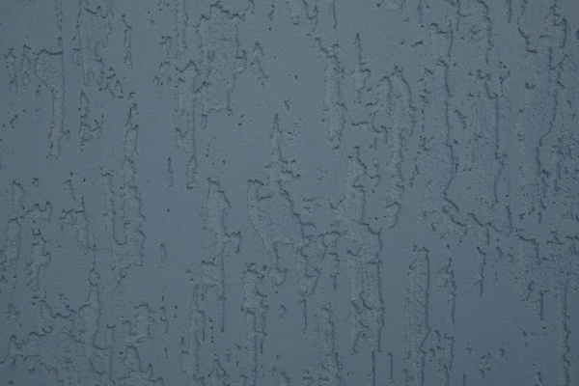9_1.png:** 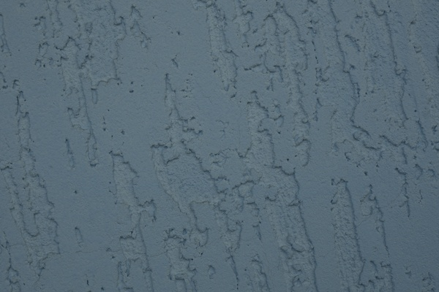

**Table 1 - Found homography parameters and normalization accuracy assessment**

|  |  |  |  |  |  |  |  |  |  |  |  |  |
| --- | --- | --- | --- | --- | --- | --- | --- | --- | --- | --- | --- | --- |
| Original:  img1: 0 img2: 0 | h11 | h12 | h13 | h21 | h22 | h23 | h31 | h32 | h33 | avg ErrIM (pixel) | max ErrIM | Expert rate |
| SIFT | 1,342 | 0,256 | -186,887 | -0,256 | 1,329 | 17,741 | 0 | -0 | 1 | 0,272 | 0,747 |  |
| SURF128 | 1,344 | 0,256 | -186,23 | -0,254 | 1,333 | 17,128 | 0 | -0 | 1 | 0,705 | 1,665 |  |
| SURF64 | 1,324 | 0,257 | -182,805 | -0,257 | 1,323 | 18,165 | -0 | -0 | 1 | 0,829 | 2,589 |  |
| ORB | 1,334 | 0,257 | -185,143 | -0,257 | 1,323 | 18,569 | 0 | -0 | 1 | 0,871 | 2,371 |  |
| ORB1000 | 1,326 | 0,254 | -183,42 | -0,257 | 1,317 | 18,649 | 0 | -0 | 1 | 0,91 | 2,299 |  |
| BRISK | 1,343 | 0,26 | -187,18 | -0,258 | 1,335 | 17,561 | 0 | -0 | 1 | 0,352 | 1,706 |  |
| KAZE | 0 | 0 | 0 | 0 | 0 | 0 | 0 | 0 | 0 | 0 | ~ |  |
| AKAZE | 0 | 0 | 0 | 0 | 0 | 0 | 0 | 0 | 0 | 0 | ~ |  |
|  |  |  |  |  |  |  |  |  |  |  |  |  |

where h11, h12, h13, h21, h22, h23, h31, h32, h33 - parameters of found homography matrix H* or of original one H;   
avgErrPar - average error of found parameters, the accuracy of found homography matrix parameters with a preliminary minimax normalization of found and original matrices;  
avgErrIM - average error of inlier coordinate matching;  
inliers - correct matches; outliers - false matches;  
maxErrIM – maximum error of inlier coordinate matching;  
avgErrCPM - average error of corner point matching;  
maxErrCPM - maximum error of corner point matching;  
expert rate - experts assessment of normalization accuracy with a 5-point scale: 0 - normalization failed, 1 - insufficient, 2 - satisfactory, 3 - good, 4 – excellent.

**Table 2 - Quantitative evaluation of descriptors, precision and recall estimation (with found overlap)**

|  |  |  |  |  |  |  |  |  |  |  |  |  |  |  |  |  |
| --- | --- | --- | --- | --- | --- | --- | --- | --- | --- | --- | --- | --- | --- | --- | --- | --- |
| Name | NP1 | NP2 | NM | NI | DP1 | DP2 | OP1 | OP2 | NPO1 | NPO2 | NMO | DPO1 | DPO2 | Precision | RecallO1 | Comments |
| SIFT | 141 | 215 | 48 | 46 | 0,0006 | 0,0009 | 54,3958 | 100 | 67 | 215 | 46 | 0,0005 | 0,0009 | 0,9583 | 0,6866 |  |
| SURF128 | 347 | 492 | 53 | 42 | 0,0014 | 0,0021 | 54,6333 | 100 | 219 | 492 | 51 | 0,0017 | 0,0021 | 0,7925 | 0,1918 |  |
| SURF64 | 347 | 492 | 72 | 66 | 0,0014 | 0,0021 | 54,5292 | 100 | 217 | 492 | 70 | 0,0017 | 0,0021 | 0,9167 | 0,3041 |  |
| ORB | 1302 | 1132 | 199 | 180 | 0,0054 | 0,0047 | 54,5325 | 100 | 930 | 1132 | 198 | 0,0071 | 0,0047 | 0,9045 | 0,1935 |  |
| ORB1000 | 667 | 730 | 125 | 109 | 0,0028 | 0,003 | 54,5142 | 100 | 486 | 730 | 125 | 0,0037 | 0,003 | 0,872 | 0,2243 |  |
| BRISK | 299 | 267 | 29 | 29 | 0,0012 | 0,0011 | 54,4696 | 100 | 184 | 267 | 29 | 0,0014 | 0,0011 | 1 | 0,1576 |  |
| KAZE | 0 | 0 | 0 | 0 | 0 | 0 | 0 | 0 | 0 | 0 | 0 | � | � | � | � |  |
| AKAZE | 0 | 0 | 0 | 0 | 0 | 0 | 0 | 0 | 0 | 0 | 0 | � | � | � | � |  |

where NP - number of found key points; NP1, NP2 - number of found key points for image1 and image2 respectively;  
NM - number of matches found with NNDR method, NM=NI+NO;  
NI - number of inliers found with RANSAC method;  
NO - number of outliers discarded with RANSAC method;   
DP - density of key points (per cent), DP= NP/(height x width) , height, width - vertical and horizontal image sizes respectively (pixels)  
DP1, DP2 - density of key points points for image1 and image2 respectively;  
OP1, OP2 - overlap percentage for image1 and image2 respectively;  
NPO1, NPO2 - number of found key points on overlap for image1 and image2 respectivelyy;  
NMO - number of matches on overlap found with NNDR method;  
DPO1, DPO2 - density of key points points on overlap for image1 and image2 respectively;   
OA - overlap area (pixels), OA1, OA2 - overlap area for image1 and image2 respectively;  
DPO1= NPO1/OA1; DPO2= NPO2/OA2;  
Precision = NI/ NM - the rate to evaluate the part of inliers to all found matches with NNDR method;  
RecallO1 = NI/ NPO1 - completeness of inlier retrieval relative to the number of all key points on overlap for image1. The rate illustrates usefulness of the found key points for normalization.

**Table 3 - Estimation of time costs**

|  |  |  |  |  |  |  |  |  |  |  |
| --- | --- | --- | --- | --- | --- | --- | --- | --- | --- | --- |
| Name | NP1 | NP2 | DesT1, sec | DesT2, sec | MatchT, sec | InlierT, sec | AvgDesT, ms | AvgMatchT, ms | AvgInlierT, ms | TotalNormT, sec |
| SIFT | 141 | 215 | 0,03654 | 0,037963 | 0,000465 | 0,000275 | 0,21786 | 0,009692 | 0,005973 | 0,075243 |
| SURF128 | 347 | 492 | 0,023817 | 0,024432 | 0,001947 | 0,000428 | 0,059147 | 0,036741 | 0,010183 | 0,050624 |
| SURF64 | 347 | 492 | 0,017239 | 0,023727 | 0,001004 | 0,000306 | 0,048953 | 0,013937 | 0,004633 | 0,042276 |
| ORB | 1302 | 1132 | 0,008071 | 0,007675 | 0,004507 | 0,000373 | 0,006489 | 0,022649 | 0,002074 | 0,020627 |
| ORB1000 | 667 | 730 | 0,007145 | 0,00712 | 0,001823 | 0,000417 | 0,010232 | 0,014584 | 0,003823 | 0,016504 |
| BRISK | 299 | 267 | 0,005463 | 0,004947 | 0,000607 | 0,000185 | 0,018398 | 0,020915 | 0,006379 | 0,011201 |
| KAZE | 0 | 0 | 0,101462 | 0,08336 | 0 | 0 | 0 | 0 | 0 | 0,184822 |
| AKAZE | 0 | 0 | 0,010558 | 0,010273 | 0 | 0 | 0 | 0 | 0 | 0,020831 |

where DesT – descriptor creation time (time for key point detection and descriptor computation), DesT1, DesT2 – creation time of descriptors for image1 and image2 respectively;  
MatchT - retrieval time of matching found with NNDR method for the pair;  
InlierT – inlier retrieval time found with RANSAC method for the pair;  
AvgDesT – average time for one descriptor creation;  
AvgMatchT - average time for one match retrieval with NNDR method;  
AvgInlierT – average time for one inlier retrieval with RANSAC method;  
TotalNormT – total normalization time for the pair.