**Normalization results for pairs 10_0.png_10_1.png from subset png\texture_nature**

**10_0.png: 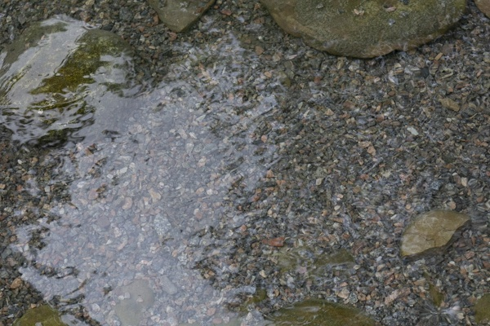10_1.png:** 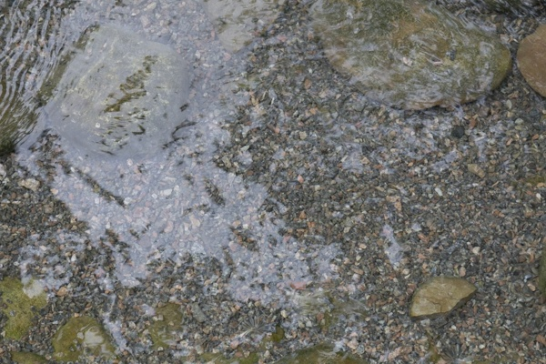

**Table 1 - Found homography parameters and normalization accuracy assessment**

|  |  |  |  |  |  |  |  |  |  |  |  |  |  |  |  |
| --- | --- | --- | --- | --- | --- | --- | --- | --- | --- | --- | --- | --- | --- | --- | --- |
| Original:  img1: 0 img2: 0 | h11 | h12 | h13 | h21 | h22 | h23 | h31 | h32 | h33 | avg ErrPar (param) | avg ErrIM (pixel) | max ErrIM | avg ErrCPM (corner) | max ErrCPM | Expert rate |
| SIFT | 0,879 | -0,038 | 69,134 | 0,137 | 1,014 | -10,659 | 0 | 0 | 1 | 0 | 0,647 | 1,957 | ~ | ~ |  |
| SURF128 | 0 | 0 | 0 | 0 | 0 | 0 | 0 | 0 | 0 | 0 | -1 |  | ~ | ~ |  |
| SURF64 | -0,3 | 0,716 | 215,274 | -0,573 | 0,851 | 237,182 | -0,002 | 0,001 | 1 | 0 | 0,164 | 0,395 | ~ | ~ |  |
| ORB | 0,981 | -0,06 | 60,639 | 0,205 | 1,012 | -15,926 | 0 | 0 | 1 | 0 | 0,87 | 1,264 | ~ | ~ |  |
| ORB1000 | -1,097 | 0,003 | 303,055 | -1,059 | -0,633 | 435,83 | -0,003 | -0 | 1 | 0 | 0 | 0 | ~ | ~ |  |
| BRISK | 0,789 | -0,056 | 89,9 | 0,089 | 0,959 | 9,047 | -0 | 0 | 1 | 0 | 0,68 | 1,532 | ~ | ~ |  |
| KAZE | 0 | 0 | 0 | 0 | 0 | 0 | 0 | 0 | 0 | 0 | -1 |  | ~ | ~ |  |
| AKAZE | 0,304 | -0,961 | 195,026 | 0,168 | -0,559 | 117,443 | 0,001 | -0,005 | 1 | 0 | 0 | 0 | ~ | ~ |  |
| Original matrix |  |  |  |  |  |  |  |  |  |  |  |  |  |  |  |

where h11, h12, h13, h21, h22, h23, h31, h32, h33 - parameters of found homography matrix H* or of original one H;   
avgErrPar - average error of found parameters, the accuracy of found homography matrix parameters with a preliminary minimax normalization of found and original matrices;  
avgErrIM - average error of inlier coordinate matching;  
inliers - correct matches; outliers - false matches;  
maxErrIM – maximum error of inlier coordinate matching;  
avgErrCPM - average error of corner point matching;  
maxErrCPM - maximum error of corner point matching;  
expert rate - experts assessment of normalization accuracy with a 5-point scale: 0 - normalization failed, 1 - insufficient, 2 - satisfactory, 3 - good, 4 – excellent.

**Table 2 - Quantitative evaluation of descriptors, precision and recall estimation (with found overlap)**

|  |  |  |  |  |  |  |  |  |  |  |  |  |  |  |  |  |
| --- | --- | --- | --- | --- | --- | --- | --- | --- | --- | --- | --- | --- | --- | --- | --- | --- |
| Name | NP1 | NP2 | NM | NI | DP1 | DP2 | OP1 | OP2 | NPO1 | NPO2 | NMO | DPO1 | DPO2 | Precision | RecallO1 | Comments |
| SIFT | 4389 | 4486 | 64 | 54 | 0,0183 | 0,0187 | 97,8363 | 75,5554 | 4316 | 3440 | 64 | 0,0184 | 0,019 | 0,8438 | 0,0125 |  |
| SURF128 | 2569 | 2637 | 2 | 0 | 0,0107 | 0,011 | 0 | 0 | 0 | 0 | 0 | � | � | 0 | � |  |
| SURF64 | 2569 | 2637 | 12 | 5 | 0,0107 | 0,011 | 95,0588 | 52,9096 | 2486 | 1544 | 12 | 0,0109 | 0,0122 | 0,4167 | 0,002 |  |
| ORB | 14914 | 16375 | 36 | 9 | 0,0621 | 0,0682 | 97,9437 | 74,5537 | 14914 | 15310 | 36 | 0,0634 | 0,0856 | 0,25 | 0,0006 |  |
| ORB1000 | 1000 | 1000 | 6 | 4 | 0,0042 | 0,0042 | 59,7221 | 99,3933 | 628 | 996 | 5 | 0,0044 | 0,0042 | 0,6667 | 0,0064 |  |
| BRISK | 4676 | 5690 | 11 | 6 | 0,0195 | 0,0237 | 97,8029 | 72,135 | 4658 | 4805 | 11 | 0,0198 | 0,0278 | 0,5455 | 0,0013 |  |
| KAZE | 637 | 685 | 1 | 0 | 0,0027 | 0,0029 | 0 | 0 | 0 | 0 | 0 | � | � | 0 | � |  |
| AKAZE | 681 | 817 | 5 | 4 | 0,0028 | 0,0034 | 98,9617 | 99,3788 | 677 | 816 | 5 | 0,0029 | 0,0034 | 0,8 | 0,0059 |  |

where NP - number of found key points; NP1, NP2 - number of found key points for image1 and image2 respectively;  
NM - number of matches found with NNDR method, NM=NI+NO;  
NI - number of inliers found with RANSAC method;  
NO - number of outliers discarded with RANSAC method;   
DP - density of key points (per cent), DP= NP/(height x width) , height, width - vertical and horizontal image sizes respectively (pixels)  
DP1, DP2 - density of key points points for image1 and image2 respectively;  
OP1, OP2 - overlap percentage for image1 and image2 respectively;  
NPO1, NPO2 - number of found key points on overlap for image1 and image2 respectivelyy;  
NMO - number of matches on overlap found with NNDR method;  
DPO1, DPO2 - density of key points points on overlap for image1 and image2 respectively;   
OA - overlap area (pixels), OA1, OA2 - overlap area for image1 and image2 respectively;  
DPO1= NPO1/OA1; DPO2= NPO2/OA2;  
Precision = NI/ NM - the rate to evaluate the part of inliers to all found matches with NNDR method;  
RecallO1 = NI/ NPO1 - completeness of inlier retrieval relative to the number of all key points on overlap for image1. The rate illustrates usefulness of the found key points for normalization.

**Table 3 - Estimation of time costs**

|  |  |  |  |  |  |  |  |  |  |  |
| --- | --- | --- | --- | --- | --- | --- | --- | --- | --- | --- |
| Name | NP1 | NP2 | DesT1, sec | DesT2, sec | MatchT, sec | InlierT, sec | AvgDesT, ms | AvgMatchT, ms | AvgInlierT, ms | TotalNormT, sec |
| SIFT | 4389 | 4486 | 0,14919 | 0,077714 | 0,333007 | 0,004372 | 0,025657 | 5,203238 | 0,080965 | 0,564283 |
| SURF128 | 2569 | 2637 | 0,235097 | 0,152832 | 0,090004 | 0 | 0,074734 | 45,002248 | 0 | 0,477934 |
| SURF64 | 2569 | 2637 | 0,106267 | 0,098003 | 0,050202 | 0,004603 | 0,039264 | 4,183524 | 0,920507 | 0,259075 |
| ORB | 14914 | 16375 | 0,032785 | 0,044569 | 0,893851 | 0,0343 | 0,002459 | 24,829197 | 3,811139 | 1,005505 |
| ORB1000 | 1000 | 1000 | 0,077805 | 0,023299 | 0,007503 | 0,000625 | 0,050551 | 1,250474 | 0,156245 | 0,109232 |
| BRISK | 4676 | 5690 | 0,073087 | 0,08505 | 0,096288 | 0,001599 | 0,015288 | 8,753494 | 0,266524 | 0,256025 |
| KAZE | 637 | 685 | 0,131397 | 0,154582 | 0,005323 | 0 | 0,215971 | 5,322753 | 0 | 0,291302 |
| AKAZE | 681 | 817 | 0,022888 | 0,021786 | 0,003789 | 0,00027 | 0,030137 | 0,757896 | 0,067413 | 0,048733 |

where DesT – descriptor creation time (time for key point detection and descriptor computation), DesT1, DesT2 – creation time of descriptors for image1 and image2 respectively;  
MatchT - retrieval time of matching found with NNDR method for the pair;  
InlierT – inlier retrieval time found with RANSAC method for the pair;  
AvgDesT – average time for one descriptor creation;  
AvgMatchT - average time for one match retrieval with NNDR method;  
AvgInlierT – average time for one inlier retrieval with RANSAC method;  
TotalNormT – total normalization time for the pair.