**Normalization results for pairs 11_0.png_11_1.png from subset png\texture_nature**

**11_0.png: 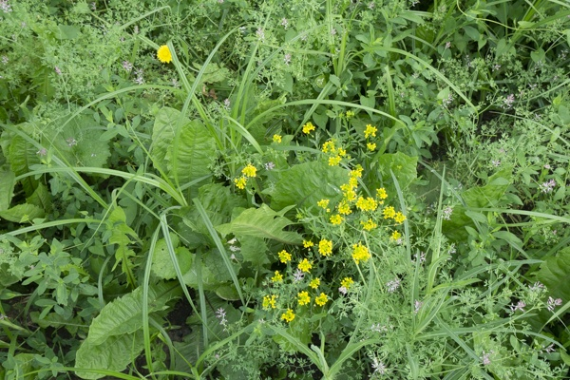11_1.png:** 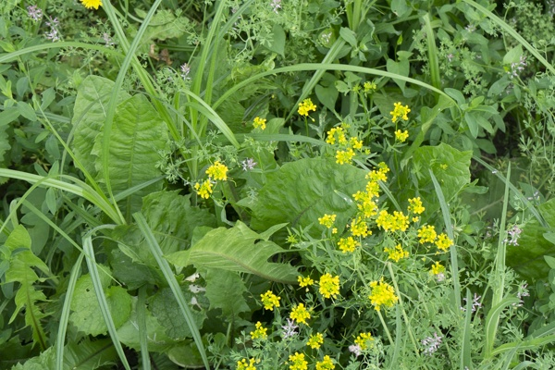

**Table 1 - Found homography parameters and normalization accuracy assessment**

|  |  |  |  |  |  |  |  |  |  |  |  |  |  |  |  |
| --- | --- | --- | --- | --- | --- | --- | --- | --- | --- | --- | --- | --- | --- | --- | --- |
| Original:  img1: 0 img2: 0 | h11 | h12 | h13 | h21 | h22 | h23 | h31 | h32 | h33 | avg ErrPar (param) | avg ErrIM (pixel) | max ErrIM | avg ErrCPM (corner) | max ErrCPM | Expert rate |
| SIFT | 1,559 | -0,009 | -169,49 | 0,002 | 1,561 | -93,812 | 0 | 0 | 1 | 0 | 0,904 | 3,302 | ~ | ~ |  |
| SURF128 | 1,542 | -0,01 | -166,919 | 0,002 | 1,54 | -91,572 | 0 | -0 | 1 | 0 | 1,005 | 4,052 | ~ | ~ |  |
| SURF64 | 1,567 | -0,008 | -170,889 | 0,006 | 1,564 | -94,662 | 0 | 0 | 1 | 0 | 1,076 | 3,479 | ~ | ~ |  |
| ORB | 1,528 | 0,009 | -165,834 | -0,007 | 1,554 | -91,11 | -0 | 0 | 1 | 0 | 1,317 | 4,244 | ~ | ~ |  |
| ORB1000 | 1,501 | -0,005 | -158,948 | -0,01 | 1,524 | -87,013 | -0 | 0 | 1 | 0 | 1,289 | 2,876 | ~ | ~ |  |
| BRISK | 1,53 | -0,014 | -164,252 | -0,004 | 1,53 | -89,287 | -0 | 0 | 1 | 0 | 1,243 | 4,052 | ~ | ~ |  |
| KAZE | 1,555 | -0,014 | -168,266 | 0,004 | 1,551 | -93,261 | 0 | 0 | 1 | 0 | 1,082 | 4,053 | ~ | ~ |  |
| AKAZE | 1,554 | -0,003 | -169,366 | 0,001 | 1,564 | -94,002 | 0 | 0 | 1 | 0 | 1,016 | 2,79 | ~ | ~ |  |
| Original matrix |  |  |  |  |  |  |  |  |  |  |  |  |  |  |  |

where h11, h12, h13, h21, h22, h23, h31, h32, h33 - parameters of found homography matrix H* or of original one H;   
avgErrPar - average error of found parameters, the accuracy of found homography matrix parameters with a preliminary minimax normalization of found and original matrices;  
avgErrIM - average error of inlier coordinate matching;  
inliers - correct matches; outliers - false matches;  
maxErrIM – maximum error of inlier coordinate matching;  
avgErrCPM - average error of corner point matching;  
maxErrCPM - maximum error of corner point matching;  
expert rate - experts assessment of normalization accuracy with a 5-point scale: 0 - normalization failed, 1 - insufficient, 2 - satisfactory, 3 - good, 4 – excellent.

**Table 2 - Quantitative evaluation of descriptors, precision and recall estimation (with found overlap)**

|  |  |  |  |  |  |  |  |  |  |  |  |  |  |  |  |  |
| --- | --- | --- | --- | --- | --- | --- | --- | --- | --- | --- | --- | --- | --- | --- | --- | --- |
| Name | NP1 | NP2 | NM | NI | DP1 | DP2 | OP1 | OP2 | NPO1 | NPO2 | NMO | DPO1 | DPO2 | Precision | RecallO1 | Comments |
| SIFT | 4261 | 3955 | 856 | 757 | 0,0178 | 0,0165 | 42,0583 | 100 | 1739 | 3955 | 846 | 0,0172 | 0,0165 | 0,8843 | 0,4353 |  |
| SURF128 | 3016 | 2884 | 371 | 263 | 0,0126 | 0,012 | 42,2425 | 100 | 1465 | 2884 | 370 | 0,0145 | 0,012 | 0,7089 | 0,1795 |  |
| SURF64 | 3016 | 2884 | 491 | 388 | 0,0126 | 0,012 | 42,1633 | 100 | 1458 | 2884 | 491 | 0,0144 | 0,012 | 0,7902 | 0,2661 |  |
| ORB | 17931 | 13687 | 1936 | 1381 | 0,0747 | 0,057 | 42,65 | 100 | 11355 | 13687 | 1922 | 0,1109 | 0,057 | 0,7133 | 0,1216 |  |
| ORB1000 | 1000 | 1000 | 145 | 104 | 0,0042 | 0,0042 | 42,6183 | 100 | 793 | 1000 | 145 | 0,0078 | 0,0042 | 0,7172 | 0,1311 |  |
| BRISK | 7666 | 5853 | 758 | 621 | 0,0319 | 0,0244 | 42,1088 | 100 | 4109 | 5853 | 753 | 0,0407 | 0,0244 | 0,8193 | 0,1511 |  |
| KAZE | 1515 | 1390 | 286 | 217 | 0,0063 | 0,0058 | 42,1154 | 100 | 710 | 1390 | 285 | 0,007 | 0,0058 | 0,7587 | 0,3056 |  |
| AKAZE | 1483 | 1268 | 205 | 169 | 0,0062 | 0,0053 | 42,12 | 100 | 877 | 1268 | 203 | 0,0087 | 0,0053 | 0,8244 | 0,1927 |  |

where NP - number of found key points; NP1, NP2 - number of found key points for image1 and image2 respectively;  
NM - number of matches found with NNDR method, NM=NI+NO;  
NI - number of inliers found with RANSAC method;  
NO - number of outliers discarded with RANSAC method;   
DP - density of key points (per cent), DP= NP/(height x width) , height, width - vertical and horizontal image sizes respectively (pixels)  
DP1, DP2 - density of key points points for image1 and image2 respectively;  
OP1, OP2 - overlap percentage for image1 and image2 respectively;  
NPO1, NPO2 - number of found key points on overlap for image1 and image2 respectivelyy;  
NMO - number of matches on overlap found with NNDR method;  
DPO1, DPO2 - density of key points points on overlap for image1 and image2 respectively;   
OA - overlap area (pixels), OA1, OA2 - overlap area for image1 and image2 respectively;  
DPO1= NPO1/OA1; DPO2= NPO2/OA2;  
Precision = NI/ NM - the rate to evaluate the part of inliers to all found matches with NNDR method;  
RecallO1 = NI/ NPO1 - completeness of inlier retrieval relative to the number of all key points on overlap for image1. The rate illustrates usefulness of the found key points for normalization.

**Table 3 - Estimation of time costs**

|  |  |  |  |  |  |  |  |  |  |  |
| --- | --- | --- | --- | --- | --- | --- | --- | --- | --- | --- |
| Name | NP1 | NP2 | DesT1, sec | DesT2, sec | MatchT, sec | InlierT, sec | AvgDesT, ms | AvgMatchT, ms | AvgInlierT, ms | TotalNormT, sec |
| SIFT | 4261 | 3955 | 0,072102 | 0,075869 | 0,19101 | 0,000737 | 0,018052 | 0,223142 | 0,000973 | 0,339718 |
| SURF128 | 3016 | 2884 | 0,089305 | 0,084606 | 0,094406 | 0,000747 | 0,029473 | 0,254462 | 0,002839 | 0,269064 |
| SURF64 | 3016 | 2884 | 0,087477 | 0,098668 | 0,048736 | 0,000717 | 0,031608 | 0,099257 | 0,001847 | 0,235597 |
| ORB | 17931 | 13687 | 0,038073 | 0,031281 | 0,817632 | 0,001563 | 0,002204 | 0,42233 | 0,001131 | 0,88855 |
| ORB1000 | 1000 | 1000 | 0,012781 | 0,011798 | 0,004369 | 0,000616 | 0,012289 | 0,030129 | 0,005927 | 0,029564 |
| BRISK | 7666 | 5853 | 0,128625 | 0,131042 | 0,180143 | 0,000813 | 0,019583 | 0,237655 | 0,001309 | 0,440623 |
| KAZE | 1515 | 1390 | 0,164687 | 0,157232 | 0,029266 | 0,00059 | 0,11091 | 0,102328 | 0,002719 | 0,351775 |
| AKAZE | 1483 | 1268 | 0,027018 | 0,022879 | 0,008083 | 0,000511 | 0,01813 | 0,039429 | 0,003025 | 0,058492 |

where DesT – descriptor creation time (time for key point detection and descriptor computation), DesT1, DesT2 – creation time of descriptors for image1 and image2 respectively;  
MatchT - retrieval time of matching found with NNDR method for the pair;  
InlierT – inlier retrieval time found with RANSAC method for the pair;  
AvgDesT – average time for one descriptor creation;  
AvgMatchT - average time for one match retrieval with NNDR method;  
AvgInlierT – average time for one inlier retrieval with RANSAC method;  
TotalNormT – total normalization time for the pair.