**Normalization results for pairs 12_0.png_12_1.png from subset png\texture_nature**

**12_0.png: 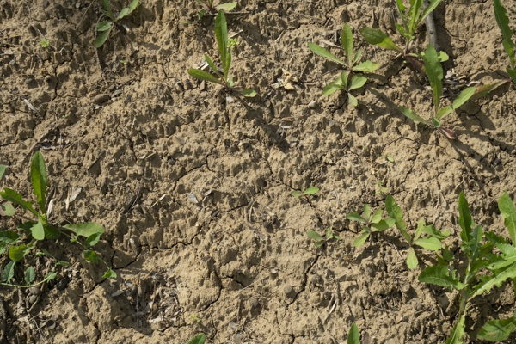12_1.png:** 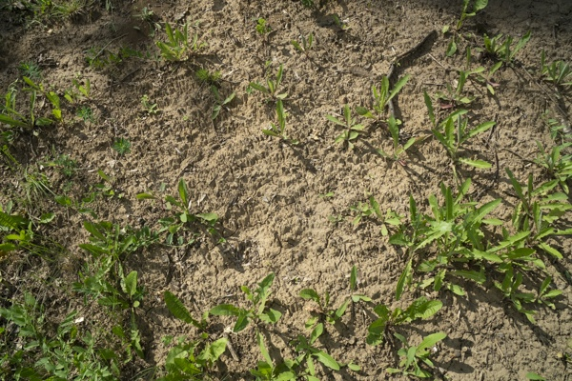

**Table 1 - Found homography parameters and normalization accuracy assessment**

|  |  |  |  |  |  |  |  |  |  |  |  |  |  |  |  |
| --- | --- | --- | --- | --- | --- | --- | --- | --- | --- | --- | --- | --- | --- | --- | --- |
| Original:  img1: 0 img2: 0 | h11 | h12 | h13 | h21 | h22 | h23 | h31 | h32 | h33 | avg ErrPar (param) | avg ErrIM (pixel) | max ErrIM | avg ErrCPM (corner) | max ErrCPM | Expert rate |
| SIFT | 0,479 | 0,011 | 168,508 | -0,008 | 0,482 | 99,218 | -0 | 0 | 1 | 0 | 0,635 | 2,295 | ~ | ~ |  |
| SURF128 | 0,488 | 0,012 | 167,34 | -0,005 | 0,487 | 98,347 | 0 | 0 | 1 | 0 | 0,655 | 2,554 | ~ | ~ |  |
| SURF64 | 0,48 | 0,013 | 167,736 | -0,008 | 0,485 | 98,661 | -0 | 0 | 1 | 0 | 0,646 | 2,175 | ~ | ~ |  |
| ORB | 0,483 | 0,013 | 167,473 | -0,007 | 0,486 | 98,526 | -0 | 0 | 1 | 0 | 0,714 | 2,762 | ~ | ~ |  |
| ORB1000 | 0,491 | 0,017 | 166,595 | -0,006 | 0,486 | 99,031 | 0 | 0 | 1 | 0 | 0,759 | 2,57 | ~ | ~ |  |
| BRISK | 0,482 | 0,012 | 167,494 | -0,008 | 0,485 | 98,641 | -0 | 0 | 1 | 0 | 0,712 | 3,392 | ~ | ~ |  |
| KAZE | 0,484 | 0,015 | 167,013 | -0,006 | 0,487 | 98,281 | -0 | 0 | 1 | 0 | 0,693 | 2,213 | ~ | ~ |  |
| AKAZE | 0,486 | 0,008 | 167,323 | -0,006 | 0,485 | 98,47 | 0 | -0 | 1 | 0 | 0,488 | 2,201 | ~ | ~ |  |
| Original matrix |  |  |  |  |  |  |  |  |  |  |  |  |  |  |  |

where h11, h12, h13, h21, h22, h23, h31, h32, h33 - parameters of found homography matrix H* or of original one H;   
avgErrPar - average error of found parameters, the accuracy of found homography matrix parameters with a preliminary minimax normalization of found and original matrices;  
avgErrIM - average error of inlier coordinate matching;  
inliers - correct matches; outliers - false matches;  
maxErrIM – maximum error of inlier coordinate matching;  
avgErrCPM - average error of corner point matching;  
maxErrCPM - maximum error of corner point matching;  
expert rate - experts assessment of normalization accuracy with a 5-point scale: 0 - normalization failed, 1 - insufficient, 2 - satisfactory, 3 - good, 4 – excellent.

**Table 2 - Quantitative evaluation of descriptors, precision and recall estimation (with found overlap)**

|  |  |  |  |  |  |  |  |  |  |  |  |  |  |  |  |  |
| --- | --- | --- | --- | --- | --- | --- | --- | --- | --- | --- | --- | --- | --- | --- | --- | --- |
| Name | NP1 | NP2 | NM | NI | DP1 | DP2 | OP1 | OP2 | NPO1 | NPO2 | NMO | DPO1 | DPO2 | Precision | RecallO1 | Comments |
| SIFT | 5997 | 5572 | 893 | 879 | 0,025 | 0,0232 | 100 | 23,3758 | 5997 | 1456 | 893 | 0,025 | 0,026 | 0,9843 | 0,1466 |  |
| SURF128 | 3298 | 3462 | 246 | 241 | 0,0137 | 0,0144 | 100 | 23,5437 | 3298 | 954 | 246 | 0,0137 | 0,0169 | 0,9797 | 0,0731 |  |
| SURF64 | 3298 | 3462 | 318 | 302 | 0,0137 | 0,0144 | 100 | 23,5288 | 3298 | 952 | 318 | 0,0137 | 0,0169 | 0,9497 | 0,0916 |  |
| ORB | 27375 | 27897 | 2128 | 1832 | 0,1141 | 0,1162 | 100 | 23,6371 | 27375 | 10599 | 2128 | 0,1141 | 0,1868 | 0,8609 | 0,0669 |  |
| ORB1000 | 1000 | 1000 | 97 | 76 | 0,0042 | 0,0042 | 100 | 23,4371 | 1000 | 506 | 97 | 0,0042 | 0,009 | 0,7835 | 0,076 |  |
| BRISK | 12610 | 12477 | 954 | 943 | 0,0525 | 0,052 | 100 | 23,575 | 12610 | 4181 | 954 | 0,0525 | 0,0739 | 0,9885 | 0,0748 |  |
| KAZE | 2283 | 1739 | 141 | 128 | 0,0095 | 0,0072 | 100 | 23,5275 | 2283 | 524 | 141 | 0,0095 | 0,0093 | 0,9078 | 0,0561 |  |
| AKAZE | 2400 | 1993 | 152 | 135 | 0,01 | 0,0083 | 100 | 23,6883 | 2400 | 743 | 152 | 0,01 | 0,0131 | 0,8882 | 0,0563 |  |

where NP - number of found key points; NP1, NP2 - number of found key points for image1 and image2 respectively;  
NM - number of matches found with NNDR method, NM=NI+NO;  
NI - number of inliers found with RANSAC method;  
NO - number of outliers discarded with RANSAC method;   
DP - density of key points (per cent), DP= NP/(height x width) , height, width - vertical and horizontal image sizes respectively (pixels)  
DP1, DP2 - density of key points points for image1 and image2 respectively;  
OP1, OP2 - overlap percentage for image1 and image2 respectively;  
NPO1, NPO2 - number of found key points on overlap for image1 and image2 respectivelyy;  
NMO - number of matches on overlap found with NNDR method;  
DPO1, DPO2 - density of key points points on overlap for image1 and image2 respectively;   
OA - overlap area (pixels), OA1, OA2 - overlap area for image1 and image2 respectively;  
DPO1= NPO1/OA1; DPO2= NPO2/OA2;  
Precision = NI/ NM - the rate to evaluate the part of inliers to all found matches with NNDR method;  
RecallO1 = NI/ NPO1 - completeness of inlier retrieval relative to the number of all key points on overlap for image1. The rate illustrates usefulness of the found key points for normalization.

**Table 3 - Estimation of time costs**

|  |  |  |  |  |  |  |  |  |  |  |
| --- | --- | --- | --- | --- | --- | --- | --- | --- | --- | --- |
| Name | NP1 | NP2 | DesT1, sec | DesT2, sec | MatchT, sec | InlierT, sec | AvgDesT, ms | AvgMatchT, ms | AvgInlierT, ms | TotalNormT, sec |
| SIFT | 5997 | 5572 | 0,094581 | 0,096659 | 0,382242 | 0,000691 | 0,016559 | 0,428042 | 0,000785 | 0,574173 |
| SURF128 | 3298 | 3462 | 0,096603 | 0,137433 | 0,135412 | 0,000409 | 0,034494 | 0,550454 | 0,001695 | 0,369857 |
| SURF64 | 3298 | 3462 | 0,190199 | 0,11762 | 0,074289 | 0,000395 | 0,045822 | 0,233612 | 0,001308 | 0,382503 |
| ORB | 27375 | 27897 | 0,05552 | 0,053245 | 2,404822 | 0,001406 | 0,001968 | 1,130085 | 0,000767 | 2,514993 |
| ORB1000 | 1000 | 1000 | 0,014633 | 0,013533 | 0,007378 | 0,000479 | 0,014082 | 0,076057 | 0,006296 | 0,036022 |
| BRISK | 12610 | 12477 | 0,227411 | 0,205423 | 0,524812 | 0,000803 | 0,017249 | 0,550117 | 0,000851 | 0,958449 |
| KAZE | 2283 | 1739 | 0,253876 | 0,150338 | 0,049253 | 0,000334 | 0,098826 | 0,349314 | 0,00261 | 0,453802 |
| AKAZE | 2400 | 1993 | 0,026661 | 0,0256 | 0,021861 | 0,000341 | 0,011976 | 0,14382 | 0,002525 | 0,074463 |

where DesT – descriptor creation time (time for key point detection and descriptor computation), DesT1, DesT2 – creation time of descriptors for image1 and image2 respectively;  
MatchT - retrieval time of matching found with NNDR method for the pair;  
InlierT – inlier retrieval time found with RANSAC method for the pair;  
AvgDesT – average time for one descriptor creation;  
AvgMatchT - average time for one match retrieval with NNDR method;  
AvgInlierT – average time for one inlier retrieval with RANSAC method;  
TotalNormT – total normalization time for the pair.