**Normalization results for pairs 13_0.png_13_1.png from subset png\texture_nature**

**13_0.png: 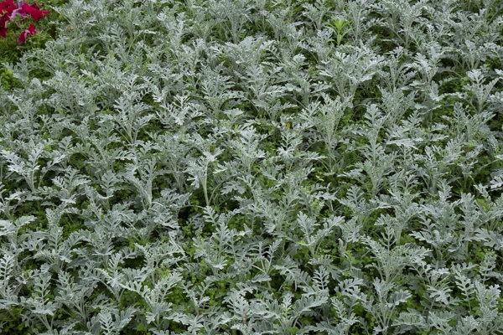13_1.png:** 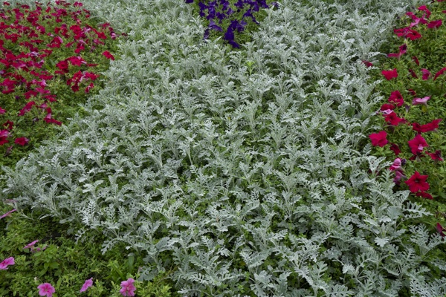

**Table 1 - Found homography parameters and normalization accuracy assessment**

|  |  |  |  |  |  |  |  |  |  |  |  |  |  |  |  |
| --- | --- | --- | --- | --- | --- | --- | --- | --- | --- | --- | --- | --- | --- | --- | --- |
| Original:  img1: 0 img2: 0 | h11 | h12 | h13 | h21 | h22 | h23 | h31 | h32 | h33 | avg ErrPar (param) | avg ErrIM (pixel) | max ErrIM | avg ErrCPM (corner) | max ErrCPM | Expert rate |
| SIFT | 0,594 | 0,062 | 97,192 | -0,063 | 0,579 | 96,021 | 0 | -0 | 1 | 0 | 0,57 | 2,344 | ~ | ~ |  |
| SURF128 | 0,592 | 0,066 | 96,907 | -0,064 | 0,581 | 95,957 | 0 | 0 | 1 | 0 | 0,775 | 2,895 | ~ | ~ |  |
| SURF64 | 0,605 | 0,069 | 95,07 | -0,06 | 0,588 | 94,821 | 0 | 0 | 1 | 0 | 0,762 | 2,78 | ~ | ~ |  |
| ORB | 0,598 | 0,059 | 96,827 | -0,062 | 0,579 | 95,644 | 0 | -0 | 1 | 0 | 0,82 | 3,025 | ~ | ~ |  |
| ORB1000 | 0,591 | 0,071 | 96,913 | -0,07 | 0,593 | 95,301 | 0 | 0 | 1 | 0 | 0,844 | 1,84 | ~ | ~ |  |
| BRISK | 0,595 | 0,06 | 97,036 | -0,063 | 0,579 | 95,771 | 0 | -0 | 1 | 0 | 0,753 | 3,183 | ~ | ~ |  |
| KAZE | 0,593 | 0,066 | 96,814 | -0,064 | 0,582 | 95,608 | 0 | 0 | 1 | 0 | 0,67 | 3,25 | ~ | ~ |  |
| AKAZE | 0,596 | 0,069 | 95,955 | -0,063 | 0,585 | 95,118 | 0 | 0 | 1 | 0 | 0,559 | 2,28 | ~ | ~ |  |
| Original matrix |  |  |  |  |  |  |  |  |  |  |  |  |  |  |  |

where h11, h12, h13, h21, h22, h23, h31, h32, h33 - parameters of found homography matrix H* or of original one H;   
avgErrPar - average error of found parameters, the accuracy of found homography matrix parameters with a preliminary minimax normalization of found and original matrices;  
avgErrIM - average error of inlier coordinate matching;  
inliers - correct matches; outliers - false matches;  
maxErrIM – maximum error of inlier coordinate matching;  
avgErrCPM - average error of corner point matching;  
maxErrCPM - maximum error of corner point matching;  
expert rate - experts assessment of normalization accuracy with a 5-point scale: 0 - normalization failed, 1 - insufficient, 2 - satisfactory, 3 - good, 4 – excellent.

**Table 2 - Quantitative evaluation of descriptors, precision and recall estimation (with found overlap)**

|  |  |  |  |  |  |  |  |  |  |  |  |  |  |  |  |  |
| --- | --- | --- | --- | --- | --- | --- | --- | --- | --- | --- | --- | --- | --- | --- | --- | --- |
| Name | NP1 | NP2 | NM | NI | DP1 | DP2 | OP1 | OP2 | NPO1 | NPO2 | NMO | DPO1 | DPO2 | Precision | RecallO1 | Comments |
| SIFT | 5077 | 4943 | 964 | 902 | 0,0212 | 0,0206 | 100 | 34,045 | 5077 | 1692 | 964 | 0,0212 | 0,0207 | 0,9357 | 0,1777 |  |
| SURF128 | 3062 | 3300 | 287 | 279 | 0,0128 | 0,0138 | 100 | 34,0767 | 3062 | 1298 | 287 | 0,0128 | 0,0159 | 0,9721 | 0,0911 |  |
| SURF64 | 3062 | 3300 | 423 | 366 | 0,0128 | 0,0138 | 100 | 34,2158 | 3062 | 1302 | 423 | 0,0128 | 0,0159 | 0,8652 | 0,1195 |  |
| ORB | 26869 | 27408 | 3247 | 2940 | 0,112 | 0,1142 | 100 | 34,3917 | 26869 | 14647 | 3247 | 0,112 | 0,1775 | 0,9055 | 0,1094 |  |
| ORB1000 | 1000 | 1000 | 119 | 96 | 0,0042 | 0,0042 | 100 | 34,5904 | 1000 | 614 | 119 | 0,0042 | 0,0074 | 0,8067 | 0,096 |  |
| BRISK | 12195 | 11955 | 1028 | 956 | 0,0508 | 0,0498 | 100 | 34,2054 | 12195 | 5660 | 1028 | 0,0508 | 0,0689 | 0,93 | 0,0784 |  |
| KAZE | 2019 | 1825 | 228 | 221 | 0,0084 | 0,0076 | 100 | 34,13 | 2019 | 798 | 228 | 0,0084 | 0,0097 | 0,9693 | 0,1095 |  |
| AKAZE | 2108 | 1929 | 179 | 157 | 0,0088 | 0,008 | 100 | 34,2946 | 2108 | 979 | 179 | 0,0088 | 0,0119 | 0,8771 | 0,0745 |  |

where NP - number of found key points; NP1, NP2 - number of found key points for image1 and image2 respectively;  
NM - number of matches found with NNDR method, NM=NI+NO;  
NI - number of inliers found with RANSAC method;  
NO - number of outliers discarded with RANSAC method;   
DP - density of key points (per cent), DP= NP/(height x width) , height, width - vertical and horizontal image sizes respectively (pixels)  
DP1, DP2 - density of key points points for image1 and image2 respectively;  
OP1, OP2 - overlap percentage for image1 and image2 respectively;  
NPO1, NPO2 - number of found key points on overlap for image1 and image2 respectivelyy;  
NMO - number of matches on overlap found with NNDR method;  
DPO1, DPO2 - density of key points points on overlap for image1 and image2 respectively;   
OA - overlap area (pixels), OA1, OA2 - overlap area for image1 and image2 respectively;  
DPO1= NPO1/OA1; DPO2= NPO2/OA2;  
Precision = NI/ NM - the rate to evaluate the part of inliers to all found matches with NNDR method;  
RecallO1 = NI/ NPO1 - completeness of inlier retrieval relative to the number of all key points on overlap for image1. The rate illustrates usefulness of the found key points for normalization.

**Table 3 - Estimation of time costs**

|  |  |  |  |  |  |  |  |  |  |  |
| --- | --- | --- | --- | --- | --- | --- | --- | --- | --- | --- |
| Name | NP1 | NP2 | DesT1, sec | DesT2, sec | MatchT, sec | InlierT, sec | AvgDesT, ms | AvgMatchT, ms | AvgInlierT, ms | TotalNormT, sec |
| SIFT | 5077 | 4943 | 0,105817 | 0,082545 | 0,314305 | 0,000795 | 0,01877 | 0,326042 | 0,000881 | 0,503462 |
| SURF128 | 3062 | 3300 | 0,10025 | 0,114136 | 0,124648 | 0,00035 | 0,033663 | 0,434314 | 0,001254 | 0,339384 |
| SURF64 | 3062 | 3300 | 0,157529 | 0,104302 | 0,06038 | 0,000487 | 0,041526 | 0,142742 | 0,001331 | 0,322698 |
| ORB | 26869 | 27408 | 0,05281 | 0,051286 | 2,224468 | 0,00227 | 0,001918 | 0,685084 | 0,000771 | 2,330834 |
| ORB1000 | 1000 | 1000 | 0,01466 | 0,014663 | 0,003707 | 0,000441 | 0,014661 | 0,031147 | 0,004597 | 0,033471 |
| BRISK | 12195 | 11955 | 0,199775 | 0,193077 | 0,52817 | 0,000738 | 0,016265 | 0,513784 | 0,000772 | 0,92176 |
| KAZE | 2019 | 1825 | 0,246753 | 0,146496 | 0,029427 | 0,000356 | 0,101243 | 0,129067 | 0,00161 | 0,423032 |
| AKAZE | 2108 | 1929 | 0,165183 | 0,074925 | 0,060057 | 0,000372 | 0,0586 | 0,335511 | 0,002369 | 0,300537 |

where DesT – descriptor creation time (time for key point detection and descriptor computation), DesT1, DesT2 – creation time of descriptors for image1 and image2 respectively;  
MatchT - retrieval time of matching found with NNDR method for the pair;  
InlierT – inlier retrieval time found with RANSAC method for the pair;  
AvgDesT – average time for one descriptor creation;  
AvgMatchT - average time for one match retrieval with NNDR method;  
AvgInlierT – average time for one inlier retrieval with RANSAC method;  
TotalNormT – total normalization time for the pair.