**Normalization results for pairs 14_0.png_14_1.png from subset png\texture_nature**

**14_0.png: 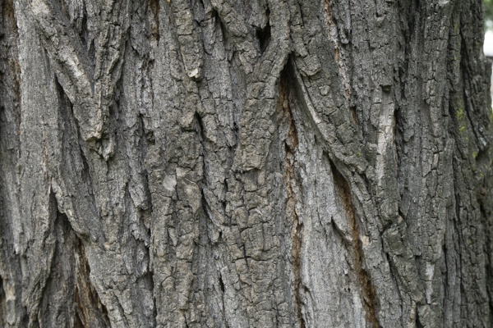14_1.png:** 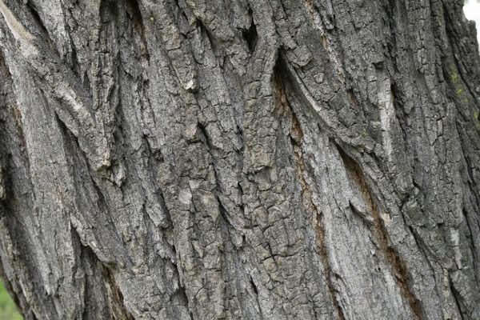

**Table 1 - Found homography parameters and normalization accuracy assessment**

|  |  |  |  |  |  |  |  |  |  |  |  |  |  |  |  |
| --- | --- | --- | --- | --- | --- | --- | --- | --- | --- | --- | --- | --- | --- | --- | --- |
| Original:  img1: 0 img2: 0 | h11 | h12 | h13 | h21 | h22 | h23 | h31 | h32 | h33 | avg ErrPar (param) | avg ErrIM (pixel) | max ErrIM | avg ErrCPM (corner) | max ErrCPM | Expert rate |
| SIFT | 0,994 | 0,175 | -13,94 | -0,185 | 0,992 | 61,662 | 0 | -0 | 1 | 0 | 0,454 | 2,328 | ~ | ~ |  |
| SURF128 | 0,995 | 0,176 | -14,086 | -0,185 | 0,994 | 61,461 | 0 | -0 | 1 | 0 | 0,809 | 3,42 | ~ | ~ |  |
| SURF64 | 0,999 | 0,178 | -14,833 | -0,184 | 0,997 | 60,891 | 0 | -0 | 1 | 0 | 0,832 | 3,526 | ~ | ~ |  |
| ORB | 0,992 | 0,175 | -13,764 | -0,187 | 0,991 | 61,718 | -0 | -0 | 1 | 0 | 0,778 | 3,652 | ~ | ~ |  |
| ORB1000 | 0,995 | 0,181 | -14,489 | -0,187 | 0,997 | 61,693 | -0 | -0 | 1 | 0 | 0,945 | 3,848 | ~ | ~ |  |
| BRISK | 0,993 | 0,176 | -13,832 | -0,186 | 0,992 | 61,675 | -0 | -0 | 1 | 0 | 0,627 | 3,32 | ~ | ~ |  |
| KAZE | 0,992 | 0,176 | -13,781 | -0,187 | 0,992 | 61,679 | -0 | -0 | 1 | 0 | 0,379 | 2,588 | ~ | ~ |  |
| AKAZE | 0,993 | 0,176 | -13,784 | -0,186 | 0,992 | 61,579 | -0 | -0 | 1 | 0 | 0,302 | 2,329 | ~ | ~ |  |
| Original matrix |  |  |  |  |  |  |  |  |  |  |  |  |  |  |  |

where h11, h12, h13, h21, h22, h23, h31, h32, h33 - parameters of found homography matrix H* or of original one H;   
avgErrPar - average error of found parameters, the accuracy of found homography matrix parameters with a preliminary minimax normalization of found and original matrices;  
avgErrIM - average error of inlier coordinate matching;  
inliers - correct matches; outliers - false matches;  
maxErrIM – maximum error of inlier coordinate matching;  
avgErrCPM - average error of corner point matching;  
maxErrCPM - maximum error of corner point matching;  
expert rate - experts assessment of normalization accuracy with a 5-point scale: 0 - normalization failed, 1 - insufficient, 2 - satisfactory, 3 - good, 4 – excellent.

**Table 2 - Quantitative evaluation of descriptors, precision and recall estimation (with found overlap)**

|  |  |  |  |  |  |  |  |  |  |  |  |  |  |  |  |  |
| --- | --- | --- | --- | --- | --- | --- | --- | --- | --- | --- | --- | --- | --- | --- | --- | --- |
| Name | NP1 | NP2 | NM | NI | DP1 | DP2 | OP1 | OP2 | NPO1 | NPO2 | NMO | DPO1 | DPO2 | Precision | RecallO1 | Comments |
| SIFT | 4032 | 4079 | 2451 | 2446 | 0,0168 | 0,017 | 89,0854 | 92,1004 | 3604 | 3817 | 2451 | 0,0169 | 0,0173 | 0,998 | 0,6787 |  |
| SURF128 | 3270 | 3320 | 950 | 892 | 0,0136 | 0,0138 | 89,0487 | 92,1317 | 3105 | 3189 | 950 | 0,0145 | 0,0144 | 0,9389 | 0,2873 |  |
| SURF64 | 3270 | 3320 | 1249 | 1045 | 0,0136 | 0,0138 | 89,0812 | 92,2125 | 3106 | 3192 | 1249 | 0,0145 | 0,0144 | 0,8367 | 0,3364 |  |
| ORB | 21549 | 23102 | 11722 | 10863 | 0,0898 | 0,0963 | 88,96 | 92,1017 | 21386 | 22975 | 11722 | 0,1002 | 0,1039 | 0,9267 | 0,5079 |  |
| ORB1000 | 1000 | 1000 | 610 | 518 | 0,0042 | 0,0042 | 89,0492 | 92,0467 | 1000 | 995 | 610 | 0,0047 | 0,0045 | 0,8492 | 0,518 |  |
| BRISK | 7966 | 8879 | 3531 | 3469 | 0,0332 | 0,037 | 89,0171 | 92,0996 | 7783 | 8717 | 3531 | 0,0364 | 0,0394 | 0,9824 | 0,4457 |  |
| KAZE | 1023 | 1126 | 764 | 741 | 0,0043 | 0,0047 | 88,9804 | 92,1112 | 963 | 1067 | 762 | 0,0045 | 0,0048 | 0,9699 | 0,7695 |  |
| AKAZE | 1132 | 1253 | 824 | 814 | 0,0047 | 0,0052 | 89,0037 | 92,1133 | 1121 | 1238 | 824 | 0,0052 | 0,0056 | 0,9879 | 0,7261 |  |

where NP - number of found key points; NP1, NP2 - number of found key points for image1 and image2 respectively;  
NM - number of matches found with NNDR method, NM=NI+NO;  
NI - number of inliers found with RANSAC method;  
NO - number of outliers discarded with RANSAC method;   
DP - density of key points (per cent), DP= NP/(height x width) , height, width - vertical and horizontal image sizes respectively (pixels)  
DP1, DP2 - density of key points points for image1 and image2 respectively;  
OP1, OP2 - overlap percentage for image1 and image2 respectively;  
NPO1, NPO2 - number of found key points on overlap for image1 and image2 respectivelyy;  
NMO - number of matches on overlap found with NNDR method;  
DPO1, DPO2 - density of key points points on overlap for image1 and image2 respectively;   
OA - overlap area (pixels), OA1, OA2 - overlap area for image1 and image2 respectively;  
DPO1= NPO1/OA1; DPO2= NPO2/OA2;  
Precision = NI/ NM - the rate to evaluate the part of inliers to all found matches with NNDR method;  
RecallO1 = NI/ NPO1 - completeness of inlier retrieval relative to the number of all key points on overlap for image1. The rate illustrates usefulness of the found key points for normalization.

**Table 3 - Estimation of time costs**

|  |  |  |  |  |  |  |  |  |  |  |
| --- | --- | --- | --- | --- | --- | --- | --- | --- | --- | --- |
| Name | NP1 | NP2 | DesT1, sec | DesT2, sec | MatchT, sec | InlierT, sec | AvgDesT, ms | AvgMatchT, ms | AvgInlierT, ms | TotalNormT, sec |
| SIFT | 4032 | 4079 | 0,076732 | 0,073847 | 0,176114 | 0,001755 | 0,018567 | 0,071853 | 0,000717 | 0,328448 |
| SURF128 | 3270 | 3320 | 0,098182 | 0,103507 | 0,125984 | 0,001055 | 0,0306 | 0,132614 | 0,001182 | 0,328727 |
| SURF64 | 3270 | 3320 | 0,125872 | 0,103009 | 0,068209 | 0,000991 | 0,034759 | 0,05461 | 0,000948 | 0,298081 |
| ORB | 21549 | 23102 | 0,040764 | 0,043026 | 1,668785 | 0,007298 | 0,001876 | 0,142363 | 0,000671 | 1,759873 |
| ORB1000 | 1000 | 1000 | 0,011947 | 0,013855 | 0,003517 | 0,000587 | 0,0129 | 0,005765 | 0,001133 | 0,029905 |
| BRISK | 7966 | 8879 | 0,119477 | 0,132409 | 0,200987 | 0,002369 | 0,014955 | 0,05692 | 0,000682 | 0,455242 |
| KAZE | 1023 | 1126 | 0,220271 | 0,121236 | 0,012955 | 0,000628 | 0,161493 | 0,016956 | 0,000848 | 0,35509 |
| AKAZE | 1132 | 1253 | 0,019135 | 0,016757 | 0,006974 | 0,000693 | 0,015138 | 0,008464 | 0,00085 | 0,043559 |

where DesT – descriptor creation time (time for key point detection and descriptor computation), DesT1, DesT2 – creation time of descriptors for image1 and image2 respectively;  
MatchT - retrieval time of matching found with NNDR method for the pair;  
InlierT – inlier retrieval time found with RANSAC method for the pair;  
AvgDesT – average time for one descriptor creation;  
AvgMatchT - average time for one match retrieval with NNDR method;  
AvgInlierT – average time for one inlier retrieval with RANSAC method;  
TotalNormT – total normalization time for the pair.