**Normalization results for pairs 15_0.png_15_1.png from subset png\texture_nature**

**15_0.png: 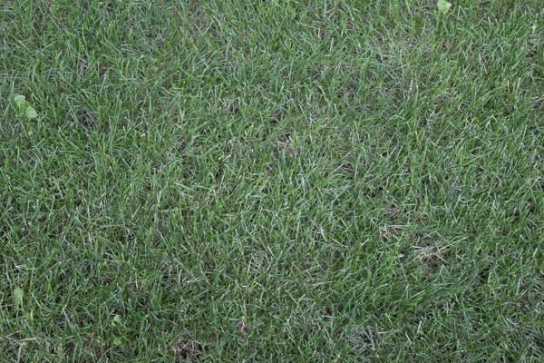15_1.png:** 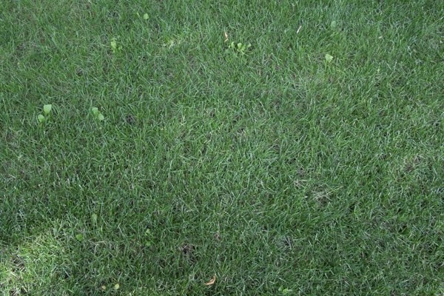

**Table 1 - Found homography parameters and normalization accuracy assessment**

|  |  |  |  |  |  |  |  |  |  |  |  |  |  |  |  |
| --- | --- | --- | --- | --- | --- | --- | --- | --- | --- | --- | --- | --- | --- | --- | --- |
| Original:  img1: 0 img2: 0 | h11 | h12 | h13 | h21 | h22 | h23 | h31 | h32 | h33 | avg ErrPar (param) | avg ErrIM (pixel) | max ErrIM | avg ErrCPM (corner) | max ErrCPM | Expert rate |
| SIFT | 0,671 | -0,001 | 112,986 | -0,002 | 0,676 | 73,606 | -0 | -0 | 1 | 0 | 0,493 | 1,924 | ~ | ~ |  |
| SURF128 | 0,675 | 0,001 | 111,917 | -0,002 | 0,682 | 73,03 | -0 | 0 | 1 | 0 | 0,537 | 1,941 | ~ | ~ |  |
| SURF64 | 0,669 | 0,001 | 112,713 | -0,004 | 0,679 | 73,528 | -0 | 0 | 1 | 0 | 0,622 | 2,013 | ~ | ~ |  |
| ORB | 0,679 | -0,004 | 111,789 | 0 | 0,679 | 72,828 | -0 | -0 | 1 | 0 | 0,733 | 2,87 | ~ | ~ |  |
| ORB1000 | 0,675 | 0,002 | 112,03 | -0,002 | 0,682 | 72,709 | -0 | -0 | 1 | 0 | 0,895 | 2,952 | ~ | ~ |  |
| BRISK | 0,673 | -0,002 | 112,6 | -0,002 | 0,678 | 73,276 | -0 | -0 | 1 | 0 | 0,601 | 2,636 | ~ | ~ |  |
| KAZE | 0,668 | 0,001 | 112,82 | -0,004 | 0,678 | 73,743 | -0 | 0 | 1 | 0 | 0,382 | 1,144 | ~ | ~ |  |
| AKAZE | 0,677 | 0,004 | 111,097 | -0,001 | 0,684 | 72,403 | -0 | 0 | 1 | 0 | 0,309 | 1,597 | ~ | ~ |  |
| Original matrix |  |  |  |  |  |  |  |  |  |  |  |  |  |  |  |

where h11, h12, h13, h21, h22, h23, h31, h32, h33 - parameters of found homography matrix H* or of original one H;   
avgErrPar - average error of found parameters, the accuracy of found homography matrix parameters with a preliminary minimax normalization of found and original matrices;  
avgErrIM - average error of inlier coordinate matching;  
inliers - correct matches; outliers - false matches;  
maxErrIM – maximum error of inlier coordinate matching;  
avgErrCPM - average error of corner point matching;  
maxErrCPM - maximum error of corner point matching;  
expert rate - experts assessment of normalization accuracy with a 5-point scale: 0 - normalization failed, 1 - insufficient, 2 - satisfactory, 3 - good, 4 – excellent.

**Table 2 - Quantitative evaluation of descriptors, precision and recall estimation (with found overlap)**

|  |  |  |  |  |  |  |  |  |  |  |  |  |  |  |  |  |
| --- | --- | --- | --- | --- | --- | --- | --- | --- | --- | --- | --- | --- | --- | --- | --- | --- |
| Name | NP1 | NP2 | NM | NI | DP1 | DP2 | OP1 | OP2 | NPO1 | NPO2 | NMO | DPO1 | DPO2 | Precision | RecallO1 | Comments |
| SIFT | 3052 | 2388 | 618 | 616 | 0,0127 | 0,01 | 100 | 46,5738 | 3052 | 1177 | 618 | 0,0127 | 0,0105 | 0,9968 | 0,2018 |  |
| SURF128 | 3808 | 3348 | 197 | 182 | 0,0159 | 0,014 | 100 | 46,7717 | 3808 | 1844 | 197 | 0,0159 | 0,0164 | 0,9239 | 0,0478 |  |
| SURF64 | 3808 | 3348 | 337 | 299 | 0,0159 | 0,014 | 100 | 46,7575 | 3808 | 1843 | 337 | 0,0159 | 0,0164 | 0,8872 | 0,0785 |  |
| ORB | 25039 | 20291 | 2737 | 2421 | 0,1043 | 0,0845 | 100 | 46,9554 | 25039 | 13641 | 2737 | 0,1043 | 0,121 | 0,8845 | 0,0967 |  |
| ORB1000 | 996 | 925 | 122 | 110 | 0,0042 | 0,0039 | 100 | 46,9358 | 996 | 609 | 122 | 0,0042 | 0,0054 | 0,9016 | 0,1104 |  |
| BRISK | 10437 | 7613 | 644 | 620 | 0,0435 | 0,0317 | 100 | 46,7933 | 10437 | 4408 | 644 | 0,0435 | 0,0393 | 0,9627 | 0,0594 |  |
| KAZE | 441 | 137 | 27 | 26 | 0,0018 | 0,0006 | 100 | 46,6854 | 441 | 59 | 27 | 0,0018 | 0,0005 | 0,963 | 0,059 |  |
| AKAZE | 713 | 244 | 46 | 44 | 0,003 | 0,001 | 100 | 47,0554 | 713 | 145 | 46 | 0,003 | 0,0013 | 0,9565 | 0,0617 |  |

where NP - number of found key points; NP1, NP2 - number of found key points for image1 and image2 respectively;  
NM - number of matches found with NNDR method, NM=NI+NO;  
NI - number of inliers found with RANSAC method;  
NO - number of outliers discarded with RANSAC method;   
DP - density of key points (per cent), DP= NP/(height x width) , height, width - vertical and horizontal image sizes respectively (pixels)  
DP1, DP2 - density of key points points for image1 and image2 respectively;  
OP1, OP2 - overlap percentage for image1 and image2 respectively;  
NPO1, NPO2 - number of found key points on overlap for image1 and image2 respectivelyy;  
NMO - number of matches on overlap found with NNDR method;  
DPO1, DPO2 - density of key points points on overlap for image1 and image2 respectively;   
OA - overlap area (pixels), OA1, OA2 - overlap area for image1 and image2 respectively;  
DPO1= NPO1/OA1; DPO2= NPO2/OA2;  
Precision = NI/ NM - the rate to evaluate the part of inliers to all found matches with NNDR method;  
RecallO1 = NI/ NPO1 - completeness of inlier retrieval relative to the number of all key points on overlap for image1. The rate illustrates usefulness of the found key points for normalization.

**Table 3 - Estimation of time costs**

|  |  |  |  |  |  |  |  |  |  |  |
| --- | --- | --- | --- | --- | --- | --- | --- | --- | --- | --- |
| Name | NP1 | NP2 | DesT1, sec | DesT2, sec | MatchT, sec | InlierT, sec | AvgDesT, ms | AvgMatchT, ms | AvgInlierT, ms | TotalNormT, sec |
| SIFT | 3052 | 2388 | 0,068466 | 0,053619 | 0,070982 | 0,00053 | 0,022443 | 0,114858 | 0,00086 | 0,193597 |
| SURF128 | 3808 | 3348 | 0,097981 | 0,083832 | 0,114106 | 0,000346 | 0,025384 | 0,57922 | 0,001903 | 0,296266 |
| SURF64 | 3808 | 3348 | 0,097141 | 0,084566 | 0,061095 | 0,000449 | 0,025383 | 0,181291 | 0,0015 | 0,243252 |
| ORB | 25039 | 20291 | 0,072713 | 0,038587 | 1,503282 | 0,001764 | 0,002402 | 0,549244 | 0,000728 | 1,616346 |
| ORB1000 | 996 | 925 | 0,012204 | 0,011079 | 0,005357 | 0,000337 | 0,012114 | 0,043911 | 0,003062 | 0,028977 |
| BRISK | 10437 | 7613 | 0,162257 | 0,106809 | 0,238085 | 0,000636 | 0,014787 | 0,369696 | 0,001025 | 0,507786 |
| KAZE | 441 | 137 | 0,127276 | 0,11641 | 0,001045 | 0,000242 | 0,569159 | 0,038697 | 0,009307 | 0,244974 |
| AKAZE | 713 | 244 | 0,017389 | 0,013355 | 0,001538 | 0,000248 | 0,03956 | 0,033428 | 0,005632 | 0,032529 |

where DesT – descriptor creation time (time for key point detection and descriptor computation), DesT1, DesT2 – creation time of descriptors for image1 and image2 respectively;  
MatchT - retrieval time of matching found with NNDR method for the pair;  
InlierT – inlier retrieval time found with RANSAC method for the pair;  
AvgDesT – average time for one descriptor creation;  
AvgMatchT - average time for one match retrieval with NNDR method;  
AvgInlierT – average time for one inlier retrieval with RANSAC method;  
TotalNormT – total normalization time for the pair.