**Normalization results for pairs 16_0.png_16_1.png from subset png\texture_nature**

**16_0.png: 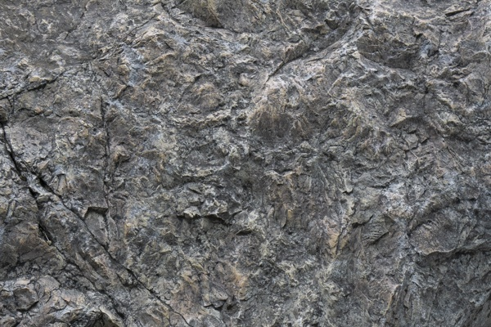16_1.png:** 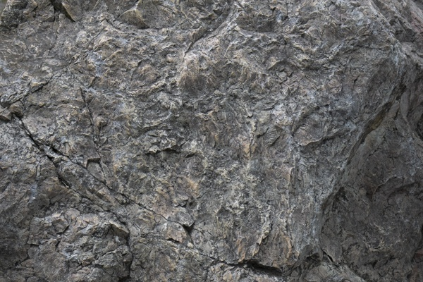

**Table 1 - Found homography parameters and normalization accuracy assessment**

|  |  |  |  |  |  |  |  |  |  |  |  |  |  |  |  |
| --- | --- | --- | --- | --- | --- | --- | --- | --- | --- | --- | --- | --- | --- | --- | --- |
| Original:  img1: 0 img2: 0 | h11 | h12 | h13 | h21 | h22 | h23 | h31 | h32 | h33 | avg ErrPar (param) | avg ErrIM (pixel) | max ErrIM | avg ErrCPM (corner) | max ErrCPM | Expert rate |
| SIFT | 0,77 | 0,175 | -0,305 | -0,144 | 0,765 | 52,991 | 0 | 0 | 1 | 0 | 0,279 | 1,607 | ~ | ~ |  |
| SURF128 | 0,771 | 0,175 | -0,532 | -0,143 | 0,766 | 52,754 | 0 | 0 | 1 | 0 | 0,777 | 2,905 | ~ | ~ |  |
| SURF64 | 0,771 | 0,177 | -0,927 | -0,144 | 0,768 | 52,838 | 0 | 0 | 1 | 0 | 0,812 | 4,173 | ~ | ~ |  |
| ORB | 0,772 | 0,175 | -0,684 | -0,144 | 0,767 | 52,793 | 0 | 0 | 1 | 0 | 0,768 | 3,65 | ~ | ~ |  |
| ORB1000 | 0,763 | 0,17 | 0,79 | -0,146 | 0,759 | 53,694 | 0 | 0 | 1 | 0 | 0,919 | 3,237 | ~ | ~ |  |
| BRISK | 0,77 | 0,174 | -0,269 | -0,144 | 0,765 | 52,864 | 0 | 0 | 1 | 0 | 0,643 | 3,476 | ~ | ~ |  |
| KAZE | 0,768 | 0,173 | -0,141 | -0,144 | 0,762 | 53,132 | 0 | 0 | 1 | 0 | 0,523 | 3,035 | ~ | ~ |  |
| AKAZE | 0,77 | 0,174 | -0,43 | -0,144 | 0,764 | 53,006 | 0 | 0 | 1 | 0 | 0,283 | 2,327 | ~ | ~ |  |
| Original matrix |  |  |  |  |  |  |  |  |  |  |  |  |  |  |  |

where h11, h12, h13, h21, h22, h23, h31, h32, h33 - parameters of found homography matrix H* or of original one H;   
avgErrPar - average error of found parameters, the accuracy of found homography matrix parameters with a preliminary minimax normalization of found and original matrices;  
avgErrIM - average error of inlier coordinate matching;  
inliers - correct matches; outliers - false matches;  
maxErrIM – maximum error of inlier coordinate matching;  
avgErrCPM - average error of corner point matching;  
maxErrCPM - maximum error of corner point matching;  
expert rate - experts assessment of normalization accuracy with a 5-point scale: 0 - normalization failed, 1 - insufficient, 2 - satisfactory, 3 - good, 4 – excellent.

**Table 2 - Quantitative evaluation of descriptors, precision and recall estimation (with found overlap)**

|  |  |  |  |  |  |  |  |  |  |  |  |  |  |  |  |  |
| --- | --- | --- | --- | --- | --- | --- | --- | --- | --- | --- | --- | --- | --- | --- | --- | --- |
| Name | NP1 | NP2 | NM | NI | DP1 | DP2 | OP1 | OP2 | NPO1 | NPO2 | NMO | DPO1 | DPO2 | Precision | RecallO1 | Comments |
| SIFT | 4608 | 4002 | 1710 | 1698 | 0,0192 | 0,0167 | 98,0021 | 55,1167 | 4521 | 2506 | 1710 | 0,0192 | 0,0189 | 0,993 | 0,3756 |  |
| SURF128 | 3065 | 3034 | 474 | 466 | 0,0128 | 0,0126 | 97,9821 | 55,1608 | 3037 | 1994 | 474 | 0,0129 | 0,0151 | 0,9831 | 0,1534 |  |
| SURF64 | 3065 | 3034 | 671 | 601 | 0,0128 | 0,0126 | 97,9367 | 55,16 | 3036 | 1988 | 671 | 0,0129 | 0,015 | 0,8957 | 0,198 |  |
| ORB | 23452 | 21114 | 4797 | 4491 | 0,0977 | 0,088 | 97,9758 | 55,2696 | 23450 | 16671 | 4797 | 0,0997 | 0,1257 | 0,9362 | 0,1915 |  |
| ORB1000 | 1000 | 1000 | 272 | 234 | 0,0042 | 0,0042 | 97,9283 | 55,3646 | 1000 | 856 | 272 | 0,0043 | 0,0064 | 0,8603 | 0,234 |  |
| BRISK | 9132 | 7882 | 1797 | 1778 | 0,0381 | 0,0328 | 97,9821 | 55,2238 | 9095 | 5953 | 1797 | 0,0387 | 0,0449 | 0,9894 | 0,1955 |  |
| KAZE | 1209 | 933 | 354 | 340 | 0,005 | 0,0039 | 98,0138 | 55,1421 | 1197 | 672 | 354 | 0,0051 | 0,0051 | 0,9605 | 0,284 |  |
| AKAZE | 1304 | 1028 | 274 | 268 | 0,0054 | 0,0043 | 97,9725 | 55,2204 | 1303 | 820 | 274 | 0,0055 | 0,0062 | 0,9781 | 0,2057 |  |

where NP - number of found key points; NP1, NP2 - number of found key points for image1 and image2 respectively;  
NM - number of matches found with NNDR method, NM=NI+NO;  
NI - number of inliers found with RANSAC method;  
NO - number of outliers discarded with RANSAC method;   
DP - density of key points (per cent), DP= NP/(height x width) , height, width - vertical and horizontal image sizes respectively (pixels)  
DP1, DP2 - density of key points points for image1 and image2 respectively;  
OP1, OP2 - overlap percentage for image1 and image2 respectively;  
NPO1, NPO2 - number of found key points on overlap for image1 and image2 respectivelyy;  
NMO - number of matches on overlap found with NNDR method;  
DPO1, DPO2 - density of key points points on overlap for image1 and image2 respectively;   
OA - overlap area (pixels), OA1, OA2 - overlap area for image1 and image2 respectively;  
DPO1= NPO1/OA1; DPO2= NPO2/OA2;  
Precision = NI/ NM - the rate to evaluate the part of inliers to all found matches with NNDR method;  
RecallO1 = NI/ NPO1 - completeness of inlier retrieval relative to the number of all key points on overlap for image1. The rate illustrates usefulness of the found key points for normalization.

**Table 3 - Estimation of time costs**

|  |  |  |  |  |  |  |  |  |  |  |
| --- | --- | --- | --- | --- | --- | --- | --- | --- | --- | --- |
| Name | NP1 | NP2 | DesT1, sec | DesT2, sec | MatchT, sec | InlierT, sec | AvgDesT, ms | AvgMatchT, ms | AvgInlierT, ms | TotalNormT, sec |
| SIFT | 4608 | 4002 | 0,066522 | 0,061684 | 0,152263 | 0,001308 | 0,014924 | 0,089042 | 0,00077 | 0,281778 |
| SURF128 | 3065 | 3034 | 0,079391 | 0,077408 | 0,074547 | 0,000447 | 0,025707 | 0,157272 | 0,000958 | 0,231793 |
| SURF64 | 3065 | 3034 | 0,068641 | 0,070688 | 0,03874 | 0,00064 | 0,022846 | 0,057735 | 0,001064 | 0,17871 |
| ORB | 23452 | 21114 | 0,045759 | 0,040065 | 1,09981 | 0,002792 | 0,001924 | 0,22927 | 0,000621 | 1,188426 |
| ORB1000 | 1000 | 1000 | 0,012553 | 0,011727 | 0,003476 | 0,000443 | 0,012139 | 0,012781 | 0,001894 | 0,028199 |
| BRISK | 9132 | 7882 | 0,138878 | 0,115248 | 0,17735 | 0,001137 | 0,014914 | 0,098692 | 0,000639 | 0,432614 |
| KAZE | 1209 | 933 | 0,182307 | 0,177474 | 0,009511 | 0,000512 | 0,170504 | 0,026866 | 0,001506 | 0,369804 |
| AKAZE | 1304 | 1028 | 0,01802 | 0,014448 | 0,004906 | 0,000303 | 0,013936 | 0,017906 | 0,001132 | 0,037678 |

where DesT – descriptor creation time (time for key point detection and descriptor computation), DesT1, DesT2 – creation time of descriptors for image1 and image2 respectively;  
MatchT - retrieval time of matching found with NNDR method for the pair;  
InlierT – inlier retrieval time found with RANSAC method for the pair;  
AvgDesT – average time for one descriptor creation;  
AvgMatchT - average time for one match retrieval with NNDR method;  
AvgInlierT – average time for one inlier retrieval with RANSAC method;  
TotalNormT – total normalization time for the pair.