**Normalization results for pairs 17_0.png_17_1.png from subset png\texture_nature**

**17_0.png: 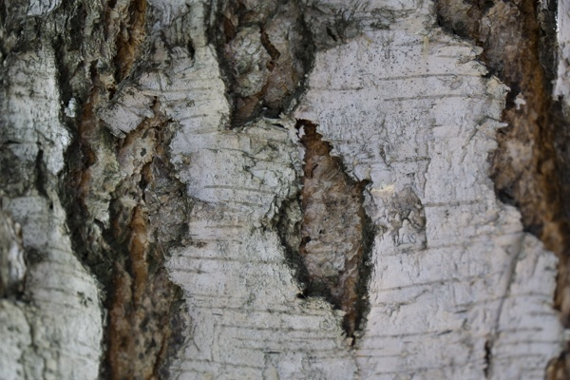17_1.png:** 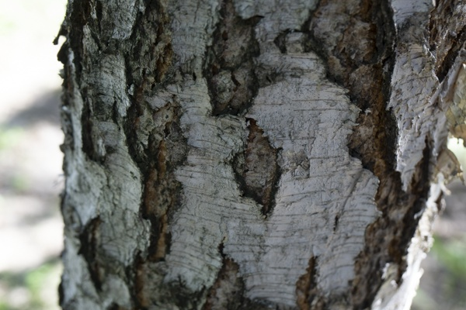

**Table 1 - Found homography parameters and normalization accuracy assessment**

|  |  |  |  |  |  |  |  |  |  |  |  |  |  |  |  |
| --- | --- | --- | --- | --- | --- | --- | --- | --- | --- | --- | --- | --- | --- | --- | --- |
| Original:  img1: 0 img2: 0 | h11 | h12 | h13 | h21 | h22 | h23 | h31 | h32 | h33 | avg ErrPar (param) | avg ErrIM (pixel) | max ErrIM | avg ErrCPM (corner) | max ErrCPM | Expert rate |
| SIFT | 0,65 | 0,009 | 123,295 | 0,132 | 0,606 | 39,49 | 0 | 0 | 1 | 0 | 1,213 | 3,033 | ~ | ~ |  |
| SURF128 | 0,597 | -0,005 | 126,422 | 0,105 | 0,568 | 45,464 | -0 | 0 | 1 | 0 | 1,37 | 3,628 | ~ | ~ |  |
| SURF64 | 0,568 | -0,02 | 131,453 | 0,019 | 0,54 | 70,675 | -0 | 0 | 1 | 0 | 1,524 | 3,239 | ~ | ~ |  |
| ORB | 0,609 | -0,032 | 128,541 | 0,096 | 0,55 | 51,018 | -0 | 0 | 1 | 0 | 1,333 | 3,238 | ~ | ~ |  |
| ORB1000 | 0,633 | -0,024 | 126,754 | 0,123 | 0,562 | 44,544 | 0 | 0 | 1 | 0 | 1,249 | 2,993 | ~ | ~ |  |
| BRISK | 0,624 | -0,009 | 125,28 | 0,101 | 0,567 | 48,892 | -0 | 0 | 1 | 0 | 1,379 | 3,491 | ~ | ~ |  |
| KAZE | 0,626 | -0,006 | 124,707 | 0,104 | 0,564 | 48,371 | -0 | 0 | 1 | 0 | 1,385 | 3,168 | ~ | ~ |  |
| AKAZE | 0,614 | -0,007 | 126,396 | 0,099 | 0,568 | 48,216 | -0 | 0 | 1 | 0 | 1,161 | 3,148 | ~ | ~ |  |
| Original matrix |  |  |  |  |  |  |  |  |  |  |  |  |  |  |  |

where h11, h12, h13, h21, h22, h23, h31, h32, h33 - parameters of found homography matrix H* or of original one H;   
avgErrPar - average error of found parameters, the accuracy of found homography matrix parameters with a preliminary minimax normalization of found and original matrices;  
avgErrIM - average error of inlier coordinate matching;  
inliers - correct matches; outliers - false matches;  
maxErrIM – maximum error of inlier coordinate matching;  
avgErrCPM - average error of corner point matching;  
maxErrCPM - maximum error of corner point matching;  
expert rate - experts assessment of normalization accuracy with a 5-point scale: 0 - normalization failed, 1 - insufficient, 2 - satisfactory, 3 - good, 4 – excellent.

**Table 2 - Quantitative evaluation of descriptors, precision and recall estimation (with found overlap)**

|  |  |  |  |  |  |  |  |  |  |  |  |  |  |  |  |  |
| --- | --- | --- | --- | --- | --- | --- | --- | --- | --- | --- | --- | --- | --- | --- | --- | --- |
| Name | NP1 | NP2 | NM | NI | DP1 | DP2 | OP1 | OP2 | NPO1 | NPO2 | NMO | DPO1 | DPO2 | Precision | RecallO1 | Comments |
| SIFT | 3589 | 2795 | 490 | 205 | 0,015 | 0,0116 | 100 | 34,1283 | 3589 | 1171 | 490 | 0,015 | 0,0143 | 0,4184 | 0,0571 |  |
| SURF128 | 2547 | 2199 | 194 | 87 | 0,0106 | 0,0092 | 100 | 35,1654 | 2547 | 1051 | 194 | 0,0106 | 0,0125 | 0,4485 | 0,0342 |  |
| SURF64 | 2547 | 2199 | 310 | 141 | 0,0106 | 0,0092 | 100 | 34,2283 | 2547 | 1016 | 310 | 0,0106 | 0,0124 | 0,4548 | 0,0554 |  |
| ORB | 12344 | 8975 | 724 | 389 | 0,0514 | 0,0374 | 100 | 34,5696 | 12344 | 5186 | 724 | 0,0514 | 0,0625 | 0,5373 | 0,0315 |  |
| ORB1000 | 1000 | 1000 | 84 | 62 | 0,0042 | 0,0042 | 100 | 33,9342 | 1000 | 482 | 84 | 0,0042 | 0,0059 | 0,7381 | 0,062 |  |
| BRISK | 3875 | 2461 | 277 | 149 | 0,0161 | 0,0103 | 100 | 33,9662 | 3875 | 1249 | 277 | 0,0161 | 0,0153 | 0,5379 | 0,0385 |  |
| KAZE | 954 | 840 | 102 | 52 | 0,004 | 0,0035 | 100 | 33,7358 | 954 | 281 | 102 | 0,004 | 0,0035 | 0,5098 | 0,0545 |  |
| AKAZE | 808 | 671 | 62 | 33 | 0,0034 | 0,0028 | 100 | 34,1 | 808 | 312 | 62 | 0,0034 | 0,0038 | 0,5323 | 0,0408 |  |

where NP - number of found key points; NP1, NP2 - number of found key points for image1 and image2 respectively;  
NM - number of matches found with NNDR method, NM=NI+NO;  
NI - number of inliers found with RANSAC method;  
NO - number of outliers discarded with RANSAC method;   
DP - density of key points (per cent), DP= NP/(height x width) , height, width - vertical and horizontal image sizes respectively (pixels)  
DP1, DP2 - density of key points points for image1 and image2 respectively;  
OP1, OP2 - overlap percentage for image1 and image2 respectively;  
NPO1, NPO2 - number of found key points on overlap for image1 and image2 respectivelyy;  
NMO - number of matches on overlap found with NNDR method;  
DPO1, DPO2 - density of key points points on overlap for image1 and image2 respectively;   
OA - overlap area (pixels), OA1, OA2 - overlap area for image1 and image2 respectively;  
DPO1= NPO1/OA1; DPO2= NPO2/OA2;  
Precision = NI/ NM - the rate to evaluate the part of inliers to all found matches with NNDR method;  
RecallO1 = NI/ NPO1 - completeness of inlier retrieval relative to the number of all key points on overlap for image1. The rate illustrates usefulness of the found key points for normalization.

**Table 3 - Estimation of time costs**

|  |  |  |  |  |  |  |  |  |  |  |
| --- | --- | --- | --- | --- | --- | --- | --- | --- | --- | --- |
| Name | NP1 | NP2 | DesT1, sec | DesT2, sec | MatchT, sec | InlierT, sec | AvgDesT, ms | AvgMatchT, ms | AvgInlierT, ms | TotalNormT, sec |
| SIFT | 3589 | 2795 | 0,05932 | 0,053619 | 0,077382 | 0,004619 | 0,017855 | 0,157922 | 0,022531 | 0,19494 |
| SURF128 | 2547 | 2199 | 0,062127 | 0,054534 | 0,045976 | 0,003345 | 0,024595 | 0,23699 | 0,038449 | 0,165983 |
| SURF64 | 2547 | 2199 | 0,057536 | 0,058846 | 0,024244 | 0,003217 | 0,024674 | 0,078206 | 0,022813 | 0,143842 |
| ORB | 12344 | 8975 | 0,026057 | 0,02064 | 0,247135 | 0,00259 | 0,002204 | 0,341347 | 0,006657 | 0,296422 |
| ORB1000 | 1000 | 1000 | 0,010595 | 0,010025 | 0,0043 | 0,000601 | 0,010309 | 0,051195 | 0,009694 | 0,025521 |
| BRISK | 3875 | 2461 | 0,057188 | 0,036753 | 0,024955 | 0,001765 | 0,014846 | 0,090088 | 0,011843 | 0,12066 |
| KAZE | 954 | 840 | 0,178355 | 0,121698 | 0,006912 | 0,002027 | 0,165916 | 0,067768 | 0,038977 | 0,308992 |
| AKAZE | 808 | 671 | 0,016552 | 0,012424 | 0,002356 | 0,001713 | 0,0195 | 0,038003 | 0,051913 | 0,033046 |

where DesT – descriptor creation time (time for key point detection and descriptor computation), DesT1, DesT2 – creation time of descriptors for image1 and image2 respectively;  
MatchT - retrieval time of matching found with NNDR method for the pair;  
InlierT – inlier retrieval time found with RANSAC method for the pair;  
AvgDesT – average time for one descriptor creation;  
AvgMatchT - average time for one match retrieval with NNDR method;  
AvgInlierT – average time for one inlier retrieval with RANSAC method;  
TotalNormT – total normalization time for the pair.