**Normalization results for pairs 18_0.png_18_1.png from subset png\texture_nature**

**18_0.png: 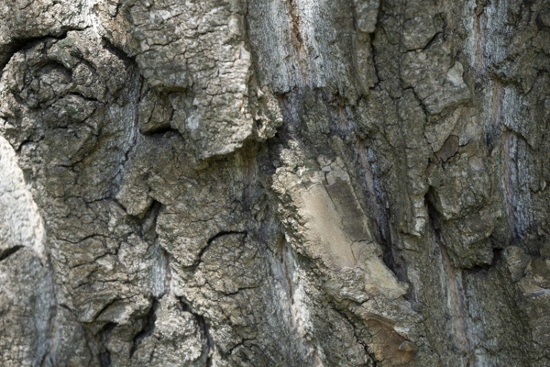18_1.png:** 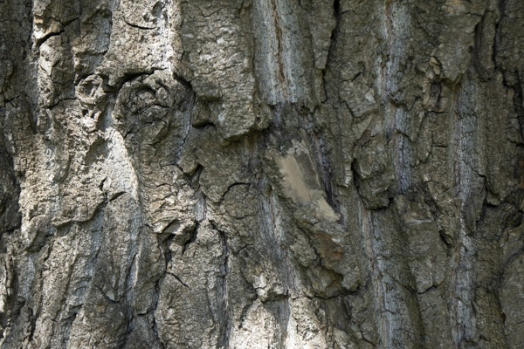

**Table 1 - Found homography parameters and normalization accuracy assessment**

|  |  |  |  |  |  |  |  |  |  |  |  |  |  |  |  |
| --- | --- | --- | --- | --- | --- | --- | --- | --- | --- | --- | --- | --- | --- | --- | --- |
| Original:  img1: 0 img2: 0 | h11 | h12 | h13 | h21 | h22 | h23 | h31 | h32 | h33 | avg ErrPar (param) | avg ErrIM (pixel) | max ErrIM | avg ErrCPM (corner) | max ErrCPM | Expert rate |
| SIFT | 0,572 | -0,021 | 134,193 | 0,003 | 0,593 | 57,435 | -0 | -0 | 1 | 0 | 1,101 | 3,368 | ~ | ~ |  |
| SURF128 | 0,559 | -0,024 | 135,333 | 0 | 0,592 | 56,75 | -0 | -0 | 1 | 0 | 1,13 | 3,277 | ~ | ~ |  |
| SURF64 | 0,555 | -0,032 | 136,938 | 0,001 | 0,583 | 57,261 | -0 | -0 | 1 | 0 | 1,122 | 3,174 | ~ | ~ |  |
| ORB | 0,572 | -0,035 | 135,453 | 0,006 | 0,581 | 57,363 | -0 | -0 | 1 | 0 | 1,117 | 3,1 | ~ | ~ |  |
| ORB1000 | 0,005 | -0,353 | 114,485 | -0,048 | -0,599 | 205,385 | -0 | -0,003 | 1 | 0 | 0 | 0 | ~ | ~ |  |
| BRISK | 0,587 | -0,029 | 132,848 | 0,016 | 0,597 | 52,983 | 0 | -0 | 1 | 0 | 1,211 | 3,33 | ~ | ~ |  |
| KAZE | 0,568 | -0,035 | 135,537 | -0 | 0,577 | 59,426 | -0 | -0 | 1 | 0 | 0,913 | 2,768 | ~ | ~ |  |
| AKAZE | 0,596 | -0,025 | 131,864 | 0,012 | 0,595 | 55,889 | 0 | -0 | 1 | 0 | 1,057 | 2,659 | ~ | ~ |  |
| Original matrix |  |  |  |  |  |  |  |  |  |  |  |  |  |  |  |

where h11, h12, h13, h21, h22, h23, h31, h32, h33 - parameters of found homography matrix H* or of original one H;   
avgErrPar - average error of found parameters, the accuracy of found homography matrix parameters with a preliminary minimax normalization of found and original matrices;  
avgErrIM - average error of inlier coordinate matching;  
inliers - correct matches; outliers - false matches;  
maxErrIM – maximum error of inlier coordinate matching;  
avgErrCPM - average error of corner point matching;  
maxErrCPM - maximum error of corner point matching;  
expert rate - experts assessment of normalization accuracy with a 5-point scale: 0 - normalization failed, 1 - insufficient, 2 - satisfactory, 3 - good, 4 – excellent.

**Table 2 - Quantitative evaluation of descriptors, precision and recall estimation (with found overlap)**

|  |  |  |  |  |  |  |  |  |  |  |  |  |  |  |  |  |
| --- | --- | --- | --- | --- | --- | --- | --- | --- | --- | --- | --- | --- | --- | --- | --- | --- |
| Name | NP1 | NP2 | NM | NI | DP1 | DP2 | OP1 | OP2 | NPO1 | NPO2 | NMO | DPO1 | DPO2 | Precision | RecallO1 | Comments |
| SIFT | 4407 | 3663 | 620 | 468 | 0,0184 | 0,0153 | 100 | 35,6275 | 4407 | 1404 | 620 | 0,0184 | 0,0164 | 0,7548 | 0,1062 |  |
| SURF128 | 2879 | 2988 | 172 | 132 | 0,012 | 0,0124 | 100 | 35,9817 | 2879 | 1209 | 172 | 0,012 | 0,014 | 0,7674 | 0,0458 |  |
| SURF64 | 2879 | 2988 | 229 | 166 | 0,012 | 0,0124 | 100 | 35,8325 | 2879 | 1202 | 229 | 0,012 | 0,014 | 0,7249 | 0,0577 |  |
| ORB | 17896 | 18614 | 802 | 545 | 0,0746 | 0,0776 | 100 | 35,6433 | 17896 | 9346 | 802 | 0,0746 | 0,1093 | 0,6796 | 0,0305 |  |
| ORB1000 | 1000 | 1000 | 7 | 4 | 0,0042 | 0,0042 | 90,5329 | 99,7496 | 959 | 991 | 7 | 0,0044 | 0,0041 | 0,5714 | 0,0042 |  |
| BRISK | 6459 | 6992 | 272 | 197 | 0,0269 | 0,0291 | 100 | 36,1212 | 6459 | 2959 | 272 | 0,0269 | 0,0341 | 0,7243 | 0,0305 |  |
| KAZE | 1028 | 1017 | 69 | 40 | 0,0043 | 0,0042 | 100 | 35,5392 | 1028 | 382 | 69 | 0,0043 | 0,0045 | 0,5797 | 0,0389 |  |
| AKAZE | 973 | 1046 | 49 | 36 | 0,0041 | 0,0044 | 100 | 35,625 | 973 | 453 | 49 | 0,0041 | 0,0053 | 0,7347 | 0,037 |  |

where NP - number of found key points; NP1, NP2 - number of found key points for image1 and image2 respectively;  
NM - number of matches found with NNDR method, NM=NI+NO;  
NI - number of inliers found with RANSAC method;  
NO - number of outliers discarded with RANSAC method;   
DP - density of key points (per cent), DP= NP/(height x width) , height, width - vertical and horizontal image sizes respectively (pixels)  
DP1, DP2 - density of key points points for image1 and image2 respectively;  
OP1, OP2 - overlap percentage for image1 and image2 respectively;  
NPO1, NPO2 - number of found key points on overlap for image1 and image2 respectivelyy;  
NMO - number of matches on overlap found with NNDR method;  
DPO1, DPO2 - density of key points points on overlap for image1 and image2 respectively;   
OA - overlap area (pixels), OA1, OA2 - overlap area for image1 and image2 respectively;  
DPO1= NPO1/OA1; DPO2= NPO2/OA2;  
Precision = NI/ NM - the rate to evaluate the part of inliers to all found matches with NNDR method;  
RecallO1 = NI/ NPO1 - completeness of inlier retrieval relative to the number of all key points on overlap for image1. The rate illustrates usefulness of the found key points for normalization.

**Table 3 - Estimation of time costs**

|  |  |  |  |  |  |  |  |  |  |  |
| --- | --- | --- | --- | --- | --- | --- | --- | --- | --- | --- |
| Name | NP1 | NP2 | DesT1, sec | DesT2, sec | MatchT, sec | InlierT, sec | AvgDesT, ms | AvgMatchT, ms | AvgInlierT, ms | TotalNormT, sec |
| SIFT | 4407 | 3663 | 0,081477 | 0,072521 | 0,131551 | 0,000718 | 0,019143 | 0,212178 | 0,001534 | 0,286267 |
| SURF128 | 2879 | 2988 | 0,064403 | 0,073448 | 0,065799 | 0,000503 | 0,023474 | 0,382551 | 0,003814 | 0,204153 |
| SURF64 | 2879 | 2988 | 0,063767 | 0,07204 | 0,035873 | 0,000657 | 0,023128 | 0,156649 | 0,00396 | 0,172337 |
| ORB | 17896 | 18614 | 0,034742 | 0,036087 | 0,719181 | 0,001227 | 0,001939 | 0,896733 | 0,002252 | 0,791237 |
| ORB1000 | 1000 | 1000 | 0,011567 | 0,011209 | 0,00323 | 0,001187 | 0,011388 | 0,461434 | 0,296874 | 0,027194 |
| BRISK | 6459 | 6992 | 0,099598 | 0,101317 | 0,108681 | 0,000839 | 0,014955 | 0,399563 | 0,00426 | 0,310435 |
| KAZE | 1028 | 1017 | 0,114206 | 0,115722 | 0,008709 | 0,001257 | 0,112441 | 0,126224 | 0,031419 | 0,239894 |
| AKAZE | 973 | 1046 | 0,020329 | 0,019987 | 0,004248 | 0,000574 | 0,02 | 0,086684 | 0,015957 | 0,045138 |

where DesT – descriptor creation time (time for key point detection and descriptor computation), DesT1, DesT2 – creation time of descriptors for image1 and image2 respectively;  
MatchT - retrieval time of matching found with NNDR method for the pair;  
InlierT – inlier retrieval time found with RANSAC method for the pair;  
AvgDesT – average time for one descriptor creation;  
AvgMatchT - average time for one match retrieval with NNDR method;  
AvgInlierT – average time for one inlier retrieval with RANSAC method;  
TotalNormT – total normalization time for the pair.