**Normalization results for pairs 19_0.png_19_1.png from subset png\texture_nature**

**19_0.png: 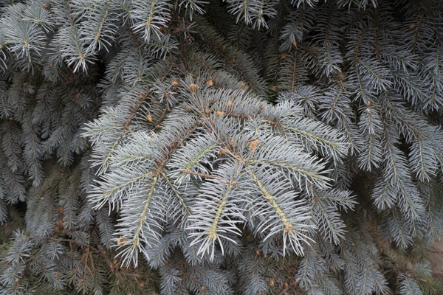19_1.png:** 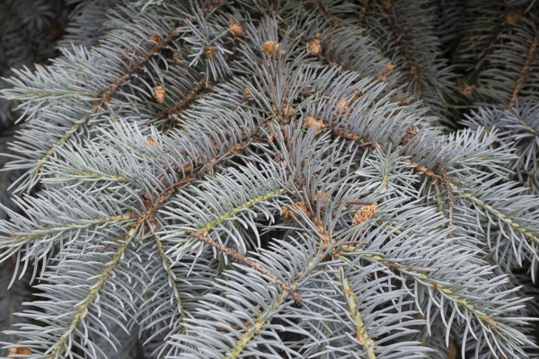

**Table 1 - Found homography parameters and normalization accuracy assessment**

|  |  |  |  |  |  |  |  |  |  |  |  |  |  |  |  |
| --- | --- | --- | --- | --- | --- | --- | --- | --- | --- | --- | --- | --- | --- | --- | --- |
| Original:  img1: 0 img2: 0 | h11 | h12 | h13 | h21 | h22 | h23 | h31 | h32 | h33 | avg ErrPar (param) | avg ErrIM (pixel) | max ErrIM | avg ErrCPM (corner) | max ErrCPM | Expert rate |
| SIFT | 1,768 | -0,5 | -101,737 | 0,441 | 1,898 | -286,542 | -0 | 0 | 1 | 0 | 1,26 | 3,549 | ~ | ~ |  |
| SURF128 | 1,908 | -0,46 | -126,291 | 0,452 | 2,093 | -311,548 | -0 | 0,001 | 1 | 0 | 1,439 | 3,113 | ~ | ~ |  |
| SURF64 | 1,956 | -0,491 | -128,95 | 0,494 | 2,106 | -321,656 | -0 | 0,001 | 1 | 0 | 1,568 | 2,943 | ~ | ~ |  |
| ORB | 1,795 | -0,51 | -100,496 | 0,449 | 1,996 | -302,408 | -0 | 0 | 1 | 0 | 1,465 | 3,491 | ~ | ~ |  |
| ORB1000 | 2,008 | -0,602 | -117,473 | 0,551 | 2,154 | -342,429 | 0 | 0 | 1 | 0 | 0,945 | 2,639 | ~ | ~ |  |
| BRISK | 1,708 | -0,505 | -89,121 | 0,408 | 1,905 | -281,431 | -0 | 0 | 1 | 0 | 1,534 | 3,313 | ~ | ~ |  |
| KAZE | 1,377 | -0,552 | -33,844 | 0,314 | 1,57 | -221,734 | -0,001 | -0 | 1 | 0 | 1,315 | 2,952 | ~ | ~ |  |
| AKAZE | 1,835 | -0,353 | -136,585 | 0,409 | 2,116 | -307,63 | -0 | 0,001 | 1 | 0 | 1,203 | 2,142 | ~ | ~ |  |
| Original matrix |  |  |  |  |  |  |  |  |  |  |  |  |  |  |  |

where h11, h12, h13, h21, h22, h23, h31, h32, h33 - parameters of found homography matrix H* or of original one H;   
avgErrPar - average error of found parameters, the accuracy of found homography matrix parameters with a preliminary minimax normalization of found and original matrices;  
avgErrIM - average error of inlier coordinate matching;  
inliers - correct matches; outliers - false matches;  
maxErrIM – maximum error of inlier coordinate matching;  
avgErrCPM - average error of corner point matching;  
maxErrCPM - maximum error of corner point matching;  
expert rate - experts assessment of normalization accuracy with a 5-point scale: 0 - normalization failed, 1 - insufficient, 2 - satisfactory, 3 - good, 4 – excellent.

**Table 2 - Quantitative evaluation of descriptors, precision and recall estimation (with found overlap)**

|  |  |  |  |  |  |  |  |  |  |  |  |  |  |  |  |  |
| --- | --- | --- | --- | --- | --- | --- | --- | --- | --- | --- | --- | --- | --- | --- | --- | --- |
| Name | NP1 | NP2 | NM | NI | DP1 | DP2 | OP1 | OP2 | NPO1 | NPO2 | NMO | DPO1 | DPO2 | Precision | RecallO1 | Comments |
| SIFT | 3098 | 5121 | 151 | 83 | 0,0129 | 0,0213 | 28,0183 | 100 | 1096 | 5121 | 146 | 0,0163 | 0,0213 | 0,5497 | 0,0757 |  |
| SURF128 | 3346 | 3581 | 36 | 14 | 0,0139 | 0,0149 | 28,3671 | 100 | 1221 | 3581 | 35 | 0,0179 | 0,0149 | 0,3889 | 0,0115 |  |
| SURF64 | 3346 | 3581 | 71 | 21 | 0,0139 | 0,0149 | 28,2054 | 100 | 1218 | 3581 | 65 | 0,018 | 0,0149 | 0,2958 | 0,0172 |  |
| ORB | 20351 | 21457 | 589 | 274 | 0,0848 | 0,0894 | 27,9875 | 100 | 10234 | 21457 | 561 | 0,1524 | 0,0894 | 0,4652 | 0,0268 |  |
| ORB1000 | 1000 | 1000 | 26 | 12 | 0,0042 | 0,0042 | 28,7517 | 100 | 706 | 1000 | 24 | 0,0102 | 0,0042 | 0,4615 | 0,017 |  |
| BRISK | 7972 | 8741 | 251 | 130 | 0,0332 | 0,0364 | 27,7187 | 100 | 3709 | 8741 | 246 | 0,0558 | 0,0364 | 0,5179 | 0,035 |  |
| KAZE | 755 | 1549 | 37 | 19 | 0,0031 | 0,0065 | 27,325 | 100 | 308 | 1549 | 37 | 0,0047 | 0,0065 | 0,5135 | 0,0617 |  |
| AKAZE | 902 | 1781 | 35 | 17 | 0,0038 | 0,0074 | 27,7333 | 100 | 502 | 1781 | 33 | 0,0075 | 0,0074 | 0,4857 | 0,0339 |  |

where NP - number of found key points; NP1, NP2 - number of found key points for image1 and image2 respectively;  
NM - number of matches found with NNDR method, NM=NI+NO;  
NI - number of inliers found with RANSAC method;  
NO - number of outliers discarded with RANSAC method;   
DP - density of key points (per cent), DP= NP/(height x width) , height, width - vertical and horizontal image sizes respectively (pixels)  
DP1, DP2 - density of key points points for image1 and image2 respectively;  
OP1, OP2 - overlap percentage for image1 and image2 respectively;  
NPO1, NPO2 - number of found key points on overlap for image1 and image2 respectivelyy;  
NMO - number of matches on overlap found with NNDR method;  
DPO1, DPO2 - density of key points points on overlap for image1 and image2 respectively;   
OA - overlap area (pixels), OA1, OA2 - overlap area for image1 and image2 respectively;  
DPO1= NPO1/OA1; DPO2= NPO2/OA2;  
Precision = NI/ NM - the rate to evaluate the part of inliers to all found matches with NNDR method;  
RecallO1 = NI/ NPO1 - completeness of inlier retrieval relative to the number of all key points on overlap for image1. The rate illustrates usefulness of the found key points for normalization.

**Table 3 - Estimation of time costs**

|  |  |  |  |  |  |  |  |  |  |  |
| --- | --- | --- | --- | --- | --- | --- | --- | --- | --- | --- |
| Name | NP1 | NP2 | DesT1, sec | DesT2, sec | MatchT, sec | InlierT, sec | AvgDesT, ms | AvgMatchT, ms | AvgInlierT, ms | TotalNormT, sec |
| SIFT | 3098 | 5121 | 0,059336 | 0,071938 | 0,133053 | 0,001616 | 0,0166 | 0,881144 | 0,019472 | 0,265944 |
| SURF128 | 3346 | 3581 | 0,078246 | 0,081531 | 0,091846 | 0,005762 | 0,023075 | 2,551268 | 0,41155 | 0,257384 |
| SURF64 | 3346 | 3581 | 0,079896 | 0,085148 | 0,050899 | 0,017311 | 0,023827 | 0,716881 | 0,824336 | 0,233254 |
| ORB | 20351 | 21457 | 0,038605 | 0,040705 | 0,951635 | 0,003141 | 0,001896 | 1,615679 | 0,011464 | 1,034087 |
| ORB1000 | 1000 | 1000 | 0,011751 | 0,012316 | 0,003164 | 0,003019 | 0,012033 | 0,121685 | 0,251619 | 0,030251 |
| BRISK | 7972 | 8741 | 0,116285 | 0,127522 | 0,168082 | 0,002039 | 0,014587 | 0,669648 | 0,015685 | 0,413927 |
| KAZE | 755 | 1549 | 0,111001 | 0,120428 | 0,009162 | 0,00198 | 0,112383 | 0,247632 | 0,104232 | 0,242571 |
| AKAZE | 902 | 1781 | 0,01913 | 0,019935 | 0,005495 | 0,002479 | 0,0162 | 0,156993 | 0,145849 | 0,047039 |

where DesT – descriptor creation time (time for key point detection and descriptor computation), DesT1, DesT2 – creation time of descriptors for image1 and image2 respectively;  
MatchT - retrieval time of matching found with NNDR method for the pair;  
InlierT – inlier retrieval time found with RANSAC method for the pair;  
AvgDesT – average time for one descriptor creation;  
AvgMatchT - average time for one match retrieval with NNDR method;  
AvgInlierT – average time for one inlier retrieval with RANSAC method;  
TotalNormT – total normalization time for the pair.