**Normalization results for pairs 1_0.png_1_1.png from subset png\texture_nature**

**1_0.png: 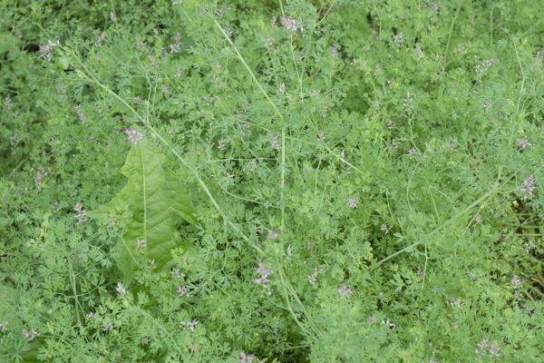1_1.png:** 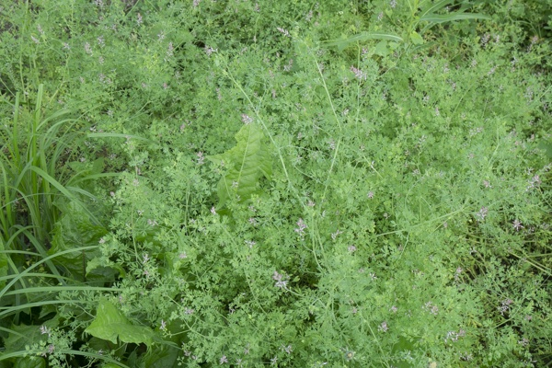

**Table 1 - Found homography parameters and normalization accuracy assessment**

|  |  |  |  |  |  |  |  |  |  |  |  |  |  |  |  |
| --- | --- | --- | --- | --- | --- | --- | --- | --- | --- | --- | --- | --- | --- | --- | --- |
| Original:  img1: 0 img2: 0 | h11 | h12 | h13 | h21 | h22 | h23 | h31 | h32 | h33 | avg ErrPar (param) | avg ErrIM (pixel) | max ErrIM | avg ErrCPM (corner) | max ErrCPM | Expert rate |
| SIFT | 0,591 | -0,153 | 204,327 | 0,159 | 0,613 | 10,392 | -0 | 0 | 1 | 0 | 0,806 | 3,463 | ~ | ~ |  |
| SURF128 | 0,579 | -0,161 | 204,308 | 0,153 | 0,603 | 12,089 | -0 | -0 | 1 | 0 | 0,889 | 2,197 | ~ | ~ |  |
| SURF64 | 0,577 | -0,157 | 204,686 | 0,154 | 0,609 | 11,43 | -0 | 0 | 1 | 0 | 0,978 | 3,708 | ~ | ~ |  |
| ORB | 0,59 | -0,139 | 203,302 | 0,156 | 0,625 | 10,369 | -0 | 0 | 1 | 0 | 1,017 | 3,072 | ~ | ~ |  |
| ORB1000 | 0,513 | -0,199 | 214,839 | 0,118 | 0,53 | 28,83 | -0 | -0 | 1 | 0 | 1,04 | 2,431 | ~ | ~ |  |
| BRISK | 0,592 | -0,154 | 203,96 | 0,158 | 0,616 | 10,498 | -0 | 0 | 1 | 0 | 0,853 | 2,595 | ~ | ~ |  |
| KAZE | 0,585 | -0,156 | 204,412 | 0,158 | 0,604 | 11,455 | -0 | 0 | 1 | 0 | 0,826 | 2,162 | ~ | ~ |  |
| AKAZE | 0,591 | -0,158 | 204,246 | 0,158 | 0,612 | 10,865 | -0 | 0 | 1 | 0 | 0,851 | 2,069 | ~ | ~ |  |
| Original matrix |  |  |  |  |  |  |  |  |  |  |  |  |  |  |  |

where h11, h12, h13, h21, h22, h23, h31, h32, h33 - parameters of found homography matrix H* or of original one H;   
avgErrPar - average error of found parameters, the accuracy of found homography matrix parameters with a preliminary minimax normalization of found and original matrices;  
avgErrIM - average error of inlier coordinate matching;  
inliers - correct matches; outliers - false matches;  
maxErrIM – maximum error of inlier coordinate matching;  
avgErrCPM - average error of corner point matching;  
maxErrCPM - maximum error of corner point matching;  
expert rate - experts assessment of normalization accuracy with a 5-point scale: 0 - normalization failed, 1 - insufficient, 2 - satisfactory, 3 - good, 4 – excellent.

**Table 2 - Quantitative evaluation of descriptors, precision and recall estimation (with found overlap)**

|  |  |  |  |  |  |  |  |  |  |  |  |  |  |  |  |  |
| --- | --- | --- | --- | --- | --- | --- | --- | --- | --- | --- | --- | --- | --- | --- | --- | --- |
| Name | NP1 | NP2 | NM | NI | DP1 | DP2 | OP1 | OP2 | NPO1 | NPO2 | NMO | DPO1 | DPO2 | Precision | RecallO1 | Comments |
| SIFT | 3935 | 3834 | 231 | 225 | 0,0164 | 0,016 | 100 | 39,7512 | 3935 | 1495 | 231 | 0,0164 | 0,0157 | 0,974 | 0,0572 |  |
| SURF128 | 2877 | 2960 | 43 | 33 | 0,012 | 0,0123 | 100 | 40,2496 | 2877 | 1338 | 43 | 0,012 | 0,0139 | 0,7674 | 0,0115 |  |
| SURF64 | 2877 | 2960 | 107 | 83 | 0,012 | 0,0123 | 100 | 40,1692 | 2877 | 1334 | 107 | 0,012 | 0,0138 | 0,7757 | 0,0288 |  |
| ORB | 15785 | 17067 | 694 | 497 | 0,0658 | 0,0711 | 100 | 39,8925 | 15785 | 9478 | 694 | 0,0658 | 0,099 | 0,7161 | 0,0315 |  |
| ORB1000 | 1000 | 1000 | 45 | 31 | 0,0042 | 0,0042 | 100 | 38,3767 | 1000 | 440 | 45 | 0,0042 | 0,0048 | 0,6889 | 0,031 |  |
| BRISK | 5927 | 6518 | 199 | 183 | 0,0247 | 0,0272 | 100 | 39,8825 | 5927 | 3064 | 199 | 0,0247 | 0,032 | 0,9196 | 0,0309 |  |
| KAZE | 682 | 741 | 33 | 28 | 0,0028 | 0,0031 | 100 | 39,6162 | 682 | 225 | 33 | 0,0028 | 0,0024 | 0,8485 | 0,0411 |  |
| AKAZE | 743 | 756 | 34 | 29 | 0,0031 | 0,0032 | 100 | 39,93 | 743 | 345 | 34 | 0,0031 | 0,0036 | 0,8529 | 0,039 |  |

where NP - number of found key points; NP1, NP2 - number of found key points for image1 and image2 respectively;  
NM - number of matches found with NNDR method, NM=NI+NO;  
NI - number of inliers found with RANSAC method;  
NO - number of outliers discarded with RANSAC method;   
DP - density of key points (per cent), DP= NP/(height x width) , height, width - vertical and horizontal image sizes respectively (pixels)  
DP1, DP2 - density of key points points for image1 and image2 respectively;  
OP1, OP2 - overlap percentage for image1 and image2 respectively;  
NPO1, NPO2 - number of found key points on overlap for image1 and image2 respectivelyy;  
NMO - number of matches on overlap found with NNDR method;  
DPO1, DPO2 - density of key points points on overlap for image1 and image2 respectively;   
OA - overlap area (pixels), OA1, OA2 - overlap area for image1 and image2 respectively;  
DPO1= NPO1/OA1; DPO2= NPO2/OA2;  
Precision = NI/ NM - the rate to evaluate the part of inliers to all found matches with NNDR method;  
RecallO1 = NI/ NPO1 - completeness of inlier retrieval relative to the number of all key points on overlap for image1. The rate illustrates usefulness of the found key points for normalization.

**Table 3 - Estimation of time costs**

|  |  |  |  |  |  |  |  |  |  |  |
| --- | --- | --- | --- | --- | --- | --- | --- | --- | --- | --- |
| Name | NP1 | NP2 | DesT1, sec | DesT2, sec | MatchT, sec | InlierT, sec | AvgDesT, ms | AvgMatchT, ms | AvgInlierT, ms | TotalNormT, sec |
| SIFT | 3935 | 3834 | 0,063404 | 0,062178 | 0,113853 | 0,000511 | 0,016164 | 0,492872 | 0,002272 | 0,239946 |
| SURF128 | 2877 | 2960 | 0,070147 | 0,066156 | 0,065297 | 0,000475 | 0,023365 | 1,518528 | 0,014387 | 0,202074 |
| SURF64 | 2877 | 2960 | 0,07426 | 0,064425 | 0,035339 | 0,000502 | 0,023788 | 0,33027 | 0,006045 | 0,174525 |
| ORB | 15785 | 17067 | 0,031959 | 0,033587 | 0,58955 | 0,000967 | 0,001995 | 0,849496 | 0,001946 | 0,656064 |
| ORB1000 | 1000 | 1000 | 0,011334 | 0,011106 | 0,003378 | 0,000695 | 0,011219 | 0,075063 | 0,022417 | 0,026512 |
| BRISK | 5927 | 6518 | 0,088371 | 0,096957 | 0,095345 | 0,000408 | 0,014892 | 0,47912 | 0,00223 | 0,281081 |
| KAZE | 682 | 741 | 0,110233 | 0,111676 | 0,004366 | 0,000555 | 0,15617 | 0,132313 | 0,019809 | 0,22683 |
| AKAZE | 743 | 756 | 0,018379 | 0,018542 | 0,00257 | 0,000687 | 0,02463 | 0,075585 | 0,023693 | 0,040177 |

where DesT – descriptor creation time (time for key point detection and descriptor computation), DesT1, DesT2 – creation time of descriptors for image1 and image2 respectively;  
MatchT - retrieval time of matching found with NNDR method for the pair;  
InlierT – inlier retrieval time found with RANSAC method for the pair;  
AvgDesT – average time for one descriptor creation;  
AvgMatchT - average time for one match retrieval with NNDR method;  
AvgInlierT – average time for one inlier retrieval with RANSAC method;  
TotalNormT – total normalization time for the pair.