**Normalization results for pairs 20_0.png_20_1.png from subset png\texture_nature**

**20_0.png: 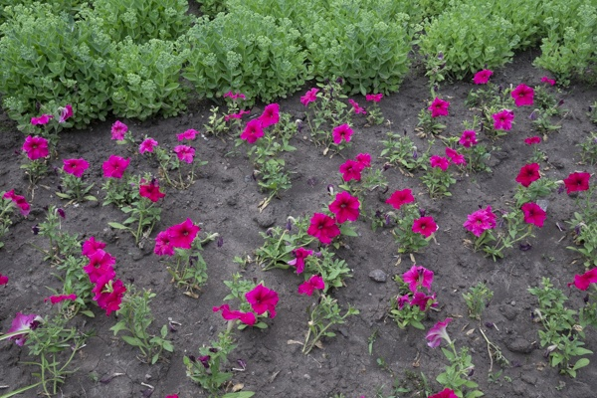20_1.png:** 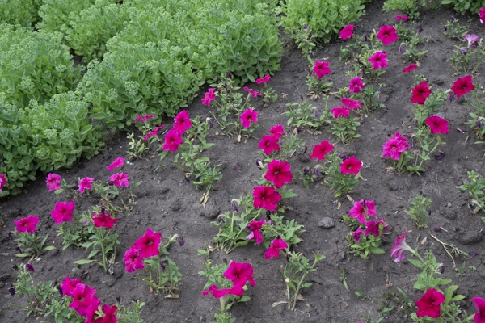

**Table 1 - Found homography parameters and normalization accuracy assessment**

|  |  |  |  |  |  |  |  |  |  |  |  |  |  |  |  |
| --- | --- | --- | --- | --- | --- | --- | --- | --- | --- | --- | --- | --- | --- | --- | --- |
| Original:  img1: 0 img2: 0 | h11 | h12 | h13 | h21 | h22 | h23 | h31 | h32 | h33 | avg ErrPar (param) | avg ErrIM (pixel) | max ErrIM | avg ErrCPM (corner) | max ErrCPM | Expert rate |
| SIFT | 1,107 | 0,402 | -118,607 | -0,352 | 1,013 | 134,888 | 0 | -0 | 1 | 0 | 1,17 | 4,019 | ~ | ~ |  |
| SURF128 | 1,096 | 0,396 | -115,45 | -0,348 | 1,004 | 133,839 | 0 | -0 | 1 | 0 | 1,298 | 3,453 | ~ | ~ |  |
| SURF64 | 1,084 | 0,391 | -112,546 | -0,346 | 0,995 | 133,56 | 0 | -0 | 1 | 0 | 1,409 | 3,726 | ~ | ~ |  |
| ORB | 1,097 | 0,406 | -117,654 | -0,352 | 1,002 | 135,984 | 0 | -0 | 1 | 0 | 1,378 | 4,095 | ~ | ~ |  |
| ORB1000 | 1,114 | 0,393 | -118,868 | -0,347 | 0,994 | 136,288 | 0 | -0 | 1 | 0 | 1,267 | 3,288 | ~ | ~ |  |
| BRISK | 1,108 | 0,403 | -119,263 | -0,352 | 1,004 | 136,212 | 0 | -0 | 1 | 0 | 1,251 | 3,948 | ~ | ~ |  |
| KAZE | 1,098 | 0,417 | -118,346 | -0,351 | 1,009 | 135,134 | 0 | -0 | 1 | 0 | 1,226 | 3,821 | ~ | ~ |  |
| AKAZE | 1,101 | 0,403 | -118,076 | -0,354 | 1,005 | 136,271 | 0 | -0 | 1 | 0 | 1,018 | 4,131 | ~ | ~ |  |
| Original matrix |  |  |  |  |  |  |  |  |  |  |  |  |  |  |  |

where h11, h12, h13, h21, h22, h23, h31, h32, h33 - parameters of found homography matrix H* or of original one H;   
avgErrPar - average error of found parameters, the accuracy of found homography matrix parameters with a preliminary minimax normalization of found and original matrices;  
avgErrIM - average error of inlier coordinate matching;  
inliers - correct matches; outliers - false matches;  
maxErrIM – maximum error of inlier coordinate matching;  
avgErrCPM - average error of corner point matching;  
maxErrCPM - maximum error of corner point matching;  
expert rate - experts assessment of normalization accuracy with a 5-point scale: 0 - normalization failed, 1 - insufficient, 2 - satisfactory, 3 - good, 4 – excellent.

**Table 2 - Quantitative evaluation of descriptors, precision and recall estimation (with found overlap)**

|  |  |  |  |  |  |  |  |  |  |  |  |  |  |  |  |  |
| --- | --- | --- | --- | --- | --- | --- | --- | --- | --- | --- | --- | --- | --- | --- | --- | --- |
| Name | NP1 | NP2 | NM | NI | DP1 | DP2 | OP1 | OP2 | NPO1 | NPO2 | NMO | DPO1 | DPO2 | Precision | RecallO1 | Comments |
| SIFT | 3334 | 3413 | 965 | 796 | 0,0139 | 0,0142 | 75,5175 | 91,1771 | 2533 | 3101 | 963 | 0,014 | 0,0142 | 0,8249 | 0,3143 |  |
| SURF128 | 2699 | 2730 | 186 | 130 | 0,0112 | 0,0114 | 75,7904 | 91,1833 | 2200 | 2569 | 185 | 0,0121 | 0,0117 | 0,6989 | 0,0591 |  |
| SURF64 | 2699 | 2730 | 374 | 242 | 0,0112 | 0,0114 | 76,1762 | 91,1104 | 2214 | 2567 | 371 | 0,0121 | 0,0117 | 0,6471 | 0,1093 |  |
| ORB | 15436 | 15395 | 2606 | 2070 | 0,0643 | 0,0641 | 75,8212 | 91,0529 | 13932 | 15100 | 2604 | 0,0766 | 0,0691 | 0,7943 | 0,1486 |  |
| ORB1000 | 1000 | 1000 | 236 | 145 | 0,0042 | 0,0042 | 75,6304 | 90,6646 | 912 | 978 | 236 | 0,005 | 0,0045 | 0,6144 | 0,159 |  |
| BRISK | 5624 | 5571 | 1157 | 949 | 0,0234 | 0,0232 | 75,5208 | 91,0146 | 4785 | 5362 | 1157 | 0,0264 | 0,0245 | 0,8202 | 0,1983 |  |
| KAZE | 802 | 853 | 262 | 181 | 0,0033 | 0,0036 | 76,1408 | 91,0575 | 644 | 802 | 262 | 0,0035 | 0,0037 | 0,6908 | 0,2811 |  |
| AKAZE | 872 | 875 | 253 | 187 | 0,0036 | 0,0036 | 75,5783 | 91,0771 | 761 | 854 | 251 | 0,0042 | 0,0039 | 0,7391 | 0,2457 |  |

where NP - number of found key points; NP1, NP2 - number of found key points for image1 and image2 respectively;  
NM - number of matches found with NNDR method, NM=NI+NO;  
NI - number of inliers found with RANSAC method;  
NO - number of outliers discarded with RANSAC method;   
DP - density of key points (per cent), DP= NP/(height x width) , height, width - vertical and horizontal image sizes respectively (pixels)  
DP1, DP2 - density of key points points for image1 and image2 respectively;  
OP1, OP2 - overlap percentage for image1 and image2 respectively;  
NPO1, NPO2 - number of found key points on overlap for image1 and image2 respectivelyy;  
NMO - number of matches on overlap found with NNDR method;  
DPO1, DPO2 - density of key points points on overlap for image1 and image2 respectively;   
OA - overlap area (pixels), OA1, OA2 - overlap area for image1 and image2 respectively;  
DPO1= NPO1/OA1; DPO2= NPO2/OA2;  
Precision = NI/ NM - the rate to evaluate the part of inliers to all found matches with NNDR method;  
RecallO1 = NI/ NPO1 - completeness of inlier retrieval relative to the number of all key points on overlap for image1. The rate illustrates usefulness of the found key points for normalization.

**Table 3 - Estimation of time costs**

|  |  |  |  |  |  |  |  |  |  |  |
| --- | --- | --- | --- | --- | --- | --- | --- | --- | --- | --- |
| Name | NP1 | NP2 | DesT1, sec | DesT2, sec | MatchT, sec | InlierT, sec | AvgDesT, ms | AvgMatchT, ms | AvgInlierT, ms | TotalNormT, sec |
| SIFT | 3334 | 3413 | 0,063617 | 0,062263 | 0,088188 | 0,000821 | 0,018661 | 0,091386 | 0,001031 | 0,214888 |
| SURF128 | 2699 | 2730 | 0,068865 | 0,065691 | 0,063488 | 0,000712 | 0,024788 | 0,341335 | 0,005479 | 0,198756 |
| SURF64 | 2699 | 2730 | 0,068706 | 0,063761 | 0,031005 | 0,000982 | 0,024405 | 0,0829 | 0,004059 | 0,164454 |
| ORB | 15436 | 15395 | 0,031215 | 0,03086 | 0,515165 | 0,001989 | 0,002013 | 0,197684 | 0,00096 | 0,579229 |
| ORB1000 | 1000 | 1000 | 0,011199 | 0,011056 | 0,003092 | 0,001079 | 0,011127 | 0,013103 | 0,007443 | 0,026427 |
| BRISK | 5624 | 5571 | 0,08221 | 0,081219 | 0,075197 | 0,001225 | 0,014597 | 0,064993 | 0,00129 | 0,239851 |
| KAZE | 802 | 853 | 0,114375 | 0,112915 | 0,005954 | 0,000757 | 0,137493 | 0,022724 | 0,004182 | 0,234002 |
| AKAZE | 872 | 875 | 0,018692 | 0,018885 | 0,003135 | 0,000673 | 0,021509 | 0,012391 | 0,003601 | 0,041386 |

where DesT – descriptor creation time (time for key point detection and descriptor computation), DesT1, DesT2 – creation time of descriptors for image1 and image2 respectively;  
MatchT - retrieval time of matching found with NNDR method for the pair;  
InlierT – inlier retrieval time found with RANSAC method for the pair;  
AvgDesT – average time for one descriptor creation;  
AvgMatchT - average time for one match retrieval with NNDR method;  
AvgInlierT – average time for one inlier retrieval with RANSAC method;  
TotalNormT – total normalization time for the pair.