**Normalization results for pairs 2_0.png_2_1.png from subset png\texture_nature**

**2_0.png: 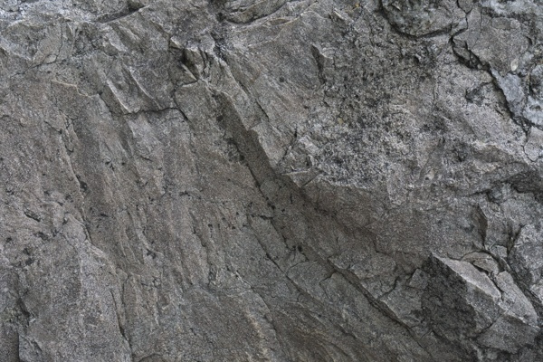2_1.png:** 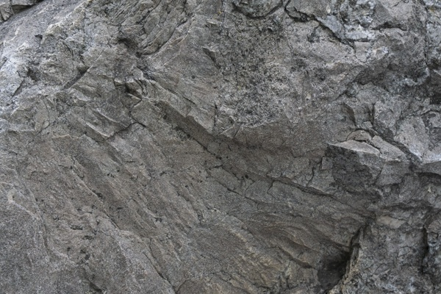

**Table 1 - Found homography parameters and normalization accuracy assessment**

|  |  |  |  |  |  |  |  |  |  |  |  |  |  |  |  |
| --- | --- | --- | --- | --- | --- | --- | --- | --- | --- | --- | --- | --- | --- | --- | --- |
| Original:  img1: 0 img2: 0 | h11 | h12 | h13 | h21 | h22 | h23 | h31 | h32 | h33 | avg ErrPar (param) | avg ErrIM (pixel) | max ErrIM | avg ErrCPM (corner) | max ErrCPM | Expert rate |
| SIFT | 0,777 | 0,331 | -2,715 | -0,321 | 0,78 | 137,986 | 0 | 0 | 1 | 0 | 0,929 | 3,099 | ~ | ~ |  |
| SURF128 | 0,773 | 0,325 | -2,387 | -0,324 | 0,778 | 138,029 | 0 | 0 | 1 | 0 | 1,213 | 3,661 | ~ | ~ |  |
| SURF64 | 0,768 | 0,33 | -1,759 | -0,327 | 0,783 | 138,184 | 0 | 0 | 1 | 0 | 1,302 | 3,266 | ~ | ~ |  |
| ORB | 0,775 | 0,332 | -2,698 | -0,324 | 0,781 | 138,118 | 0 | 0 | 1 | 0 | 1,074 | 3,685 | ~ | ~ |  |
| ORB1000 | 0,811 | 0,327 | -8,851 | -0,318 | 0,784 | 137,495 | 0 | -0 | 1 | 0 | 1,057 | 2,952 | ~ | ~ |  |
| BRISK | 0,776 | 0,331 | -2,638 | -0,321 | 0,781 | 137,618 | 0 | 0 | 1 | 0 | 0,932 | 3,557 | ~ | ~ |  |
| KAZE | 0,785 | 0,337 | -4,523 | -0,32 | 0,779 | 137,82 | 0 | 0 | 1 | 0 | 0,881 | 2,523 | ~ | ~ |  |
| AKAZE | 0,781 | 0,323 | -3,373 | -0,319 | 0,769 | 138,238 | 0 | -0 | 1 | 0 | 0,848 | 2,566 | ~ | ~ |  |
| Original matrix |  |  |  |  |  |  |  |  |  |  |  |  |  |  |  |

where h11, h12, h13, h21, h22, h23, h31, h32, h33 - parameters of found homography matrix H* or of original one H;   
avgErrPar - average error of found parameters, the accuracy of found homography matrix parameters with a preliminary minimax normalization of found and original matrices;  
avgErrIM - average error of inlier coordinate matching;  
inliers - correct matches; outliers - false matches;  
maxErrIM – maximum error of inlier coordinate matching;  
avgErrCPM - average error of corner point matching;  
maxErrCPM - maximum error of corner point matching;  
expert rate - experts assessment of normalization accuracy with a 5-point scale: 0 - normalization failed, 1 - insufficient, 2 - satisfactory, 3 - good, 4 – excellent.

**Table 2 - Quantitative evaluation of descriptors, precision and recall estimation (with found overlap)**

|  |  |  |  |  |  |  |  |  |  |  |  |  |  |  |  |  |
| --- | --- | --- | --- | --- | --- | --- | --- | --- | --- | --- | --- | --- | --- | --- | --- | --- |
| Name | NP1 | NP2 | NM | NI | DP1 | DP2 | OP1 | OP2 | NPO1 | NPO2 | NMO | DPO1 | DPO2 | Precision | RecallO1 | Comments |
| SIFT | 2794 | 2988 | 1137 | 1033 | 0,0116 | 0,0124 | 95,9762 | 64,1871 | 2667 | 1771 | 1136 | 0,0116 | 0,0115 | 0,9085 | 0,3873 |  |
| SURF128 | 2921 | 2806 | 274 | 211 | 0,0122 | 0,0117 | 95,7592 | 64,5817 | 2847 | 1995 | 274 | 0,0124 | 0,0129 | 0,7701 | 0,0741 |  |
| SURF64 | 2921 | 2806 | 485 | 382 | 0,0122 | 0,0117 | 95,7304 | 64,4775 | 2845 | 1989 | 485 | 0,0124 | 0,0129 | 0,7876 | 0,1343 |  |
| ORB | 14373 | 13391 | 4063 | 3672 | 0,0599 | 0,0558 | 95,8721 | 64,4363 | 14328 | 10572 | 4063 | 0,0623 | 0,0684 | 0,9038 | 0,2563 |  |
| ORB1000 | 992 | 974 | 276 | 214 | 0,0041 | 0,0041 | 95,6842 | 65,2975 | 992 | 737 | 276 | 0,0043 | 0,0047 | 0,7754 | 0,2157 |  |
| BRISK | 4664 | 4281 | 998 | 829 | 0,0194 | 0,0178 | 95,9596 | 64,2521 | 4599 | 2992 | 998 | 0,02 | 0,0194 | 0,8307 | 0,1803 |  |
| KAZE | 466 | 473 | 163 | 153 | 0,0019 | 0,002 | 96,0075 | 64,3812 | 450 | 288 | 162 | 0,002 | 0,0019 | 0,9387 | 0,34 |  |
| AKAZE | 461 | 413 | 101 | 94 | 0,0019 | 0,0017 | 95,9671 | 64,5633 | 461 | 303 | 101 | 0,002 | 0,002 | 0,9307 | 0,2039 |  |

where NP - number of found key points; NP1, NP2 - number of found key points for image1 and image2 respectively;  
NM - number of matches found with NNDR method, NM=NI+NO;  
NI - number of inliers found with RANSAC method;  
NO - number of outliers discarded with RANSAC method;   
DP - density of key points (per cent), DP= NP/(height x width) , height, width - vertical and horizontal image sizes respectively (pixels)  
DP1, DP2 - density of key points points for image1 and image2 respectively;  
OP1, OP2 - overlap percentage for image1 and image2 respectively;  
NPO1, NPO2 - number of found key points on overlap for image1 and image2 respectivelyy;  
NMO - number of matches on overlap found with NNDR method;  
DPO1, DPO2 - density of key points points on overlap for image1 and image2 respectively;   
OA - overlap area (pixels), OA1, OA2 - overlap area for image1 and image2 respectively;  
DPO1= NPO1/OA1; DPO2= NPO2/OA2;  
Precision = NI/ NM - the rate to evaluate the part of inliers to all found matches with NNDR method;  
RecallO1 = NI/ NPO1 - completeness of inlier retrieval relative to the number of all key points on overlap for image1. The rate illustrates usefulness of the found key points for normalization.

**Table 3 - Estimation of time costs**

|  |  |  |  |  |  |  |  |  |  |  |
| --- | --- | --- | --- | --- | --- | --- | --- | --- | --- | --- |
| Name | NP1 | NP2 | DesT1, sec | DesT2, sec | MatchT, sec | InlierT, sec | AvgDesT, ms | AvgMatchT, ms | AvgInlierT, ms | TotalNormT, sec |
| SIFT | 2794 | 2988 | 0,058003 | 0,056783 | 0,063716 | 0,000865 | 0,019881 | 0,056038 | 0,000837 | 0,179367 |
| SURF128 | 2921 | 2806 | 0,065556 | 0,067665 | 0,062885 | 0,00068 | 0,023278 | 0,229505 | 0,00322 | 0,196785 |
| SURF64 | 2921 | 2806 | 0,067529 | 0,059978 | 0,035111 | 0,000642 | 0,022246 | 0,072393 | 0,00168 | 0,163259 |
| ORB | 14373 | 13391 | 0,029011 | 0,027479 | 0,417115 | 0,002983 | 0,002035 | 0,102661 | 0,000812 | 0,476587 |
| ORB1000 | 992 | 974 | 0,010817 | 0,010326 | 0,003284 | 0,000569 | 0,010753 | 0,011897 | 0,002657 | 0,024996 |
| BRISK | 4664 | 4281 | 0,069702 | 0,064225 | 0,048991 | 0,000801 | 0,014973 | 0,049089 | 0,000966 | 0,18372 |
| KAZE | 466 | 473 | 0,109732 | 0,108297 | 0,00216 | 0,000312 | 0,232215 | 0,013253 | 0,002039 | 0,2205 |
| AKAZE | 461 | 413 | 0,017825 | 0,017603 | 0,001081 | 0,000332 | 0,040644 | 0,010703 | 0,003536 | 0,036842 |

where DesT – descriptor creation time (time for key point detection and descriptor computation), DesT1, DesT2 – creation time of descriptors for image1 and image2 respectively;  
MatchT - retrieval time of matching found with NNDR method for the pair;  
InlierT – inlier retrieval time found with RANSAC method for the pair;  
AvgDesT – average time for one descriptor creation;  
AvgMatchT - average time for one match retrieval with NNDR method;  
AvgInlierT – average time for one inlier retrieval with RANSAC method;  
TotalNormT – total normalization time for the pair.