**Normalization results for pairs 3_0.png_3_1.png from subset png\texture_nature**

**3_0.png: 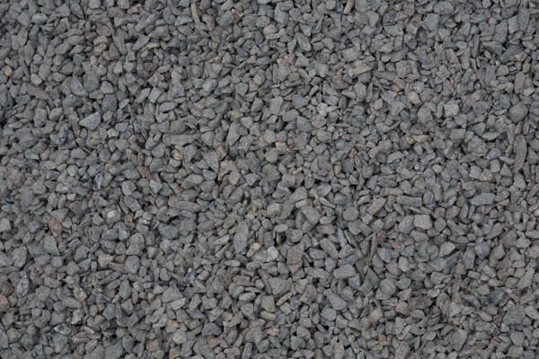3_1.png:** 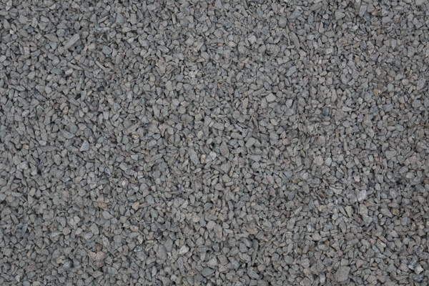

**Table 1 - Found homography parameters and normalization accuracy assessment**

|  |  |  |  |  |  |  |  |  |  |  |  |  |  |  |  |
| --- | --- | --- | --- | --- | --- | --- | --- | --- | --- | --- | --- | --- | --- | --- | --- |
| Original:  img1: 0 img2: 0 | h11 | h12 | h13 | h21 | h22 | h23 | h31 | h32 | h33 | avg ErrPar (param) | avg ErrIM (pixel) | max ErrIM | avg ErrCPM (corner) | max ErrCPM | Expert rate |
| SIFT | 0,646 | 0,428 | -2,422 | -0,357 | 0,619 | 161,953 | 0 | 0 | 1 | 0 | 1,027 | 3,41 | ~ | ~ |  |
| SURF128 | 0,639 | 0,437 | -2,835 | -0,359 | 0,622 | 161,586 | 0 | 0 | 1 | 0 | 1,148 | 2,114 | ~ | ~ |  |
| SURF64 | 0,644 | 0,436 | -2,834 | -0,359 | 0,624 | 161,81 | 0 | 0 | 1 | 0 | 1,203 | 3,381 | ~ | ~ |  |
| ORB | 0,642 | 0,441 | -3,139 | -0,362 | 0,629 | 161,729 | 0 | 0 | 1 | 0 | 1,161 | 3,334 | ~ | ~ |  |
| ORB1000 | 0,664 | 0,453 | -7,509 | -0,361 | 0,638 | 162,044 | 0 | 0 | 1 | 0 | 1,288 | 3,226 | ~ | ~ |  |
| BRISK | 0,65 | 0,412 | -1,954 | -0,356 | 0,614 | 162,029 | 0 | 0 | 1 | 0 | 0,868 | 2,996 | ~ | ~ |  |
| KAZE | 0,648 | 0,43 | -0,934 | -0,359 | 0,624 | 162,529 | 0 | 0 | 1 | 0 | 0,951 | 3,162 | ~ | ~ |  |
| AKAZE | 0,652 | 0,434 | -3,516 | -0,359 | 0,627 | 162,175 | 0 | 0 | 1 | 0 | 0,984 | 2,571 | ~ | ~ |  |
| Original matrix |  |  |  |  |  |  |  |  |  |  |  |  |  |  |  |

where h11, h12, h13, h21, h22, h23, h31, h32, h33 - parameters of found homography matrix H* or of original one H;   
avgErrPar - average error of found parameters, the accuracy of found homography matrix parameters with a preliminary minimax normalization of found and original matrices;  
avgErrIM - average error of inlier coordinate matching;  
inliers - correct matches; outliers - false matches;  
maxErrIM – maximum error of inlier coordinate matching;  
avgErrCPM - average error of corner point matching;  
maxErrCPM - maximum error of corner point matching;  
expert rate - experts assessment of normalization accuracy with a 5-point scale: 0 - normalization failed, 1 - insufficient, 2 - satisfactory, 3 - good, 4 – excellent.

**Table 2 - Quantitative evaluation of descriptors, precision and recall estimation (with found overlap)**

|  |  |  |  |  |  |  |  |  |  |  |  |  |  |  |  |  |
| --- | --- | --- | --- | --- | --- | --- | --- | --- | --- | --- | --- | --- | --- | --- | --- | --- |
| Name | NP1 | NP2 | NM | NI | DP1 | DP2 | OP1 | OP2 | NPO1 | NPO2 | NMO | DPO1 | DPO2 | Precision | RecallO1 | Comments |
| SIFT | 5752 | 5865 | 1169 | 1017 | 0,024 | 0,0244 | 97,5025 | 46,5196 | 5636 | 2703 | 1169 | 0,0241 | 0,0242 | 0,87 | 0,1804 |  |
| SURF128 | 3073 | 3210 | 45 | 32 | 0,0128 | 0,0134 | 97,3796 | 46,6354 | 3016 | 1746 | 45 | 0,0129 | 0,0156 | 0,7111 | 0,0106 |  |
| SURF64 | 3073 | 3210 | 91 | 81 | 0,0128 | 0,0134 | 97,4208 | 46,42 | 3017 | 1739 | 91 | 0,0129 | 0,0156 | 0,8901 | 0,0268 |  |
| ORB | 21434 | 24627 | 2169 | 1824 | 0,0893 | 0,1026 | 97,2567 | 46,4646 | 21364 | 15183 | 2169 | 0,0915 | 0,1362 | 0,8409 | 0,0854 |  |
| ORB1000 | 1000 | 1000 | 107 | 91 | 0,0042 | 0,0042 | 97,3808 | 46,3183 | 999 | 676 | 107 | 0,0043 | 0,0061 | 0,8505 | 0,0911 |  |
| BRISK | 8161 | 9868 | 626 | 411 | 0,034 | 0,0411 | 97,5329 | 46,165 | 8103 | 5365 | 626 | 0,0346 | 0,0484 | 0,6565 | 0,0507 |  |
| KAZE | 1764 | 1327 | 187 | 141 | 0,0073 | 0,0055 | 97,4892 | 46,115 | 1729 | 643 | 186 | 0,0074 | 0,0058 | 0,754 | 0,0816 |  |
| AKAZE | 1973 | 1855 | 216 | 171 | 0,0082 | 0,0077 | 97,4429 | 46,2275 | 1965 | 1075 | 216 | 0,0084 | 0,0097 | 0,7917 | 0,087 |  |

where NP - number of found key points; NP1, NP2 - number of found key points for image1 and image2 respectively;  
NM - number of matches found with NNDR method, NM=NI+NO;  
NI - number of inliers found with RANSAC method;  
NO - number of outliers discarded with RANSAC method;   
DP - density of key points (per cent), DP= NP/(height x width) , height, width - vertical and horizontal image sizes respectively (pixels)  
DP1, DP2 - density of key points points for image1 and image2 respectively;  
OP1, OP2 - overlap percentage for image1 and image2 respectively;  
NPO1, NPO2 - number of found key points on overlap for image1 and image2 respectivelyy;  
NMO - number of matches on overlap found with NNDR method;  
DPO1, DPO2 - density of key points points on overlap for image1 and image2 respectively;   
OA - overlap area (pixels), OA1, OA2 - overlap area for image1 and image2 respectively;  
DPO1= NPO1/OA1; DPO2= NPO2/OA2;  
Precision = NI/ NM - the rate to evaluate the part of inliers to all found matches with NNDR method;  
RecallO1 = NI/ NPO1 - completeness of inlier retrieval relative to the number of all key points on overlap for image1. The rate illustrates usefulness of the found key points for normalization.

**Table 3 - Estimation of time costs**

|  |  |  |  |  |  |  |  |  |  |  |
| --- | --- | --- | --- | --- | --- | --- | --- | --- | --- | --- |
| Name | NP1 | NP2 | DesT1, sec | DesT2, sec | MatchT, sec | InlierT, sec | AvgDesT, ms | AvgMatchT, ms | AvgInlierT, ms | TotalNormT, sec |
| SIFT | 5752 | 5865 | 0,0916 | 0,074102 | 0,252903 | 0,000877 | 0,014279 | 0,216341 | 0,000861 | 0,419481 |
| SURF128 | 3073 | 3210 | 0,078755 | 0,071917 | 0,076415 | 0,000644 | 0,024016 | 1,698103 | 0,020117 | 0,22773 |
| SURF64 | 3073 | 3210 | 0,069787 | 0,067042 | 0,041276 | 0,000386 | 0,021797 | 0,453587 | 0,004766 | 0,178491 |
| ORB | 21434 | 24627 | 0,041317 | 0,045429 | 1,136553 | 0,001618 | 0,001885 | 0,523998 | 0,000886 | 1,224918 |
| ORB1000 | 1000 | 1000 | 0,01304 | 0,01295 | 0,00344 | 0,000367 | 0,012994 | 0,032152 | 0,004035 | 0,029798 |
| BRISK | 8161 | 9868 | 0,128939 | 0,155577 | 0,194552 | 0,001089 | 0,015782 | 0,310786 | 0,00265 | 0,480158 |
| KAZE | 1764 | 1327 | 0,123659 | 0,118231 | 0,023383 | 0,000711 | 0,079598 | 0,125041 | 0,005042 | 0,265984 |
| AKAZE | 1973 | 1855 | 0,020449 | 0,015145 | 0,01234 | 0,000676 | 0,009264 | 0,057129 | 0,003954 | 0,04861 |

where DesT – descriptor creation time (time for key point detection and descriptor computation), DesT1, DesT2 – creation time of descriptors for image1 and image2 respectively;  
MatchT - retrieval time of matching found with NNDR method for the pair;  
InlierT – inlier retrieval time found with RANSAC method for the pair;  
AvgDesT – average time for one descriptor creation;  
AvgMatchT - average time for one match retrieval with NNDR method;  
AvgInlierT – average time for one inlier retrieval with RANSAC method;  
TotalNormT – total normalization time for the pair.