**Normalization results for pairs 4_0.png_4_1.png from subset png\texture_nature**

**4_0.png: 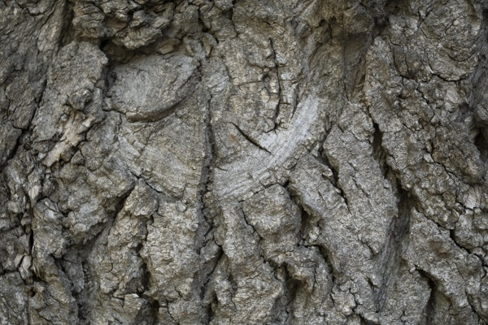4_1.png:** 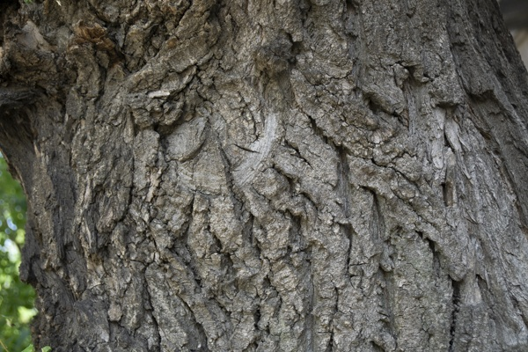

**Table 1 - Found homography parameters and normalization accuracy assessment**

|  |  |  |  |  |  |  |  |  |  |  |  |  |  |  |  |
| --- | --- | --- | --- | --- | --- | --- | --- | --- | --- | --- | --- | --- | --- | --- | --- |
| Original:  img1: 0 img2: 0 | h11 | h12 | h13 | h21 | h22 | h23 | h31 | h32 | h33 | avg ErrPar (param) | avg ErrIM (pixel) | max ErrIM | avg ErrCPM (corner) | max ErrCPM | Expert rate |
| SIFT | 0,427 | 0,152 | 110,282 | -0,191 | 0,462 | 141,893 | -0 | -0 | 1 | 0 | 0,782 | 3,714 | ~ | ~ |  |
| SURF128 | 0,426 | 0,139 | 111,228 | -0,19 | 0,455 | 141,512 | -0 | -0 | 1 | 0 | 1,068 | 2,857 | ~ | ~ |  |
| SURF64 | 0,429 | 0,15 | 110,455 | -0,193 | 0,467 | 141,429 | -0 | -0 | 1 | 0 | 1,114 | 3,155 | ~ | ~ |  |
| ORB | 0,426 | 0,134 | 111,693 | -0,189 | 0,451 | 141,754 | -0 | -0 | 1 | 0 | 0,891 | 3,195 | ~ | ~ |  |
| ORB1000 | 0,427 | 0,142 | 110,47 | -0,192 | 0,455 | 142,07 | -0 | -0 | 1 | 0 | 0,953 | 3,551 | ~ | ~ |  |
| BRISK | 0,43 | 0,149 | 110,008 | -0,192 | 0,465 | 141,666 | -0 | -0 | 1 | 0 | 0,819 | 2,729 | ~ | ~ |  |
| KAZE | 0,426 | 0,145 | 110,735 | -0,191 | 0,459 | 141,83 | -0 | -0 | 1 | 0 | 0,854 | 2,164 | ~ | ~ |  |
| AKAZE | 0,419 | 0,141 | 111,357 | -0,193 | 0,457 | 141,319 | -0 | -0 | 1 | 0 | 0,707 | 2,566 | ~ | ~ |  |
| Original matrix |  |  |  |  |  |  |  |  |  |  |  |  |  |  |  |

where h11, h12, h13, h21, h22, h23, h31, h32, h33 - parameters of found homography matrix H* or of original one H;   
avgErrPar - average error of found parameters, the accuracy of found homography matrix parameters with a preliminary minimax normalization of found and original matrices;  
avgErrIM - average error of inlier coordinate matching;  
inliers - correct matches; outliers - false matches;  
maxErrIM – maximum error of inlier coordinate matching;  
avgErrCPM - average error of corner point matching;  
maxErrCPM - maximum error of corner point matching;  
expert rate - experts assessment of normalization accuracy with a 5-point scale: 0 - normalization failed, 1 - insufficient, 2 - satisfactory, 3 - good, 4 – excellent.

**Table 2 - Quantitative evaluation of descriptors, precision and recall estimation (with found overlap)**

|  |  |  |  |  |  |  |  |  |  |  |  |  |  |  |  |  |
| --- | --- | --- | --- | --- | --- | --- | --- | --- | --- | --- | --- | --- | --- | --- | --- | --- |
| Name | NP1 | NP2 | NM | NI | DP1 | DP2 | OP1 | OP2 | NPO1 | NPO2 | NMO | DPO1 | DPO2 | Precision | RecallO1 | Comments |
| SIFT | 4493 | 3970 | 647 | 619 | 0,0187 | 0,0165 | 100 | 26,75 | 4493 | 1191 | 647 | 0,0187 | 0,0186 | 0,9567 | 0,1378 |  |
| SURF128 | 2934 | 2974 | 191 | 173 | 0,0122 | 0,0124 | 100 | 26,9125 | 2934 | 947 | 191 | 0,0122 | 0,0147 | 0,9058 | 0,059 |  |
| SURF64 | 2934 | 2974 | 257 | 216 | 0,0122 | 0,0124 | 100 | 26,9488 | 2934 | 947 | 257 | 0,0122 | 0,0146 | 0,8405 | 0,0736 |  |
| ORB | 21882 | 21034 | 1504 | 1351 | 0,0912 | 0,0876 | 100 | 26,9704 | 21882 | 9399 | 1504 | 0,0912 | 0,1452 | 0,8983 | 0,0617 |  |
| ORB1000 | 1000 | 1000 | 113 | 93 | 0,0042 | 0,0042 | 100 | 27,1079 | 1000 | 662 | 113 | 0,0042 | 0,0102 | 0,823 | 0,093 |  |
| BRISK | 8150 | 7451 | 650 | 520 | 0,034 | 0,031 | 100 | 26,9512 | 8150 | 3111 | 650 | 0,034 | 0,0481 | 0,8 | 0,0638 |  |
| KAZE | 1241 | 1060 | 111 | 102 | 0,0052 | 0,0044 | 100 | 26,8879 | 1241 | 424 | 111 | 0,0052 | 0,0066 | 0,9189 | 0,0822 |  |
| AKAZE | 1213 | 1145 | 117 | 92 | 0,0051 | 0,0048 | 100 | 27,1358 | 1213 | 532 | 117 | 0,0051 | 0,0082 | 0,7863 | 0,0758 |  |

where NP - number of found key points; NP1, NP2 - number of found key points for image1 and image2 respectively;  
NM - number of matches found with NNDR method, NM=NI+NO;  
NI - number of inliers found with RANSAC method;  
NO - number of outliers discarded with RANSAC method;   
DP - density of key points (per cent), DP= NP/(height x width) , height, width - vertical and horizontal image sizes respectively (pixels)  
DP1, DP2 - density of key points points for image1 and image2 respectively;  
OP1, OP2 - overlap percentage for image1 and image2 respectively;  
NPO1, NPO2 - number of found key points on overlap for image1 and image2 respectivelyy;  
NMO - number of matches on overlap found with NNDR method;  
DPO1, DPO2 - density of key points points on overlap for image1 and image2 respectively;   
OA - overlap area (pixels), OA1, OA2 - overlap area for image1 and image2 respectively;  
DPO1= NPO1/OA1; DPO2= NPO2/OA2;  
Precision = NI/ NM - the rate to evaluate the part of inliers to all found matches with NNDR method;  
RecallO1 = NI/ NPO1 - completeness of inlier retrieval relative to the number of all key points on overlap for image1. The rate illustrates usefulness of the found key points for normalization.

**Table 3 - Estimation of time costs**

|  |  |  |  |  |  |  |  |  |  |  |
| --- | --- | --- | --- | --- | --- | --- | --- | --- | --- | --- |
| Name | NP1 | NP2 | DesT1, sec | DesT2, sec | MatchT, sec | InlierT, sec | AvgDesT, ms | AvgMatchT, ms | AvgInlierT, ms | TotalNormT, sec |
| SIFT | 4493 | 3970 | 0,069567 | 0,061508 | 0,136655 | 0,00054 | 0,015488 | 0,211213 | 0,000872 | 0,26827 |
| SURF128 | 2934 | 2974 | 0,067952 | 0,07237 | 0,074613 | 0,000417 | 0,023747 | 0,390646 | 0,002409 | 0,215352 |
| SURF64 | 2934 | 2974 | 0,073296 | 0,075565 | 0,037268 | 0,000913 | 0,025194 | 0,145013 | 0,004225 | 0,187043 |
| ORB | 21882 | 21034 | 0,041355 | 0,039099 | 0,994486 | 0,001055 | 0,001873 | 0,661227 | 0,00078 | 1,075995 |
| ORB1000 | 1000 | 1000 | 0,012149 | 0,01161 | 0,003139 | 0,000435 | 0,011879 | 0,02778 | 0,004675 | 0,027333 |
| BRISK | 8150 | 7451 | 0,120442 | 0,104401 | 0,142861 | 0,000783 | 0,014394 | 0,219785 | 0,001505 | 0,368486 |
| KAZE | 1241 | 1060 | 0,120075 | 0,110863 | 0,011013 | 0,000332 | 0,100671 | 0,09922 | 0,003252 | 0,242283 |
| AKAZE | 1213 | 1145 | 0,014754 | 0,023478 | 0,005161 | 0,000491 | 0,016334 | 0,04411 | 0,005335 | 0,043885 |

where DesT – descriptor creation time (time for key point detection and descriptor computation), DesT1, DesT2 – creation time of descriptors for image1 and image2 respectively;  
MatchT - retrieval time of matching found with NNDR method for the pair;  
InlierT – inlier retrieval time found with RANSAC method for the pair;  
AvgDesT – average time for one descriptor creation;  
AvgMatchT - average time for one match retrieval with NNDR method;  
AvgInlierT – average time for one inlier retrieval with RANSAC method;  
TotalNormT – total normalization time for the pair.