**Normalization results for pairs 5_0.png_5_1.png from subset png\texture_nature**

**5_0.png: 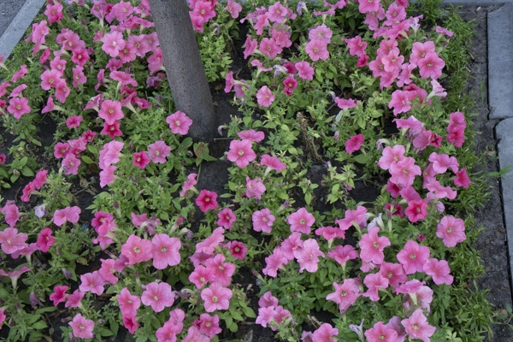5_1.png:** 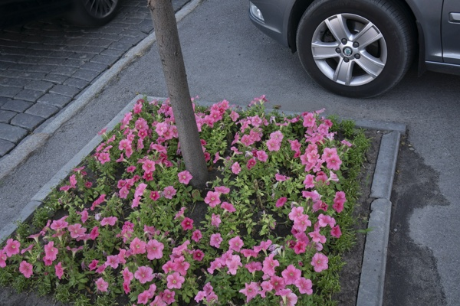

**Table 1 - Found homography parameters and normalization accuracy assessment**

|  |  |  |  |  |  |  |  |  |  |  |  |  |  |  |  |
| --- | --- | --- | --- | --- | --- | --- | --- | --- | --- | --- | --- | --- | --- | --- | --- |
| Original:  img1: 0 img2: 0 | h11 | h12 | h13 | h21 | h22 | h23 | h31 | h32 | h33 | avg ErrPar (param) | avg ErrIM (pixel) | max ErrIM | avg ErrCPM (corner) | max ErrCPM | Expert rate |
| SIFT | 0,536 | -0,194 | 148,906 | 0,047 | 0,598 | 126,927 | -0 | -0 | 1 | 0 | 1,247 | 2,982 | ~ | ~ |  |
| SURF128 | 0,546 | -0,185 | 144,708 | 0,046 | 0,608 | 127,05 | -0 | -0 | 1 | 0 | 1,39 | 3,887 | ~ | ~ |  |
| SURF64 | 0,54 | -0,166 | 143,688 | 0,028 | 0,64 | 127,744 | -0 | 0 | 1 | 0 | 1,306 | 2,915 | ~ | ~ |  |
| ORB | 0,569 | -0,201 | 144,565 | 0,058 | 0,609 | 126,133 | -0 | -0 | 1 | 0 | 1,413 | 3,424 | ~ | ~ |  |
| ORB1000 | 0,567 | -0,173 | 140,404 | 0,061 | 0,628 | 122,653 | -0 | -0 | 1 | 0 | 1,056 | 2,561 | ~ | ~ |  |
| BRISK | 0,541 | -0,192 | 146,362 | 0,044 | 0,599 | 127,573 | -0 | -0 | 1 | 0 | 1,189 | 3,333 | ~ | ~ |  |
| KAZE | 0,641 | -0,215 | 140,522 | 0,119 | 0,652 | 108,929 | 0 | -0 | 1 | 0 | 1,715 | 3,248 | ~ | ~ |  |
| AKAZE | 0,55 | -0,186 | 145,395 | 0,049 | 0,61 | 126,443 | -0 | -0 | 1 | 0 | 1,154 | 2,649 | ~ | ~ |  |
| Original matrix |  |  |  |  |  |  |  |  |  |  |  |  |  |  |  |

where h11, h12, h13, h21, h22, h23, h31, h32, h33 - parameters of found homography matrix H* or of original one H;   
avgErrPar - average error of found parameters, the accuracy of found homography matrix parameters with a preliminary minimax normalization of found and original matrices;  
avgErrIM - average error of inlier coordinate matching;  
inliers - correct matches; outliers - false matches;  
maxErrIM – maximum error of inlier coordinate matching;  
avgErrCPM - average error of corner point matching;  
maxErrCPM - maximum error of corner point matching;  
expert rate - experts assessment of normalization accuracy with a 5-point scale: 0 - normalization failed, 1 - insufficient, 2 - satisfactory, 3 - good, 4 – excellent.

**Table 2 - Quantitative evaluation of descriptors, precision and recall estimation (with found overlap)**

|  |  |  |  |  |  |  |  |  |  |  |  |  |  |  |  |  |
| --- | --- | --- | --- | --- | --- | --- | --- | --- | --- | --- | --- | --- | --- | --- | --- | --- |
| Name | NP1 | NP2 | NM | NI | DP1 | DP2 | OP1 | OP2 | NPO1 | NPO2 | NMO | DPO1 | DPO2 | Precision | RecallO1 | Comments |
| SIFT | 4663 | 2768 | 234 | 130 | 0,0194 | 0,0115 | 95,7121 | 39,2688 | 4472 | 2136 | 234 | 0,0195 | 0,0227 | 0,5556 | 0,0291 |  |
| SURF128 | 2739 | 2093 | 43 | 34 | 0,0114 | 0,0087 | 95,9508 | 39,6192 | 2687 | 1241 | 43 | 0,0117 | 0,0131 | 0,7907 | 0,0127 |  |
| SURF64 | 2739 | 2093 | 71 | 45 | 0,0114 | 0,0087 | 96,1388 | 40,5571 | 2690 | 1285 | 70 | 0,0117 | 0,0132 | 0,6338 | 0,0167 |  |
| ORB | 19309 | 12475 | 327 | 217 | 0,0805 | 0,052 | 95,9204 | 39,9021 | 19248 | 10343 | 327 | 0,0836 | 0,108 | 0,6636 | 0,0113 |  |
| ORB1000 | 1000 | 1000 | 31 | 21 | 0,0042 | 0,0042 | 95,8879 | 39,9625 | 1000 | 798 | 31 | 0,0043 | 0,0083 | 0,6774 | 0,021 |  |
| BRISK | 7680 | 4720 | 199 | 140 | 0,032 | 0,0197 | 95,8179 | 39,5754 | 7580 | 3911 | 199 | 0,033 | 0,0412 | 0,7035 | 0,0185 |  |
| KAZE | 1786 | 978 | 74 | 40 | 0,0074 | 0,0041 | 95,8058 | 41,4542 | 1734 | 771 | 74 | 0,0075 | 0,0077 | 0,5405 | 0,0231 |  |
| AKAZE | 1771 | 981 | 85 | 54 | 0,0074 | 0,0041 | 95,9483 | 39,5592 | 1761 | 812 | 85 | 0,0076 | 0,0086 | 0,6353 | 0,0307 |  |

where NP - number of found key points; NP1, NP2 - number of found key points for image1 and image2 respectively;  
NM - number of matches found with NNDR method, NM=NI+NO;  
NI - number of inliers found with RANSAC method;  
NO - number of outliers discarded with RANSAC method;   
DP - density of key points (per cent), DP= NP/(height x width) , height, width - vertical and horizontal image sizes respectively (pixels)  
DP1, DP2 - density of key points points for image1 and image2 respectively;  
OP1, OP2 - overlap percentage for image1 and image2 respectively;  
NPO1, NPO2 - number of found key points on overlap for image1 and image2 respectivelyy;  
NMO - number of matches on overlap found with NNDR method;  
DPO1, DPO2 - density of key points points on overlap for image1 and image2 respectively;   
OA - overlap area (pixels), OA1, OA2 - overlap area for image1 and image2 respectively;  
DPO1= NPO1/OA1; DPO2= NPO2/OA2;  
Precision = NI/ NM - the rate to evaluate the part of inliers to all found matches with NNDR method;  
RecallO1 = NI/ NPO1 - completeness of inlier retrieval relative to the number of all key points on overlap for image1. The rate illustrates usefulness of the found key points for normalization.

**Table 3 - Estimation of time costs**

|  |  |  |  |  |  |  |  |  |  |  |
| --- | --- | --- | --- | --- | --- | --- | --- | --- | --- | --- |
| Name | NP1 | NP2 | DesT1, sec | DesT2, sec | MatchT, sec | InlierT, sec | AvgDesT, ms | AvgMatchT, ms | AvgInlierT, ms | TotalNormT, sec |
| SIFT | 4663 | 2768 | 0,068003 | 0,056228 | 0,10837 | 0,001539 | 0,017448 | 0,463117 | 0,011836 | 0,234139 |
| SURF128 | 2739 | 2093 | 0,064386 | 0,063853 | 0,044091 | 0,000443 | 0,027007 | 1,025365 | 0,01302 | 0,172772 |
| SURF64 | 2739 | 2093 | 0,06068 | 0,061494 | 0,024927 | 0,000929 | 0,025766 | 0,351078 | 0,020654 | 0,14803 |
| ORB | 19309 | 12475 | 0,037624 | 0,025878 | 0,525256 | 0,000896 | 0,002011 | 1,606288 | 0,004127 | 0,589654 |
| ORB1000 | 1000 | 1000 | 0,012472 | 0,010259 | 0,0031 | 0,000692 | 0,011365 | 0,10001 | 0,032946 | 0,026524 |
| BRISK | 7680 | 4720 | 0,114252 | 0,064426 | 0,088096 | 0,000675 | 0,014262 | 0,442693 | 0,004824 | 0,26745 |
| KAZE | 1786 | 978 | 0,124565 | 0,11579 | 0,014308 | 0,001636 | 0,094069 | 0,193356 | 0,040908 | 0,256299 |
| AKAZE | 1771 | 981 | 0,019561 | 0,01314 | 0,006652 | 0,000923 | 0,012219 | 0,078257 | 0,017091 | 0,040276 |

where DesT – descriptor creation time (time for key point detection and descriptor computation), DesT1, DesT2 – creation time of descriptors for image1 and image2 respectively;  
MatchT - retrieval time of matching found with NNDR method for the pair;  
InlierT – inlier retrieval time found with RANSAC method for the pair;  
AvgDesT – average time for one descriptor creation;  
AvgMatchT - average time for one match retrieval with NNDR method;  
AvgInlierT – average time for one inlier retrieval with RANSAC method;  
TotalNormT – total normalization time for the pair.