**Normalization results for pairs 6_0.png_6_1.png from subset png\texture_nature**

**6_0.png: 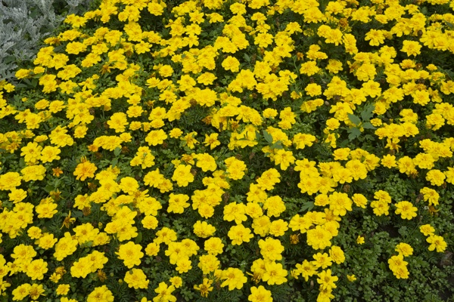6_1.png:** 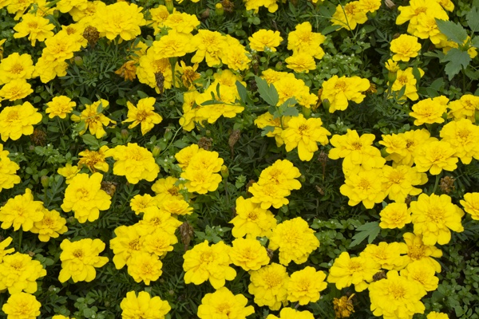

**Table 1 - Found homography parameters and normalization accuracy assessment**

|  |  |  |  |  |  |  |  |  |  |  |  |  |  |  |  |
| --- | --- | --- | --- | --- | --- | --- | --- | --- | --- | --- | --- | --- | --- | --- | --- |
| Original:  img1: 0 img2: 0 | h11 | h12 | h13 | h21 | h22 | h23 | h31 | h32 | h33 | avg ErrPar (param) | avg ErrIM (pixel) | max ErrIM | avg ErrCPM (corner) | max ErrCPM | Expert rate |
| SIFT | 2,191 | 0,234 | -472,039 | -0,24 | 2,165 | -186,786 | 0 | 0 | 1 | 0 | 0,852 | 3,977 | ~ | ~ |  |
| SURF128 | 2,103 | 0,206 | -446,534 | -0,243 | 2,09 | -175,749 | 0 | 0 | 1 | 0 | 1,233 | 3,293 | ~ | ~ |  |
| SURF64 | 2,191 | 0,241 | -472,636 | -0,243 | 2,172 | -186,596 | 0 | 0 | 1 | 0 | 1,263 | 3,421 | ~ | ~ |  |
| ORB | 2,132 | 0,213 | -454,592 | -0,24 | 2,11 | -178,64 | 0 | 0 | 1 | 0 | 1,381 | 4,168 | ~ | ~ |  |
| ORB1000 | 2,177 | 0,236 | -469,005 | -0,236 | 2,153 | -185,902 | 0 | 0 | 1 | 0 | 1,26 | 2,944 | ~ | ~ |  |
| BRISK | 2,197 | 0,237 | -473,118 | -0,241 | 2,173 | -187,251 | 0 | 0 | 1 | 0 | 1,234 | 3,565 | ~ | ~ |  |
| KAZE | 2,143 | 0,227 | -459,264 | -0,242 | 2,13 | -181,768 | 0 | 0 | 1 | 0 | 1,316 | 3,208 | ~ | ~ |  |
| AKAZE | 2,14 | 0,214 | -456,255 | -0,238 | 2,112 | -179,733 | 0 | 0 | 1 | 0 | 1,177 | 3,241 | ~ | ~ |  |
| Original matrix |  |  |  |  |  |  |  |  |  |  |  |  |  |  |  |

where h11, h12, h13, h21, h22, h23, h31, h32, h33 - parameters of found homography matrix H* or of original one H;   
avgErrPar - average error of found parameters, the accuracy of found homography matrix parameters with a preliminary minimax normalization of found and original matrices;  
avgErrIM - average error of inlier coordinate matching;  
inliers - correct matches; outliers - false matches;  
maxErrIM – maximum error of inlier coordinate matching;  
avgErrCPM - average error of corner point matching;  
maxErrCPM - maximum error of corner point matching;  
expert rate - experts assessment of normalization accuracy with a 5-point scale: 0 - normalization failed, 1 - insufficient, 2 - satisfactory, 3 - good, 4 – excellent.

**Table 2 - Quantitative evaluation of descriptors, precision and recall estimation (with found overlap)**

|  |  |  |  |  |  |  |  |  |  |  |  |  |  |  |  |  |
| --- | --- | --- | --- | --- | --- | --- | --- | --- | --- | --- | --- | --- | --- | --- | --- | --- |
| Name | NP1 | NP2 | NM | NI | DP1 | DP2 | OP1 | OP2 | NPO1 | NPO2 | NMO | DPO1 | DPO2 | Precision | RecallO1 | Comments |
| SIFT | 5683 | 3861 | 711 | 644 | 0,0237 | 0,0161 | 23,1829 | 100 | 1329 | 3861 | 676 | 0,0239 | 0,0161 | 0,9058 | 0,4846 |  |
| SURF128 | 2833 | 2489 | 243 | 186 | 0,0118 | 0,0104 | 23,2021 | 100 | 786 | 2489 | 241 | 0,0141 | 0,0104 | 0,7654 | 0,2366 |  |
| SURF64 | 2833 | 2489 | 308 | 243 | 0,0118 | 0,0104 | 23,2575 | 100 | 784 | 2489 | 301 | 0,014 | 0,0104 | 0,789 | 0,3099 |  |
| ORB | 20152 | 13554 | 1480 | 1090 | 0,084 | 0,0565 | 23,2867 | 100 | 7019 | 13554 | 1418 | 0,1256 | 0,0565 | 0,7365 | 0,1553 |  |
| ORB1000 | 1000 | 1000 | 101 | 64 | 0,0042 | 0,0042 | 23,3371 | 100 | 478 | 1000 | 97 | 0,0085 | 0,0042 | 0,6337 | 0,1339 |  |
| BRISK | 8688 | 5215 | 634 | 534 | 0,0362 | 0,0217 | 23,2175 | 100 | 2555 | 5215 | 623 | 0,0459 | 0,0217 | 0,8423 | 0,209 |  |
| KAZE | 2616 | 1773 | 171 | 125 | 0,0109 | 0,0074 | 23,2046 | 100 | 679 | 1773 | 157 | 0,0122 | 0,0074 | 0,731 | 0,1841 |  |
| AKAZE | 2632 | 1528 | 194 | 160 | 0,011 | 0,0064 | 23,2283 | 100 | 840 | 1528 | 178 | 0,0151 | 0,0064 | 0,8247 | 0,1905 |  |

where NP - number of found key points; NP1, NP2 - number of found key points for image1 and image2 respectively;  
NM - number of matches found with NNDR method, NM=NI+NO;  
NI - number of inliers found with RANSAC method;  
NO - number of outliers discarded with RANSAC method;   
DP - density of key points (per cent), DP= NP/(height x width) , height, width - vertical and horizontal image sizes respectively (pixels)  
DP1, DP2 - density of key points points for image1 and image2 respectively;  
OP1, OP2 - overlap percentage for image1 and image2 respectively;  
NPO1, NPO2 - number of found key points on overlap for image1 and image2 respectivelyy;  
NMO - number of matches on overlap found with NNDR method;  
DPO1, DPO2 - density of key points points on overlap for image1 and image2 respectively;   
OA - overlap area (pixels), OA1, OA2 - overlap area for image1 and image2 respectively;  
DPO1= NPO1/OA1; DPO2= NPO2/OA2;  
Precision = NI/ NM - the rate to evaluate the part of inliers to all found matches with NNDR method;  
RecallO1 = NI/ NPO1 - completeness of inlier retrieval relative to the number of all key points on overlap for image1. The rate illustrates usefulness of the found key points for normalization.

**Table 3 - Estimation of time costs**

|  |  |  |  |  |  |  |  |  |  |  |
| --- | --- | --- | --- | --- | --- | --- | --- | --- | --- | --- |
| Name | NP1 | NP2 | DesT1, sec | DesT2, sec | MatchT, sec | InlierT, sec | AvgDesT, ms | AvgMatchT, ms | AvgInlierT, ms | TotalNormT, sec |
| SIFT | 5683 | 3861 | 0,072581 | 0,062669 | 0,177281 | 0,000664 | 0,014501 | 0,24934 | 0,00103 | 0,313195 |
| SURF128 | 2833 | 2489 | 0,078461 | 0,061273 | 0,054239 | 0,000629 | 0,026156 | 0,223205 | 0,003383 | 0,194602 |
| SURF64 | 2833 | 2489 | 0,073041 | 0,062677 | 0,030221 | 0,000542 | 0,025481 | 0,098121 | 0,002232 | 0,166482 |
| ORB | 20152 | 13554 | 0,040359 | 0,029046 | 0,594497 | 0,001284 | 0,002072 | 0,401687 | 0,001178 | 0,665186 |
| ORB1000 | 1000 | 1000 | 0,013848 | 0,011815 | 0,003202 | 0,000936 | 0,012831 | 0,031703 | 0,014629 | 0,029801 |
| BRISK | 8688 | 5215 | 0,138776 | 0,080514 | 0,110067 | 0,000657 | 0,015705 | 0,173606 | 0,001229 | 0,330013 |
| KAZE | 2616 | 1773 | 0,130598 | 0,10988 | 0,036352 | 0,001027 | 0,055948 | 0,212584 | 0,008219 | 0,277858 |
| AKAZE | 2632 | 1528 | 0,019592 | 0,017294 | 0,013307 | 0,000451 | 0,00938 | 0,068593 | 0,00282 | 0,050645 |

where DesT – descriptor creation time (time for key point detection and descriptor computation), DesT1, DesT2 – creation time of descriptors for image1 and image2 respectively;  
MatchT - retrieval time of matching found with NNDR method for the pair;  
InlierT – inlier retrieval time found with RANSAC method for the pair;  
AvgDesT – average time for one descriptor creation;  
AvgMatchT - average time for one match retrieval with NNDR method;  
AvgInlierT – average time for one inlier retrieval with RANSAC method;  
TotalNormT – total normalization time for the pair.